

**Computer Science Department**

**COMP133 ( Second Semester ‘23/’24 )**

**Assign # 1 *Due Date: Wednesday 27/03/2024 by 10:00 pm ( on Ritaj )***

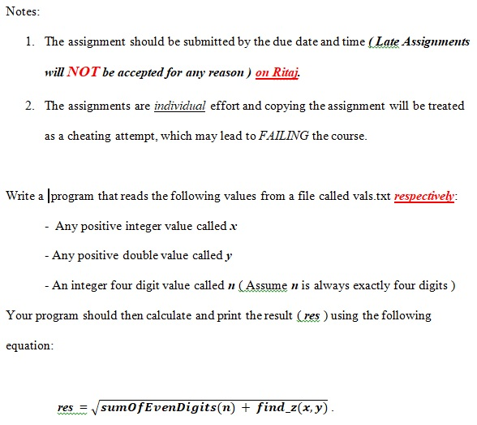

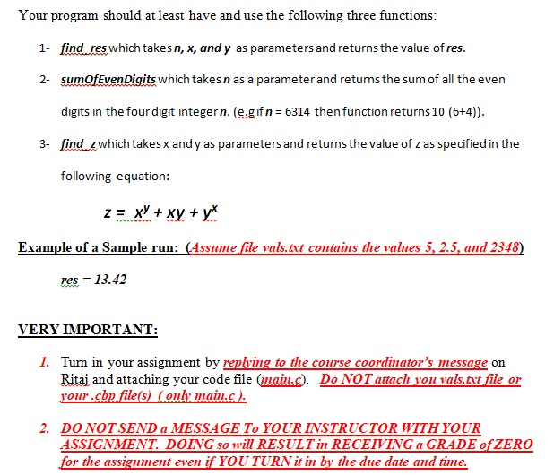

1. ***LATE ASSIGNMENTS WILL NOT BE ACCEPTED FOR ANY REASON. IF YOU DECIDE TO WAIT UNTIL THE LAST MOMENT TO TURN IN YOUR ASSIGNMENT, THEN YOU WILL BE FULLY RESPONSIBLE FOR ANY PROBLEMS THAT MAY ARISE ( e.g. No electricity, No internet, Ritaj Block, or any other situation). Make sure you always leave at least one extra day to be able to handle any situation that may arise and so that you do not receive a zero Grade.***
2. ***IT IS YOUR RESPONSIBILITY TO MAKE SURE YOUR main.c FILE HAS BEEN ATTACHED AND SENT CORRECTLY. IF YOUR CODE FILE (main.c) CANNOT BE OPENED FOR ANY REASON, IT WILL NOT BE GRADED.***
3. You must include your full name, student id number, and both your lecture and lab section numbers in a comment at the beginning of your ***main.c*** code file.

**IMPORTANT FINAL NOTE: YOU ARE NOT ALLOWED TO USE LOOPS ANYWHERE IN YOUR PROGRAM. USING ANY LOOPS WILL RESULT IN YOU RECEIVING A GRADE OF ZERO FOR THE WHOLE ASSIGNMENT.**