CHAPTER 15

**ALLOCATION OF SUPPORT-DEPARTMENT COSTS,**

**COMMON COSTS, AND REVENUES**

**15-1** Distinguish between the single-rate and the dual-rate methods.

The single-rate (cost-allocation) method makes no distinction between fixed costs and variable costs in the cost pool. It allocates costs in each cost pool to cost objects using the same rate per unit of the single allocation base. The dual-rate (cost-allocation) method classifies costs in each cost pool into two pools—a variable-cost pool and a fixed-cost pool—with each pool using a different cost-allocation base.

**15-2** Describe how the dual-rate method is useful to division managers in decision making.

The dual-rate method provides information to division managers about cost behavior. Recognizing the different behavior of fixed costs and variable costs is useful in decision making.

**15-3** How do budgeted cost rates motivate the support-department manager to improve efficiency?

Budgeted cost rates motivate the manager of the support department to improve efficiency because the support department bears the risk of any unfavorable cost variances.

**15-4** Give examples of allocation bases used to allocate support-department cost pools to operating departments.

Examples of bases used to allocate support department cost pools to operating departments include the number of employees, square feet of space, number of direct labor hours, and machine-hours.

**15-5** Why might a manager prefer that budgeted rather than actual cost-allocation rates be used for costs being allocated to his or her department from another department?

The use of budgeted indirect cost allocation rates rather than actual indirect rates has several attractive features to the manager of a user department:

a. The user knows the costs in advance and can factor them into ongoing operating choices.

1. The cost allocated to a particular user department does not depend on the amount of resources used by other user departments.
2. Inefficiencies at the department providing the service do not affect the costs allocated to the user department.

**15-6 “**To ensure unbiased cost allocations, fixed costs should be allocated on the basis of estimated long-run use by user-department managers.” Do you agree? Why?

Disagree. Allocating costs on “the basis of estimated long-run use by user department managers” means department managers can lower their cost allocations by deliberately underestimating their long-run use (assuming all other managers do not similarly underestimate their usage).

**15-7** Distinguish among the three methods of allocating the costs of support departments to operating departments.

The three methods differ in how they recognize reciprocal services among support departments:

a. The direct (allocation) method ignores any services rendered by one support department to another; it allocates each support department’s costs directly to the operating departments.

b. The step-down (allocation) method allocates support-department costs to other support departments and to operating departments in a sequential manner that partially recognizes the mutual services provided among all support departments.

c. The reciprocal (allocation) method allocates support-department costs to operating departments by fully recognizing the mutual services provided among all support departments.

**15-8** What is conceptually the most defensible method for allocating support-department costs? Why?

The reciprocal method is theoretically the most defensible method because it fully recognizes the mutual services provided among all departments, irrespective of whether those departments are operating or support departments.

**15-9** Distinguish between two methods of allocating common costs.

The stand-alone cost-allocation method uses information pertaining to each user of a cost object as a separate entity to determine the cost-allocation weights.

The incremental cost-allocation method ranks the individual users of a cost object in the order of users most responsible for the common costs and then uses this ranking to allocate costs among those users. The first-ranked user of the cost object is the primary user and is allocated costs up to the costs of the primary user as a stand-alone user. The second-ranked user is the first incremental user and is allocated the additional cost that arises from two users instead of only the primary user. The third-ranked user is the second incremental user and is allocated the additional cost that arises from three users instead of two users, and so on.

**15-10** What are the challenges of using the incremental cost allocation method when allocating common costs and how might they be overcome?

The challenges of using the incremental method is that every user wants to be considered the lowest-ranked user because only small incremental costs are allocated to each subsequently-ranked user. No user wants to be the first-ranked user because all costs up to the costs of the primary user are allocated to that user. This challenge could be overcome by using the Shapley Value method. This method calculates an average cost based on the costs allocated to each user as first the primary user, the second-ranked user, the third-ranked user, and so on.

**15-11** What role does the Cost Accounting Standards Board play when companies contract with the U.S. government?

All contracts with U.S. government agencies must comply with cost accounting standards issued by the Cost Accounting Standards Board (CASB).

**15-12** What is one key way to reduce cost-allocation disputes that arise with government contracts?

Areas of dispute between contracting parties can be reduced by making the “rules of the game” explicit and in writing at the time the contract is signed.

**15-13** Describe how companies are increasingly facing revenue-allocation decisions.

Companies increasingly are selling packages of products or services for a single price. Revenue allocation is required when managers in charge of developing or marketing individual products in a bundle are evaluated using product‑specific revenues.

**15-14** Distinguish between the stand-alone and the incremental revenue-allocation methods.

The stand-alone revenue-allocation method uses product‑specific information on the products in the bundle as weights for allocating the bundled revenues to the individual products.

The incremental revenue allocation method ranks individual products in a bundle according to criteria determined by management—such as the product in the bundle with the most sales—and then uses this ranking to allocate bundled revenues to the individual products. The first-ranked product is the primary product in the bundle and is allocated revenue up to the revenue of the primary product as a stand-alone product. The second-ranked product is the first incremental product and is allocated the additional revenue that arises from two products instead of only the primary product. The third-ranked product is the second incremental product and is allocated the additional revenue that arises from three products instead of two products, and so on.

**15-15** Identify and discuss arguments that individual product managers may put forward to support their preferred revenue-allocation method.

Managers typically will argue that their individual product is the prime reason why consumers buy a bundle of products. Evidence on this argument could come from the sales of the products when sold as individual products. Otherpieces of evidence include surveys of users of each product and surveys of people who purchase the bundle of products.



**15-16** Single-rate versus dual-rate methods, support department. The Cincinnati power plant that services all manufacturing departments of Eastern Mountain Engineering has a budget for the coming year. This budget has been expressed in the following monthly terms:

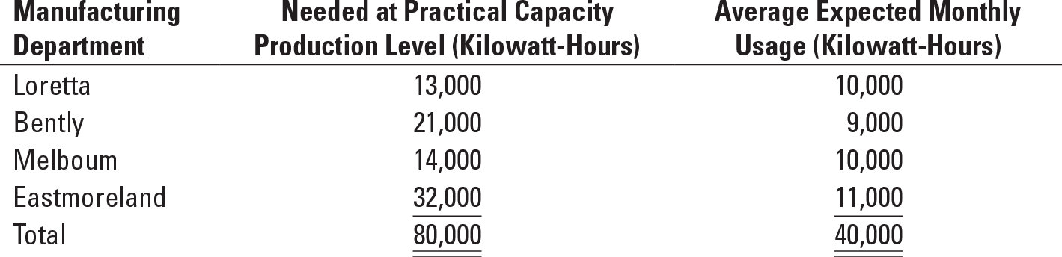

The expected monthly costs for operating the power plant during the budget year are $20,000: $8,000 variable and $12,000 fixed.

Required:

**1.** Assume that a single cost pool is used for the power plant costs. What budgeted amounts will be allocated to each manufacturing department if (a) the rate is calculated based on practical capacity and costs are allocated based on practical capacity and (b) the rate is calculated based on expected monthly usage and costs are allocated based on expected monthly usage?

**2.** Assume the dual-rate method is used with separate cost pools for the variable and fixed costs. Variable costs are allocated on the basis of expected monthly usage. Fixed costs are allocated on the basis of practical capacity. What budgeted amounts will be allocated to each manufacturing department? Why might you prefer the dual-rate method?

**SOLUTION**

(20 min.) **Single-rate versus dual-rate methods, support department.**

Bases available (kilowatt hours):

|  |  |  |  |  |  |
| --- | --- | --- | --- | --- | --- |
|  | **Loretta** | **Bently** | **Melboum** | **Eastmoreland** | **Total** |
| Practical capacity  Expected monthly usage | 13,000  10,000 | 21,000  9,000 | 14,000  10,000 | 32,000  11,000 | 80,000  40,000 |

1a. Single-rate method based on practical capacity:

Total costs in pool = $8,000 + $12,000 = $20,000

Practical capacity = 80,000 kilowatt hours

Allocation rate = $20,000 ÷ 80,000 = $0.25 per hour of capacity

|  |  |  |  |  |  |
| --- | --- | --- | --- | --- | --- |
|  | **Loretta** | **Bently** | **Melboum** | Eastmoreland | **Total** |
| Practical capacity in hours  Costs allocated at $0.25 per hour | 13,000  $3,250 | 21,000  $5,250 | 14,000  $3,500 | 32,000  $8,000 | 80,000  $20,000 |

8

1b. Single-rate method based on expected monthly usage:

Total costs in pool = $8,000 + $12,000 = $20,000

Expected usage = 40,000 kilowatt hours

Allocation rate = $20,000 ÷ 40,000 = $0.50 per hour of expected usage

|  |  |  |  |  |  |
| --- | --- | --- | --- | --- | --- |
|  | Loretta | **Bently** | **Melboum** | Eastmoreland | **Total** |
| Expected monthly usage in hours  Costs allocated at $0.50 per hour | 10,000  $5,000 | 9,000  $4,500 | 10,000  $5,000 | 11,000  $5,500 | 40,000  $20,000 |

2. Variable-Cost Pool:

Total costs in pool = $8,000

Expected usage = 40,000 kilowatt hours

Allocation rate = $8,000 ÷ 40,000 = $0.20 per hour of expected usage

Fixed-Cost Pool:

Total costs in pool = $12,000

Practical capacity = 80,000 kilowatt hours

Allocation rate = $12,000 ÷ 80,000 = $0.15 per hour of capacity

|  |  |  |  |  |  |
| --- | --- | --- | --- | --- | --- |
|  | **Loretta** | Bently | **Melboum** | **Eastmoreland** | Total |
| Variable-cost pool  $0.20 × 10,000; 9,000; 10,000, 11,000  Fixed-cost pool  $0.15 × 13,000; 21,000; 14,000, 32,000  Total | $2,000  1,950  $3,950 | $1,800  3,150  $4,950 | $2,000  2,100  $4,100 | $2,200  4,800  $7,000 | $ 8,000  12,000  $20,000 |

The dual-rate method permits a more refined allocation of the power department costs; it permits the use of different allocation bases for different cost pools. The fixed costs result from decisions most likely associated with the scale of the facility, or the practical capacity level. The variable costs result from decisions most likely associated with monthly usage.

**15-17** Single-rate method, budgeted versus actual costs and quantities. Chocolat Inc. is a producer of premium chocolate based in Palo Alto. The company has a separate division for each of its two products: dark chocolate and milk chocolate. Chocolat purchases ingredients from Wisconsin for its dark chocolate division and from Louisiana for its milk chocolate division. Both locations are the same distance from Chocolat’s Palo Alto plant.

Chocolat Inc. operates a fleet of trucks as a cost center that charges the divisions for variable costs (drivers and fuel) and fixed costs (vehicle depreciation, insurance, and registration fees) of operating the fleet. Each division is evaluated on the basis of its operating income. For 2017, the trucking fleet had a practical capacity of 50 round-trips between the Palo Alto plant and the two suppliers. It recorded the following information:

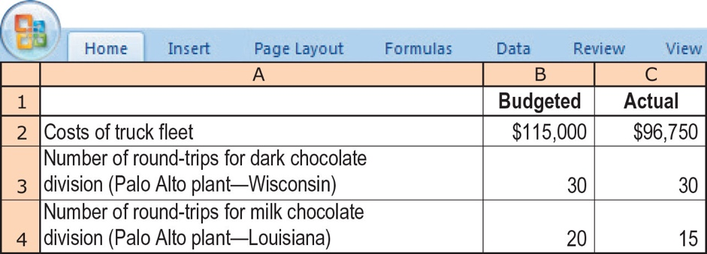

Required:

**1.** Using the single-rate method, allocate costs to the dark chocolate division and the milk chocolate division in these three ways.

**a.** Calculate the budgeted rate per round-trip and allocate costs based on round-trips budgeted for each division.

**b**. Calculate the budgeted rate per round-trip and allocate costs based on actual round-trips used by each division.

**c**. Calculate the actual rate per round-trip and allocate costs based on actual round-trips used by each division.

**2.** Describe the advantages and disadvantages of using each of the three methods in requirement 1. Would you encourage Chocolat Inc. to use one of these methods? Explain and indicate any assumptions you made.

**SOLUTION**

(20–25 min.) **Single-rate method, budgeted versus actual costs and quantities.**

1. a. Budgeted rate =  = $115,000/50 trips = $2,300 per round-trip

Indirect costs allocated to Dark Choc. Division = $2,300 per round-trip 30 budgeted round trips

= $69,000

Indirect costs allocated to Milk Choc. Division = $2,300 per round-trip 20 budgeted round trips = $46,000

1. Budgeted rate = $2,300 per round-trip

Indirect costs allocated to Dark Choc. Division = $2,300 per round-trip 30 actual round trips

= $69,000

Indirect costs allocated to Milk Choc. Division = $2,300 per round-trip 15 actual round trips

= $34,500

c. Actual rate =  = $96,750/ 45 trips = $2,150 per round-trip

Indirect costs allocated to Dark Choc. Division = $2,150 per round-trip 30 actual round trips

= $64,500

Indirect costs allocated to Milk Choc. Division = $2,150 per round-trip 15 actual round trips

= $32,250

2. When budgeted rates/budgeted quantities are used, the Dark Chocolate and Milk Chocolate Divisions know at the start of 2017 that they will be charged a total of $69,000 and $46,000, respectively, for transportation. In effect, the fleet resource becomes a fixed cost for each division. Then, each may be motivated to over-use the trucking fleet, knowing that their 2017 transportation costs will not change.

When budgeted rates/actual quantities are used, the Dark Chocolate and Milk Chocolate Divisions know at the start of 2017 that they will be charged a rate of $2,300 per round trip, i.e., they know the price per unit of this resource. This enables them to make operating decisions knowing the rate they will have to pay for transportation. Each can still control its total transportation costs by minimizing the number of round trips it uses. Assuming that the budgeted rate was based on honest estimates of their annual usage, this method will also provide an estimate of the excess trucking capacity (the portion of fleet costs not charged to either division). In contrast, when actual costs/actual quantities are used, the two divisions must wait until year-end to know their transportation charges.

The use of actual costs/actual quantities makes the costs allocated to one division a function of the actual demand of other users. In 2017, the actual usage was 45 trips, which is 5 trips below the 50 trips budgeted. The Dark Chocolate Division used all the 30 trips it had budgeted. The Milk Chocolate Division used only 15 of the 20 trips budgeted. When costs are allocated based on actual costs and actual quantities, the same fixed costs are spread over fewer trips resulting in a higher rate than if the Milk Chocolate Division had used its budgeted 20 trips. As a result, the Dark Chocolate Division bears a proportionately higher share of the fixed costs.

Using actual costs/actual rates also means that any efficiencies or inefficiencies of the trucking fleet get passed along to the user divisions. In general, this will have the effect of making the truck fleet less careful about its costs although, in 2017, it appears to have managed its costs well, leading to a lower actual cost per roundtrip relative to the budgeted cost per round trip.

For the reasons stated previously, of the three single-rate methods suggested in this problem, the budgeted rate and actual quantity may be the best one to use. (The management of Chocolat Inc. would have to ensure that the managers of the Dark Chocolate and Milk Chocolate divisions do not systematically overestimate their budgeted use of the fleet division in an effort to drive down the budgeted rate).

**15-18** Dual-rate method, budgeted versus actual costs and quantities (continuation of   
15-17). Chocolat Inc. decides to examine the effect of using the dual-rate method for allocating truck costs to each round-trip. At the start of 2017, the budgeted costs were:

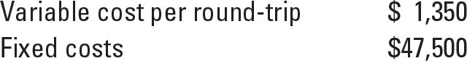

The actual results for the 45 round-trips made in 2017 were:

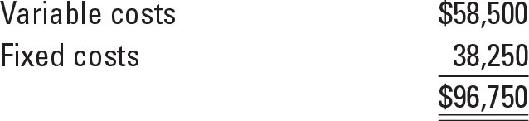

Assume all other information to be the same as in Exercise 15-17.

Required:

**1.** Using the dual-rate method, what are the costs allocated to the dark chocolate division and the milk chocolate division when (a) variable costs are allocated using the budgeted rate per round-trip and actual round-trips used by each division and when (b) fixed costs are allocated based on the budgeted rate per round-trip and round-trips budgeted for each division?

**2.** From the viewpoint of the dark chocolate division, what are the effects of using the dual-rate method rather than the single-rate method?

**SOLUTION**

(20 min.)**Dual-rate method, budgeted versus actual costs and quantities (continuation of 15-17).**

1. Charges with dual rate method.

Variable indirect cost rate = $1,350 per trip

Fixed indirect cost rate = $47,500 budgeted costs/ 50 round trips budgeted

= $950 per trip

Dark Chocolate Division

Variable indirect costs, $1,350 × 30 $40,500

Fixed indirect costs, $950 × 30 28,500

$69,000

Milk Chocolate Division

Variable indirect costs, $1,350 × 15 $20,250

Fixed indirect costs, $950 × 20 19,000

$39,250

1. The dual rate changes how the fixed indirect cost component is treated. By using budgeted trips made, the Dark Chocolate Division is unaffected by changes from its own budgeted usage or that of other divisions. When budgeted rates and actual trips are used for allocation (see requirement 1.b. of problem 15-17), the Dark Chocolate Division is assigned the same $28,500 for fixed costs as under the dual-rate method because it made the same number of trips as budgeted. However, note that the Milk Chocolate Division is allocated $19,000 in fixed trucking costs under the dual-rate system, compared to $950 × 15 actual trips = $14,250 when actual trips are used for allocation. As such, the Dark Chocolate Division is not made to appear disproportionately more expensive than the Milk Chocolate Division simply because the latter did not make the number of trips it budgeted at the start of the year.

**15-19** Support-department cost allocation; direct and step-down methods. Phoenix Partners provides management consulting services to government and corporate clients. Phoenix has two support departments—administrative services (AS) and information systems (IS)—and two operating departments—government consulting (GOVT) and corporate consulting (CORP). For the first quarter of 2017, Phoenix’s cost records indicate the following:

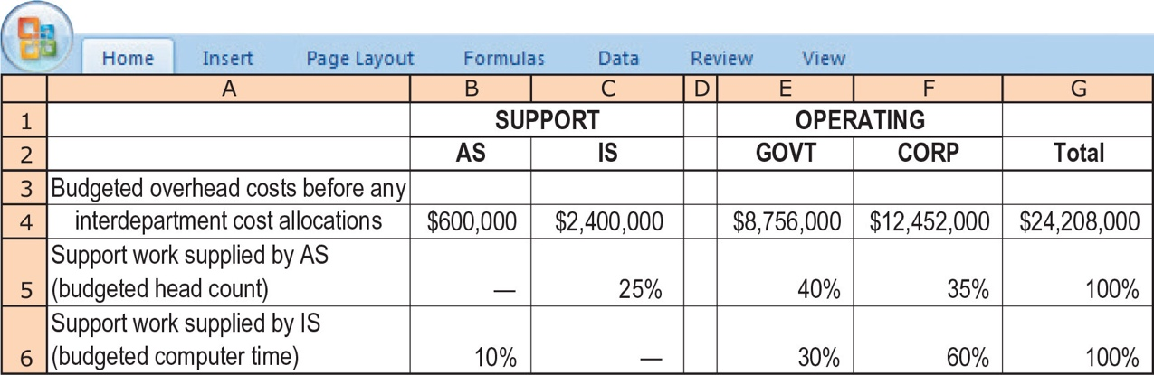

Required:

**1.** Allocate the two support departments’ costs to the two operating departments using the following methods:

**a.** Direct method

**b.** Step-down method (allocate AS first)

**c.** Step-down method (allocate IS first)

**2.** Compare and explain differences in the support-department costs allocated to each operating department.

**3.** What approaches might be used to decide the sequence in which to allocate support departments when using the step-down method?

**SOLUTION**

(30 min.) **Support department cost allocation; direct and step-down methods.**

1. **AS IS GOVT CORP**

a. Direct method costs $600,000 $2,400,000

Alloc. of AS costs

(40/75, 35/75) (600,000) $ 320,000 $ 280,000

Alloc. of IS costs

(30/90, 60/90) (2,400,000) 800,000 1,600,000

$ 0 $ 0 $1,120,000 $1,880,000

b. Step-down (AS first) costs $600,000 $2,400,000

Alloc. of AS costs

(0.25, 0.40, 0.35) (600,000) 150,000 $ 240,000 $ 210,000

Alloc. of IS costs

(30/90, 60/90) (2,550,000) 850,000 1,700,000

$ 0 $ 0 $1,090,000 $1,910,000

c. Step-down (IS first) costs $600,000 $2,400,000

Alloc. of IS costs

(0.10, 0.30, 0.60) 240,000 (2,400,000) $ 720,000 $1,440,000

Alloc. of AS costs

(40/75, 35/75) (840,000) 448,000 392,000

$ 0 $ 0 $1,168,000 $1,832,000

2. **GOVT CORP**

Direct method $1,120,000 $1,880,000

Step-down (AS first) 1,090,000 1,910,000

Step-down (IS first) 1,168,000 1,832,000

The direct method ignores any services to other support departments. The step-down method partially recognizes services to other support departments. The information systems support group (with total budget of $2,400,000) provides 10% of its services to the AS group. The AS support group (with total budget of $600,000) provides 25% of its services to the information systems support group. When the AS group is allocated first, a total of $2,550,000 is then assigned out from the IS group. Given CORP’s disproportionate (2:1) usage of the services of IS, this method then results in the highest overall allocation of costs to CORP. By contrast, GOVT’s usage of the AS group exceeds that of CORP (by a ratio of 8:7), and so GOVT is assigned relatively more in support costs when AS costs are assigned second, after they have already been incremented by the AS share of IS costs as well.

3. Three criteria that could determine the sequence in the step-down method are as follows:

a. Allocate support departments on a ranking of the percentage of their total services provided to other support departments.

1. Administrative Services 25%

2. Information Systems 10%

b. Allocate support departments on a ranking of the total dollar amount in the support departments.

1. Information Systems $2,400,000

2. Administrative Services $ 600,000

c. Allocate support departments on a ranking of the dollar amounts of service provided to other support departments

1. Information Systems

(0.10 × $2,400,000) = $240,000

2. Administrative Services

(0.25 × $600,000) = $150,000

The approach in (a) above typically better approximates the theoretically preferred reciprocal method. It results in a higher percentage of support-department costs provided to other support departments being incorporated into the step-down process than does (b) or (c), above.

**15-20** Support-department cost allocation, reciprocal method (continuation of 15-19). Refer to the data given in Exercise 15-19.

Required:

**1.** Allocate the two support departments’ costs to the two operating departments using the reciprocal method. Use (a) linear equations and (b) repeated iterations.

**2.** Compare and explain differences in requirement 1 with those in requirement 1 of Exercise 15-19. Which method do you prefer? Why?

**SOLUTION**

(50 min.) **Support-department cost allocation, reciprocal method** **(continuation of 15-19).**

1a.

|  |  |  |  |
| --- | --- | --- | --- |
|  | **Support Departments** |  | **Operating Departments** |

**AS I S Govt. Corp.**

|  |  |  |  |  |
| --- | --- | --- | --- | --- |
| Costs | $600,000 | $2,400,000 |  |  |
| Alloc. of AS costs (0.25, 0.40, 0.35) | (861,538) | 215,385 | $ 344,615 | $ 301,538 |
| Alloc. of IS costs  (0.10, 0.30, 0.60) | 261,538 | (2,615,385) | 784,616 | 1,569,231 |
|  | $ 0 | $ 0 | $1,129,231 | $1,870,769 |

###### Reciprocal Method Computation

###### AS = $600,000 + 0.10 IS

IS **=** $2,400,000 + 0.25AS

IS = $2,400,000 + 0.25 ($600,000 + 0.10 IS)

= $2,400,000 + $150,000 + 0.025 IS

0.975IS = $2,550,000

IS = $2,550,000 ÷ 0.975

= $2,615,385

AS = $600,000 + 0.10 ($2,615,385)

= $600,000 + $261,538

= $861,538

1b.

|  |  |  |  |
| --- | --- | --- | --- |
|  | **Support Departments** |  | **Operating Departments** |

**AS I S Govt. Corp.**

|  |  |  |  |  |
| --- | --- | --- | --- | --- |
| Costs | $600,000 | $2,400,000 |  |  |
| 1st Allocation of AS  (0.25, 0.40, 0.35) | (600,000) | 150,000 | $ 240,000 | $ 210,000 |
|  |  | 2,550,000 |  |  |
| 1st Allocation of IS  (0.10, 0.30, 0.60) | 255,000 | (2,550,000) | 765,000 | 1,530,000 |
| 2nd Allocation of AS  (0.25, 0.40, 0.35) | (255,000) | 63,750 | 102,000 | 89,250 |
| 2nd Allocation of IS  (0.10, 0.30, 0.60) | 6,375 | (63,750) | 19,125 | 38,250 |
| 3rd Allocation of AS  (0.25, 0.40, 0.35) | (6,375) | 1,594 | 2,550 | 2,231 |
| 3rd Allocation of IS  (0.10, 0.30, 0.60) | 160 | (1,594) | 478 | 956 |
| 4th Allocation of AS  (0.25, 0.40, 0.35) | (160) | 40 | 64 | 56 |
| 4th Allocation of IS  (0.10, 0.30, 0.60) | 4 | (40) | 12 | 24 |
| 5th Allocation of AS  (0.25, 0.40, 0.35) | (4) | 1 | 2 | 1 |
| 5th Allocation of IS  (0.10, 0.30, 0.60) | 0 | (1) | 0 | 1 |
| Total allocation | $ 0 | $ 0 | $1,129,231 | $1,870,769 |

2.

|  |  |  |  |
| --- | --- | --- | --- |
|  |  | **Govt. Consulting** | **Corp. Consulting** |

a. Direct $1,120,000 $1,880,000

b. Step-Down (AS first) 1,090,000 1,910,000

c. Step-Down (IS first) 1,168,000 1,832,080

d. Reciprocal 1,129,231 1,870,769

The four methods differ in the level of support department cost allocation across support departments. The level of reciprocal service by support departments is material. Administrative Services supplies 25% of its services to Information Systems. Information Systems supplies 10% of its services to Administrative Services. The Information Department has a budget of $2,400,000 that is 400% higher than Administrative Services.

The reciprocal method recognizes all the interactions and is thus the most accurate. This is especially clear from looking at the repeated iterations calculations.

**15-21** Direct and step-down allocation. E-books, an online book retailer, has two operating departments—corporate sales and consumer sales—and two support departments—human resources and information systems. Each sales department conducts merchandising and marketing operations independently. E-books uses number of employees to allocate human resources costs and processing time to allocate information systems costs. The following data are available for September 2017:

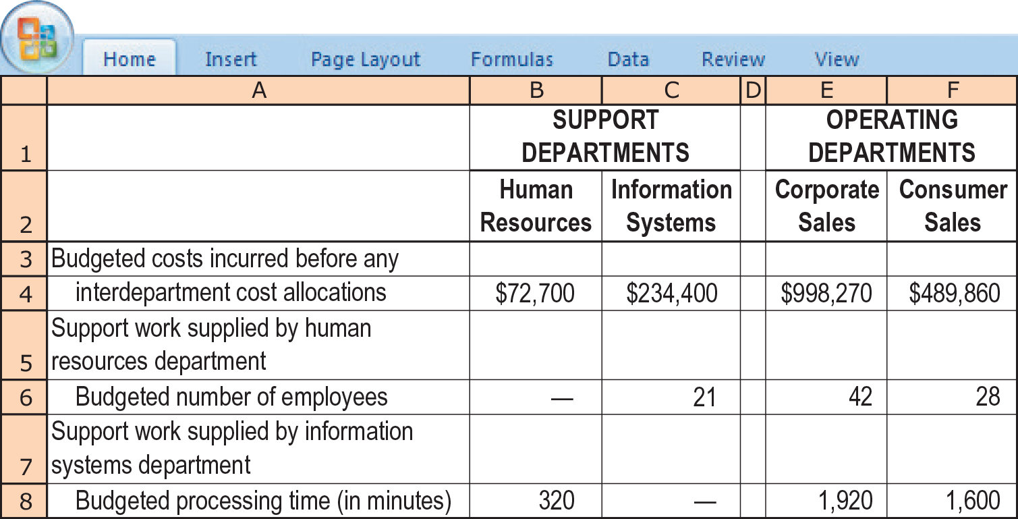

Required:

**1.** Allocate the support departments’ costs to the operating departments using the direct method.

**2.** Rank the support departments based on the percentage of their services provided to other support departments. Use this ranking to allocate the support departments’ costs to the operating departments based on the step-down method.

**3.** How could you have ranked the support departments differently?

**SOLUTION**

(40 min.) **Direct and step-down allocation.**

1.

|  |  |  |  |  |  |
| --- | --- | --- | --- | --- | --- |
|  | **Support Departments** | | **Operating Departments** | |  |
|  | **HR** | **Info. Systems** | **Corporate** | **Consumer** | **Total** |
| Costs Incurred | $72,700 | $234,400 | $ 998,270 | $489,860 | $1,795,230 |
| Alloc. of HR costs |  |  |  |  |  |
| (42/70, 28/70) | (72,700) |  | 43,620 | 29,080 |  |
| Alloc. of Info. Syst. costs |  |  |  |  |  |
| (1,920/3,520, 1,600/3,520) | ______ | (234,400) | 127,855 | 106,545 | _________ |
|  | $ 0 | $ 0 | $1,169,745 | $625,485 | $1,795,230 |

2. Rank on percentage of services rendered to other support departments.

Step 1: HR provides 23.077% of its services to information systems:

 =  = 23.077%

This 23.077% of $72,700 HR department costs is $16,777.

Step 2: Information systems provides 8.333% of its services to HR:

 =  = 8.333%

This 8.333% of $234,400 information systems department costs is $19,533.

|  |  |  |  |  |  |
| --- | --- | --- | --- | --- | --- |
|  | **Support Departments** | | **Operating Departments** | |  |
|  | **HR** | **Info. Systems** | **Corporate** | **Consumer** | Total |
| Costs Incurred | $72,700 | $234,400 | $ 998,270 | $489,860 | $1,795,230 |
| Alloc. of HR costs |  |  |  |  |  |
| (21/91, 42/91, 28/91) | (72,700) | 16,777 | 33,554 | 22,369 |  |
|  |  | 251,177 |  |  |  |
| Alloc. of Info. Syst. costs |  |  |  |  |  |
| (1,920/3,520, 1,600/3,520) | . | (251,177) | 137,006 | 114,171 |  |
|  | $ 0 | $ 0 | $1,168,830 | $626,400 | $1,795,230 |

1. An alternative ranking is based on the dollar amount of services rendered to other support departments. Using numbers from requirement 2, this approach would use the following sequence:

Step 1: Allocate Information Systems first ($19,533 provided to HR).

Step 2: Allocate HR second ($16,777 provided to Information Systems).

**15-22** Reciprocal cost allocation (continuation of 15-21). Consider E-books again. The controller of E-books reads a widely used textbook that states that “the reciprocal method is conceptually the most defensible.” He seeks your assistance.

Required:

**1.** Describe the key features of the reciprocal method.

**2.** Allocate the support departments’ costs (human resources and information systems) to the two operating departments using the reciprocal method. Use (a) linear equations and (b) repeated iterations.

**3.** In the case presented in this exercise, which method (direct, step-down, or reciprocal) would you recommend? Why?

**SOLUTION**

(30 min.) **Reciprocal cost allocation (continuation of 15-21).**

1. The reciprocal allocation method explicitly includes the mutual services provided among all support departments. Interdepartmental relationships are fully incorporated into the support department cost allocations.

2. HR = $72,700 + 0.08333 IS

IS = $234,400 + 0.23077 HR

HR = $72,700 + [0.08333($234,400 + 0.23077 HR)]

= $72,700 + [$19,532.55 + 0.01923 HR]

0.98077 HR = $92,232.55

HR = $92,232.55 ÷ 0.98077

= $94,041

IS = $234,400 + (0.23077 × $94,041)

= $256,102

|  |  |  |  |  |  |
| --- | --- | --- | --- | --- | --- |
|  | **Support Depts.** | | **Operating Depts.** | |  |
|  | **HR** | **Info. Systems** | **Corporate** | **Consumer** | **Total** |
| Costs Incurred | $72,700 | $234,400 | $ 998,270 | $489,860 | $1,795,230 |
| Alloc. of HR costs |  |  |  |  |  |
| (21/91, 42/91, 28/91) | (94,041) | 21,702 | 43,404 | 28,935 |  |
|  |  |  |  |  |  |
| Alloc. of Info. Syst. costs |  |  |  |  |  |
| (320/3,840, 1,920/3,840, |  |  |  |  |  |
| 1,600/3,840) | 21,341 | (256,102) | 128,051 | 106,710 | _________ |
|  | $ 0 | $ 0 | $1,169,725 | $625,505 | $1,795,230 |

Solution Exhibit 15-22 presents the reciprocal method using repeated iterations.

**SOLUTION EXHIBIT 15-22**

**Reciprocal Method of Allocating Support Department Costs for September 2012 at**

**E-books Using Repeated Iterations**

|  |  |  |  |  |  |
| --- | --- | --- | --- | --- | --- |
|  | **Support Departments** | | **Operating Departments** | |  |
|  | **Human Resources** | **Information Systems** | **Corporate Sales** | **Consumer Sales** | **Total** |
|  |  |  |  |  |  |
| Budgeted manufacturing overhead costs |  |  |  |  |  |
| before any interdepartmental cost allocation | $72,700 | $234,400 | $998,270 | $489,860 | $1,795,230 |
|  |  |  |  |  |  |
| 1st Allocation of HR | (72,700) | 16,777 | 33,554 | 22,369 |  |
| (21/91, 42/91, 28/91)a |  | 251,177 |  |  |  |
|  |  |  |  |  |  |
| 1st Allocation of Information Systems |  |  |  |  |  |
| (320/3,840, 1,920/3,840, 1,600/3,840)b | 20,931 | (251,177) |  | 125,589 | 104,657 |
|  |  |  |  |  |  |
| 2nd Allocation of HR |  |  |  |  |  |
| (21/91, 42/91, 28/91)a | (20,931) |  | 4,830 | 9,661 | 6,440 |
|  |  |  |  |  |  |
| 2nd Allocation of Information Systems |  |  |  |  |  |
| (320/3,840, 1,920/3,840, 1,600/3,840)b | 402 | (4,830) |  | 2,415 | 2,013 |
|  |  |  |  |  |  |
| 3rd Allocation of HR |  |  |  |  |  |
| (21/91, 42/91, 28/91)a | (402) | 93 | 185 | 124 |  |
|  |  |  |  |  |  |
| 3rd Allocation of Information Systems |  |  |  |  |  |
| (320/3,840, 1,920/3,840, 1,600/3,840)b | 8 | (93) |  | 46 | 39 |
|  |  |  |  |  |  |
| 4th Allocation of HR |  |  |  |  |  |
| (21/91, 42/91, 28/91)a | (8) | 2 | 4 | 2 |  |
|  |  |  |  |  |  |
| 4th Allocation of Information Systems: |  |  |  |  |  |
| (320/3,840, 1,920/3,840, 1,600/3,840)b | 0 | (2) | 1 | 1 | _________ |
|  |  |  |  |  |  |
| Total budgeted manufacturing overhead  of operating departments | $ 0 | $ 0 | $1,169,725 | $625,505 | $1,795,230 |

Total accounts allocated and reallocated (the numbers in parentheses in first two columns)

HR $72,700 + $20,931 + $402 + $8 = $ 94,041

Information Systems $251,177 + $4,830 + $93 + $2 = $256,102

aBase is (21 + 42 + 28) or 91 employees

bBase is (320 + 1,920 + 1,600) or 3,840 minutes

3. The reciprocal method is more accurate than the direct and step-down methods when there are reciprocal relationships among support departments.

A summary of the alternatives is:

|  |  |  |
| --- | --- | --- |
|  | Corporate Sales | **Consumer Sales** |
| Direct method | $1,169,745 | $625,485 |
| Step-down method (HR first) | 1,168,830 | 626,400 |
| Reciprocal method | 1,169,725 | 625,505 |

The reciprocal method is the preferred method although, for September 2017, the numbers do not appear materially different across the alternatives.

**15-23** Allocation of common costs. Evan and Brett are students at Berkeley College. They share an apartment that is owned by Brett. Brett is considering subscribing to an Internet provider that has the following packages available:

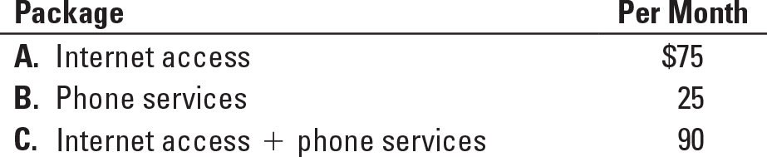

Evan spends most of his time on the Internet (“everything can be found online now”). Brett prefers to spend his time talking on the phone rather than using the Internet (“going online is a waste of time”). They agree that the purchase of the $90 total package is a “win–win” situation.

Required:

**1.** Allocate the $90 between Evan and Brett using (a) the stand-alone cost-allocation method, (b) the incremental cost-allocation method, and (c) the Shapley value method.

**2.** Which method would you recommend they use and why?

**SOLUTION**

(20−25 min.) **Allocation of common costs.**

1. Three methods of allocating the $90 are:

|  |  |  |
| --- | --- | --- |
|  | **Evan** | **Brett** |
| Stand-alone  Incremental (Brett primary)  Incremental (Evan primary)  Shapley value | $67.50  65.00  75.00  70.00 | $22.50  25.00  15.00  20.00 |

a. Stand-alone cost allocation method.

Evan:  × $90 =  × $90 = $67.50

Brett:  × $90 =  × $90 = $22.50

b. Incremental cost allocation method.

Assume Brett (the owner) is the primary user and Evan is the incremental user:

|  |  |  |
| --- | --- | --- |
| **User** | **Costs**  **Allocated** | **Cumulative Costs**  **Allocated** |
| Brett  Evan  Total | $25  65 ($90 – $25)  $90 | $25  $90 |

This method may generate some dispute over the ranking. Notice that Evan pays only $65 despite his prime interest in the more expensive Internet access package. Brett could make the argument that if Evan were ranked first he would have to pay $75 because he is the major Internet user. Then, Brett would only have to pay $15!

Assume Evan is the primary user and Brett is the incremental user:

|  |  |  |
| --- | --- | --- |
| **User** | **Costs**  **Allocated** | **Cumulative Costs**  **Allocated** |
| Evan  Brett  Total | $75  15 ($90 – $75)  $90 | $75  $90 |

c. Shapley value (average over costs allocated as the primary and incremental user).

|  |  |
| --- | --- |
| **User** | **Costs**  **Allocated** |
| Evan  Brett | ($65 + $75)  2 = $70  ($25 + $15)  2 = $20 |

2. The Shapley value approach is recommended. It is fairer than the incremental method because it avoids considering one user as the primary user and allocating more of the common costs to that user. It also avoids disputes about who is the primary user. It allocates costs in a manner that is close to the costs allocated under the stand-alone method but takes a more comprehensive view of the common cost allocation problem by considering primary and incremental users that the stand-alone method ignores.

More generally, other criteria to guide common cost allocations include the following:

a. Cause and effect. It is not possible to trace individual causes (either Internet access or phone services) to individual effects (uses by Evan or Brett). The $90 total package is a bundled product.

b. Benefits received. There are various ways of operationalizing the benefits received:

(i) Monthly service charge for their prime interest––Internet access for Evan ($75), and phone services for Brett ($25). This measure captures the services available to each person.

(ii) Actual usage by each person. This would involve keeping a record of usage by each person and then allocating the $90 on a percent usage time basis. This measure captures the services actually used by each person, but it may prove burdensome, and it would be subject to honest reporting by Evan and Brett.

c. Ability to pay.This criterion requires that Evan and Brett agree upon their relative ability to pay.

d. Fairness or equity. This criterion is relatively nebulous. One approach would be to split the $90 using the Shapely value or the stand-alone method.

**15-24** Allocation of common costs. Gordon Grimes, a self-employed consultant near Atlanta, received an invitation to visit a prospective client in Seattle. A few days later, he received an invitation to make a presentation to a prospective client in Denver. He decided to combine his visits, traveling from Atlanta to Seattle, Seattle to Denver, and Denver to Atlanta.

Grimes received offers for his consulting services from both companies. Upon his return, he decided to accept the engagement in Denver. He is puzzled over how to allocate his travel costs between the two clients. He has collected the following data for regular round-trip fares with no stopovers:

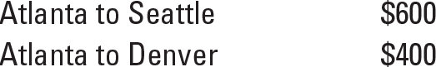

Grimes paid $900 for his three-leg flight (Atlanta–Seattle, Seattle–Denver, Denver–Atlanta). In addition, he paid $45 each way ($90 total) for limousines from his home to Atlanta Airport and back when he returned.

Required:

**1.** How should Grimes allocate the $900 airfare between the clients in Seattle and Denver using (a) the stand-alone cost-allocation method, (b) the incremental cost-allocation method, and (c) the Shapley value method?

**2.** Which method would you recommend Grimes use and why?

**3.** How should Grimes allocate the $90 limousine charges between the clients in Seattle and Denver?

**SOLUTION**

(20 min.) **Allocation of common costs.**

1. Alternative approaches for the allocation of the $900 airfare include the following:

a. The stand-alone cost allocation method. This method would allocate the air fare on the basis of each client’s percentage of the total of the individual stand-alone costs.

Seattle client  × $900 = $540

Denver client  × $900 = 360

$900

Advocates of this method often emphasize an equity or fairness rationale.

b. The incremental cost allocation method. This requires the choice of a primary party and an incremental party.

If the Seattle client is the primary party, the allocation would be:

Seattle client $600

Denver client ($900 − $600) 300

$900

One rationale is that Grimes was planning to make the Seattle trip, and the Denver stop was added subsequently. Some students have suggested allocating as much as possible to the Seattle client because Grimes had decided not to work for them.

If the Denver client is the primary party, the allocation would be:

Denver client $400

Seattle client ($900 − $400) 500

$900

One rationale is that the Denver client is the one who is going to use Grimes’s services and, presumably, receives more benefits from the travel expenditures.

c. Grimes could calculate the Shapley value that considers each client in turn as the primary party: The Seattle client is allocated $600 as the primary party and $500 as the incremental party for an average of ($600 + $500) ÷ 2 = $550. The Denver client is allocated $300 as the primary party and $400 as the incremental party for an average of ($300 + $400) ÷ 2 = $350. The Shapley value approach would allocate $550 to the Seattle client and $350 to the Denver client.

2. Grimes should use the Shapley value method. It is fairer than the incremental method because it avoids considering one party as the primary party and allocating more of the common costs to that party. It also avoids disputes about who is the primary party. It allocates costs in a manner that is close to the costs allocated under the stand-alone method but takes a more comprehensive view of the common cost allocation problem by considering primary and incremental users, which the stand-alone method ignores.

The Shapley value (or the stand-alone cost allocation method) would be the preferred methods if Grimes was to send the travel expenses to the Seattle and Denver clients before deciding which engagement to accept. Other factors such as whether to charge the Denver client more because Grimes is accepting the Denver engagement or the Seattle client more because Grimes is not going to work for them can be considered if Grimes sends in his travel expenses after making his decision. However, each company would not want to be considered as the primary party and so is likely to object to these arguments.

3. A simple approach is to split the $90 equally between the two clients. The limousine costs at the Atlanta end are not a function of distance traveled on the plane.

An alternative approach is to add the $90 to the $900 (total of $990) and to the individual air fares if Grimes had traveled only to Seattle ($600 + $90 = $690) or only to Denver ($400 + $90 = $490) and repeat requirement 1:

a. Stand-alone cost allocation method.

Seattle client  × $990 = $579

Denver client  × $990 = $411

Total $990

1. Incremental cost allocation method.

With Seattle client as the primary party:

Seattle client $690

Denver client ($990 − $690) 300

$990

With Denver client as the primary party:

Denver client $490

Seattle client ($990 − $490) 500

$990

1. Shapley value.

Seattle client: ($690 + $500) ÷ 2 = $595

Denver client: ($300 + $490) ÷ 2 = $395

As discussed in requirement 2, the Shapley value or the stand-alone cost allocation method would be the preferred approaches.

*Note:* If any student in the class has faced this situation when visiting prospective employers, ask them how they handled it.

**15-25** Revenue allocation, bundled products. Couture Corp sells Samsung 7 cases. It has a Men’s Division and a Women’s Division. Couture is now considering the sale of a bundled product called Dynamic Duo consisting of Smarty, a men’s case, and Sublime, a women’s case. For the most recent year, Couture sold equal quantities of Smarty and Sublime and reported the following:

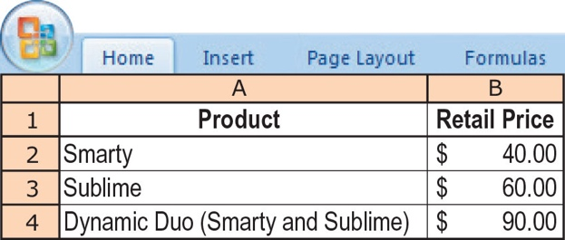

Required:

**1.** Allocate revenue from the sale of each unit of Dynamic Duo to Smarty and Sublime using the following:

**a.** The stand-alone revenue-allocation method based on selling price of each product

**b.** The incremental revenue-allocation method, with Smarty ranked as the primary product

**c.** The incremental revenue-allocation method, with Sublime ranked as the primary product

**d.** The Shapley value method

**2.** Of the four methods in requirement 1, which one would you recommend for allocating Couture’s revenues to Smarty and Sublime? Explain.

**SOLUTION**

(20 min.) **Revenue allocation, bundled products.**

1a.Under the stand-alone revenue-allocation method based on selling price, Smarty will be allocated 40% of all revenues, or $36 of the bundled selling price, and Sublime will be allocated 60% of all revenues, or $54 of the bundled selling price, as shown below.

|  |  |  |  |
| --- | --- | --- | --- |
| **Stand-alone method, based on selling prices** | **Smarty** | **Sublime** | **Total** |
| Selling price | $40 | $60 | $100 |
| Selling price as a % of total  ($40  $100; $60  $100) | 40% | 60% | 100% |
| Allocation of $90 bundled selling price  (40%  $90; 60%  $90) | $36 | $54 | $90 |

1b.Under the incremental revenue-allocation method, with Smarty ranked as the primary product, Smarty will be allocated $40 (its own stand-alone selling price), and Sublime will be allocated $50 of the $90 selling price, as shown below.

|  |  |  |
| --- | --- | --- |
| **Incremental Method**  **(Smarty rank 1)** | **Smarty** | **Sublime** |
| Selling price | $40 | $60 |
| Allocation of $90 bundled selling price  ($40; $50 = $90 – $40) | $40 | $50 |

1c. Under the incremental revenue-allocation method, with Sublime ranked as the primary product, Sublime will be allocated $60 (its own stand-alone selling price) and Smarty will be allocated $30 of the $90 selling price, as shown below.

|  |  |  |
| --- | --- | --- |
| **Incremental Method**  **(Sublime rank 1)** | **Smarty** | **Sublime** |
| Selling price | $40 | $60 |
| Allocation of $90 bundled selling price  ($30 = $90 – $60; $60) | $30 | $60 |

1d. Under the Shapley value method, each product will be allocated the average of its allocations in 1b and 1c, i.e., the average of its allocations when it is the primary product and when it is the secondary product, as shown below.

|  |  |  |
| --- | --- | --- |
| **Shapley Value Method** | **Smarty** | **Sublime** |
| Allocation when Smarty = Rank 1;  Sublime = Rank 2 (from 1b.) | $40 | $50 |
| Allocation when Sublime = Rank 1;  Smarty = Rank 2 (from 1c.) | $30 | $60 |
| Average of allocated selling price  ($40 + $30)  2; ($50 + $60)  2 | $35 | $55 |

2. A summary of the allocations based on the four methods in requirement 1 is shown below.

|  |  |  |  |  |
| --- | --- | --- | --- | --- |
|  | **Stand-alone**  **(Selling Prices)** | **Incremental (Smarty first)** | **Incremental  (Sublime first)** | **Shapley** |
| Smarty | $36 | $40 | $30 | $35 |
| Sublime | 54 | 50 | 60 | 55 |
| Total for Sync | $90 | $90 | $90 | $90 |

If there is no clear indication of which product is the more “important” product, or if it can be reasonably assumed that the two products are equally important to the company's strategy (since Couture sold the same quantities of Smarty and Sublime individually), the Shapley value method is the fairest of all the methods because it averages the effect of product rank. In this particular case, note that the allocations from the stand-alone method based on selling price are reasonably similar to the allocations from the Shapley value method, so the managers at Couture may well want to use the much simpler stand-alone method. The stand-alone method also does not require ranking the products in the suite, and so it is less likely to cause debates among product managers in the Men's and Women's Divisions. If, however, one of the products (Smarty or Sublime) is clearly the product that is driving sales of the bundled product, then that product should be considered the primary product or weighted more heavily (rather than equally) when applying the Shapley value method. As the chapter indicates, this can be achieved by using revenues of each product rather than their prices as the weights in the Shapley value calculations.

**15-26** Allocation of common costs. Jim Dandy Auto Sales uses all types of media to advertise its products (television, radio, newspaper, Internet, and so on). At the end of 2016, the company president, Jim McKinnley, decided that all advertising costs would be incurred by corporate headquarters and allocated to each of the company’s four sales locations based on number of vehicles sold. Jim was confident that his corporate purchasing manager could negotiate better advertising contracts on a corporate-wide basis than each of the sales managers could on their own. McKinnley budgeted total advertising cost for 2017 to be $1.6 million. He introduced the new plan to his sales managers just before the New Year. The managers had already drawn up their advertising plans for 2017 and the corporate plan would do the same advertising for them as they had planned. Total advertising costs for 2017 were $1,600,000. If the managers had done this same advertising on their own, their advertising costs would be as follows:



The manager of the East sales location, Tom Stevens, was not happy. He complained that the new allocation method was unfair and increased his advertising costs significantly. The East location sold high volumes of low-priced used cars and most of the corporate advertising budget was related to new car sales.

Required:

**1.** Show the amount of the 2017 advertising cost ($1,600,000) that would be allocated to each of the divisions under the following criteria:

**a.** McKinnley’s allocation method based on number of cars sold

**b.** The stand-alone method if divisions had done their own advertising

**c.** The incremental-allocation method, with divisions ranked on the basis of dollars they would have spent on advertising in 2017

**2.** Which method do you think is most equitable to the divisional sales managers? What other options might President Jim McKinnley have for allocating the advertising costs?

**SOLUTION**

(20-25 min. ) **Allocation of common costs.**

1. a. McKinnley’s method based on number of cars sold:

|  |  |  |  |  |
| --- | --- | --- | --- | --- |
| **Sales Location**  **(1)** | **Number of cars sold**  **(2)** | **Percentage**  **(3) = (2) ÷ 14,000** | **Joint Cost**  **(4)** | **Allocation**  **(5) = (3) × (4)** |

East 5,600 5,600 ÷ 16,000 = 0.35 $1,600,000 $ 560,000

West 1,440 1,440 ÷ 16,000 = 0.09 1,600,000 144,000

North 3,200 3,200 ÷ 16,000 = 0.20 1,600,000 320,000

South 5,760 5,760 ÷ 16,000 = 0.36 1,600,000 576,000

16,000 $1,600,000

1. b. Stand-alone method:

|  |  |  |  |  |
| --- | --- | --- | --- | --- |
| **Sales Location**  **(1)** | **Stand-alone cost**  **(2)** | **Percentage  (costs in thousands)**  **(3) = (2) ÷ $2,180** | **Joint Cost**  **(4)** | **Allocation**  **(5) = (3) × (4)** |

East $ 279,500 $279.5 ÷ $2,150 = 0.13 $1,600,000 $ 208,000

West 473,000 $473.0 ÷ $2,150 = 0.22 1,600,000 352,000

North 580,500 $580.5 ÷ $2,150 = 0.27 1,600,000 432,000

South 817,000 $817.0 ÷ $2,150 = 0.38 1,600,000 608,000

$2,150,000 $1,600,000

1. c. Incremental method (locations ranked in order of largest advertising dollars to smallest advertising dollars):

|  |  |  |
| --- | --- | --- |
| **Sales Location** | **Allocated Cost** | **Cost Remaining to Allocate** |

South $ 817,000 ($1,600,000 – $817,000= $783,000)

North 580,500 ($ 783,000 – $580,500 = $202,500)

West 202,500 ($ 202,500 – $202,500 = $ 0)

East 0

$1,600,000

2. In this situation, the stand-alone method is probably the best method because the weights it uses for allocation are based on the individual advertising cost for each location as a separate entity. Therefore, each entity gets the same relative proportion of advertising costs, and each location will have lower total advertising costs. The sales managers would likely not consider the incremental method fair because the locations with the higher advertising costs would be subsidizing the locations with the lower advertising costs (especially the East location, which would pay nothing in advertising). If the East sales manager is correct in his assertion that most of the advertising cost is for new car sales and not used car sales (the majority of the East location’s business), then McKinnley’s method of allocating costs based on number of cars sold would be particularly unfair to East, which would pay $560,000 of the $1,600,000 in total advertising cost. McKinnley could alternatively separate the total $1,600,000 of advertising cost into two cost pools: one for new car advertising and one for used car advertising and allocate on the basis of new cars sold and used cars sold, to make this method more equitable to the various sales locations.

**15-27** Single-rate, dual-rate, and practical capacity allocation. Preston Department Store has a new promotional program that offers a free gift-wrapping service for its customers. Preston’s customer-service department has practical capacity to wrap 5,000 gifts at a budgeted fixed cost of $4,950 each month. The budgeted variable cost to gift-wrap an item is $0.35. During the most recent month, the department budgeted to wrap 4,500 gifts. Although the service is free to customers, a gift-wrapping service cost allocation is made to the department where the item was purchased. The customer-service department reported the following for the most recent month:

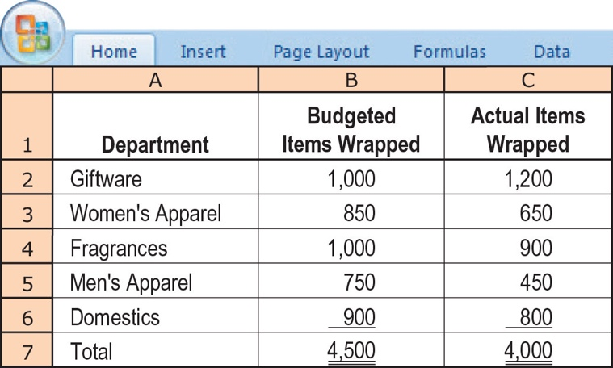

Required:

**1.** Using the single-rate method, allocate gift-wrapping costs to different departments in these three ways:

**a.** Calculate the budgeted rate based on the budgeted number of gifts to be wrapped and allocate costs based on the budgeted use (of gift-wrapping services).

**b.** Calculate the budgeted rate based on the budgeted number of gifts to be wrapped and allocate costs based on actual usage.

**c.** Calculate the budgeted rate based on the practical gift-wrapping capacity available and allocate costs based on actual usage.

**2.** Using the dual-rate method, compute the amount allocated to each department when (a) the fixed-cost rate is calculated using budgeted fixed costs and the practical gift-wrapping capacity, (b) fixed costs are allocated based on budgeted fixed costs and budgeted usage of gift-wrapping services, and (c) variable costs are allocated using the budgeted variable-cost rate and actual usage.

**3.** Comment on your results in requirements 1 and 2. Discuss the advantages of the dual-rate method.

**SOLUTION**

(20 min.) **Single-rate, dual-rate, and practical capacity allocation.**

Budgeted number of gifts wrapped = 4,500

Budgeted fixed costs = $4,950

Fixed cost per gift based on budgeted volume = $4,950 ÷ 4,500 = $1.10

Average budgeted variable cost per gift = 0.35

Total cost per gift wrapped $1.45

1.a. Allocation based on budgeted usage of gift-wrapping services:

|  |  |
| --- | --- |
| Giftware (1,000 × $1.45) | $1,450.00 |
| Women’s Apparel (850 × $1.45) | 1,232.50 |
| Fragrances (1,000 × $1.45) | 1,450.00 |
| Men’s Apparel (750 × $1.45) | 1,087.50 |
| Domestics (900 × $1.45) | 1,305.00 |
| Total | $6,525.00 |

1.b. Allocation based on actual usage of gift-wrapping services:

|  |  |
| --- | --- |
| Giftware (1,200 × $1.45) | $1,740.00 |
| Women’s Apparel (650 × $1.45) | 942.50 |
| Fragrances (900 × $1.45) | 1,305.00 |
| Men’s Apparel (450 × $1.45) | 652.50 |
| Domestics (800 × $1.45) | 1,160.00 |
| Total | $5,800.00 |

1.c. Practical gift-wrapping capacity = 5,000

Budgeted fixed costs = $4,950

Fixed cost per gift based on practical capacity = $4,950 ÷ 5,000 = $0.99

Average budgeted variable cost per gift = 0.35

Total cost per gift wrapped $1.34

Allocation based on actual usage of gift-wrapping services:

Giftware (1,200 × $1.34) $1,608.00

Women’s Apparel (650 × $1.34) 871.00

Fragrances (900 × $1.34) 1,206.00

Men’s Apparel (450 × $1.34) 603.00

## Domestics (800 × $1.34) 1,072.00

Total $5,360.00

## 2. Budgeted rate for fixed costs =

= $4,950 ÷ 5,000 gifts = $0.99 per gift

Fixed costs allocated on budgeted usage.

Rate for variable costs = $0.35 per item

Variable costs based on actual usage.

Allocation:

|  |  |  |  |
| --- | --- | --- | --- |
| **Department** | **Variable Costs** | **Fixed Costs** | **Total** |
| Giftware | 1,200 × $0.35 = $ 420.00 | 1,000 × $0.99 = $ 990.00 | $1,410.00 |
| Women’s Apparel | 650 × $0.35 = 227.50 | 850 × $0.99 = 841.50 | 1,069.00 |
| Fragrances | 900 × $0.35 = 315.00 | 1,000 × $0.99 = 990.00 | 1,305.00 |
| Men’s Apparel | 450 × $0.35 = 157.50 | 750 × $0.99 = 742.50 | 900.00 |
| Domestics | 800 × $0.35 = 280.00 | 900 × $0.99 = 891.00 | 1,171.00 |
| Total | $1,400.00 | $4,455.00 | $5,855.00 |

3. The dual-rate method has two major advantages over the single-rate method:

1. Fixed costs and variable costs can be allocated differently—fixed costs based on rates calculated using practical capacity and budgeted usage and variable costs based on budgeted rates and actual usage.
2. Fixed costs are allocated proportionately to the departments causing the incurrence of those costs based on the budgeted usage of each department.

c. The costs allocated to a department are not affected by the usage by other departments.

*Note:* If capacity costs are the result of a long-term decision by top management, it may be desirable to allocate to each department the cost of capacity used based on budgeted (or actual) usage. The users are then not allocated the costs of unused capacity.

**15-28** Revenue allocation. Fang Inc. produces and sells DVDs to business people and students who are planning extended stays in China. It has been very successful with two DVDs: Beginning Mandarin and Conversational Mandarin. It is introducing a third DVD, Reading Chinese Characters. It has also decided to market its new DVD in two different packages grouping the Reading Chinese Characters DVD with each of the other two language DVDs. Information about the separate DVDs and the packages follow.

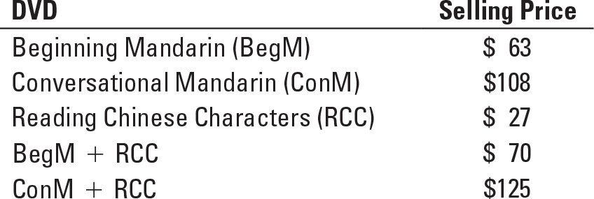

Required:

**1.** Using selling prices, allocate revenues from the BegM + RCC package to each DVD in that package using (a) the stand-alone method; and (b) the incremental method, with BegM and RCC in turn as the primary product.

**2.** Using the selling prices, allocate revenues from the ConM + RCC package to each DVD in that package using (a) the stand-alone method; and (b) the incremental method, with ConM and RCC in turn as the primary product.

**3.** Which method is most appropriate for allocating revenues among the DVDs? Why?

**SOLUTION**

(20 min.) **Revenue allocation**

1. a. Stand-alone method for the BegM + RCC package

|  |  |  |  |  |
| --- | --- | --- | --- | --- |
| **DVD**  **(1)** | **Separate Revenue**  **(2)** | **Percentage**  **(3) = (2) ÷ $120** | **Joint**  **Revenue**  **(4)** | **Allocation**  **(5) = (3) × (4)** |

BegM $63 $63 ÷ $90 = 0.70 $70 $49

RCC 27 $27 ÷ $90 = 0.30 70 21

$90 $70

1. b. Incremental method

|  |  |  |
| --- | --- | --- |
| i) | **Allocated Revenue** | **Revenue Remaining** |
|  | **(BegM first)** | **To Allocate** |

BegM $63 $7 ($70 ─ $63)

RCC 7

|  |  |  |
| --- | --- | --- |
| ii) | **Allocated Revenue** | **Revenue Remaining** |
|  | **(RCC first)** | **To Allocate** |

RCC $27 $43 ($70 ─ $27)

BegM 43

1. c. Shapley method (assuming each DVD is demanded in equal proportion)

i) BegM ($63 + $43) ÷ 2 = $53

ii) RCC ($7 + $27) ÷ 2 = $17

2. a. Stand-alone method for the ConM + RCC package

|  |  |  |  |  |
| --- | --- | --- | --- | --- |
| **DVD**  **(1)** | **Separate Revenue**  **(2)** | **Percentage**  **(3) = (2) ÷ $160** | **Joint Revenue**  **(4)** | **Allocation**  **(5) = (3) × (4)** |

ConM $ 108 $108 ÷ $135 = 0.80 $125 $100

RCC 27 $ 27 ÷ $135 = 0.20 125 25

$135 $125

2. b. Incremental method

|  |  |  |
| --- | --- | --- |
| i) | **Allocated Revenue**  **(ConM first)** | **Revenue Remaining**  **To Allocate** |

ConM $108 $17 ($125 – $108)

RCC 17

|  |  |  |
| --- | --- | --- |
| ii) | **Allocated Revenue**  **(RCC first)** | **Revenue Remaining**  **To Allocate** |

RCC $ 27 $98 ($125 – $27)

ConM 98

2. c. Shapley method (assuming each DVD is demanded in equal proportion)

i) ConM ($108 + $98) ÷ 2 = $103

ii) RCC ($ 17 + $27) ÷ 2 = $ 22

1. For each DVD package, the stand-alone method and the Shapley method give approximately the same allocation to each DVD. These methods are fair if the demand for the DVDs is approximately equal. The stand-alone method might be slightly preferable here because it is simpler and easier to explain.

The incremental method would be appropriate if one DVD (BegM or ConM) has a higher level of demand than the other DVD (RCC, which has only been recently introduced. In this situation, the dominant DVD would be sold anyway, so it should receive its stand-alone revenue, and the other DVD should receive the remainder (incremental revenue).

**15-29** Fixed-cost allocation. Central University completed construction of its newest administrative building at the end of 2017. The University’s first employees moved into the building on January 1, 2018. The building consists of office space, common meeting rooms (including a conference center), a cafeteria, and even a workout room for its exercise enthusiasts. The total 2018 building space of 250,000 square feet was utilized as follows:

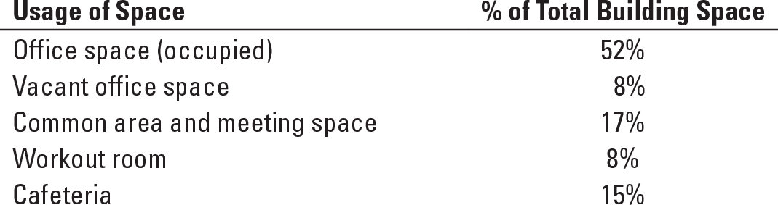

The new building cost the university $40 million and was depreciated using the straight-line method over 20 years with zero residual value so $2,000,000 per year. At the end of 2018 three departments occupied the building: executive offices of the president, accounting, and human resources. Each department’s usage of its assigned space was as follows:

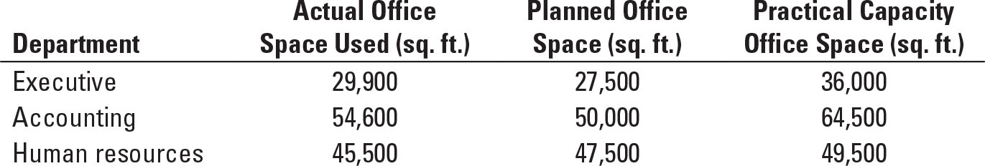

Required:

**1.** How much of the total annual building cost of $2,000,000 will be allocated in 2018 to each of the departments, if the cost is allocated to each department on the basis of the following?

**a.** Actual usage of the three departments

**b.** Planned office space of the three departments

**c.** Practical capacity of the three departments

**2.** Assume that Central University allocates the total annual building cost of $2,000,000 in the following manner:

**a.** All vacant office space is absorbed by the university and is not allocated to the departments.

**b.** All occupied office space costs are allocated on the basis of actual square footage used by each department.

**c.** All common area costs are allocated on the basis of a department’s practical capacity.

Calculate the cost allocated to each department in 2018 under this plan. Do you think the allocation method used here is appropriate? Explain.

**SOLUTION**

(20 min.) **Fixed cost allocation.**

1. i) Allocation using actual usage.

|  |  |  |  |
| --- | --- | --- | --- |
| **Department**  **(1)** | **Actual**  **Usage**  **(2)** | **Percentage of Total Usage**  **(3) = (2) ÷ 130,000** | **Allocation**  **(4) = (3) × $2,000,000a** |
| Executive | 29,900 | 0.23 | $ 460,000 |
| Accounting | 54,600 | 0.42 | 840,000 |
| Human Resources | 45,500 | 0.35 | 700,000 |
| Total | 130,000 |  | $2,000,000 |

a$40,000,000 building cost/20 years straight-line depreciation = $2,000,000 annual depreciation expense related to building.

ii) Allocation using planned usage.

|  |  |  |  |
| --- | --- | --- | --- |
| **Department**  **(1)** | **Planned**  **Usage**  **(2)** | **Percentage of Total Usage**  **(3) = (2) ÷ 125,000** | **Allocation**  **(4) = (3) × $2,000,000** |
| Executive | 27,500 | 0.22 | $ 440,000 |
| Accounting | 50,000 | 0.40 | 800,000 |
| Human Resources | 47,500 | 0.38 | 760,000 |
| Total | 125,000 |  | $2,000,000 |

iii) Allocation using practical capacity.

|  |  |  |  |
| --- | --- | --- | --- |
| **Department**  **(1)** | **Practical**  **Capacity**  **(2)** | **Percentage of Total Usage**  **(3) = (2) ÷ 150,000** | **Allocation**  **(4) = (3) × $2,000,000** |
| Executive | 36,000 | 0.24 | $ 480,000 |
| Accounting | 64,500 | 0.43 | 860,000 |
| Human Resources | 49,500 | 0.33 | 660,000 |
| Total | 150,000 |  | $2,000,000 |

|  |  |  |
| --- | --- | --- |
| **Usage of Space**  **(1)** | **Percentage of Total Building Space**  **(2)** | **Total Annual Building Cost**  **(3) = (2) × $2,000,000** |
| Office space (occupied) | 52% | $1,040,000 |
| Vacant office space | 8% | 160,000 |
| Common area and meeting space | 17% | 340,000 |
| Workout room | 8% | 160,000 |
| Cafeteria | 15% | 300,000 |

Total 100% $2,000,000

1. $160,000 of Vacant Office Space cost will not be allocated to the departments but will be absorbed by the university’s central administration.

b) Allocation of Office space (occupied) costs ($1,040,000) using actual usage.

|  |  |  |  |
| --- | --- | --- | --- |
| **Department**  **(1)** | **Actual**  **Usage**  **(2)** | **Percentage of**  **Total Usage**  **(3) = (2) ÷ 130,000** | **Allocation**  **(4) = (3) × $1,040,000** |
| Executive | 29,900 | 0.23 | $ 239,200 |
| Accounting | 54,600 | 0.42 | 436,800 |
| Human Resources | 45,500 | 0.35 | 364,000 |
| Total | 130,000 |  | $1,040,000 |

c) Allocation of all common space cost such as common area and meeting space, workout room, and cafeteria ($340,000 + $160,000 + $300,000 = $800,000) using practical capacity.

|  |  |  |  |
| --- | --- | --- | --- |
| **Department**  **(1)** | **Practical**  **Capacity**  **(2)** | **Percentage of  Total Usage**  **(3) = (2) ÷ 150,000** | **Allocation**  **(4) = (3) × $800,000** |
| Executive | 36,000 | 0.24 | $192,000 |
| Accounting | 64,500 | 0.43 | 344,000 |
| Human Resources | 49,500 | 0.33 | 264,000 |
| Total | 150,000 |  | $800,000 |

|  |  |  |  |
| --- | --- | --- | --- |
| **Department**  **(1)** | **Allocated Cost of Occupied Office Space**  **(2)** | **Allocated Cost of Common Space**  **(3)** | **Total Cost Allocated to Department**  **(4) = (2) + (3)** |
| Executive | $ 239,200 | $192,000 | $ 431,200 |
| Accounting | 436,800 | 344,000 | 780,800 |
| Human Resources | 364,000 | 264,000 | 628,000 |
| Total | $1,040,000 | $800,000 | $1,840,000 |

The departments would likely consider portions of the allocation method used here “fair.” In particular, the individual departments do not pay for unused office space that is intended for use by other departments (perhaps even ones that are not yet in the building). The total costs allocated to the departments is $1,840,000 ($2,000,000 – the cost of vacant space, $160,000). This creates an incentive for central administration to fill the unoccupied space with departments, so that the vacant office space cost of $160,000 can be allocated down.

As for the allocation of occupied office space costs, it may have been more appropriate to allocate this based on relative practical capacity rather than actual usage by department. The current system does not appropriately consider that the building was constructed based on the practical capacity intended to be dedicated to each department. As a result, departments who are taking up less space than originally assigned to them are not penalized for this. Moreover, the assignment of the cost will change year to year under the present system, depending on that period’s relative use of space by all departments, while a practical capacity-based system would yield stable cost allocations. If, as a result of changed circumstances, a department will not be utilizing the practical capacity initially assigned to it, Central University’s president might choose to house another department in the building. The university would then assign the cost of the building based on the practical capacities assigned to all the departments in the building, including the practical capacity assigned to the new department.

Finally, allocating the common space cost based on practical capacity is the most equitable method because the allocation of cost is based on “assigned space” by department rather than actual usage of space or planned usage of space by department. The allocation of cost is also not dependent on how departments utilize their office space in relation to one another.

**15-30** Allocating costs of support departments; step-down and direct methods. The Eastern Summit Company has prepared department overhead budgets for budgeted-volume levels before allocations as follows:

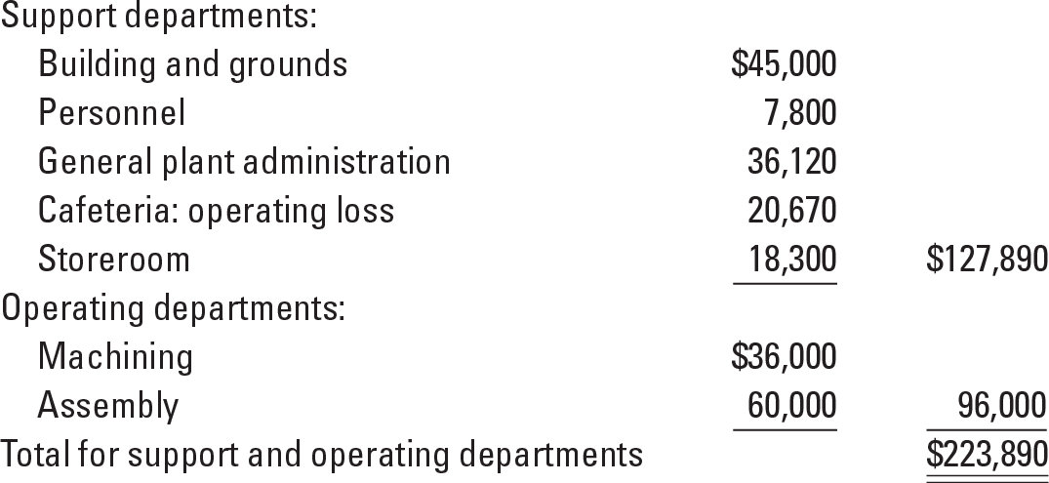

Management has decided that the most appropriate inventory costs are achieved by using individual-department overhead rates. These rates are developed after support-department costs are allocated to operating departments.

Bases for allocation are to be selected from the following:

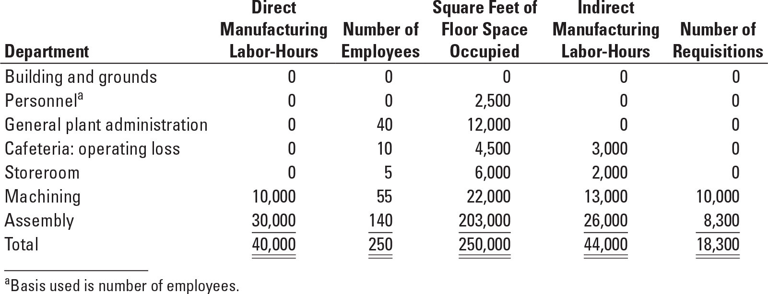

Required:

**1.** Using the step-down method, allocate support-department costs. Develop overhead rates per direct manufacturing labor-hour for machining and assembly. Allocate the costs of the support departments in the order given in this problem. Use the allocation base for each support department you think is most appropriate.

**2.** Using the direct method, rework requirement 1.

**3.** Based on the following information about two jobs, determine the total overhead costs for each job by using rates developed in (a) requirement 1 and (b) requirement 2.

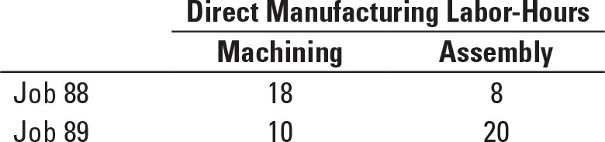

**4.** The company evaluates the performance of the operating department managers on the basis of how well they managed their total costs, including allocated costs. As the manager of the Machining Department, which allocation method would you prefer from the results obtained in requirements 1 and 2? Explain.

**SOLUTION**

(45 min.) **Allocating costs of support departments; step-down and direct methods.**

|  |  |  |  |  |  |  |  |
| --- | --- | --- | --- | --- | --- | --- | --- |
|  | **Building & Grounds** | **Personnel** | **General Plant Admin.** | **Cafeteria Operating Loss** | **Storeroom** | **Machining** | **Assembly** |
| 1. Step-down Method: | $ 45,000 | $7,800 | $ 36,120 | $ 20,670 | $18,300 | $36,000 | $ 60,000 |
| (1) Building & grounds at $0.18/sq.ft.  ($45,000 ÷ 250,000) | $(45,000) | 450 | 2,160 | 810 | 1,080 | 3,960 | 36,540 |
| (2) Personnel at $33/employee  ($8,250 ÷ 250) |  | $(8,250) | 1,320 | 330 | 165 | 1,815 | 4,620 |
| (3) General plant administration at $0.90 per  ind. manuf. labor-hour ($39,600 ÷ 44,000) |  |  | $(39,600) | 2,700 | 1,800 | 11,700 | 23,400 |
| (4) Cafeteria at $122.55/employee  ($24,510 ÷ 200) |  |  |  | $(24,510) | 613 | 6,740 | 17,157 |
| (5) Storeroom at $1.1999/requisition  ($21,958 ÷ 18,300) |  |  |  |  | $(21,958) | 11,999 | 9,959 |
| (6) Costs allocated to operating depts. |  |  |  |  |  | $72,214 | $151,676 |
| (7) Divide (6) by dir. manuf. labor-hrs. |  |  |  |  |  | **÷**10,000 | **÷**30,000 |
| (8) Overhead rate per direct  manuf. labor-hour |  |  |  |  |  | $ 7.221 | $ 5.056 |
|  |  |  |  |  |  |  |  |
| 2.Direct method: | $45,000 | $7,800 | $36,120 | $20,670 | $18,300 | $36,000 | $ 60,000 |
| (1) Building & grounds,  22,000/225,000; 203,000/225,000 | (45,000) |  |  |  |  | 4,400 | 40,600 |
| (2) Personnel, 55/195; 140/195 |  | (7,800) |  |  |  | 2,200 | 5,600 |
| (3) General plant administration,  13,000/39,000; 26,000/39,000 |  |  | (36,120) |  |  | 12,040 | 24,080 |
| (4) Cafeteria, 55/195; 140/195 |  |  |  | (20,670) |  | 5,830 | 14,840 |
| (5) Storeroom: 10,000/18,300;  8,300/18,300 |  |  |  |  | (18,300) | 10,000 | 8,300 |
| (6) Costs allocated to operating depts. |  |  |  |  |  | $70,470 | $153,420 |
| (7) Divide (6) by direct manufacturing  labor-hours |  |  |  |  |  | ÷ 10,000 | **÷**30,000 |
| (8) Overhead rate per direct  manufacturing labor-hour |  |  |  |  |  | $ 7.047 | $ 5.114 |

3. Comparison of Methods:

Step-down method: Job 88: Machining 18 × $7.221 $129.98

Assembly 8 × $5.056 40.45 $170.43

Job 89: Machining 10 × $7.221 $ 72.21

Assembly 20 × $5.056 101.12 $173.33

Direct method: Job 88: Machining 18 × $7.047 $126.85

Assembly 8 × $5.114 40.91 $167.76

Job 89: Machining 10 × $7.047 $ 70.47

Assembly 20 × $5.114 102.28 $172.75

4. Compare the overhead rate, per direct manufacturing labor-hour, for the Machining Department under the two methods. The manager of Machining Department would prefer the direct method. The direct method results in a lower amount of support departments’ costs being allocated to the Machining Department ($7.047 per direct manufacturing labor-hour) than the step-down method ($7.221 per direct manufacturing labor-hour).

**15-31** Support-department cost allocations; single-department cost pools; direct, step-down, and reciprocal methods. The Martinez Company has two products. Product 1 is manufactured entirely in department X. Product 2 is manufactured entirely in department Y. To produce these two products, the Martinez Company has two support departments: A (a materials-handling department) and B (a power-generating department).

An analysis of the work done by departments A and B in a typical period follows:

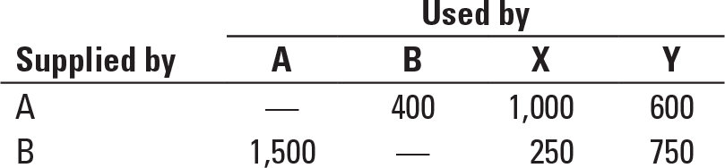

The work done in department A is measured by the direct labor-hours of materials-handling time. The work done in department B is measured by the kilowatt-hours of power. The budgeted costs of the support departments for the coming year are as follows:

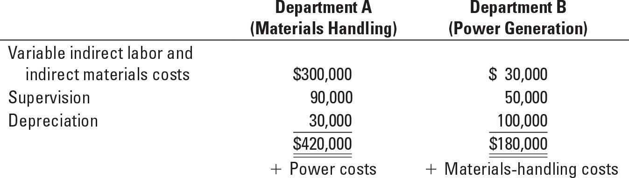

The budgeted costs of the operating departments for the coming year are $2,500,000 for department X and $1,900,000 for department Y.

Supervision costs are salary costs. Depreciation in department B is the straight-line depreciation of power-generation equipment in its 19th year of an estimated 25-year useful life; it is old, but well-maintained, equipment.

Required:

**1.** What are the allocations of costs of support departments A and B to operating departments X and Y using (a) the direct method, (b) the step-down method (allocate department A first), (c) the step-down method (allocate department B first), and (d) the reciprocal method?

**2.** An outside company has offered to supply all the power needed by the Martinez Company and to provide all the services of the present power department. The cost of this service will be $80 per kilowatthour of power. Should Martinez accept? Explain.

**SOLUTION**

(40-60 min.) **Support-department cost allocations; single-department cost** **pools; direct, step-down, and reciprocal methods.**

All the following computations are in dollars.

1.

Direct method:

**To X** **To Y**

A 1,000/1,600 × $420,000 = $262,500 600/1,600 × $420,000 = $157,500

B 250/1,000 × $180,000 = 45,000 750/1,000 × $180,000 = 135,000

Total $307,500 $292,500

Step-down method, allocating A first:

|  |  |  |  |  |
| --- | --- | --- | --- | --- |
|  | **A** | **B** | **X** | **Y** |

Costs to be allocated $420,000 $180,000 — —

Allocate A: (400; 1,000; 600 ÷ 2,000) (420,000) 84,000 $210,000 $126,000

Allocate B: (250; 750 ÷ 1,000) — (264,000) 66,000 198,000

Total $ 0 $ 0 $276,000 $324,000

Step-down method, allocating B first:

|  |  |  |  |  |
| --- | --- | --- | --- | --- |
|  | **A** | **B** | **X** | **Y** |

Costs to be allocated $420,000 $180,000 — —

Allocate B: (1500; 250; 750 ÷ 2,500) 108,000 (180,000) $ 18,000 $ 54,000

Allocate A: (1,000; 600 ÷ 1,600) (528,000) — 330,000 198,000

Total $ 0 $ 0 $348,000 $252,000

Note that these methods produce significantly different results, so the choice of method may frequently make a difference in the budgeted department overhead rates.

Reciprocal method:

Stage 1: Let A = total costs of materials-handling department

B = total costs of power-generating department

(1) A = $420,000 + 0.6 B

(2) B = $180,000 + 0.2 A

Stage 2: Substituting in (1): A = $420,000 + 0.6 ($180,000 + 0.2 A)

A = $420,000 + $108,000 + 0.12 A

0.88 A = $528,000

A = $600,000

Substituting in (2): B = $180,000 + 0.2 ($600,000)

B = $300,000

Stage 3:

**A B X Y**

Original amounts $420,000 $180,000 — —

Allocation of A (600,000) 120,000 (20%) $300,000 (50%) $180,000 (30%)

Allocation of B 180,000 (60%) (300,000) 30,000 (10%) 90,000 (30%)

Totals accounted for $ 0 $ 0 $330,000 $270,000

**SOLUTION EXHIBIT 15-31**

**Reciprocal Method of Allocating Support Department Costs for Martinez Company Using Repeated Iterations.**

|  |  |  |  |  |
| --- | --- | --- | --- | --- |
|  | **Support Departments** | | **Operating Departments** | |
|  | **A** | **B** | **X** | **Y** |
| Budgeted manufacturing overhead costs before any interdepartmental cost allocations | $420,000 | $180,000 |  |  |
| 1st Allocation of Dept. A  (2/10, 5/10, 3/10)a | (420,000) | 84,000 | $210,000 | $126,000 |
|  |  | 132,000 |  |  |
| 1st Allocation of Dept. B  (6/10, 1/10, 3/10)b | 158,400 | (264,000) | 26,400 | 79,200 |
| 2nd Allocation of Dept. A  (2/10, 5/10, 3/10)a | (158,400) | 31,680 | 79,200 | 47,520 |
| 2nd Allocation of Dept B:  (6/10, 1/10, 3/10)b | 19,008 | (31,680) | 3,168 | 9,504 |
| 3rd Allocation of Dept A:  (2/10, 5/10, 3/10)a | (19,008) | 3,802 | 9,504 | 5,702 |
| 3rd Allocation of Dept. B:  (6/10, 1/10, 3/10)b | 2,282 | (3,802) | 380 | 1,140 |
| 4th Allocation of Dept. A  (2/10, 5/10, 3/10)a | (2,282) | 456 | 1,140 | 686 |
| 4th Allocation of Dept. B  (6/10, 1/10, 3/10)b | 274 | (456) | 46 | 136 |
| 5th Allocation of Dept A  (2/10, 5/10, 3/10)a | (274) | 56 | 136 | 82 |
| 5th Allocation of Dept B  (6/10, 1/10, 3/10)b | 34 | (56) | 6 | 16 |
| 6th Allocation of Dept A  (2/10, 5/10, 3/10)a | (34) | 6 | 18 | 10 |
| 6th Allocation of Dept B  (6/10, 1/10, 3/10)b | 4 | (6) | 0 | 2 |
| 7th Allocation of Dept A  (2/10, 5/10, 3/10)a | (4) | 0 | 2 | 2 |
| Total budgeted manufacturing  overhead of operating departments | $ 0 | $ 0 | $330,000 | $270,000 |

Total accounts allocated and reallocated (the numbers in parentheses in first two columns)

Dept A; Materials Handling: $420,000 + $158,400 + $19,008 + $2,282 + $274 + $34 + $4 = $600,000

Dept B; Power Generation: $264,000 + $31,680 + $3,802 + $456 + $56 + $6 = $300,000

aBase is (400 + 1,000 +600) or 2,000 labor-hours; 400 ÷ 2,000 = 2/10, 1,000 ÷ 2,000 = 5/10, 600 ÷ 2,000 = 3/10.

bBase is (1,500 + 250 + 750) or 2,500 kWh ; 1,500 ÷ 2,500 = 6/10, 250 ÷ 2,500 = 1/10, 750 ÷ 2,500 = 3/10.

Comparison of methods:

#### Method of Allocation X Y

Direct method $307,500 $292,500

Step-down: A first 276,000 324,000

Step-down: B first 348,000 252,000

Reciprocal method 330,000 270,000

2. It appears that the cost of power is $72 per kilowatt-hour ($180,000 ÷ 2,500 Kwh) plus the material handling costs. But Martinez should make the decision after considering the effects of the interdependencies and the fixed costs. Note that the power needs would be less (students frequently miss this) if they were purchased from the outside:

|  |  |
| --- | --- |
| **Outside** | |
| **Power Units** | |
| **Needed** | **Needed** |

X 250

Y 750

A (1,500 units minus 20% of 1,500 units, because there is no

need to service the nonexistent power department) 1,200

Total units 2,200

Total costs, 2,200 × $80 = $176,000

In contrast, the total costs that would be saved by not producing the power inside would depend on the effects of the decision on various costs:

|  |  |
| --- | --- |
|  | **Avoidable Costs of**  **2,500 Units of Power Produced Inside** |
| Variable indirect labor and indirect material costs  Supervision in power department  Materials handling, 20% of $300,000*  Probable minimum cost savings  Possible additional savings:  a. Can any supervision in materials handling be saved because of overseeing less volume?  Minimum savings is probably zero; the maximum is probably 20% of $90,000 or $18,000.  b. Is any depreciation a truly variable, wear-and-tear type of cost?  Total savings by not producing 2,500 units of power | $ 30,000  50,000  60,000  $140,000  ?  ?  ________  $140,000 + ? |

* Materials handling costs are higher because the power department uses 20% of materials handling. Therefore, materials-handling costs will decrease by 20%.

In the short run (at least until a capital investment in equipment is necessary), the data suggest continuing to produce internally because the costs eliminated would probably be less than the comparable purchase costs.

**15-32** Common costs. Tate Inc. and Booth Inc. are two small manufacturing companies that are considering leasing a cutting machine together. If Tate rents the machine on its own, it will cost $26,000. If Booth rents the machine alone, it will cost $14,000. If they rent the machine together, the cost will decrease to $36,000.

Required:

**1.** Calculate Tate’s and Booth’s respective share of fees under the stand-alone cost-allocation method.

**2.** Calculate Tate’s and Booth’s respective share of fees using the incremental cost-allocation method assuming (a) Tate is the primary party and (b) Booth is the primary party.

**3.** Calculate Tate’s and Booth’s respective share of fees using the Shapley value method.

**4.** Which method would you recommend Tate and Booth use to share the fees?

**SOLUTION**

(25 min.) **Common costs.**

1. Stand-alone cost-allocation method.

Tate Inc. =  = $23,400

Booth Inc. =  = $12,600

$36,000

## 2. With Tate Inc. as the primary party:

|  |  |  |
| --- | --- | --- |
| **Party** | Costs Allocated | **Cumulative Costs Allocated** |
| Tate | $26,000 | $26,000 |
| Booth | 10,000 ($36,000 – $26,000) | $36,000 |
| Total | $36,000 |  |

## 

With Booth Inc. as the primary party:

|  |  |  |
| --- | --- | --- |
| **Party** | Costs Allocated | **Cumulative Costs Allocated** |
| Booth | $14,000 | $14,000 |
| Tate | 22,000 ($36,000 – $14,000) | $36,000 |
| Total | $36,000 |  |

3. To use the Shapley value method, consider each party as first the primary party and then the incremental party. Compute the average of the two to determine the allocation.

Tate Inc.:

## Allocation as the primary party $26,000

Allocation as the incremental party 22,000

Total $48,000

Allocation ($48,000 ÷ 2) $24,000

Booth Inc.:

Allocation as the primary party $14,000

Allocation as the incremental party 10,000

Total $24,000

Allocation ($24,000 ÷ 2) $12,000

Using this approach, Tate Inc. is allocated $24,000, and Booth, Inc. is allocated $12,000 of the total costs of $36,000.

4. The results of the four cost-allocation methods are shown below.

|  |  |  |
| --- | --- | --- |
|  | **Tate Inc.** | **Booth Inc.** |
| Stand-alone method | $23,400 | $12,600 |
| Incremental (Tate primary) | 26,000 | 10,000 |
| Incremental (Booth primary) | 22,000 | 14,000 |
| Shapley value | 24,000 | 12,000 |

The allocations are very sensitive to the method used. With the incremental cost-allocation method, Tate Inc. and Booth Inc. would probably have disputes over who is the primary party because the primary party gets allocated all of the primary party’s costs. The stand-alone method is simple and fair because it allocates the common cost of the cutting machine in proportion to the individual costs of leasing the machine. The Shapley values are also fair. They result in allocations that are similar to those of the stand-alone method. Either of the methods can be chosen. Given its simplicity, the stand-alone method is likely more acceptable.

**15-33** Stand-alone revenue allocation. Magic Systems, Inc., sells computer hardware to end consumers. The CX30 is sold as a “bundle,” which includes three hardware products: a personal computer (PC) tower, a 26-inch monitor, and a color laser printer. Each of these products is made in a separate manufacturing division of Magic Systems and can be purchased individually as well as in a bundle. Magic Systems sells roughly equal quantities of the three products. The individual selling prices and per unit costs are as follows:

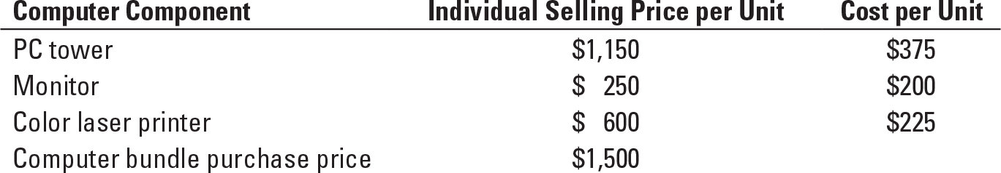

Required:

**1.** Allocate the revenue from the computer bundle purchase to each of the hardware products using the stand-alone method based on the individual selling price per unit.

**2.** Allocate the revenue from the computer bundle purchase to each of the hardware products using the stand-alone method based on cost per unit.

**3.** Allocate the revenue from the computer bundle purchase to each of the hardware products using the stand-alone method based on physical units (that is, the number of individual units of product sold per bundle).

**4.** Which basis of allocation makes the most sense in this situation? Explain your answer.

**SOLUTION**

(20-25 mins.) **Stand-alone revenue allocation**

1. Allocation using individual selling price per unit.

|  |  |  |  |
| --- | --- | --- | --- |
| **Computer Hardware Component** | **Individual Selling Price per Unit** | **Percentage of Total Price** | **Allocation**  **% × $1,500** |
| PC tower | $1,150 | 0.575 | $ 862.50 |
| Monitor | 250 | 0.125 | 187.50 |
| Color laser printer | 600 | 0.30 | 450.00 |
| Total | $2,000 |  | $1,500.00 |

1. Allocation using cost per unit

|  |  |  |  |
| --- | --- | --- | --- |
| **Computer Hardware Component** | **Cost per Unit** | **Percentage of Total Cost** | **Allocation**  **% × $1,500** |
| PC tower | $375 | 0.46875 | $ 703.12 |
| Monitor | 200 | 0.25 | 375.00 |
| Color laser printer | 225 | 0.28125 | 421.88 |
| Total | $800 |  | $1,500.00 |

1. Allocation using number of individual units of product sold per bundle

|  |  |  |  |
| --- | --- | --- | --- |
| **Computer Hardware Component** | **Individual Units of Product Sold per Bundle** | **Percentage of Total Price** | **Allocation**  **% × $1,500** |
| PC tower | 1 | 0.333 | $ 500 |
| Monitor | 1 | 0.333 | 500 |
| Color laser printer | 1 | 0.333 | 500 |
| Total | 3 |  | $1,500 |

1. Sharing on the basis of revenue makes the most sense. Using this method each division takes a uniform percentage decrease in the revenue received regardless of the cost of the division’s individual products. For example:

|  |  |  |  |  |
| --- | --- | --- | --- | --- |
|  |  |  |  |  |
| **Computer Hardware Component** | **Individual Price per Unit**  **(a)** | **Allocated Revenue per Unit**  **(b)** | **Decrease in Price**  **(c) = (a) –(b)** | **Percentage Decrease in Price by Product**  **(d) = (c)÷(a)** |
| PC tower | $1,150 | $ 862.50 | ($287.50) | –25% |
| Monitor | $ 250 | $ 187.50 | ($ 62.50) | –25% |
| Color laser printer | $ 600 | $ 450.00 | ($150.00) | –25% |
| Total | $2,000 | $1,500.00 | ($500.00) |  |

Furthermore, the cost-based method might actually discourage cost efficiencies. Increasing the cost per unit of product relative to other products would give the division a greater share of the overall revenue.

Last, under the physical unit allocation method, the motivation of the divisional managers to produce for the bundled purchase would likely change significantly. The PC Tower Division would see the largest decrease in revenue and the Monitor Division would see the largest increase in revenue. The PC Tower Division would have much less incentive to produce for the bundled purchase, if the divisional revenue were cut from $1,140 to $500 dollars per unit. The Monitor Division would be highly motivated to produce for the bundled purchase, as the sales revenue per unit would go from $260 to $500. This method is also not the most reasonable because the relative price of $500 for each component is not representative of the amount individual price customers are willing to pay for each of the components independently.

**15-34** Support-department cost allocations; single-department cost pools; direct, step-down, and reciprocal methods. Sportz, Inc., manufactures athletic shoes and athletic clothing for both amateur and professional athletes. The company has two product lines (clothing and shoes), which are produced in separate manufacturing facilities; however, both manufacturing facilities share the same support services for information technology and human resources. The following shows costs (in thousands) for each manufacturing facility and for each support department.

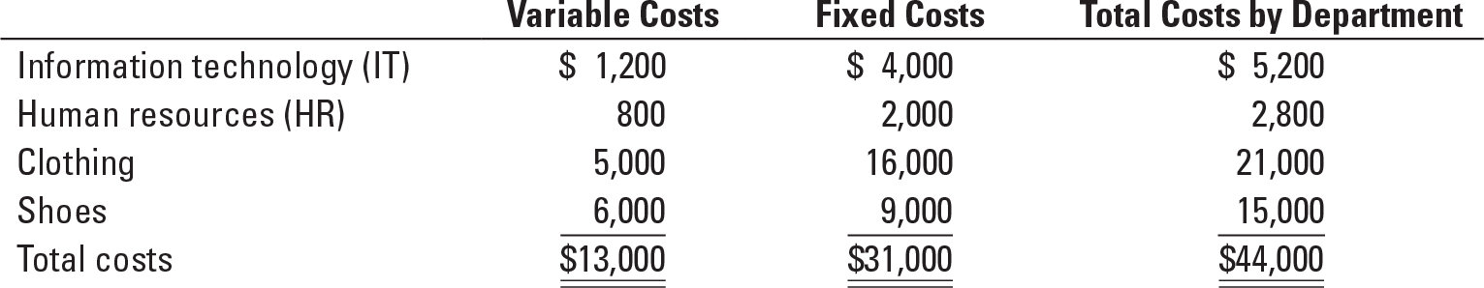

The total costs of the support departments (IT and HR) are allocated to the production departments (clothing and shoes) using a single rate based on the following:

|  |  |
| --- | --- |
| Information technology: | Number of IT labor-hours worked by department |
| Human resources: | Number of employees supported by department |

Data on the bases, by department, are given as follows:

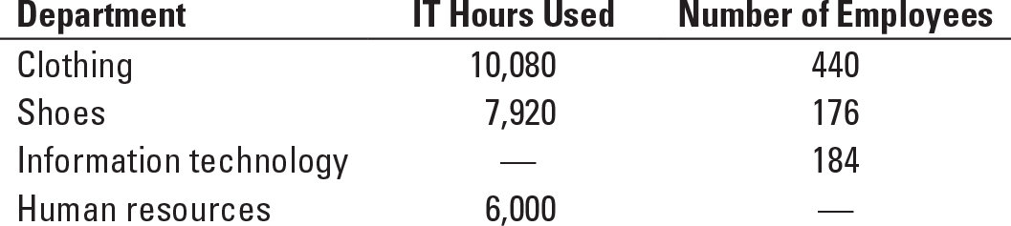

Required:

**1.** What are the total costs of the production departments (clothing and shoes) after  the support-department costs of information technology and human resources have been allocated using (a) the direct method, (b) the step-down method (allocate information technology first), (c) the step-down method (allocate human resources first), and (d) the reciprocal method?

**2.** Assume that all of the work of the IT department could be outsourced to an independent company for $97.50 per hour. If Sportz no longer operated its own IT department, 30% of the fixed costs of the IT department could be eliminated. Should Sportz outsource its IT services?

**SOLUTION**

(40-60 min.) **Support-department cost allocations: single-department cost pools; direct, step-down, and reciprocal methods.**

1. a. Allocate the total Support Department costs to the production departments under the Direct Allocation Method:

|  |  |  |
| --- | --- | --- |
|  | **Clothing** | **Shoes** |
| Departmental Costs | $21,000 | $15,000 |
|  |  |  |
| From: |  |  |
| Information Technology |  |  |
| (10,080/18,000) × $5,200 | 2,912 |  |
| ( 7,920/18,000) × $5,200 |  | 2,288 |
|  |  |  |
| Human Resources |  |  |
| (440/616) × $2,800 | 2,000 |  |
| (176/616) × $2,800 | . | 800 |
|  |  |  |
| Total Departmental Costs | $25,912 | $18,088 |

Total Costs to account for: $44,000

1. Allocate the Support Department Costs to the Production Department under the Step-down (Sequential) Allocation Method IT first sequentially:

To:

|  |  |  |  |  |
| --- | --- | --- | --- | --- |
|  | **IT** | **HR** | **Clothing** | **Shoes** |
| Departmental Costs | $5,200 | $2,800 | $21,000 | $15,000 |
|  |  |  |  |  |
| From: |  |  |  |  |
| Information Technology | (5,200) |  |  |  |
| ( 6,000/24,000) × $5,200 |  | 1,300 |  |  |
| (10,080/24,000) × $5,200 |  |  | 2,184 |  |
| ( 7,920/24,000) × $5,200 |  |  |  | 1,716 |
|  |  |  |  |  |
| Human Resources |  | (4,100) |  |  |
| (440/616) × $4,100 |  |  | 2,929 |  |
| (176/616) × $4,100 | . | . | . | 1,171 |
| Total Departmental Costs | $ 0 | $ 0 | $26,113 | $17,887 |

Total Costs to account for: $44,000

1. Allocate the Support Department Costs to the Production Department under the Step-down (Sequential) Allocation Method HR first sequentially:

To:

|  |  |  |  |  |
| --- | --- | --- | --- | --- |
|  | **HR** | **IT** | **Clothing** | **Shoes** |
| Departmental Costs | $2,800 | $5,200 | $21,000 | $15,000 |
|  |  |  |  |  |
| From: |  |  |  |  |
| Human Resources | (2,800) |  |  |  |
| (184/800) × $2,800 |  | 644 |  |  |
| (440/800) × $2,800 |  |  | 1,540 |  |
| (176/800) × $2,800 |  |  |  | $ 616 |
|  |  |  |  |  |
| Information Technology |  | (5,844) |  |  |
| (10,080/18,000) × $5,844 |  |  | 3,273 |  |
| ( 7,920/18,000) × $5,844 | . | . | . | $2,571 |
| Total Departmental Costs | $ 0 | $ 0 | $25,813 | $18,187 |

Total Costs to account for: $44,000

1. Allocate the Support Department Costs to the Production Department under the Reciprocal Allocation Method:

i. Assign reciprocal equations to the support departments. Note that IT uses 184/800 or 0.23 of HR department resources (allocation based on number of employees) and HR uses 6,000/24,000 of IT department resources (allocation based on number of IT hours).

IT = ($5,200 + 0.23 HR)

HR = ($2,800 + 0.25 IT)

ii. Solve the equation to complete the reciprocal costs of the support departments

IT = $5,200 + 0.23 HR

IT = $5,200 + 0.23($2,800 + 0.25 IT)

IT = $5,200 + $644 + 0.0575 IT

0.9425 IT = $5,844

IT = $6,200

HR = $2,800 + 0.25 IT

HR = $2,800 + 0.25($6,200)

HR = $2,800 + $1,550

HR = $4,350

iii. Allocate Reciprocal costs to departments (all numbers rounded to nearest dollar)

|  |  |  |  |  |
| --- | --- | --- | --- | --- |
|  | **IT** | **HR** | **Clothing** | **Shoes** |
| Departmental Costs | $ 5,200 | $ 2,800 | $21,000 | $15,000 |
| Information Technology | $(6,200) |  |  |  |
| ( 6,000/24,000) × $6,200 |  | 1,550 |  |  |
| (10,080/24,000) × $6,200 |  |  | 2,604 |  |
| ( 7,920/24,000) × $6,200 |  |  |  | $2,046 |
| Human Resources |  | $(4,350) |  |  |
| (184/800) × $4,350 | $1,000 |  |  |  |
| (440/800) × $4,350 |  |  | 2,393 |  |
| (176/800) × $4,350 | . | . | . | 957 |
|  |  |  |  |  |
| Total Departmental Costs | $ 0 | $ 0 | $25,997 | $18,003 |

Costs allocated to the Clothing Department equal $4,997 ($2,604 + $2,393). Costs allocated to the Shoes Department equal $3,003 ($2,046 + $957). Total Costs to account for is $44,000.

Solution Exhibit 15-34 shows the allocation of the IT and HR Department costs to the Clothing Department ($4,997) and to the Shoes Department ($3,003) using repeated iterations.

**SOLUTION EXHIBIT 15-34**

**Reciprocal Method of Allocating Support Department Costs for Sportz, Inc. Using Repeated Iterations.**

|  |  |  |  |
| --- | --- | --- | --- |
|  | **Support Departments** |  | **Operating Departments** |

**IT HR Clothing Shoes**

|  |  |  |  |  |
| --- | --- | --- | --- | --- |
| Budgeted manufacturing overhead costs before any interdepartmental cost allocations | $5,200 | $2,800 |  |  |
| 1st Allocation of IT Dept.  (0.25, 0.42, 0.33)a | (5,200) | 1,300 | $2,184 | $1,716 |
|  |  | 4,100 |  |  |
| 1st Allocation of HR Dept.  (0.23, 0.55, 0.22)b | 943 | (4,100) | 2,255 | 902 |
| 2nd Allocation of IT Dept.  (0.25, 0.42, 0.33)a | (943) | 236 | 396 | 311 |
| 2nd Allocation of HR Dept.  (0.23, 0.55, 0.22)b | 54 | (236) | 130 | 52 |
| 3rd Allocation of IT Dept.  (0.25, 0.42, 0.33)a | (54) | 13 | 23 | 18 |
| 3rd Allocation of HR Dept.  (0.23, 0.55, 0.22)b | 3 | (13) | 7 | 3 |
| 4th Allocation of IT Dept. |  |  |  |  |
| (0.25, 0.42, 0.33)a | (3) | 1 | 1 | 1 |
| 4th Allocation of HR Dept.  (0.25, 0.42, 0.33)a | 0 | (1) | 1 | 0 |
| Total budgeted manufacturing  overhead of operating departments | $ 0 | $ 0 | $4,997 | $3,003 |

Total accounts allocated and reallocated (the numbers in parentheses in first two columns)

IT Dept.: $5,200 + $943 + +$54 + $3 = $6,200

HR Dept.: $4,100 + $236 + $13 + 1 = $4,350

aBase is (6,000 + 10,080 + 7,920) or 24,000 IT-hours; 6,000 ÷ 24,000 = 0.25, 10,080 ÷ 24,000 = 0.42, 7,920 ÷ 24,000 = 0.33.

bBase is (184 + 440 + 176) or 800 employees ; 184 ÷ 800 = 0.23, 440 ÷ 800 = 0.55, 176 ÷ 800 = 0.22.

2. If Sportz decides to outsource its Information Technology needs, the company has to pay $97.50 per hour for the 24,000 hours of IT services it needs, for a total outlay of $2,340,000. In return, Sportz saves 30% of the IT department’s fixed costs ($4,000,000 × 0.30 = $1,200,000). The issue then is how much it saves in variable costs. The key is to recognize that Sportz saves more than the $1,200,000 of variable costs assigned to IT because of the interlinks between the IT and HR groups. To quantify this, we have to calculate the reciprocated cost of the IT department using the variable costs alone.

IT = $1,200,000 + 0.23 HR

HR = $ 800,000 + 0.25 IT

IT = $1,200,000 + 0.23($800,000 + 0.25 IT)

IT = $1,384,000 + 0.0575 IT

0.9425 IT = $1,384,000

IT = $1,468,435

Sportz’s total savings therefore amount to $1,200,000 + $1,468,435 = $2,668,435, which exceeds the direct outsourcing payment of $2,340,000. Therefore, on financial grounds alone, Sportz should outsource its Information Technology services.

Beyond the financial perspective, Sportz should decide how important it is to the company to have control over its own IT support. It may be critical, especially with information technology, that the knowledge and expertise be maintained within the firm so critical decisions do not depend on a third party. It may also be critical for security purposes to maintain IT support internally so that company information is kept confidential. In addition, by maintaining IT support in-house, the response time to production departments and other support departments will likely be greater than if the services are outsourced. It is also possible that the quality of the service would be higher as well. Finally, Sportz should consider the internal repercussions of dismissing a large portion of its workforce. This could create morale issues for the company’s remaining workers.

**15-35** Revenue allocation, bundled products. Boca Resorts (BR) operates a five-star hotel with a world-class spa. BR has a decentralized management structure, with three divisions:

• Lodging (rooms, conference facilities)

• Food (restaurants and in-room service)

• Spa

Starting next month, BR will offer a two-day, two-person “getaway package” for $1,000.

This deal includes the following:

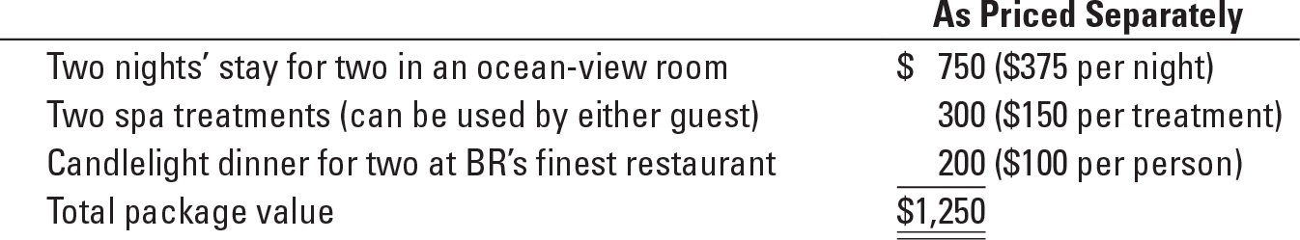

Jennifer Gibson, president of the spa division, recently asked the CEO of BR how her division would share in the $1,000 revenue from the getaway package. The spa was operating at 100% capacity. Currently, anyone booking the package was guaranteed access to a spa appointment. Gibson noted that every “getaway” booking would displace $300 of other spa bookings not related to the package. She emphasized that the high demand reflected the devotion of her team to keeping the spa rated one of the “Best 10 Luxury Spas in the World” by Travel Monthly. As an aside, she also noted that the lodging and food divisions had to turn away customers during only “peak-season events such as the New Year’s period.”

Required:

**1.** Using selling prices, allocate the $1,000 getaway-package revenue to the three divisions using:

**a.** The stand-alone revenue-allocation method

**b.** The incremental revenue-allocation method (with spa first, then lodging, and then food)

**2.** What are the pros and cons of the two methods in requirement 1?

**3.** Because the spa division is able to book the spa at 100% capacity, the company CEO has decided to revise the getaway package to only include the lodging and food offerings shown previously. The new package will sell for $800. Allocate the revenue to the lodging and food divisions using the following:

a. The Shapley value method

b. The weighted Shapley value method, assuming that lodging is three times as likely to sell as the food

**SOLUTION**

(20–25 min.) **Revenue allocation, bundled products.**

1.a. The stand-alone revenues (using unit selling prices) of the three components of the $800 package are:

Lodging $375 × 2 = $ 750

Recreation $150 × 2 = 300

Food $100 × 2 = 200

$1,250

Lodging 

Spa 

Food 

Total Allocated $1,000

b.

|  |  |  |
| --- | --- | --- |
| **Product** | RevenueAllocated | **Cumulative Revenue**  **Allocated** |
| Spa | $300 | $300 |
| Lodging | 700 ($1,000 – $300) | $1,000 |
| Food | 0 | $1,000 |
|  | $1,000 |  |

2. The pros of the stand-alone-revenue-allocation method include the following:

a. Each item in the bundle receives a positive weight, which means the resulting allocations are more likely to be accepted by all parties than a method allocating zero revenues to one or more products.

b. It uses market-based evidence (unit selling prices) to decide the revenue allocations—unit prices are one indicator of benefits received.

1. It is simple to implement.

The cons of the stand-alone revenue-allocation method include the following:

a. It ignores the relative importance of the individual components in attracting consumers to purchase the bundle.

b. It ignores the opportunity cost of the individual components in the bundle. The spa operates at 100% capacity. A getaway participant who does not use the spa option will not displace anyone. Thus, under the stand-alone method, the spa may be paid twice—once from the non-getaway person who does use the spa and second from an allocation of the $1,000 package amount for the getaway person who does not use the spa. (either did not want to use the spa or failed to show).

c. The weight can be artificially inflated by individual product managers setting “high” list unit prices and then being willing to frequently discount these prices. The use of *actual* unit prices or actual revenues per product in the stand-alone formula will reduce this problem.

d. The weights may change frequently if unit prices are constantly changing. This is not so much a criticism as a reflection that the marketplace may be highly competitive.

The pros of the incremental method include the following:

a. It has the potential to reflect that some products in the bundle are more highly valued than others. Not all products in the bundle have a similar “write-down” from unit list prices. Ensuring this “potential pro” becomes an “actual pro” requires that the choice of the primary product be guided by reliable evidence on consumer preferences. This is not an easy task.

b. Once the sequence is chosen, it is straightforward to implement.

The cons of the incremental method include the following:

a. Obtaining the rankings can be highly contentious and place managers in a “no-win” acrimonious debate. The revenue allocations can be sensitive to the chosen rankings.

b. Some products will have zero revenues assigned to them. Consider the Food division. It would incur the costs for the two dinners but receive no revenue.

3. Under the Shapley value method the revenue allocated represents an average of the revenue that would have been received if each product or service were ranked as both the primary party and the incremental party

a.

|  |  |  |
| --- | --- | --- |
|  | **Product** | **Revenue Received under**  **Incremental Method** |
| Primary party | Lodging | $750 |
| Incremental party | Food | 50 ($800 – $750) |
|  |  | $800 |

|  |  |  |
| --- | --- | --- |
|  | **Product** | **Revenue Received under**  **Incremental Method** |
| Primary party | Food | $200 |
| Incremental party | Lodging | 600 ($800 – $200) |
|  |  | $800 |

Revenue allocation under the *Shapley value method*, based on the data from the incremental rankings above is:

|  |  |  |
| --- | --- | --- |
| Average Lodging | ($750 + $600) ÷2 | $675 |
| Average Food | ($200 + $50) ÷ 2 | 125 |
| Total Revenue Dollars Allocated |  | $800 |

b. Assuming that lodging is three times as likely to be sold as food, the revenue allocated under the *weighted Shapley value method*, using data from the incremental rankings above would be:

|  |  |  |
| --- | --- | --- |
| Average Lodging | ($750 × 3 + $600 × 1) ÷ 4 | $712.50 |
| Average Food | ($200 × 1 + $ 50 × 3) ÷ 4 | 87.50 |
| Total Revenue Dollars Allocated |  | $800.00 |

**15-36** Support-department cost allocations; direct, step-down, and reciprocal methods. Ballantine Corporation has two operating departments: Eastern Department and Western Department. Each of the operating departments uses the services of the company’s two support departments: Engineering and Information Technology. Additionally, the Engineering and Information Technology departments use the services of each other. Data concerning the past year are as follows:

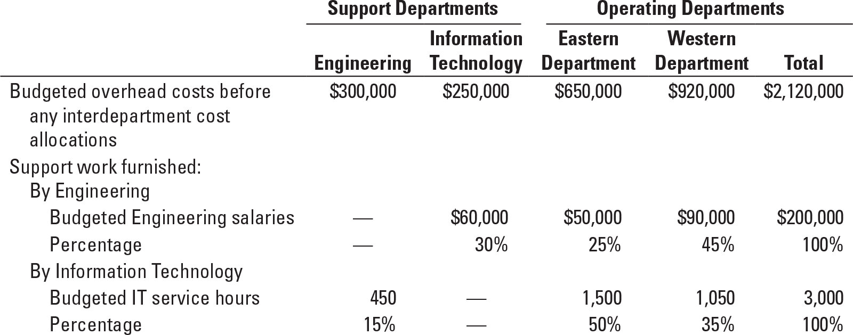

Required:

**1.** What are the total overhead costs of the operating departments (Eastern and Western) after the support-department costs of Engineering and Information Technology have been allocated using (a) the direct method, (b) the step-down method (allocate Engineering first), (c) the step-down method (allocate Information Technology first), and (d) the reciprocal method?

**2.** Which method would you recommend that Ballantine Corporation use to allocate service-department costs? Why?

**SOLUTION**

(20 min.) **Support-department cost allocations: direct, step-down, and reciprocal methods.**

1 a. Allocate the total Support Department costs to the operating departments under the Direct Allocation Method:

|  |  |  |
| --- | --- | --- |
|  | **Eastern Department** | **Western Department** |
| Departmental Overhead Costs | $650,000 | $ 920,000 |
|  |  |  |
| From: |  |  |
| Engineering |  |  |
| ($50,000/$140,000) × $300,000 | 107,143 |  |
| ($90,000/$140,000) × $300,000 |  | 192,857 |
|  |  |  |
| Information Technology |  |  |
| (1,500/2,550) × $250,000 | 147,059 |  |
| (1,050/2,550) × $250,000 | _______ | 102,941 |
|  |  |  |
| Total Departmental Overhead Costs | $904,202 | $1,215,798 |

Total Costs to account for: $2,120,000

b. Allocate the Support Department Costs to the Operating Departments under the Step-down (Sequential) Allocation Method with Engineering first sequentially:

To:

|  |  |  |  |  |
| --- | --- | --- | --- | --- |
|  | **Engineering** | **IT** | **Eastern Department** | **Western Department** |
| Departmental Overhead Costs | $ 300,000 | $250,000 | $650,000 | $ 920,000 |
|  |  |  |  |  |
| From: |  |  |  |  |
| Engineering | $(300,000) |  |  |  |
| 30% × $300,000 |  | 90,000 |  |  |
| 25% × $300,000 |  |  | 75,000 |  |
| 45% × $300,000 |  |  |  | 135,000 |
|  |  |  |  |  |
| Information Technology |  | (340,000) |  |  |
| (1,500/2,550) × $340,000 |  |  | 200,000 |  |
| (1,050/2,550) × $340,000 | . | . | . | 140,000 |
| Total Departmental Costs | $ 0 | $ 0 | $925,000 | $1,195,000 |

Total Costs to account for: $2,120,000

c. Allocate the Support Department Costs to the Operating Departments under the Step-down (Sequential) Allocation Method IT first sequentially:

To:

|  |  |  |  |  |
| --- | --- | --- | --- | --- |
|  | **IT** | **Engineering** | **Eastern Department** | **Western Department** |
| Departmental Costs | $250,000 | $300,000 | $650,000 | $ 920,000 |
|  |  |  |  |  |
| From: |  |  |  |  |
| Information Technology | (250,000) |  |  |  |
| 15% × $250,000 |  | 37,500 |  |  |
| 50% × $250,000 |  |  | 125,000 |  |
| 35% × $250,000 |  |  |  | 87,500 |
|  |  |  |  |  |
| Engineering |  | (337,500) |  |  |
| ($50,000/$140,000) × $337,500 |  |  | 120,536 |  |
| ($90,000/$140,000) × $337,500 | . | . | . | 216,964 |
| Total Departmental Costs | $ 0 | $ 0 | $895,536 | $1,224,464 |

Total Costs to account for: $2,120,000

d. Allocate the Support Department Costs to the Operating Departments under the Reciprocal Allocation Method:

Assign reciprocal equations to the support departments: Engineering (E) and Information Technology (IT)

E = $300,000 + 0.15 IT

IT = $250,000 + 0.30 E

Solve the equation to complete the reciprocal costs of the support departments

E = $300,000 + 0.15 IT

E = $300,000 + 0.15 ($250,000 + 0.30 E)

E = $300,000 + $37,500 + 0.045 E

0.955 E = $337,500

E = $353,403

IT = $250,000 + 0.30 E

IT = $250,000 + 0.30 ($353,403)

IT = $250,000 + $106,021

IT = $356,021

Allocate Reciprocal costs to departments (all numbers rounded to nearest dollar)

|  |  |  |  |  |
| --- | --- | --- | --- | --- |
|  | **Engineering** | **IT** | **Eastern Department** | **Western Department** |
| Departmental Costs | $300,000 | $250,000 | $650,000 | $ 920,000 |
| Engineering | (353,403) |  |  |  |
| 30% × $353,403 |  | 106,021 |  |  |
| 25% × $353,403 |  |  | 88,351 |  |
| 45% × $353,403 |  |  |  | 159,031 |
| Information Technology |  | (356,021) |  |  |
| 15% × $356,021 | 53,403 |  |  |  |
| 50% × $356,021 |  |  | 178,011 |  |
| 35% × $356,021 | . | . | . | 124,607 |
| Total Departmental Costs | $ 0 | $ 0 | $916,362 | $1,203,638 |

Costs allocated to the Eastern Department equal $266,362 ($88,351 + $178,011). Costs allocated to the Western Department equal $283,638 ($159,031 + $124,607). Total Support Department Costs to account for $550,000 (Engineering, $300,000 + Information Technology, $250,000).

Solution Exhibit 15-36 shows the allocation of the IT and HR Department costs to the Eastern Department and to the Western Department using repeated iterations.

2. Summary of cost allocation resulting from the four methods in part 1:

|  |  |  |
| --- | --- | --- |
|  | **Eastern Department** | **Western Department** |
| Direct method | $904,202 | $1,215,798 |
| Step-down method (Engineering primary) | $925,000 | $1,195,000 |
| Step-down method (IT primary) | $895,536 | $1,224,464 |
| Reciprocal method | $916,362 | $1,203,638 |

Although the reciprocal method produces the most accurate support department cost allocation, it is also the most complicated. The step-down method with Engineering being the primary department produces similar results. That is due to the fact that 30% of Engineering services are provided to the IT department, another support department, while only 15% of IT services are provided to Engineering. Therefore, the step-down method with Engineering as the primary department would be an acceptable substitute for the reciprocal method.

**SOLUTION EXHIBIT 15-36**

**Reciprocal Method of Allocating Support Department Costs for Ballantine Tours Using Repeated Iterations.**

|  |  |  |  |  |
| --- | --- | --- | --- | --- |
|  | **Support Departments** | | **Operating Departments** | |
|  | **Engineering** | **IT** | **Eastern** | **Western** |
| Budgeted manufacturing overhead costs before any interdepartmental cost allocations | $300,000 | $250,000 | $650,000 | $ 920,000 |
| 1st Allocation of Engg. Dept.  (30%, 25%, 45%)a | (300,000) | 90,000 | 75,000 | 135,000 |
|  |  | 340,000 |  |  |
| 1st Allocation of IT Dept.  (15%, 50%, 35%)b | 51,000 | (340,000) | 170,000 | 119,000 |
| 2nd Allocation of Engg. Dept.  (30%, 25%, 45%)a | (51,000) | 15,300 | 12,750 | 22,950 |
| 2nd Allocation of IT Dept.  (15%, 50%, 35%)b | 2,295 | (15,300) | 7,650 | 5,355 |
| 3rd Allocation of Engg. Dept.  (30%, 25%, 45%)a | (2,295) | 688 | 574 | 1,033 |
| 3rd Allocation of IT Dept.  (15%, 50%, 35%)b | 103 | (688) | 344 | 241 |
| 4th Allocation of Engg. Dept.  (30%, 25%, 45%)a | (103) | 31 | 26 | 46 |
| 4th Allocation of IT Dept.  (15%, 50%, 35%)b | 5 | (31) | 15 | 11 |
| 5th Allocation of Engg. Dept.  (30%, 25%, 45%)a | (5) | 2 | 1 | 2 |
| 5th Allocation of IT. Dept.  (15%, 50%, 35%)a | 0 | (2) | 2 | 0 |
| Total budgeted manufacturing  overhead of operating departments | $ 0 | $ 0 | $916,362 | $1,203,638 |

Total accounts allocated and reallocated (the numbers in parentheses in first two columns)

Engg. Dept.: $300,000 + $51,000 + $2,295 + $103 + $5 = $353,403

IT Dept.: $340,000 + $15,300 + $688 + $31 + $2 = $356,021

aBase is ($60,000 + $50,000 + $90,000) or $200,000; $60,000 ÷ $200,000 = 30%, $50,000 ÷ $200,000 = 25%, $90,000 ÷ $200,000 = 45%.

bBase is (450 + 1,500 + 1,050) or 3,000 IT service-hours; 450 ÷ 3,000 = 15%, 1,500 ÷ 3,000 = 50%, 1,050 ÷ 3,000 = 35%.

**Try It 15-1 Solution**

1. A combined budgeted rate is used for fixed and variable costs. The rate is calculated as follows:

| Budgeted usage of engineering-services labor-hours | 7,000 hours |
| --- | --- |
| Budgeted total cost pool: $280,000 + ($25 × 7,000 hours) | $455,000 |
| Budgeted total rate per hour: $455,000 ÷ 7,000 hours | $65 per hour used |

The rate of $65 per hour is used to allocate engineering-services department costs to the machining and assembly departments.

Under the single-rate method, the Machining and Assembly Departments are charged the budgeted rate for each hour of actual use of engineering services.

|  |  |
| --- | --- |
| Machining department: $65 per hour × 2,000 hours | $130,000 |
| Assembly department: $65 per hour × 4,000 hours | $260,000 |

1. Budgeted fixed cost rate per hour = $280,000 ÷ 7,000 hours = $40 per hour

The costs allocated to the Machining Department in 2017 equals:

|  |  |
| --- | --- |
| Fixed costs: $40 per hour × 2,500 (budgeted) hours | $100,000 |
| Variable costs: $25 per hour × 2,000 (actual) hours | 50,000 |
| Total costs | $150,000 |

The costs allocated to the Assembly Department in 2017 equals:

|  |  |
| --- | --- |
| Fixed costs: $40 per hour × 4,500 (budgeted) hours | $180,000 |
| Variable costs: $25 per hour × 4,000 (actual) hours | 100,000 |
| Total costs | $280,000 |

1. Using the 8,000 hours of practical capacity of the Engineering Services Department, the budgeted rate is:

|  |  |
| --- | --- |
| Budgeted fixed-cost rate per hour, $280,000 ÷ 8,000 hours | $35 per hour |
| Budgeted variable-cost rate per hour | 25 per hour |
| Budgeted total-cost rate per hour | $60 per hour |

Under the single rate method, the Engineering Services Department costs are allocated to the Machining and Assembly Departments as follows:

| Machining Department: $60 per hour × 2,000 (actual) hours | | | $ 120,000 | | |
| --- | --- | --- | --- | --- | --- |
| Assembly Department: $60 per hour × 4,000 (actual) hours | | | 240,000 | | |
| Fixed costs of unused engineering-services capacity: | | |  | | |
| $35 per hour × 2,000 hoursa  aPractical capacity, 8,000 hours – Actual hours used 6,000 (2,000 + 4,000) = 2,000 hours | | | 70,000 | | |
| 1. Under the dual rate method, the Engineering Services Department costs are allocated to the Machining and Assembly Departments as follows: | | |  | | |
| Machining Department | | |  | | |
| Fixed costs: $35 per hour × 2,500 (budgeted) hours | | | $ 87,500 | | |
| Variable costs: $25 per hour × 2,000 (actual) hours | | | 50,000 | | |
| Total costs | | | $137,500 | | |
| Assembly Department | | |  | | |
| Fixed costs: $35 per hour × 4,500 (budgeted) hours | | | $157,500 | | |
| Variable costs: $25 per hour × 4,000 (actual) hours | | | 100,000 | | |
| Total costs | | | $257,500 | | |
| Fixed costs of unused engineering-services capacity: | | |  | | |
| $35 per hour × 1,000 hoursb | | | $35,000 | | |
| b1,000 hours  Practical capacity of 8,000 hours − (2,500 hours budgeted to be used by Machining Department  4,500 hours budgeted to be used by Assembly Department). | | | | | |

**Try It 15-2 Solution**

1a. Allocate the total Support Department costs to the operating departments under the Direct Allocation Method:

|  |  |  |
| --- | --- | --- |
|  | **Domestic Tours** | **World Tours** |
| Departmental Overhead Costs | $1,300,000 | $1,840,000 |
|  |  |  |
| From: |  |  |
| Administration |  |  |
| ($55,000/$132,000) × $400,000 | 166,667 |  |
| ($77,000/$132,000) × $400,000 |  | 233,333 |
|  |  |  |
| Information Technology |  |  |
| (2,200/3,400) × $250,000 | 161,765 |  |
| (1,200/3,400) × $250,000 | _________ | 88,235 |
|  |  |  |
| Total Departmental Overhead Costs | $1,628,432 | $2,161,568 |

Total Costs to account for: $3,790,000

b. Allocate the Support Department Costs to the Operating Departments under the Step-down (Sequential) Allocation Method with Administration first sequentially:

To:

|  |  |  |  |  |
| --- | --- | --- | --- | --- |
|  | **Administration** | **IT** | **Domestic Tours** | **World Tours** |
| Departmental Overhead Costs | $ 400,000 | $ 250,000 | $1,300,000 | $1,840,000 |
|  |  |  |  |  |
| From: |  |  |  |  |
| Administration | $(400,000) |  |  |  |
| 40% × $400,000 |  | 160,000 |  |  |
| 25% × $400,000 |  |  | 100,000 |  |
| 35% × $400,000 |  |  |  | 140,000 |
|  |  |  |  |  |
| Information Technology |  | (410,000) |  |  |
| (2,200/3,400) × $410,000 |  |  | 265,294 |  |
| (1,200/3,400) × $410,000 | . | . | . | 144,706 |
| Total Departmental Costs | $ 0 | $ 0 | $1,665,294 | $2,124,706 |

Total Costs to account for: $3,790,000

c. Allocate the Support Department Costs to the Operating Departments under the Step-down (Sequential) Allocation Method IT first sequentially:

To:

|  |  |  |  |  |
| --- | --- | --- | --- | --- |
|  | **IT** | **Administration** | **Domestic Tours** | **World Tours** |
| Departmental Costs | $250,000 | $400,000 | $1,300,000 | $1,840,000 |
|  |  |  |  |  |
| From: |  |  |  |  |
| Information Technology | (250,000) |  |  |  |
| 15% × $250,000 |  | 37,500 |  |  |
| 55% × $250,000 |  |  | 137,500 |  |
| 30% × $250,000 |  |  |  | 75,000 |
|  |  |  |  |  |
| Administration |  | (437,500) |  |  |
| (55,000/132,000) × $437,500 |  |  | 182,292 |  |
| (77,000/132,000) × $437,500 | . | . | . | 255,208 |
| Total Departmental Costs | $ 0 | $ 0 | $1,619,792 | $2,170,208 |

Total Costs to account for: $3,790,000

d. Allocate the Support Department Costs to the Operating Departments under the Reciprocal Allocation Method:

Assign reciprocal equations to the support departments

AD = $400,000 + 0.15 IT

IT = $250,000 + 0.40 AD

Solve the equation to complete the reciprocal costs of the support departments

AD = $400,000 + 0.15 IT

AD = $400,000 + 0.15 ($250,000 + 0.40 AD)

AD = $400,000 + $37,500 + 0.06 AD

0.94 AD = $437,500

AD = $465,426

IT = $250,000 + 0.40 AD

IT = $250,000 + 0.40 ($465,426)

IT = $250,000 + $186,170

IT = $436,170

Allocate Reciprocal costs to departments (all numbers rounded to nearest dollar)

|  |  |  |  |  |
| --- | --- | --- | --- | --- |
|  | **Administration** | **IT** | **Domestic Tours** | **World Tours** |
| Departmental Costs | $400,000 | $250,000 | $1,300,000 | $1,840,000 |
| Administration | (465,426) |  |  |  |
| 40% × $465,426 |  | 186,170 |  |  |
| 25% × $465,426 |  |  | 116,357 |  |
| 35% × $465,426 |  |  |  | $ 162,899 |
| Information Technology |  | (436,170) |  |  |
| 15% × $436,170 | 65,426 |  |  |  |
| 55% × $436,170 |  |  | 239,893 |  |
| 30% × $436,170 | . | . | . | 130,851 |
| Total Departmental Costs | $ 0 | $ 0 | $1,656,250 | $2,133,750 |

Costs allocated to the Domestic Tours Department equal $356,250 ($116,357 + $239,893). Costs allocated to the World Tours Department equal $293,750 ($162,899 + $130,851). Total Support Department Costs to account for $650,000 (Administration, $400,000 + Information Technology, $250,000).

Try It Exhibit 15-2 shows the allocation of the IT and HR Department costs to the Domestic Tours Department and to the World Tours Department using repeated iterations.

**TRY IT EXHIBIT 15-2**

**Reciprocal Method of Allocating Support Department Costs for Montvale Tours Using Repeated Iterations.**

|  |  |  |  |  |
| --- | --- | --- | --- | --- |
|  | **Support Departments** | | **Operating Departments** | |
|  | **Administratn.** | **IT** | **Domestic** | **World** |
| Budgeted manufacturing overhead costs before any interdepartmental cost allocations | $400,000 | $250,000 | $1,300,000 | $1,840,000 |
| 1st Allocation of Admin. Dept.  (40%, 25%, 35%)a | (400,000) | 160,000 | 100,000 | 140,000 |
|  |  | 410,000 |  |  |
| 1st Allocation of IT Dept.  (15%, 55%, 30%)b | 61,500 | (410,000) | 225,500 | 123,000 |
| 2nd Allocation of Admin. Dept.  (40%, 25%, 35%)a | (61,500) | 24,600 | 15,375 | 21,525 |
| 2nd Allocation of IT Dept.  (15%, 55%, 30%)b | 3,690 | (24,600) | 13,530 | 7,380 |
| 3rd Allocation of Admin. Dept.  (40%, 25%, 35%)a | (3,690) | 1,476 | 923 | 1,291 |
| 3rd Allocation of IT Dept.  (15%, 55%, 30%)b | 221 | (1,476) | 812 | 443 |
| 4th Allocation of Admin. Dept.  (40%, 25%, 35%)a | (221) | 88 | 55 | 78 |
| 4th Allocation of IT Dept.  (15%, 55%, 30%)b | 13 | (88) | 49 | 26 |
| 5th Allocation of Admin. Dept.  (40%, 25%, 35%)a | (13) | 5 | 3 | 5 |
| 5th Allocation of IT Dept.  (15%, 55%, 30%)b | 1 | (5) | 3 | 1 |
| 6th Allocation of Admin. Dept.  (40%, 25%, 35%)a | (1) | 0 | 0 | 1 |
| Total budgeted manufacturing  overhead of operating departments | $ 0 | $ 0 | $1,656,250 | $2,133,750 |

Total accounts allocated and reallocated (the numbers in parentheses in first two columns)

Admin. Dept.: $400,000 + $61,500 + $3,690 + $221 + $13 + $1 = $465,425

IT Dept.: $410,000 + $24,600 + $1,476 + $88 + $5 = $436,169

aBase is ($88,000 + $55,000 + $77,000) or $220,000; $88,000 ÷ $220,000 = 40%, $55,000 ÷ $220,000 = 25%, $77,000 ÷ $220,000 = 35%.

bBase is (600 + 2,200 + 1,200) or 4,000 IT service-hours; 600 ÷ 4,000 = 15%, 2,200 ÷ 4,000 = 55%, 1,200 ÷ 4,000 = 30%.

**Try It 15-3** Solution

1. Stand-alone cost-allocation method.

Taylor Inc. =



= = $32,400



Victor Inc. =



= = $21,600



$54,000

2. With Taylor Inc. as the primary party:

|  |  |  |
| --- | --- | --- |
| **Party** | **Costs Allocated** | **Cumulative Costs Allocated** |
| Taylor | $36,000 | $36,000 |
| Victor | 18,000 ($54,000 – $36,000) | $54,000 |
| Total | $54,000 |  |

With Victor Inc. as the primary party:

|  |  |  |
| --- | --- | --- |
| **Party** | **Costs Allocated** | **Cumulative Costs Allocated** |
| Victor | $24,000 | $24,000 |
| Taylor | 30,000 ($54,000 – $24,000) | $54,000 |
| Total | $54,000 |  |

*3. To use the Shapley value method, consider each party as first the primary party and then* the incremental party. Compute the average of the two to determine the allocation.

Taylor Inc.:

Allocation as the primary party $36,000

Allocation as the incremental party 30,000

Total $66,000

Allocation ($66,000 ÷ 2) $33,000

Victor Inc.:

Allocation as the primary party $24,000

Allocation as the incremental party 18,000

Total $42,000

Allocation ($42,000 ÷ 2) $21,000

Using this approach, Taylor Inc. is allocated $33,000, and Victor, Inc. is allocated $21,000 of the total costs of $54,000.

4. The results of the four cost-allocation methods are shown below.

|  |  |  |
| --- | --- | --- |
|  | **Taylor Inc.** | **Victor Inc.** |
| Stand-alone method | $32,400 | $21,600 |
| Incremental (Taylor primary) | 36,000 | 18,000 |
| Incremental (Victor primary) | 30,000 | 24,000 |
| Shapley value | 33,000 | 21,000 |

The allocations are very sensitive to the method used. With the incremental cost-allocation method, Taylor Inc. and Victor Inc. would probably have disputes over who is the primary party because the primary party gets allocated all of the primary party’s costs. The stand-alone method is simple and fair because it allocates the common cost of the dyeing machine in proportion to the individual costs of leasing the machine. The Shapley values are also fair. They result in allocations that are similar to those of the stand-alone method. Either of the methods can be chosen. Given its simplicity, the stand-alone method is likely more acceptable.

**Try It 15-4 Solution**

1a.Under the stand-alone revenue-allocation method based on selling price, Him will be allocated 33.33% of all revenues, or $20 of the bundled selling price, and Her will be allocated 66.67% of all revenues, or $40 of the bundled selling price, as shown below.

|  |  |  |  |
| --- | --- | --- | --- |
| **Stand-alone method, based on selling prices** | **Him** | **Her** | **Total** |
| Selling price | $25 | $50 | $75 |
| Selling price as a % of total  ($25  $75; $50  $75) | 33.33% | 66.67% | 100% |
| Allocation of $60 bundled selling price  (33.33%  $60; 66.67%  $60) | $20 | $40 | $60 |

1b.Under the incremental revenue-allocation method, with Him ranked as the primary product, Him will be allocated $25 (its own stand-alone selling price), and Her will be allocated $35 of the $60 selling price, as shown below.

|  |  |  |
| --- | --- | --- |
| **Incremental Method**  **(Him rank 1)** | **Him** | **Her** |
| Selling price | $25 | $50 |
| Allocation of $60 bundled selling price  ($25; $35 = $60 – $25) | $25 | $35 |

1c. Under the incremental revenue-allocation method, with Her ranked as the primary product, Her will be allocated $50 (its own stand-alone selling price) and Him will be allocated $10 of the $60 selling price, as shown below.

|  |  |  |
| --- | --- | --- |
| **Incremental Method**  **(Her rank 1)** | **Him** | **Her** |
| Selling price | $25 | $50 |
| Allocation of $60 bundled selling price  ($10 = $60 – $50; $50) | $10 | $50 |

1d. Under the Shapley value method, each product will be allocated the average of its allocations in 1b and 1c, i.e., the average of its allocations when it is the primary product and when it is the secondary product, as shown below.

|  |  |  |
| --- | --- | --- |
| **Shapley Value Method** | **Him** | **Her** |
| Allocation when Him = Rank 1;  Her = Rank 2 (from 1b.) | $25.00 | $35.00 |
| Allocation when Her = Rank 1;  Him = Rank 2 (from 1c.) | $10.00 | $50.00 |
| Average of allocated selling price  ($25 + $10)  2; ($35 + $50)  2 | $17.50 | $42.50 |

2. A summary of the allocations based on the four methods in requirement 1 is shown below.

|  |  |  |  |  |
| --- | --- | --- | --- | --- |
|  | **Stand-alone**  **(Selling Prices)** | **Incremental (Him first)** | **Incremental  (Her first)** | **Shapley** |
| Him | $20 | $25 | $10 | $17.50 |
| Her | 40 | 35 | 50 | 42.50 |
| Total for Sync | $60 | $60 | $60 | $60.00 |

If there is no clear indication of which product is the more “important” product, or if it can be reasonably assumed that the two products are equally important to the company's strategy, the Shapley value method is the fairest of all the methods because it averages the effect of product rank. In this particular case, note that the allocations from the stand-alone method based on selling price are reasonably similar to the allocations from the Shapley value method, so the managers at Essence may well want to use the much simpler stand-alone method. The stand-alone method also does not require ranking the products in the suite, and so it is less likely to cause debates among product managers in the Men's and Women's Fragrance divisions. If, however, one of the products (Him or Her) is clearly the product that is driving sales of the bundled product, then that product should be considered the primary product or weighted more heavily (rather than equally) when applying the Shapley value method.