

Faculty of Engineering and Technology

Department of Electrical and Computer Engineering

Digital Electronics and Computer Organization

ENCS 2110

**Experiment No. 2 - Comparators, Adders, and Subtractors**

**Post Lab2**

Student Name: Alaa moqade

Student ID : 1211910

Instructor : Jamal Seyam

T.A : Haleema Hmedan

Section : 1

1) Design 8-bit BCD adder

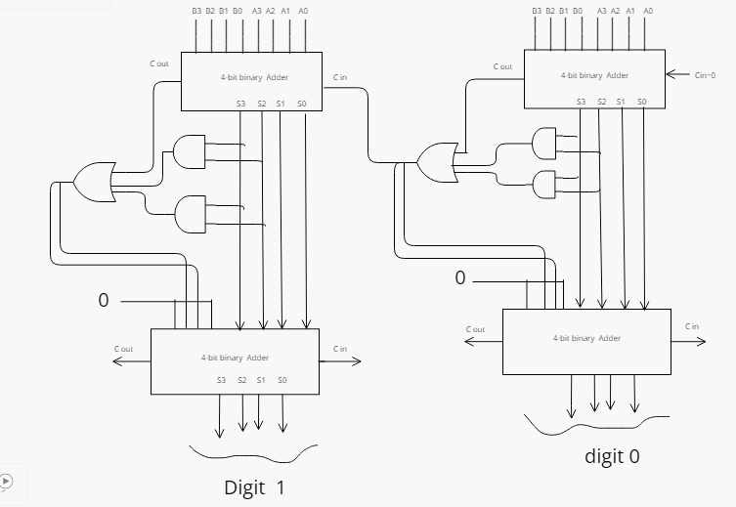

2) Design 8-bit comparator using 2 of 4-bit comparator

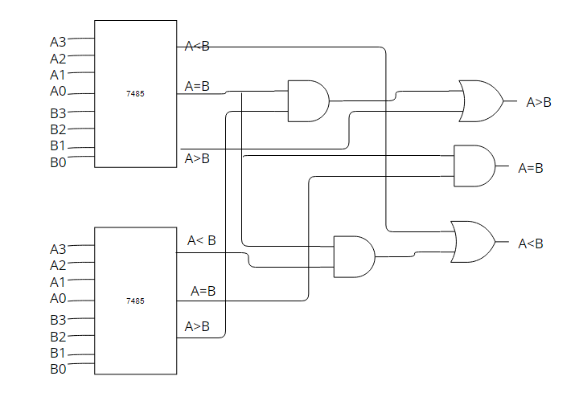

3) .A 4-inputs, 3-outputs circuit that compares 2-bit unsigned numbers and outputs a ‘1’ on one of three output lines according to whether the first number is greater than, equal to, or less than the other number. You can only use two 4×1 multiplexer.

