

**Faculty of Engineering and Technology**

**Mechanical Engineering Department**

**Fluid Mechanics laboratory**

**ENME312**

**Experiment #8**

**Radial Pumps & Positive Displacement Pumps**

**Instructors:**

**Dr. Adel Dweik**

**Eng. Alanood Moudai**

**Done by group 3:**

Khaled Wahdan 1191584

**Ahmad Sabobeh 1191922**

Aws Daraghmeh 1191856

**Date of performing the experiment: 25.4.2022**

**Date of submitting the experiment: 12.5.2022**

**Abstract**

To lift water from an elevation to another, pumps must be used. Pumps impart energy to water to deliver it from a place to another where gravity cannot be a solution. Various Pumps are used in order to get the job done, but are they the same? The answer is NO, Pumps differ based on the source of energy, delivering method and other factors. In these experiments, two types of pumps are used to compare the values and determine the efficiency of each, which are the Centrifugal Pumps and the Positive Displacement Pumps.

Centrifugal Pumps (type of Rotodynamic Pumps) are Dynamic Pressure pumps that consist of an inlet valve, outlet valve, and an impeller. It converts Electrical Energy to Mechanical/Kinetic Energy, which is then transformed to Hydraulic Energy. The Impeller’s rotational energy creates pressure difference that pushes water into the pump. Then the fluid is directed to the outlet of the pump with required pressure to encounter the major losses and the needed elevation.

On the other hand, Positive Displacement Pumps pushes water through trapping an amount of the fluid then releasing it with higher pressure. Thus, the outflow of those types of pumps isn’t continuous and has pulsations, that’s why it’s preferred to put pulsation dampers. By the mechanism, we can separate the positive displacement pumps to reciprocating and rotary.

The main **aim** of this experiment is to observe the values of electric, mechanical, and hydraulic energy in centrifugal pumps, and notice the relation of Speed, Delivery pressure, and Inlet pressure in positive displacement pumps.

As a **result**, we found the hydraulic efficiency of centrifugal pumps in each run. And the Overall, Volumetric efficiencies of gear pumps. The average efficiency for the first was 25%, the overall value in the second was 52.4% for constant speed; and 71.9 for constant Delivery Pressure.

**Objectives**

To measure:

Centrifugal Pumps:

* Flow rate Q (digitally).
* Pressure amounts P1 and P2.
* Voltage and Current.
* Force Exerted F.

Positive Displacement Pumps (maintain constant speed in the first, and constant delivery pressure in the second):

* Speed.
* Torque.
* Power.
* Pressures.
* Flow Rate.

To Analyze:

* Electrical, Hydraulic, Mechanical Powers.
* Hydraulic Head values.
* Efficiency of centrifugal pumps.
* Overall and volumetric efficiencies of positive displacement pumps.

To Determine:

* + Performance of each pump under different circumstances.
  + When to use each pump.

**Sample Calculations**

For Centrifugal Pumps:

* 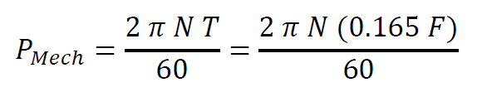Electrical Power: ----(1)
* Mechanical Power: ----(2)

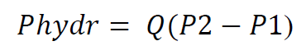

* Hydraulic Power: ----(3)

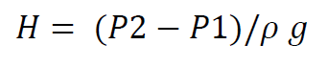

* Hydraulic Head: ----(4)

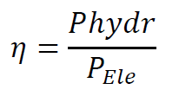

* Efficiency: ----(5)

For the Positive Displacement Pump:

* Hydraulic Power: ----(6)



* Volumetric Flow Rate(theoretical): ----(7)
* 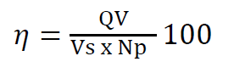Overall Efficiency: ----(8)

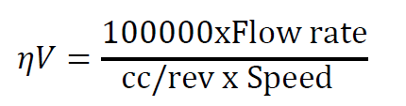

* Volumetric efficiency: ----(9)

**Results**

*Table (1): Data collected from the centrifugal pump apparatus (Flow Rate, inlet and outlet pressures, Voltage, Current, and driving force).*

|  |  |  |  |  |  |  |  |
| --- | --- | --- | --- | --- | --- | --- | --- |
| **Run** | **Q (L.P.S)** | **P1 (bar)** | **P2 (bar)** | **Voltage (V)** | **Current**  **(A)** | **F (N)** | **Q (L.P.M)** |
| 1 | 0 | 0 | 1.8 | 180 | 3 | 8 | 0 |
| 2 | 1 | 0 | 1.7 | 170 | 4 | 12.5 | 60 |
| 3 | 2 | 0 | 1.6 | 175 | 5 | 15.5 | 120 |
| 4 | 3 | 0 | 1.4 | 178 | 6 | 19 | 180 |
| 5 | 4 | -0.015 | 1 | 180 | 7 | 21 | 240 |
| 6 | 5 | -0.019 | 0.38 | 181 | 7.5 | 24 | 300 |

*Table (2): Calculations for the Centrifugal pump apparatus (Electric power, Mechanical Power, Hydraulic Power, Hydraulic Head, and efficiency).*

|  |  |  |  |  |  |
| --- | --- | --- | --- | --- | --- |
| **Run** | **Pelec (watt)** | **Pmech (watt)** | **Phydr (watt)** | **Head (m)** | **efficiency η** |
| 1 | 540 | 345.40 | 0 | 18.35 | 0 |
| 2 | 680 | 539.69 | 170 | 17.33 | 0.25 |
| 3 | 875 | 669.21 | 320 | 16.31 | 0.3656 |
| 4 | 1068 | 820.33 | 420 | 14.27 | 0.3933 |
| 5 | 1260 | 906.68 | 406 | 10.35 | 0.3222 |
| 6 | 1357.5 | 1036.20 | 199.5 | 4.07 | 0.1461 |
|  |  |  |  |  | *0.2464* |

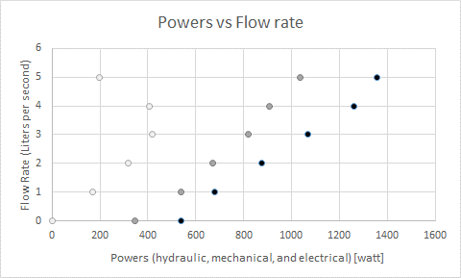

Figure (1): [Hydraulic *“white”*, Mechanical *“grey”,* and Electrical *“Black”* Power (watt)] Vs. Flow Rate (liters per second).

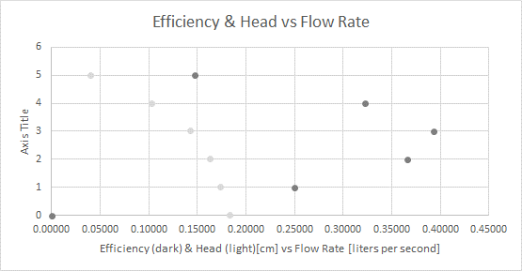

Figure (2): Efficiency *“dark”* and Hydraulic Head *“light”* (cm) Vs. Flow Rate (liters per second).

*Table (3): Collected data from the Positive Displacement Pump, maintaining constant speed.*

|  |  |  |  |  |  |  |
| --- | --- | --- | --- | --- | --- | --- |
| **Speed** | **Torque** | **Power** | Inlet Pressure P1 | Delivery Pressure P2 | Oil Temperature T1 | **Flow Rate** |
| (rev.min-1) | **(Nm)** | **(W)** | **(bar)** | **(bar)** | **(°C)** | (L.min-1) |
| 1602 | 0.84 | 141 | 0.22 | 2.0 | 20.2 | 10.9 |
| 1599 | 1.02 | 170 | 0.22 | 3.0 | 20.5 | 10.8 |
| 1602 | 1.37 | 229 | 0.22 | 4.0 | 20.5 | 10.7 |
| 1599 | 1.30 | 218 | 0.22 | 5.0 | 20.5 | 10.7 |
| 1600 | 1.43 | 240 | 0.23 | 6.0 | 20.6 | 10.7 |
| 1599 | 1.54 | 258 | 0.22 | 7.0 | 20.6 | 10.6 |
| 1603 | 1.64 | 276 | 0.22 | 7.9 | 20.8 | 10.6 |
| 1602 | 1.74 | 293 | 0.22 | 9.0 | 20.9 | 10.6 |
| 1600 | 1.85 | 311 | 0.23 | 10.3 | 20.9 | 10.5 |
| 1598 | 1.95 | 326 | 0.22 | 11.0 | 21.0 | 10.4 |
| 1599 | 2.04 | 341 | 0.23 | 12.3 | 21.0 | 10.4 |
| 1600 | 2.11 | 354 | 0.23 | 13.0 | 20.9 | 10.3 |
| 1599 | 2.18 | 365 | 0.23 | 14.0 | 21.0 | 10.3 |
| 1598 | 2.24 | 375 | 0.22 | 14.9 | 21.2 | 10.3 |

*Table (4): Calculated data from the Positive Displacement Pump, maintaining constant speed.*

|  |  |  |  |  |
| --- | --- | --- | --- | --- |
| **Pressure Difference** | **Expected Flow Rate** | **Hydraulic Power** | **Overall Efficiency** | **Volumetric Efficiency** |
| **(bar)** | (L.min-1) | **(W)** | **(%)** | **(%)** |
| 1.8 | 11.45 | 32 | 22.7 | 95.2 |
| 2.8 | 11.43 | 50 | 29.4 | 94.5 |
| 3.8 | 11.45 | 67 | 29.3 | 93.4 |
| 4.8 | 11.43 | 85 | 39.0 | 93.6 |
| 5.8 | 11.44 | 103 | 42.9 | 93.5 |
| 6.8 | 11.43 | 120 | 46.5 | 92.7 |
| 7.7 | 11.46 | 136 | 49.3 | 92.5 |
| 8.8 | 11.45 | 155 | 52.9 | 92.5 |
| 10.1 | 11.44 | 176 | 56.6 | 91.8 |
| 10.8 | 11.43 | 187 | 57.4 | 91.0 |
| 12.1 | 11.43 | 209 | 61.3 | 91.0 |
| 12.8 | 11.44 | 219 | 61.9 | 90.0 |
| 13.8 | 11.43 | 236 | 64.7 | 90.1 |
| 14.7 | 11.43 | 252 | 67.2 | 90.1 |

*Table (5): Collected data from the Positive Displacement Pump, maintaining constant Delivery Pressure.*

|  |  |  |  |  |  |  |
| --- | --- | --- | --- | --- | --- | --- |
| **Speed** | **Torque** | **Power** | Inlet Pressure P1 | Delivery Pressure P2 | Oil Temperature T1 | **Flow Rate** |
| (rev.min-1) | **(Nm)** | **(W)** | **(bar)** | **(bar)** | **(°C)** | (L.min-1) |
| 1602 | 0.84 | 141 | 0.22 | 2.0 | 20.2 | 10.9 |
| 1598 | 2.23 | 374 | 0.23 | 15.1 | 21.1 | 10.2 |
| 1500 | 2.29 | 359 | 0.22 | 15.0 | 21.1 | 10.0 |
| 1397 | 2.28 | 333 | 0.23 | 15.3 | 21.4 | 9.5 |
| 1298 | 2.25 | 306 | 0.23 | 15.0 | 21.5 | 8.9 |
| 1201 | 2.21 | 278 | 0.21 | 15.1 | 21.6 | 8.4 |
| 1100 | 2.21 | 255 | 0.21 | 15.2 | 21.7 | 7.5 |
| 997 | 2.09 | 218 | 0.21 | 14.9 | 21.8 | 6.2 |
| 887 | 2.44 | 227 | 0.23 | 18.2 | 22.0 | 5.9 |

Table (6): Calculated data from the Positive Displacement Pump, maintaining constant Delivery Pressure.

|  |  |  |  |  |
| --- | --- | --- | --- | --- |
| **Pressure Difference** | **Expected Flow Rate** | **Hydraulic Power** | **Overall Efficiency** | **Volumetric Efficiency** |
| **(bar)** | (L.min-1) | **(W)** | **(%)** | **(%)** |
| 14.9 | 11.43 | 253 | 67.6 | 89.3 |
| 14.8 | 10.72 | 246 | 68.5 | 93.2 |
| 15.1 | 9.99 | 239 | 71.8 | 95.1 |
| 14.8 | 9.28 | 219 | 71.6 | 95.9 |
| 14.9 | 8.59 | 208 | 74.8 | 97.8 |
| 15.0 | 7.86 | 187 | 73.3 | 95.4 |
| 14.7 | 7.13 | 152 | 69.7 | 87.0 |
| 18.0 | 6.34 | 177 | 78.0 | 93.0 |

**Discussion of Results**

As discussed in the Abstract, it is needed to find out the efficiencies in each type of pumps. The tables in the Results sections shows that Positive Displacement Pumps (Average Efficiency 50-70%) had better working efficiencies than the Centrifugal Pumps (Average Efficiency 25%). This outcome was expected since positive displacement pumps are better and more regulated than the centrifugal because of its working mechanism.

Table (1) and (2) demonstrate the calculations and data for the centrifugal pump, by using these data sets, Graph (1) and Graph (2) where plotted. Those two graphs helped us to spot that Run No. 6 is way out of order, so we can consider it a blunder and ignore it! This value had a very negative effect on the final values we have gotten in order to compare with other pumps.

After correcting the fore-mentioned value, the average efficiency of the centrifugal will become 33%. This is a worth mentioning change that should be notice. Not to forget, that in the positive displacement pump the operation was almost full computerized, unlike in the centrifugal pump apparatus where the margin of human error is so high.

Tables (3) and (4) show us the results when maintaining a constant speed of the discharge water. This also means a constant flow rate but a fluctuating delivering pressure. Conversely, Table (5) and (6) demonstrate the results when a constant delivery pressure was maintained. Here, the velocity and flow rate are variable but it’s clearly noticed that the efficiencies had a rich increase comparing to the constant speed trial.

Hence, Positive Displacement Pumps provide better performance when a constant pressure is required, and an okay performance at constant flow rates because of the pulsations generated of trapping and releasing amounts of water.

Some observable relationships shown by figures are: Hydraulic Head and flow rate (inversely proportional), Power and flow rate (directly proportional), and efficiency with flow rate.

**Conclusion**

There are so many pumps that can get the job done for you, but the question hovering is which one to use? The answer depends on the purpose you are using the pump for, the type of system you have, and the budget you have. The following figure shows a small comparison between 4 types of pumps with their specification to help choose the proper one.



Figure (3): *Piston*, *Gear*, *Vane*, and *Swash-plate* pumps comparison table by pulsation, cost, efficiency, ability to pump solids, damage to fluid possibility, and required level of maintenance*.*

**Applications**

Delivering water from a point to another point that has higher energy. Most common in Drinking water distribution in cities and buildings. Also, it is used where high water pressures are needed.

**References**

1. Lab Manual.
2. Attached Data Sheet,