

Birzeit University-Faculty of Engineering and Technology

Electrical and Computer Engineering Department
Electrical Machines ENEE [2408]

MatLab Assignment about Induction Motors – Fall [2024]

Prepared by :

Name: Yousef Jarabaa

ID: [ 1211211 ]

Instructor : Dr. Muhammad Abu-Khaizaran.

Section:[ 1 ]

TABLE OF FIGURE
Figure 1 :Induction motor 5
Figure 2 :Part of Induction motor 5
Figure 3 :Stator Figure 4:Stator& Rotor 6
Figure 5 :Rotor 7
Figure 6 :Squirrel–Cage&Wound Rotor Induction Motor 7
Figure 7 :Slip Rings on the rotor Figure 8:Rotor's circit 8
Figure 9 : Equivalent circuit of induction motor 10
Figure 10 :per-phase equivalent circuit of an Induction motor 11
Figure 11 : the magnetization curves between Induction motor and ordinary transformer 12
Figure 12 : Power Losses and Power-Flow Diagram 13
Figure 13 : Characteristics of Torque-Speed Curves 15
Figure 14 A:pconv VS S 18
Figure 15 A:Torque VS S 19
Figure 16 A: Torque vs speed 20
Figure 17 : Torque motor and generator vs. speed 20
Figure 18 : THREE REGION CURVE 21
Figure 19 : Current vs s and speed 24
Figure 20 : Torqind vs speed when voltage change 28
Figure 21 : torqind vs slip when voltage change 28
Figure 22 : power converted vs slip when voltage change 29
Figure 23 : Torqload vs speed When R2 change 35
Figure 24 : torqind vs slip when R2 change 35
Figure 25 : power converted vs slip when R2 change 36
Figure 26 : [Torqind & torqload] vs slip when voltage change 43
Figure 27 : Torqind vs speed when voltage change 43
Figure 28 : Torq=(0.02*w^2) vs slip when R2 different 48
Figure 29 :Torq=(0.02*w^2) vs speed when R2 different 48
Figure 30 :Torqueload= 300 vs Slip for Voltage Changes 53
Figure 31 : Torqueload= 300 vs Speed for Voltage Changes 53
Figure 32 :Torqload=[300] vs Slip for a different R2 values 57
Figure 33 ::Torq=[300N.M ] vs SPEED for a different R2 values 57
Figure 34 : Input current vs [s] with Torqload at voltage change 61
Figure 35 : : Input current vs speed with Torqload at voltage change 61

Introduction:

Induction motor: [A Synchronous motor] is an alternating current [AC] motor in which the electric current required to produce torque in a rotor is induced by electromagnetic induction from the stator's magnetic field. In addition to not needing physical electrical connections such as brushes or slip rings, this makes the motor durable, low-maintenance and most common for easy handling.
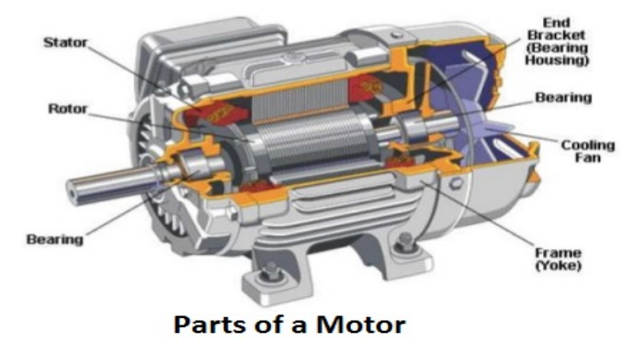
Figure 1:Induction motor

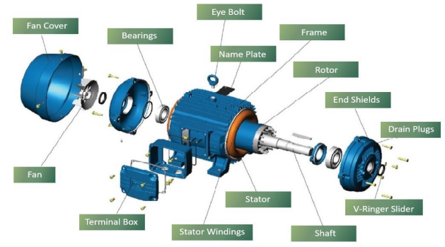
Figure 2:Part of Induction motor

Theory:
The induction motor [A Synchronous motor] has two main parts stator and rotor, as the stator is like a synchronous machine but different in the construction of the rotor. There are two types of rotors: (squirrel-cage) rotor and (wound) rotor. While wound rotors provide flexibility, they are more expensive and require higher maintenance due to brush wear. Thus, cage rotors are more common, preferred for their simplicity and reliability is consists of two main parts:

- Stator:
It is the stationary part and is composed of three sets of windings distributed in the stator slots and displaced 120° (electrical) in space. Its stator is the same as that of a Synchronous machine. However, the rotor is different.

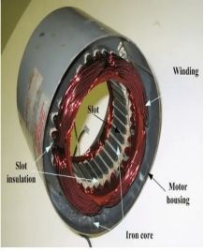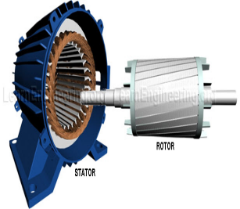
Figure 3:Stator Figure 4:Stator& Rotor

2-Rotor :
It is the rotating part and consists of a stack of insulated laminations. There are two types of Induction motors according to rotor’s construction
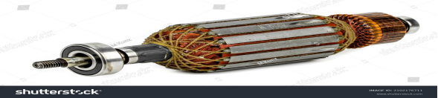
Figure 5:Rotor

- Squirrel–Cage Induction Motor
It consists of a series of conducting bars laid into slots carved in the face of the rotor and shorted at either end by large shorting rings. The conductors are carved in an iron core, as illustrated in the Figure below.

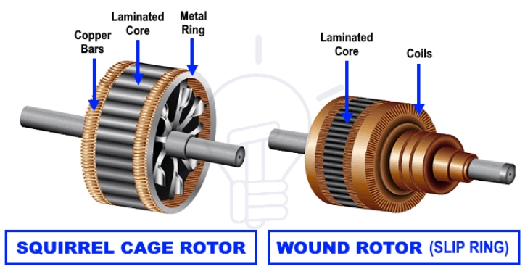
Figure 6:Squirrel–Cage&Wound Rotor Induction Motor

- Wound Rotor Induction Motor:
It has three sets of three phase windings that are mirror images of stator windings. The rotor windings are usually Y-connected, with their terminals tied to Slip Rings on the rotor shaft, and shorted via Brushes.

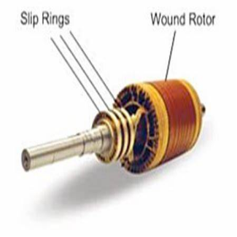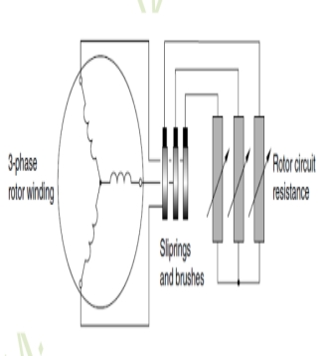
Figure 7:Slip Rings on the rotor Figure 8:Rotor's circit

Basic Induction Motor Concepts:
In the squirrel cage rotor, The windings are connected by a three-phase voltage, which produces three-phase currents
. As a result, a uniform rotating magnetic field (Bs), and the rotation speed of the stator magnetic field (Bs) is:

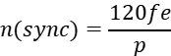
where,
Fe :electrical frequency in[ Hz].
P: is number of poles.
N(sync) : is synchronous speed in [rpm].

The Concept of Rotor Slip:
The voltages and currents induced in the rotor of the induction motor depend on the speed of the rotor relative to the magnetic fields., "slippage" is determined from the following equations:

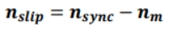
Where :
n(slip): is the slip speed of the machine.
n(sync): is the synchronous speed.
N(m): is the mechanical speed of the motor shaft (rotor).

The Slip (s): is the relative speed expressed in per unit or as a percentage of synchronous speed.

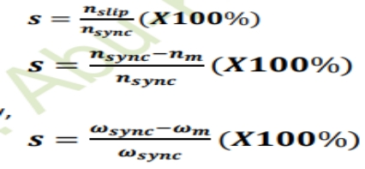
If S = 0, then the rotor turns at synchronous speed
If S = 1, then the rotor is stationary or blocked ,stall condition!

Equivalent circuit of induction motor:
The equivalent circuit for each phase of the induction motor is shown in the figure below.
It resembles a transformer circuit, but with its short-circuit secondary terminals. Hence, the induction motor is called
Rotary transformer.
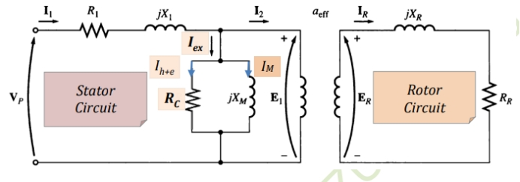
Figure 9: Equivalent circuit of induction motor

the final per-phase equivalent circuit of an Induction motor is:
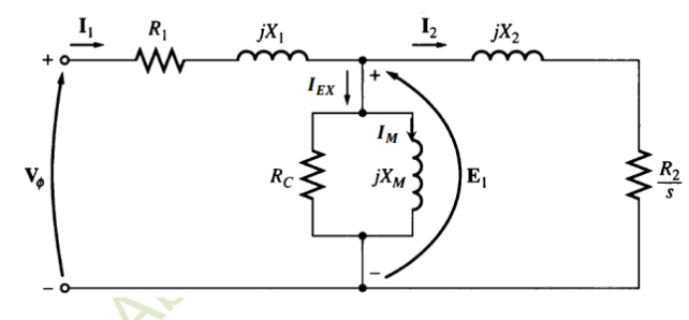
Figure 10:per-phase equivalent circuit of an Induction motor

Where:

Vp: is the RMS value of the phase voltage applied to stator windings .
R1: the stator windings resistance.
Rr: the rotor bars (windings) resistance .
Rc: the core losses resistance (a resistance accounting for eddy current and hysteresis losses)
Xm: the magnetizing inductance.
X1: the stator leakage reactance .
X2: the rotor leakage reactance.

A comparison between the magnetization curves of an Induction motor and an ordinary transformer is shown in the Figure below.

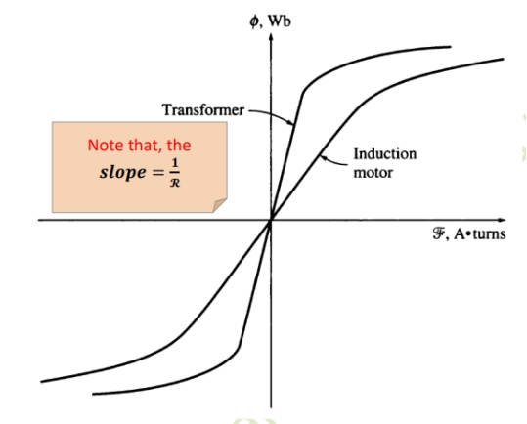
Figure 11: the magnetization curves between Induction motor and ordinary transformer

Power and Torque in Induction Motors
Power Losses and Power-Flow Diagram:
The induction motor can be described as a short-circuit winding secondary rotor transformer. Therefore, there is no electrical output power. Instead, the output power is
Mechanical. The power flow diagram of the induction motor is:

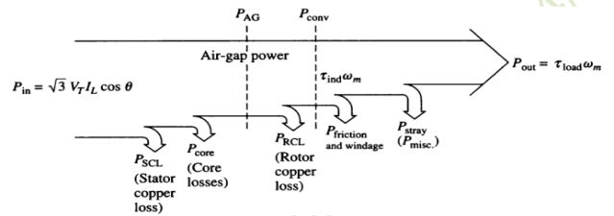
Figure 12: Power Losses and Power-Flow Diagram

Pin = (3*vl)*IL*cos(θ) # Power Input
Pscl = 3*(abs(Ieq)^2)*R1 #Stator Core Loss
Pag=Pin-Pscl #Air Gap Power
Prcl= s*Pag # Core Loss
pconv=(1-s)*Pag # Conversion Power
Pout = Pin - (pconv) #Output Power
Torqind = pconv/wm #Induced Torque
Pout = T(load)*w(m) #Output Power

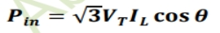
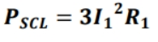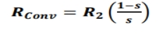
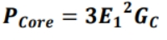
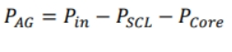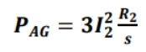
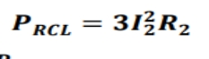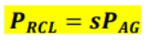
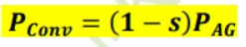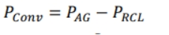
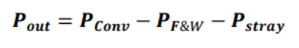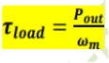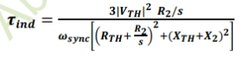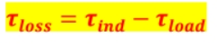

Characteristics of Torque-Speed Curves of an Induction Motor

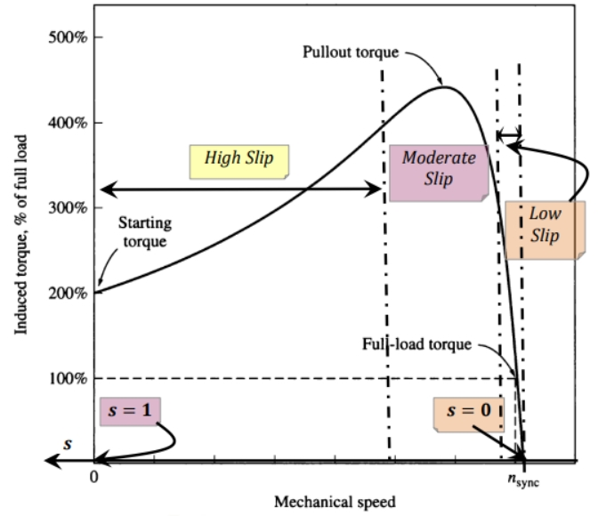
Figure 13: Characteristics of Torque-Speed Curves

For all parts next:
$$s=\frac{ns−nm}{ns}$$

when
(Slip S>0 ): Motor Mode ns>nm

(Slip S<0 ): Generator Mode nm>ns

Solving Problems PART {Code, plots, discussion and explanation of results}:

- Show the torque plot versus speed and also the torque versus “s” at rated voltage, also show the converted output power versus slip.

Code:
%yousef jarabaa #1211211
p=10;
vL=380;%v
fe=50;%Hz
vph=vL/sqrt(3);%v
s= -1.0013: 0.002 :2.0013;
Xm=80*i;
x1=0.25*i;
x2=0.3*i;
R1=0.03+(0.06*1); %ohm
R2=0.04+(0.07*1); %ohm

ns=(120.*(fe))./p; %rpm
nm=(1-s).*ns; %rpm
ws=(ns.*2.*pi)./60; %Rad/sec
wm =(1-s).*ws; %Rad/sec
fr=(s.*fe);% [hz]
R2s=(R2)./(s); %ohm
z1 = (R2s)+x2; % (jx2)[ohm]
z2 = (z1.*Xm)./(z1+Xm); % [ohm]
Zeq= x1 + R1+ z2 ; %ohm
Iph = vph./ Zeq; % [amp]
IL = Iph;% [amp]

Pin = (3.*vph).*(abs(Iph)).*(cos(phase(Iph))); % [w]
Pscl = 3.*(abs(Iph).^2)*R1; % [w]
pcore =0; % [w]
PAg=Pin-Pscl- pcore; % [w]
Prcl=( s.* PAg); % [w]
pconv=((1-s).*PAg); % [w]
Pfw = 0; %[w]
Pstray = 0; %[w]
Pout = Pin - pconv - Pfw -Pstray; % [w]

Torqind = pconv./wm ; % [N.M]
Torqload = Pout./wm ; % [N.M]
Torqloss = Torqind - Torqload ; % [N.M]

figure
plot(nm,Torqind) ;
title(' Torque vs speed by YAAJ');
xlabel('rad/s');
ylabel('N.M');
grid on

figure
plot(s,Torqind) ;
title(' Torque VS S by YAAJ');
xlabel('Slip');
ylabel('N.M');
grid on

figure
plot(s,pconv) ;
title(' pconv VS S by YAAJ ');
xlabel('slip');
ylabel('W')
grid on

PLOT [A]

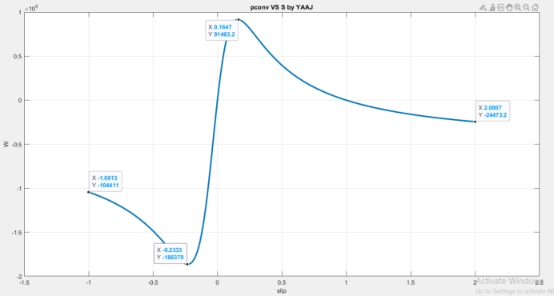
Figure 14A:pconv VS S

This graph represents the relationship between s and pconv where we notice that when s = 0 the power is equal to zero and also when s = 1 the power is equal to zero according to the following law:
When S=1 $→$
the rotor were turning at synchronous speed, then the rotor bars would be stationary relative to the stator magnetic field Bs, and there would be no induced voltage, no rotor current and hence no Br , the torque induced is 0 and the rotor slows down as a result of friction. Induction motor speeds up to near synchronous speed, but never reaches it.
$p\left(conv\right)=pAG(1−S)$ $→ =0$

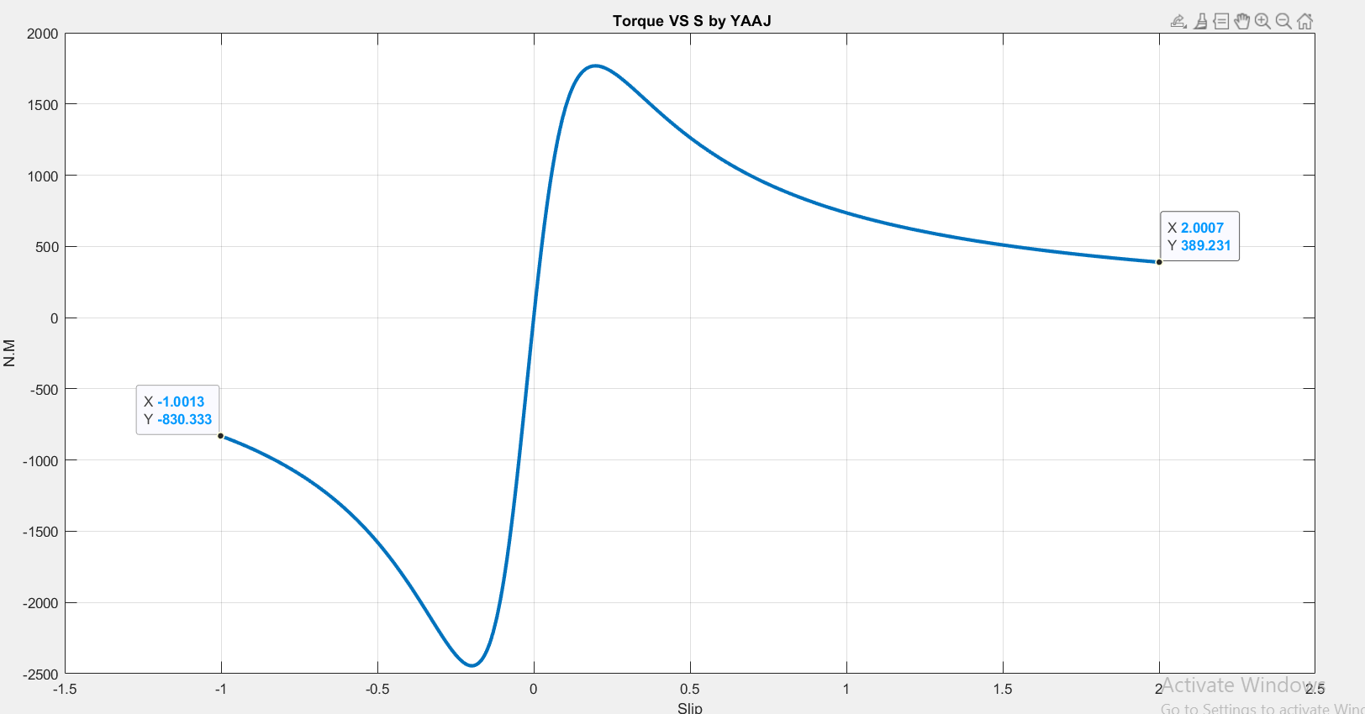
Figure 15A:Torque VS S

This graph represents the relationship between s and Torque ind where we notice that when s = 0 the Torqe ind is equal to zero according to the following law:
When S=1 $→$
$R\left(conv\right)=\frac{R2\left(1−S\right)}{S}$ =0 $→$ $P\left(AG\right)=\frac{3I^{2}R\left(conv\right) }{S}=0$

$→$ $τ\left(ind\right)=\frac{P(AG)}{ws}=τ\left(ind\right)=\frac{P(AG)}{ws}=\frac{\left(0\right)}{ws}=0$

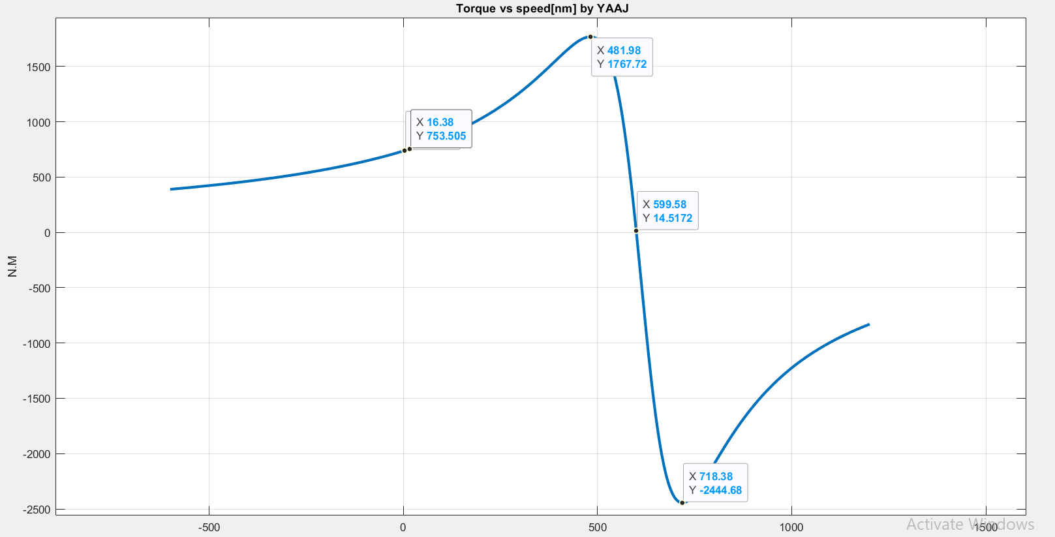
Figure 16A: Torque vs speed

When looking well, we can evaluate the chart into two main parts, which are when it is a motor or when it works as a generator, and each part we divide it into 3 parts.

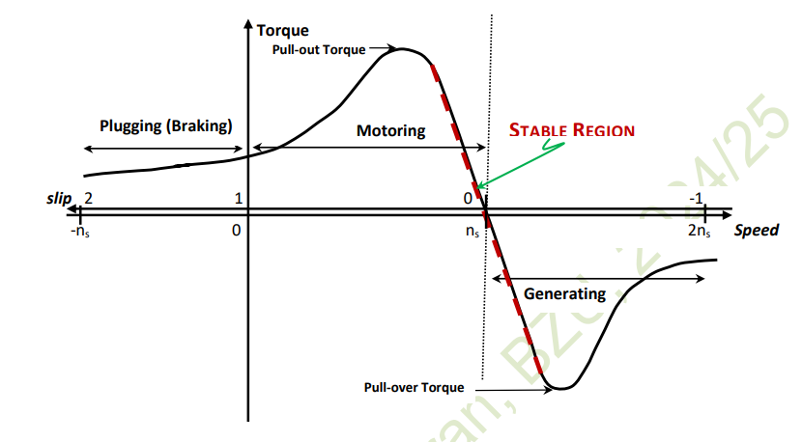
Figure 17: Torque motor and generator vs. speed

, but I will talk about the motor’s part as follows:

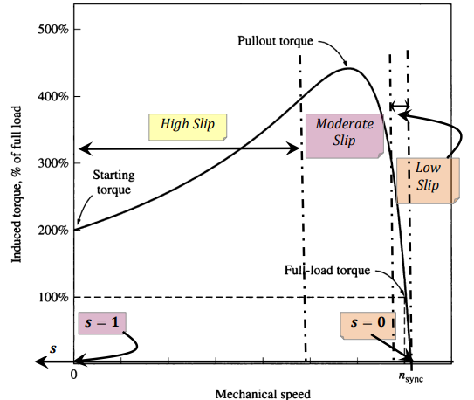
Figure 18: THREE REGION CURVE

- Low Slip Region : The motor slip increases linearly with load and the motor speed decreases linearly with load and Rotor current increases linearly with slip.

- Moderate Slip Region: The peak (Pullout) torque occurs at the point where, for an incremental increase in the load, the increase in the rotor current is exactly balanced by the decrease in the rotor power factor.

- High Slip Region : The induced torque decreases with increasing the load (increasing the slip), because the increase in rotor current is overshadowed by the decrease in the rotor power factor and this is unstable region and typically, Pullout torque is 200% to 300% of full (rated) load torque The starting torque( nsync=0)is 150% to 200%. Therefore, the Induction motor can start with full load attached to its shaft.
From figure approximate:

Start Turqe =753.5 N.M
Pullout torqe =1767.72 N.M
IF WE Divide $\frac{ Pullout torqe }{Start Turqe}→\frac{1767.7}{753.5}=235$

$→$ Pullout torque is $235\%$ from The starting torque [ 200%<235%<300%]
*The starting torque is slightly higher than its full load torque.

b-Show the Input current plot versus speed and also the input current versus “s” at rated voltage.

Code:
%yousef jarabaa #1211211
p=10;
vL=380;%v
fe=50;%Hz
vph=vL/sqrt(3);%v
s= -1.0013: 0.002 :2.0013;
Xm=80*i;
x1=0.25*i;
x2=0.3*i;
R1=0.03+(0.06*1); %ohm
R2=0.04+(0.07*1); %ohm

ns=(120.*(fe))./p; %rpm
nm=(1-s).*ns; %rpm
ws=(ns.*2.*pi)./60; %Rad/sec
wm =(1-s).*ws; %Rad/sec
fr=(s.*fe);% [hz]
R2s=(R2)./(s); %ohm
z1 = (R2s)+x2; % (jx2)[ohm]
z2 = (z1.*Xm)./(z1+Xm); % [ohm]
Zeq= x1 + R1+ z2 ; %ohm
Iph = vph./ Zeq; % [amp]
IL = Iph;% [amp]

Pin = (3.*vph).*(abs(Iph)).*(cos(phase(Iph))); % [w]
Pscl = 3.*(abs(Iph).^2)*R1; % [w]
pcore =0; % [w]
PAg=Pin-Pscl- pcore; % [w]
Prcl=( s.* PAg); % [w]
pconv=((1-s).*PAg); % [w]
Pfw = 0; %[w]
Pstray = 0; %[w]
Pout = Pin - pconv - Pfw -Pstray; % [w]

Torqind = pconv./wm ; % [N.M]
Torqload = Pout./wm ; % [N.M]
Torqloss = Torqind - Torqload ; % [N.M]

figure
subplot(2,1,1);
plot(nm, abs(Iph),'LineWidth', 2.5);
title('Input current vsspeed[I VS nm] by YAAJ ');
xlabel('rad/s');
ylabel('Amp');
subplot(2,1,2);
plot(s, abs(Iph),'LineWidth', 2.5);
title('Input current [Iph] VS S by YAAJ');
xlabel('slip');
ylabel('Amp');

PLOT [b]

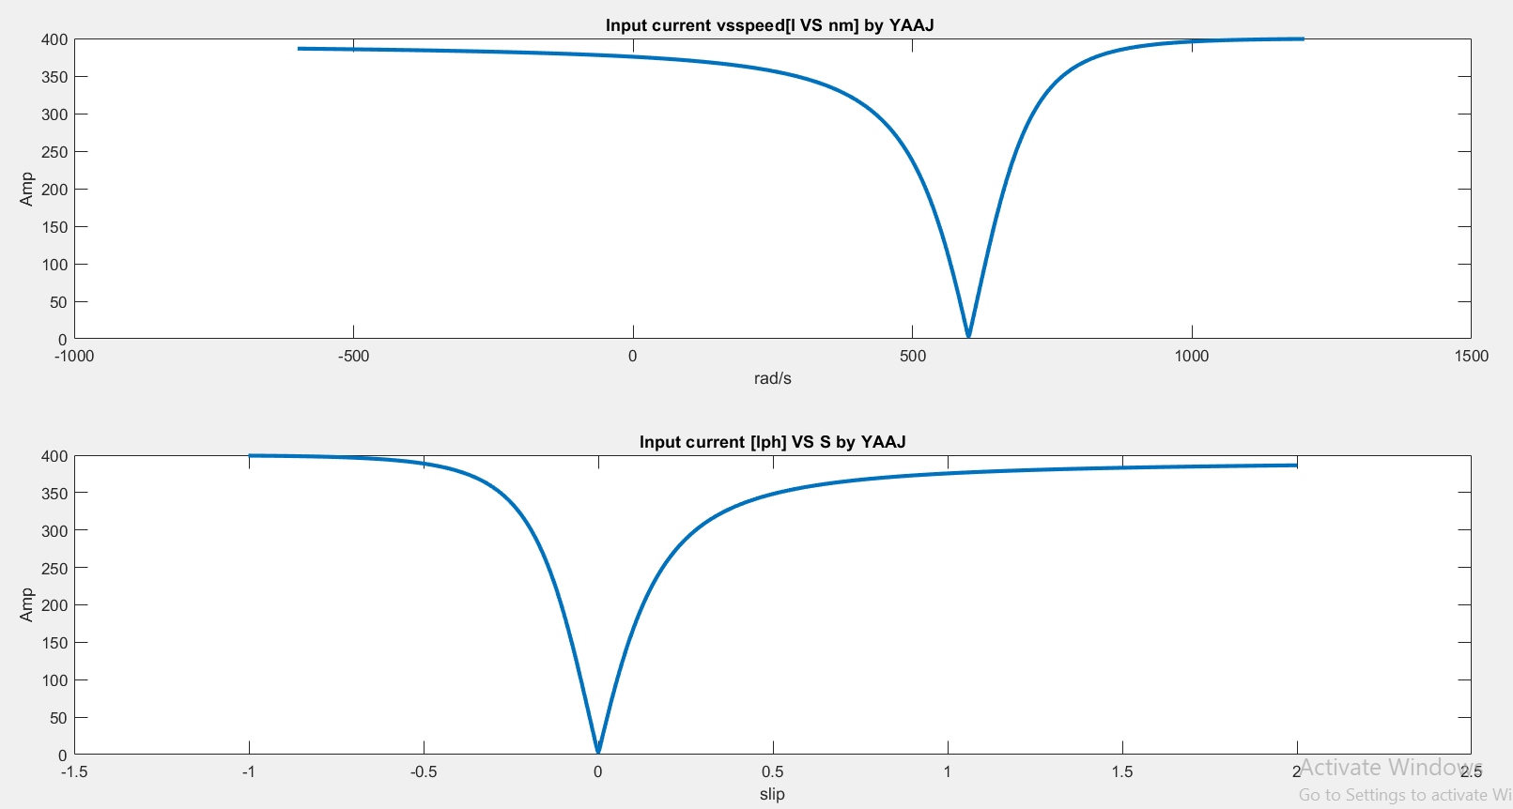
Figure 19 : Current vs s and speed

From the graph, it is clear that the input current and velocity have a nonlinear relationship. The input current decreases as the speed increases until a certain point after that the current increases with increasing speed. We see that the current remains positive for both positive and negative velocities, which means that energy flows from the source to the load depending on the direction of rotation.

$$s=\frac{ns−nm}{ns}$$
when
(Slip S>0 ): Motor Mode ns>nm

(Slip S<0 ): Generator Mode nm>ns

C- Repeat a) for VLL reduced to 90% of rated VLL, 75%, 60%, 45% then to 25% of rated voltage (show plots on the same figure)

Code:
%yousef jarabaa #1211211
p=10;
vL=380;%v
fe=50;%Hz
vph=vL/sqrt(3);%v
s= -1.0013: 0.002 :2.0013;
Xm=80*i;
x1=0.25*i;
x2=0.3*i;
R1=0.03+(0.06*1); %ohm
R2=0.04+(0.07*1); %ohm

ns=(120.*(fe))./p; %rpm
nm=(1-s).*ns; %rpm
ws=(ns.*2.*pi)./60; %Rad/sec
wm =(1-s).*ws; %Rad/sec
fr=(s.*fe);% [hz]
R2s=(R2)./(s); %ohm
z1 = (R2s)+x2; % (jx2)[ohm]
z2 = (z1.*Xm)./(z1+Xm); % [ohm]
Zeq= x1 + R1+ z2 ; %ohm
Iph = vph./ Zeq; % [amp]
IL = Iph;% [amp]

Pin = (3.*vph).*(abs(Iph)).*(cos(phase(Iph))); % [w]
Pscl = 3.*(abs(Iph).^2)*R1; % [w]
pcore =0; % [w]
PAg=Pin-Pscl- pcore; % [w]
Prcl=( s.* PAg); % [w]
pconv=((1-s).*PAg); % [w]
Pfw = 0; %[w]
Pstray = 0; %[w]
Pout = Pin - pconv - Pfw -Pstray; % [w]

Torqind = pconv./wm ; % [N.M]
Torqload = Pout./wm ; % [N.M]
Torqloss = Torqind - Torqload ; % [N.M]

vLL=[vL* 0.9;
vL*0.75;
vL*0.60;
vL*0.40;
vL*0.25];
vTh = vLL./sqrt(3);
for i = 1:size(vLL)
[pconv_vL,Torqind_vL]=Torqind_vL_change(vLL(i),vTh(i),s,p,fe,Xm,x1,x2,R1,R2,ns,ws,wm,nm,R2s);
plot(nm,Torqind_vL,'LineWidth', 2.5);
hold on
grid on
end
title('Torqind vs speed voltages change by YAAJ');
xlabel('rad/s');
ylabel('N.M');
legend('V90%','V75%','V60%','V40%','V25%');
figure
for i = 1:size(vLL)
[pconv_vL,Torqind_vL]=Torqind_vL_change(vLL(i),vTh(i),s,p,fe,Xm,x1,x2,R1,R2,ns,ws,wm,nm,R2s);
plot(s,Torqind_vL,'LineWidth', 2.5);
hold on
grid on
end
title('Torqind vs slip volteges cahnge by YAAJ ');
xlabel('slip');
ylabel('N.M');
legend('V90%','V75%','V60%','V40%','V25%');
figure
for i = 1:size(vLL)
[pconv_vL, Torqind_vL]=Torqind_vL_change(vLL(i),vTh(i),s,p,fe,Xm,x1,x2,R1,R2,ns,ws,wm,nm,R2s)
plot(s,pconv_vL,'LineWidth', 2.5);
hold on
grid on
end
title('Pconv vs speed volteges change by YAAJ ');
xlabel('slip');
ylabel('w');
legend('V90%','V75%','V60%','V40%','V25%');
function [ pconv_vL,Torqind_vL ]=Torqind_vL_change(vL,vo,s,p,fe,Xm,x1,x2,R1,R2,ns,ws,wm,nm,R2s);

z1=(R2s)+x2;
z2=(z1.*Xm)./(z1+Xm);
Zeq=(x1+ R1+ z2) ;
IL =(vo./Zeq);
I2 =(IL .* Xm )./(Xm+z1);
Pin =(sqrt(3).*vL).*abs(IL).*cos(phase(IL));
Pscl = 3.*(abs(IL).^2)*R1;
pcore =0; % [w]
PAg= Pin-Pscl- pcore; % [w]
Prcl= s.*PAg;
pconv_vL=(1-s).*PAg;
Pfw = 0; %[w]
Pstray = 0; %[w]
Pout_vl = Pin-pconv_vL - Pfw -Pstray;
Torqind_vL = pconv_vL./wm ;
end

PLOT [c]

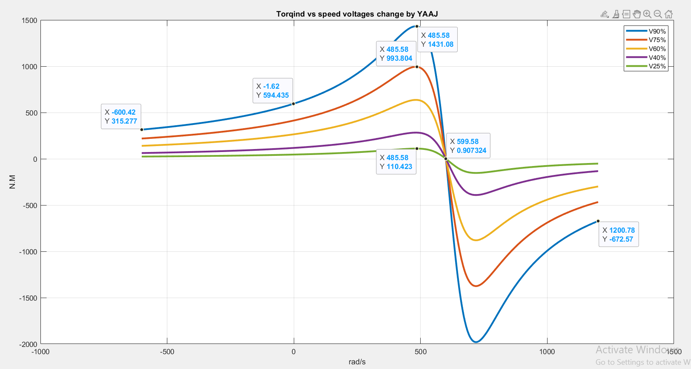
Figure 20: Torqind vs speed when voltage change

Here the maximum turq =1431 when speed = 486 and at maximum voltage

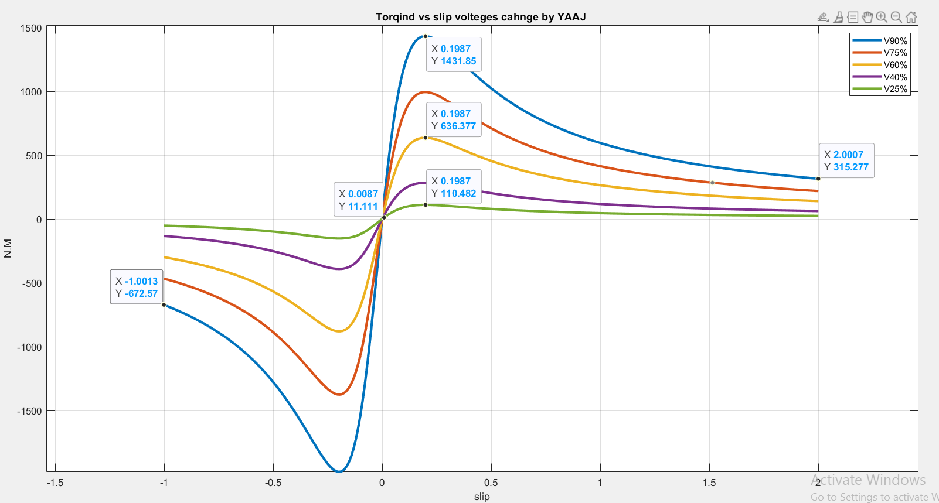
Figure 21: torqind vs slip when voltage change

Here the maximum turq =1431 when s = 0.1987 and at maximum voltage

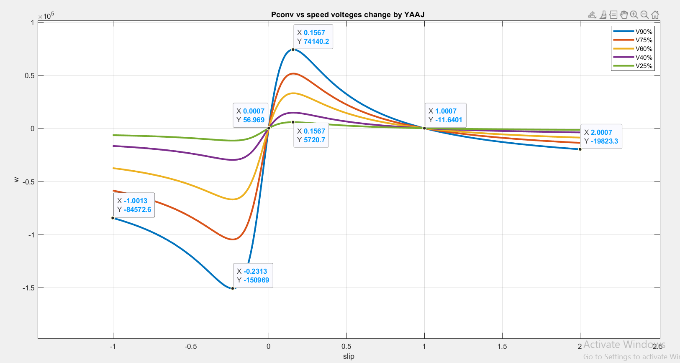
Figure 22: power converted vs slip when voltage change

Here the maximum converted power =741 when s = 0.1987 and at maximum voltage

The first figure show the relation between torque and speed at for different values of the input voltage, since the torque decreases by decreasing the voltage.
The latter also decreases, since the torque is proportional to voltage squared, and speed relational from this equation the maximum torque:
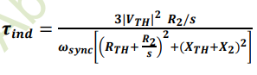
Torqind = pconv/ wm
Wm =(1-s) ws
From figure [ 3 ],as part A, This graph represents the relationship between s and pconv where we notice that when s = 0 the power is equal to zero and also when s = 1 the power is equal to zero according to the following equation:
When S=1 $→$ the rotor is stationary or at standstill, the term (1−𝑠) equals zero, and the converted power is zero because no mechanical power is being produced.
$p\left(conv\right)=pAG(1−S)$ $→ =0$

From figure [2& 3 ]
When ( s = 0 ), the relative velocity between the rotating magnetic field and the rotor is zero. This indicates a lack of relative movement, resulting in no induced electromotive force (EMF) in the rotor and, accordingly, no current flow in the rotor windings. Without current in the rotor windings, no torque is generated, as a result, energy from the electrical form to the mechanical form is not converted, and At pconv versus velocity when the rotor rotates at synchronous speed, we have fr - fe = 0 when s = 1. The rotor is closed, indicating that fr = fe, and when we reduce the voltage, the conversion power will decrease. This is because a lower voltage results in less energy being converted. Additionally, we can obtain motor power even before reaching zero since it operates as a generator. The force will be positive at the rear because it functions as a motor.

D- Repeat a) for R2 (the one you have calculated based on your ID) increased to have every time one of the following values: R2, 1.6*R2, 2.1*R2, 3*R2, 9*R2, 13*R2, 20*R2 and 40R2 (show plots on the same figure)

Code:

%yousef jarabaa #121.121.1
p=10;
vL=380;%v
fe=50;%Hz
vph=vL/sqrt(3);%v
s= -1.0013: 0.002 :2.0013;
Xm=80*i;
x1=0.25*i;
x2=0.3*i;
R1=0.03+(0.06*1); %ohm
R2=0.04+(0.07*1); %ohm

ns=(120.*(fe))./p; %rpm
nm=(1-s).*ns; %rpm
ws=(ns.*2.*pi)./60; %Rad/sec
wm =(1-s).*ws; %Rad/sec
fr=(s.*fe);% [hz]
R2s=(R2)./(s); %ohm
z1 = (R2s)+x2; % (jx2)[ohm]
z2 = (z1.*Xm)./(z1+Xm); % [ohm]
Zeq= x1 + R1+ z2 ; %ohm
Iph = vph./ Zeq; % [amp]
IL = Iph;% [amp]

Pin = (3.*vph).*(abs(Iph)).*(cos(phase(Iph))); % [w]
Pscl = (3.*(abs(Iph).^2)*R1); % [w]
pcore =0; % [w]
PAg=Pin-Pscl- pcore; % [w]
Prcl=( s.* PAg); % [w]
pconv=((1-s).*PAg); % [w]
Pfw = 0; %[w]
Pstray = 0; %[w]
Pout= Pin- pconv - Pfw -Pstray; % [w]

Torqind = Pconv ./ wm; % [N.m]
Torqload = Pout./wm ; % [N.M]
Torqloss = Torqind - Torqload ; % [N.M]

torques(idx, :) = Torqind;
outputs(idx, :) = Pconv;

figure;
hold on;
for idx = 1:length(R2_factors)
if R2_factors(idx) == 40
plot(s, torques(idx, :), 'k','LineWidth',2,'DisplayName', ['R2 x ' num2str(R2_factors(idx))]);
else
plot((1 - s) .* ws,torques(idx, :),'LineWidth', 2, 'DisplayName', ['R2 x ' num2str(R2_factors(idx))]);
end
end
hold off;
xlabel('SPEED[Rpm]') ;
ylabel('Torqind[N.M]') ;
title('Torqind vs SPEED for a different R2 values by YAAJ');
grid on;
legend;

figure;
hold on;
for idx = 1:length(R2_factors)
if R2_factors(idx) == 40
plot(s, torques(idx, :), 'k', 'LineWidth', 2, 'DisplayName', ['R2 x ' num2str(R2_factors(idx))]);
else
plot(s, torques(idx, :), 'LineWidth', 2, 'DisplayName', ['R2 x ' num2str(R2_factors(idx))]);
end
end
hold off;
xlabel('Slip[s]');
ylabel('Torqind[N.M]');
title('TorqIND vs Slip for a different R2 values by YAAJ') ;
grid on;
legend;
figure;
hold on;
for idx = 1:length(R2_factors)
if R2_factors(idx) == 40
plot(s, torques(idx, :), 'k', 'LineWidth', 2, 'DisplayName', ['R2 x ' num2str(R2_factors(idx))]);
else
plot(s, outputs(idx, :), 'LineWidth', 2, 'DisplayName', ['R2 x ' num2str(R2_factors(idx))]);
end
end
hold off;
xlabel('Slip[S]');
ylabel(' pconv[w]');
title('pconv vs slip for a different R2 values by YAAJ');
grid on;
legend;

PLOT [D]

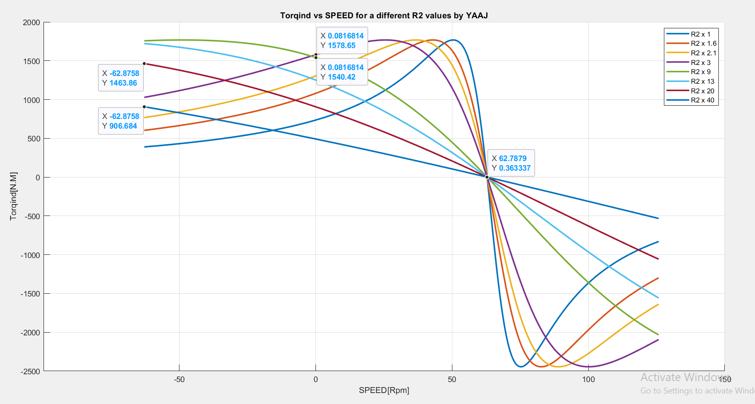
Figure 23: Torqload vs speed When R2 change

The maximum starting torq when R2 = R2*9 = 0.11 *9 =0.99
when R2 = R2*40 = 0.11 *40 =4.4

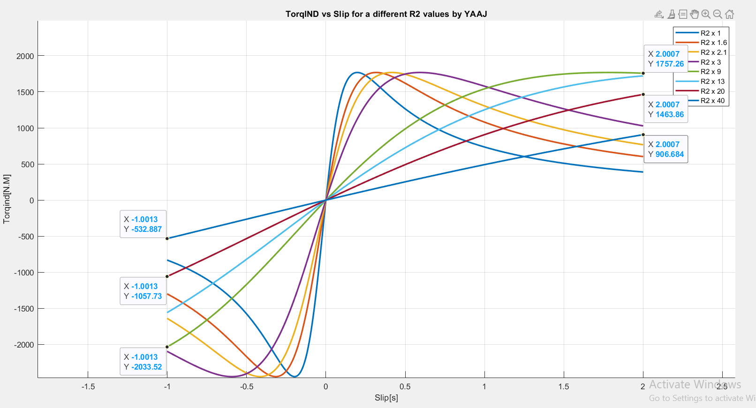
Figure 24: torqind vs slip when R2 change

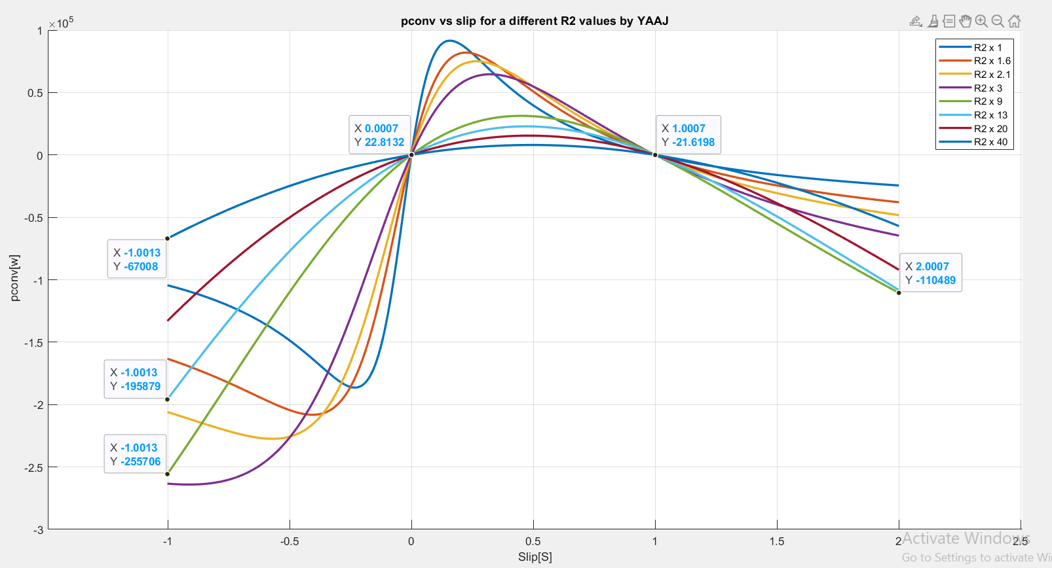
Figure 25: power converted vs slip when R2 change

The torque in the wound rotary induction motor can be increased, to start heavy loads, by using variable resistance and placing it at the highest value at the moment of operation and then gradually reducing it.So When we increase the resistance of the rotor we get increased motor slip, Reduces motor efficiency, reduces motor speed, increases speed regulation.So that the torque increases with the increase of the rotor resistance up to a certain value and this eqution expline that:

The relationship between torque and slippage, as well as torque with velocity, depends on the value of R2, and this happens when we increase the value of the rotor resistance.
It continues to increase until a specific value of resistance, and when the resistance increases
to a large amount, it begins to decrease again because it is in the numerator and denominator in the above eqtion.

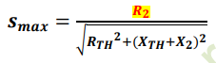
The converted energy is affected by slip (s), air gap force , rotor resistance (R2) through the formula
P conv = (1 - s) P AG.
At high slip (s = 1): P conv = 0 because the rotor does not move, resulting in the loss of all energy as heat.The increase of R2 moves the peak of P conv to higher glides, which improves torque but reduces efficiency.
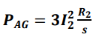

E- what range is the value of the rotor resistor (R2) that produces the maximum starting torque??

From part [d]

The maximum starting torq when R2 = R2*9 = 0.11 *9 =0.99Ώ.[best value]

when R2 = R2*40 = 0.11 *40 =4.4Ώ
The range of R2 between [ 0.99 _ 4.4]Ώ

From book:
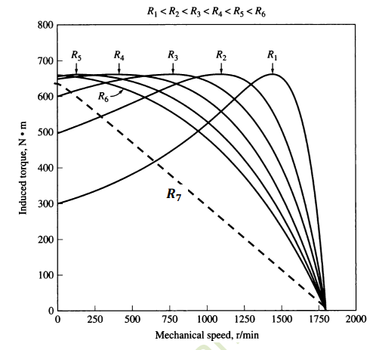

Note that, the starting torque increases with increasing the rotor resistance up to a particular value of rotor resistance R6, greater than which, the starting torque starts decreasing again as is the case with R7, which is greater than R6!

F-
Code[ 1]:

%yousef jarabaa #1211211
p=10;
vL=380;%v
fe=50;%Hz
vph=vL/sqrt(3);%v
s= -1.0013: 0.002 :2.0013;
Xm=80i;
x1=0.25i;
x2=0.3i;
R1=0.03+(0.06*1); %ohm
R2=0.04+(0.07*1); %ohm

ns=(120.*(fe))./p; %rpm
nm=(1-s).*ns; %rpm
ws=(ns.*2.*pi)./60; %Rad/sec
wm =(1-s).*ws; %Rad/sec
fr=(s.*fe);% [hz]
R2s=(R2)./(s); %ohm
z1 = (R2s)+x2; % (jx2)[ohm]
z2 = (z1.*Xm)./(z1+Xm); % [ohm]
Zeq= x1 + R1+ z2 ; %ohm
Iph = vph./ Zeq; % [amp]
IL = Iph;% [amp]

Pin = (3.*vph).*(abs(Iph)).*(cos(phase(Iph))); % [w]
Pscl = 3.*(abs(Iph).^2)*R1; % [w]
pcore =0; % [w]
PAg=Pin-Pscl- pcore; % [w]
Prcl=( s.* PAg); % [w]
pconv=((1-s).*PAg); % [w]
Pfw = 0; %[w]
Pstray = 0; %[w]
Pout = Pin - pconv - Pfw -Pstray; % [w]

Torqind = pconv./wm ; % [N.M]
Torqload = 0.02.*(wm.^2) ; % [N.M]
Torqloss = Torqind - Torqload ; % [N.M]

vLL=[vL* 0.9;
vL*0.75;
vL*0.60;
vL*0.40;
vL*0.25];
vTh = vLL./sqrt(3);
colors = {'b','r','m','c','g'};
figure;
hold on;
grid on;
for j = 1:length(vLL_factors)
R2s=R2./s;
z1=R2s+x2;
z2=(z1.*Xm)./(z1+Xm);
Zeq=x1+R1+z2;
Iph=vTh(j)./Zeq;
PAg=(3.*(abs(Iph).^2).* R2s);
Pconv=(1 - s).* PAg;
Torqind=Pconv./wm;
Torqload =0.02.* wm.^2;
plot(wm, Torqind,'LineWidth',2,'Color',colors{j});
plot(wm, Torqload,'-.','LineWidth',2,'Color',colors{j});
end
title('Torqload vs speed voltages change by YAAJ');
xlabel('rad/s');
ylabel('N.M');
legend('V90% Ind', 'V90% Load', 'V75% Ind', 'V75% Load', ...
'V60% Ind', 'V60% Load', 'V45% Ind', 'V45% Load', ...
'V25% Ind', 'V25% Load');
hold off;
figure;
hold on;
grid on;
for j=1:length(vLL_factors)
R2s=R2./s;
z1=R2s+x2;
z2=(z1.*Xm)./(z1+Xm);
Zeq=x1+R1+z2;
Iph=vTh(j)./Zeq;
PAg=(3.*(abs(Iph).^2).* R2s);
Pconv=(1 - s).* PAg;
Torqind=Pconv./wm;
Torqload =0.02.* wm.^2;
plot(s, Torqind,'LineWidth',2, 'Color',colors{j});
plot(s, Torqload,'-.', 'LineWidth',2,'Color', colors{j});
end
title('Torqload vs slip volteges cahnge by YAAJ ');
xlabel('slip');
ylabel('N.M');
legend('V90% Ind', 'V90% Load', 'V75% Ind', 'V75% Load', ...
'V60% Ind', 'V60% Load', 'V45% Ind', 'V45% Load', ...
'V25% Ind', 'V25% Load');
hold off;

PLOT [F1]

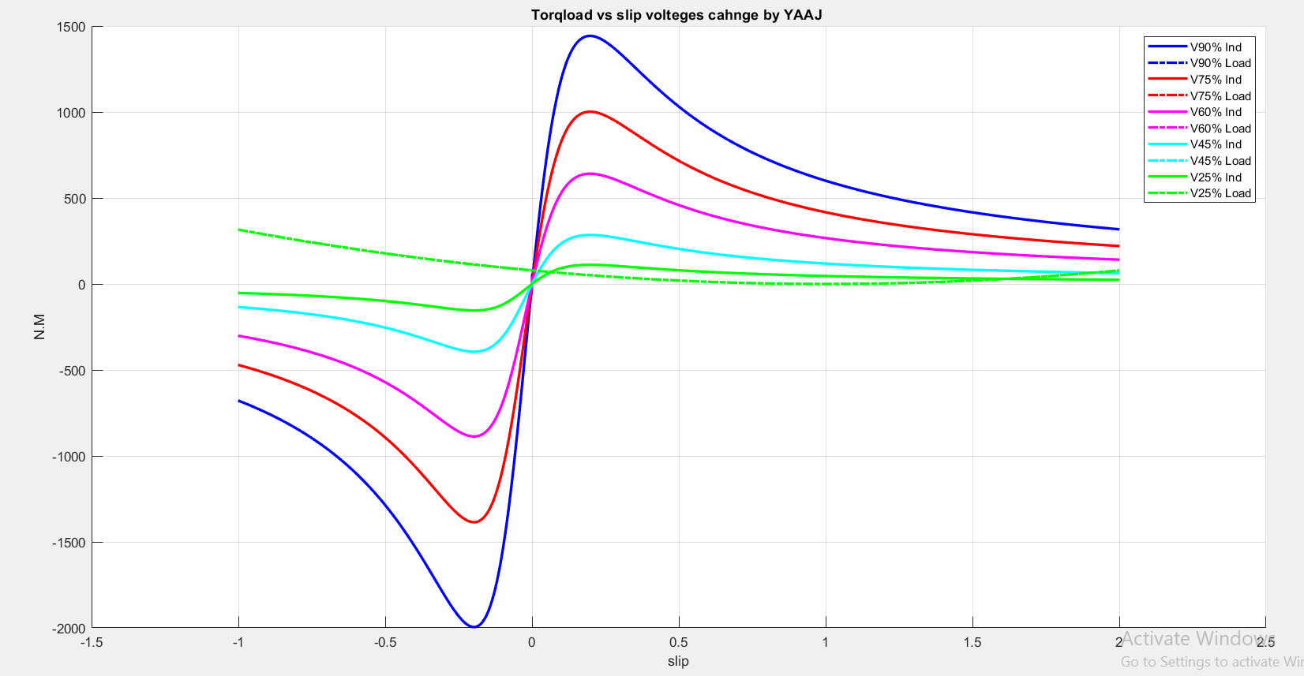
Figure 26: [Torqind & torqload] vs slip when voltage change

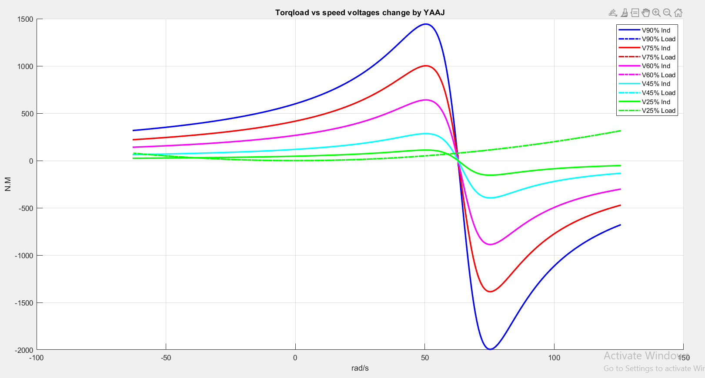
Figure 27: Torqind vs speed when voltage change

The graph shows the torque vs. slip and torque vs. speed diagrams with voltage change and its effect on motor performance. As the voltage decreases, the maximum torque and total torque across all slip values decrease significantly, with the effect being more pronounced at higher slip values. The maximum torque decreases with voltage drops, narrows the difference between induced torque and torque, indicating low torque availability under load conditions. At low glides (near synchronous speed), torque is minimal, while peaking at medium slip values before decreasing at high glides due to saturation. Low voltages lead to a significant reduction in torque, which can render the motor unable to maintain operation under load. This demonstrates the critical importance of maintaining sufficient voltage levels to ensure efficient motor performance.

Code[2]:

%yousef jarabaa #1211211
p=10;
vL=380;%v
fe=50;%Hz
vph=vL/sqrt(3);%v
s= -1.0013: 0.002 :2.0013;
Xm=80*1i;
x1=0.25*1i;
x2=0.3*1i;
R1=0.03+(0.06*1); %ohm
R2=0.04+(0.07*1); %ohm
ns=(120.*(fe))./p; %rpm
nm=(1-s).*ns; %rpm
ws=(ns.*2.*pi)./60; %Rad/sec
wm =(1-s).*ws; %Rad/sec
fr=(s.*fe);% [hz]
R2s=(R22)./(s); %ohm
z1 = (R2s)+x2; % (jx2)[ohm]
z2 = (z1.*Xm)./(z1+Xm); % [ohm]
Zeq= x1 + R1+ z2 ; %ohm
Iph = vph./ Zeq; % [amp]
IL = Iph;% [amp]

Pin = (3.*vph).*(abs(Iph)).*(cos(phase(Iph))); % [w]
Pscl = 3.*(abs(Iph).^2)*R1; % [w]
pcore =0; % [w]
PAg=Pin-Pscl- pcore; % [w]
Prcl=( s.* PAg); % [w]
pconv=((1-s).*PAg); % [w]
Pfw = 0; %[w]
Pstray = 0; %[w]
Pout = Pin - pconv - Pfw -Pstray; % [w]

Torqind = pconv./wm;% [N.M]
Torqload = Pout./wm;% [N.M]
Torqloss = Torqind-Torqload;%[N.M]
R2_factors=[1,1.6,2.1, 3 , 9,13,20,40];
torques_ind=zeros(length(R2_factors),length(s));
torques_load=zeros(1,length(s));
torques_load=0.02 .*( wm.^2);

for idx=1:length(R2_factors)
R22=R2 * R2_factors(idx);
R2s=R22 ./s;
z1=R2s+x2;
z2= (z1.* Xm) ./(z1 + Xm);
Zeq=x1+R1+z2;
Iph = vph./ Zeq;
Pin=(3 * vph).* abs(Iph) .* cos(phase(Iph));
Pscl=3 *abs(Iph).^2 * R1;
PAg=Pin-Pscl;
Pconv=(1-s).* PAg;
torques_ind(idx,:)=Pconv./wm;
end

figure;
hold on;
grid on;
for idx = 1:length(R2_factors)
plot(wm, torques_ind(idx, :), 'LineWidth', 2, 'DisplayName', ['R2 x ', num2str(R2_factors(idx))]);
end
plot(wm, torques_load, 'k-.', 'LineWidth', 2,'DisplayName',' Load Torque');
xlabel('SPEED[Rpm]') ;
ylabel('Torq[N.M]') ;
title('Torq=[0.002wm^2 vs SPEED for a different R2 values by YAAJ');
legend show;
hold off;

figure;
hold on;
grid on;
for idx = 1:length(R2_factors)
plot(s,torques_ind(idx, :), 'LineWidth',2,'DisplayName',['R2 x ',num2str(R2_factors(idx))]);
end
plot(s, torques_load,'k-.', 'LineWidth', 2,'DisplayName','Load Torque');
title('Torq=[0.002wm^2 vs slip for a different R2 values by YAAJ');
xlabel('Slip');
ylabel('Torq[N·m]');
legend show;
hold off;

PLOT [F2]

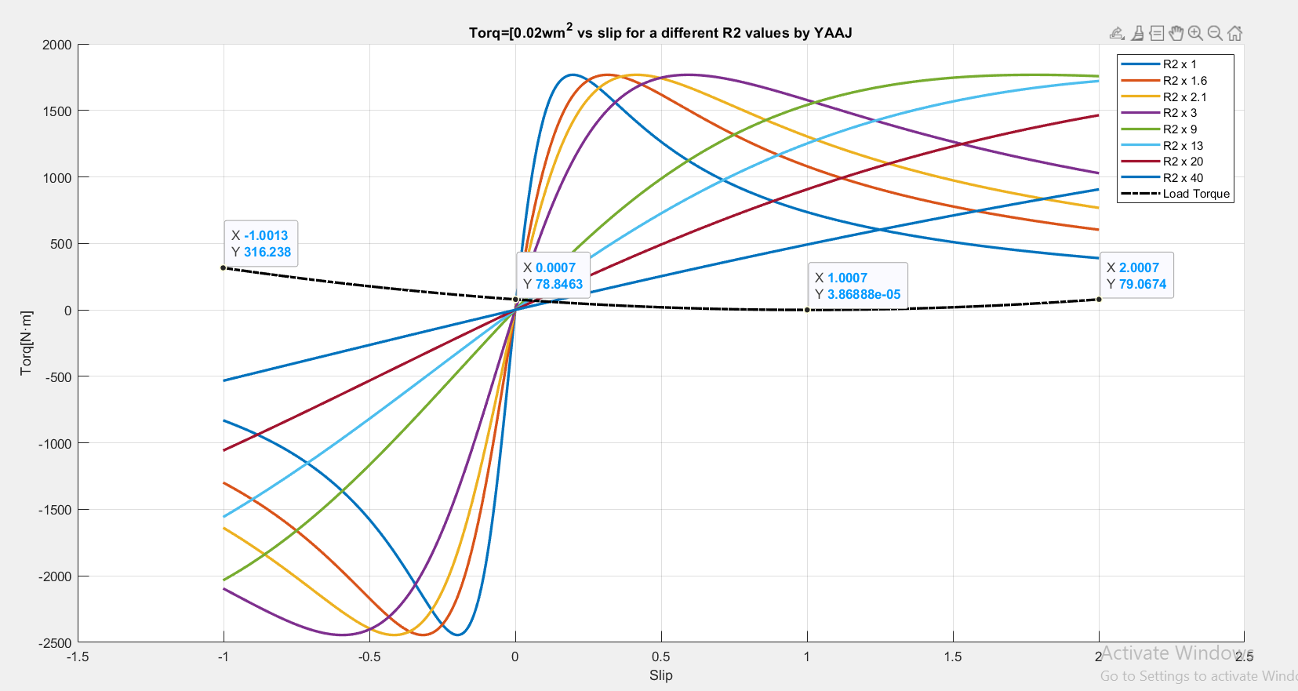
Figure 28: Torq=(0.02*w^2) vs slip when R2 different

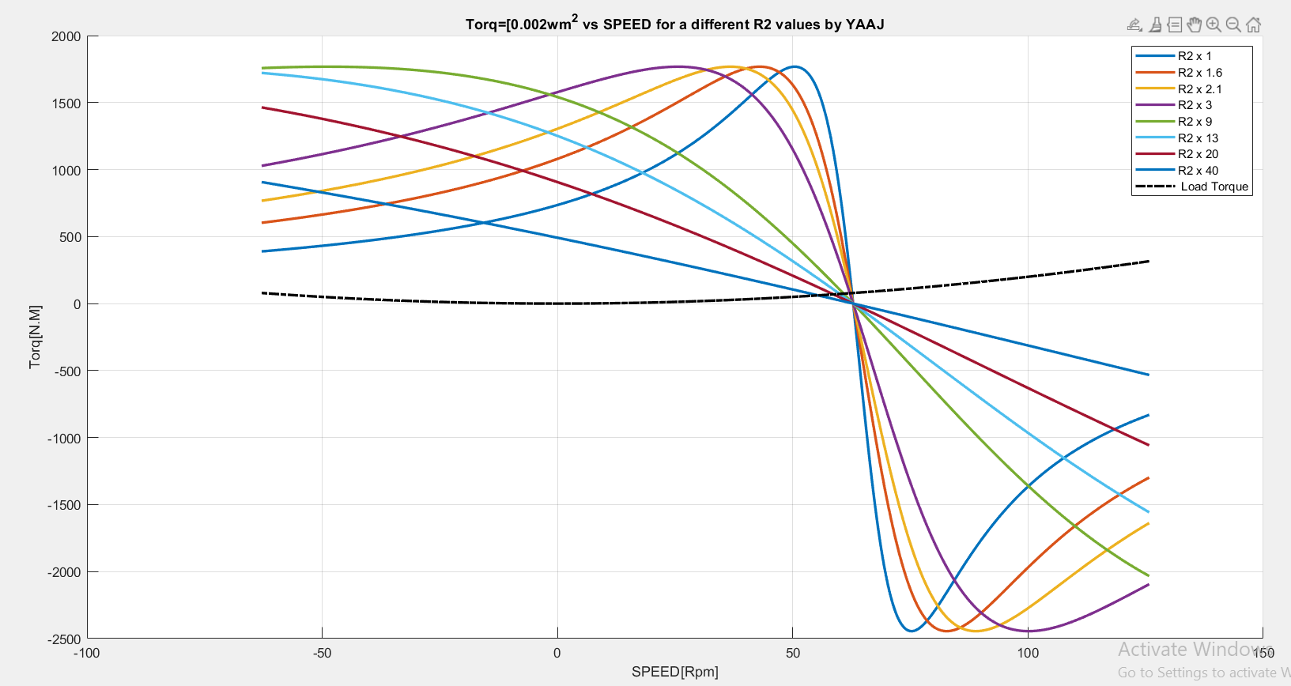
Figure 29:Torq=(0.02*w^2) vs speed when R2 different

The graphs show how the torque-slip and torque-speed change with different rotor resistance values. When the rotor resistance increases, the motor's maximum torque occurs at higher slip values, which leads to better starting torque but less efficiency at lower slips.This means that the motor can produce more torque at lower speeds, however it needs more gliding to reach peak torque. Low rotor resistance values improve efficiency and reduce slipping, but this comes with the disadvantage of low torque. The dashed black line indicates the torque of the load, and the place where it meets the torque curves indicates the operating points of the motor. Finding the right rotor resistance is essential to strike a good balance between starting performance and efficiency, depending on how the motor is used.

G-
Code[1]:

%yousef jarabaa #1211211
p=10;
vL=380;%v
fe=50;%Hz
vph=vL/sqrt(3);%v
s= -1.0013: 0.002 :2.0013;
Xm=80i;
x1=0.25i;
x2=0.3i;
R1=0.03+(0.06*1); %ohm
R2=0.04+(0.07*1); %ohm
ns=(120.*(fe))./p; %rpm
nm=(1-s).*ns; %rpm
ws=(ns.*2.*pi)./60; %Rad/sec
wm =(1-s).*ws; %Rad/sec
fr=(s.*fe);% [hz]
R2s=(R2)./(s); %ohm
z1 = (R2s)+x2; % (jx2)[ohm]
z2 = (z1.*Xm)./(z1+Xm); % [ohm]
Zeq= x1 + R1+ z2 ; %ohm
Iph = vph./ Zeq; % [amp]
IL = Iph;% [amp]

Pin=(3.*vph).*(abs(Iph)).*(cos(phase(Iph))); % [w]
Pscl=3.*(abs(Iph).^2)*R1; % [w]
pcore=0; % [w]
PAg=Pin-Pscl- pcore; % [w]
Prcl=(s.* PAg); % [w]
pconv=((1-s).*PAg); % [w]
Pfw = 0; %[w]
Pstray = 0; %[w]
Pout=Pin-pconv-Pfw -Pstray; % [w]
Torqind=pconv ./ wm; % [N.m]
Torqload=300; % [N.m]
Torqloss=Torqind - Torqload; % [N.m]

vLL_factors=[0.9,0.75,0.6,0.4,0.25];
vLL = vL*vLL_factors; % [V]
vTh = vLL./sqrt(3); % [V]
colors = {'b','r','m','c','g'};

figure;
hold on;
grid on;
for j = 1:length(vLL_factors)
R2s=R2./s;
z1= R2s+x2;
z2= (z1.* Xm)./(z1+Xm);
Zeq= x1 + R1 + z2;
Iph= vTh(j) ./ Zeq;
PAg=(3 * (abs(Iph).^ 2).* R2s);
Pconv=(1-s).*PAg;
Torqind= Pconv./wm;
plot(wm, Torqind,'LineWidth',2.5,'Color',colors{j});
end
plot(wm, Torqload * ones(1, length(wm)), 'k-.', 'LineWidth', 2, 'DisplayName', 'Load Torque');
title('Torqueload= 300 vs Speed for Voltage Changes by YAAJ');
xlabel('Speed [rad/s]');
ylabel('Torque [N.m]');
legend('V90% Ind', 'V75% Ind', 'V60% Ind', 'V40% Ind', 'V25% Ind', 'Load Torque');
hold off;

figure;
hold on;
grid on;
for j = 1:length(vLL_factors)
R2s=R2./s;
z1= R2s+x2;
z2= (z1.* Xm)./(z1+Xm);
Zeq= x1 + R1 + z2;
Iph= vTh(j) ./ Zeq;
PAg=(3 * (abs(Iph).^ 2).* R2s);
Pconv=(1-s).*PAg;
Torqind= Pconv./wm;
plot(s,Torqind,'LineWidth',2,'Color',colors{j});
end
plot(s,Torqload*ones(1,length(s)),'k-.','LineWidth',2.5,'DisplayName','Load Torque');
title('Torque load=300 vs Slip for Voltage Changes by YAAJ');
xlabel('Slip');
ylabel('Torque [N.m]');
legend('V90% Ind','V75% Ind','V60% Ind','V40% Ind','V25% Ind','Load Torque');
hold off;

PLOT [G1]

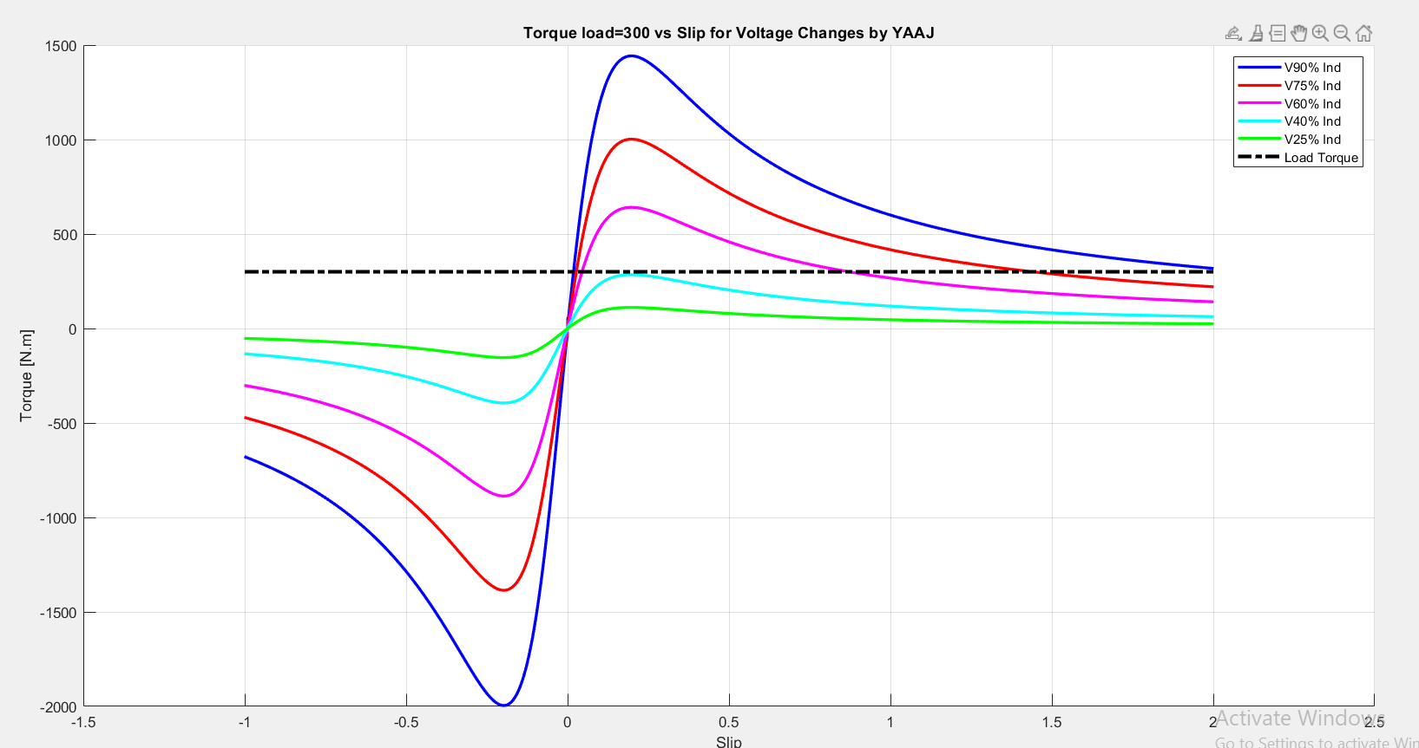
Figure 30:Torqueload= 300 vs Slip for Voltage Changes

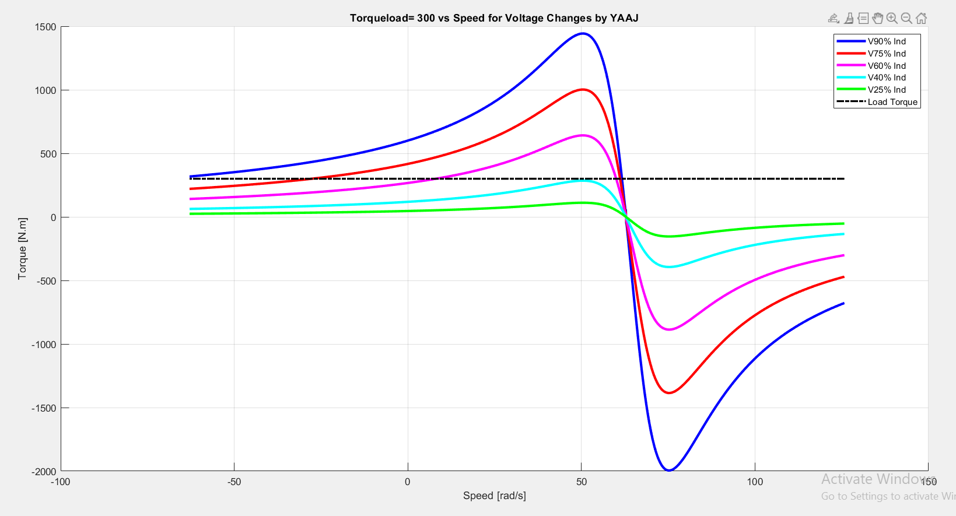
Figure 31: Torqueload= 300 vs Speed for Voltage Changes

The graphs show the relationship between torqueload , slip and speed with a different voltage to carry the motor operating torque of 300 Nm. At zero slip, which occurs when the rotor is at a synchronized speed, the torque is zero, and it also reaches zero at full slip when the rotor is completely closed. The highest torque is observed at a certain slip value, with an increase in voltage that leads to an increase in the overall torque. As the speed decreases from synchronous speed, the torque rises to the maximum point known as torque before it begins to decrease. The motor acts as a generator when it is below synchronous speed and acts as a motor when it is above it as I mentioned earlier. These graphs effectively illustrate the impact of voltage on the performance and efficiency of a motor.

Code[2]:

%yousef jarabaa #1211211
p=10;
vL=380;%v
fe=50;%Hz
vph=vL/sqrt(3);%v
s= -1.0013: 0.002 :2.0013;
Xm=80*1i;
x1=0.25*1i;
x2=0.3*1i;
R1=0.03+(0.06*1); %ohm
R2=0.04+(0.07*1); %ohm
ns=(120.*(fe))./p; %rpm
nm=(1-s).*ns; %rpm
ws=(ns.*2.*pi)./60; %Rad/sec
wm =(1-s).*ws; %Rad/sec
fr=(s.*fe);% [hz]

R2_factors=[1,1.6,2.1, 3 , 9,13,20,40];
torques_ind=zeros(length(R2_factors),length(s));
torques_load=300;

for idx=1:length(R2_factors)
R22=R2 * R2_factors(idx);
R2s=R22 ./s;
z1=R2s+x2;
z2= (z1.* Xm) ./(z1 + Xm);
Zeq=x1+R1+z2;
Iph = vph./ Zeq;
Pin=(3 * vph).* abs(Iph) .* cos(phase(Iph));
Pscl=3 *abs(Iph).^2 * R1;
PAg=Pin-Pscl;
Pconv=(1-s).* PAg;
torques_ind(idx,:)=Pconv./wm;
end

figure;
hold on;
grid on;
for idx = 1:length(R2_factors)
plot(wm, torques_ind(idx, :), 'LineWidth', 2, 'DisplayName', ['R2 x ', num2str(R2_factors(idx))]);
end
plot(wm, torques_load * ones(1, length(wm)), 'k-.', 'LineWidth', 2,'DisplayName',' Load Torque'); % Adjusted for `torques_load`
xlabel('SPEED[Rpm]') ;
ylabel('Torq[N.M]') ;
title('Torq=[0.02wm^2 vs SPEED for a different R2 values by YAAJ');
legend show;
hold off;

figure;
hold on;
grid on;
for idx = 1:length(R2_factors)
plot(s,torques_ind(idx, :), 'LineWidth',2,'DisplayName',['R2 x ',num2str(R2_factors(idx))]);
end
plot(s, torques_load * ones(1, length(s)),'k-.', 'LineWidth', 2,'DisplayName','Load Torque'); % Adjusted for `torques_load`
title('Torq=[0.02wm^2 vs slip for a different R2 values by YAAJ');
xlabel('Slip');
ylabel('Torq[N·m]');
legend show;
hold off;

PLOT [G2]

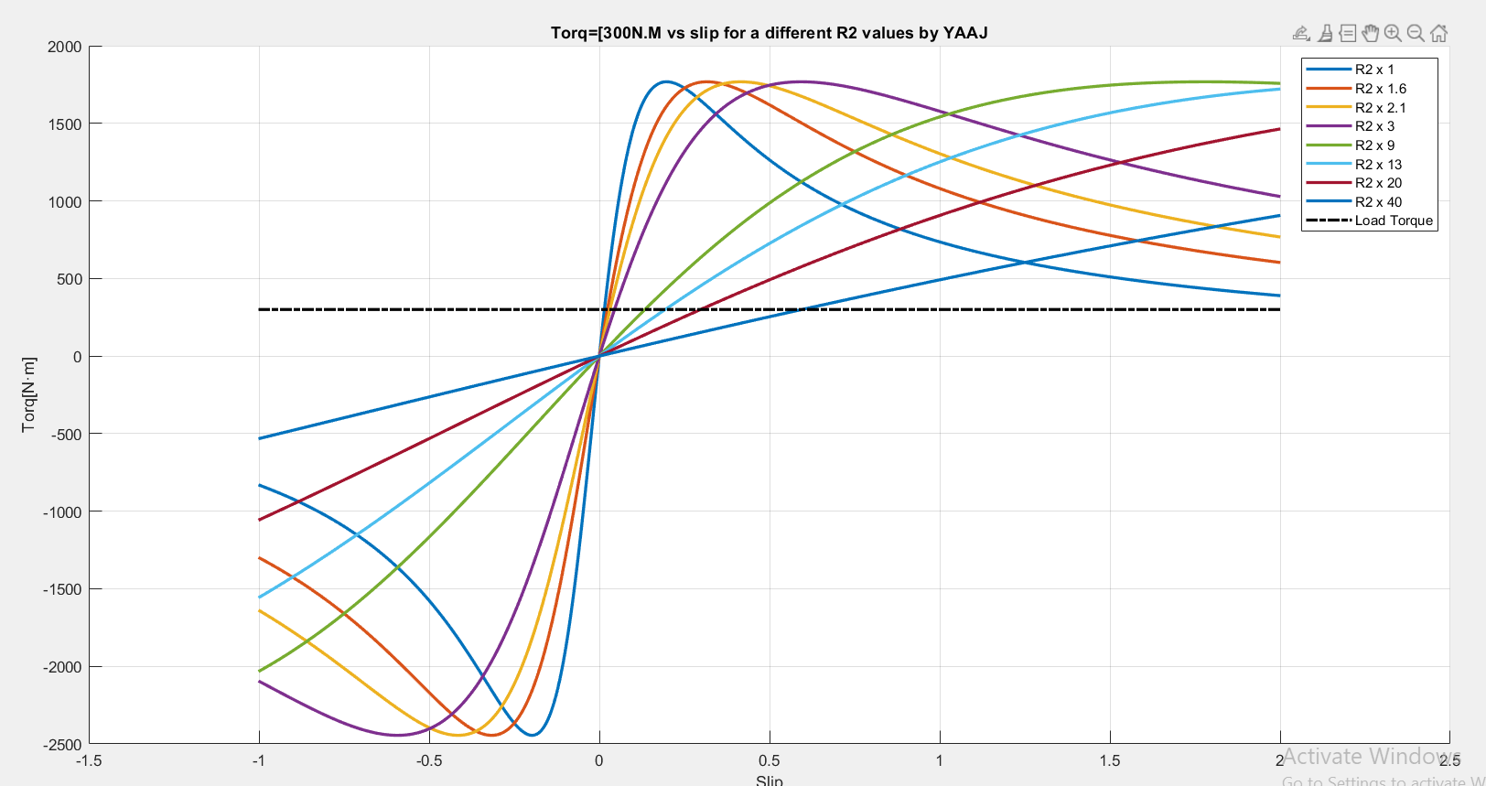
Figure 32:Torqload=[300] vs Slip for a different R2 values

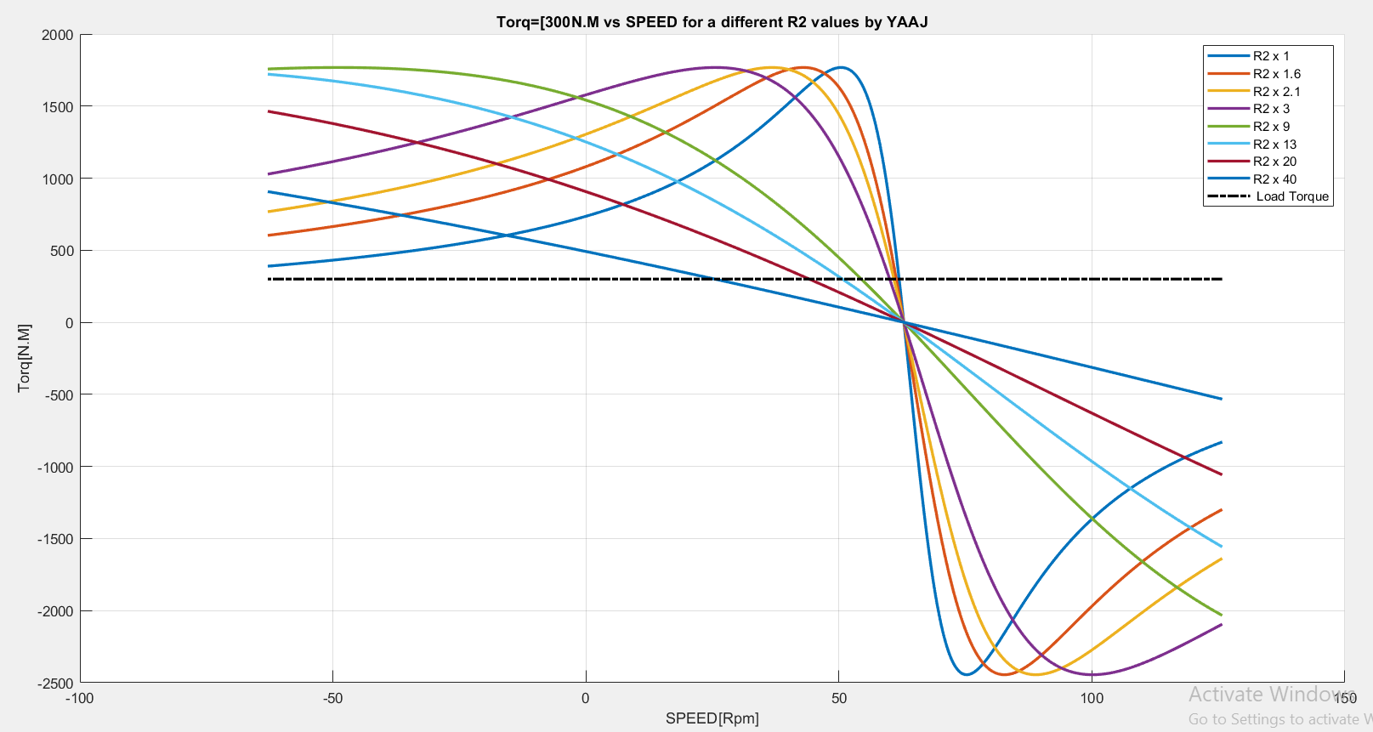
Figure 33::Torq=[300N.M ] vs SPEED for a different R2 values

Torque vs. slip and torque vs. speed graphs show how different R2 values affect engine performance while maintaining a constant torque load of 300 Nm even when the R2 value changes. In the torque vs. slip chart, as R2 increases, both the maximum torque and the total torque of all slip levels decrease. In the torque versus speed chart, higher values of R2 result in lower torque decreases across all speed levels, with maximum torque appearing at low speeds with R2 rising. These results underscore the need to select the right R2 values to ensure efficient engine performance and achieve the best torque characteristics for a load of 300 Nm.

H-
Code:

%yousef jarabaa #1211211
p=10;
vL=380;%v
fe=50;%Hz
vph=vL/sqrt(3);%v
s= -1.0013: 0.002 :2.0013;
Xm=80i;
x1=0.25i;
x2=0.3i;
R1=0.03+(0.06*1); %ohm
R2=0.04+(0.07*1); %ohm
ns=(120.*(fe))./p; %rpm
nm=(1-s).*ns; %rpm
ws=(ns.*2.*pi)./60; %Rad/sec
wm =(1-s).*ws; %Rad/sec
fr=(s.*fe);% [hz]
R2s=(R2)./(s); %ohm
z1 = (R2s)+x2; % (jx2)[ohm]
z2 = (z1.*Xm)./(z1+Xm); % [ohm]
Zeq= x1 + R1+ z2 ; %ohm
Iph = vph./ Zeq; % [amp]
IL = Iph;% [amp]

Pin=(3.*vph).*(abs(Iph)).*(cos(phase(Iph))); % [w]
Pscl=3.*(abs(Iph).^2)*R1; % [w]
pcore=0; % [w]
PAg=Pin-Pscl- pcore; % [w]
Prcl=(s.* PAg); % [w]
pconv=((1-s).*PAg); % [w]
Pfw = 0; %[w]
Pstray = 0; %[w]
Pout=Pin-pconv-Pfw -Pstray; % [w]

Torqind=pconv./wm; % [N.m]
Torqload=300; % [N.m]
Torqloss=Torqind - Torqload; % [N.m]

vLL_factors=[0.9,0.75,0.6,0.45,0.25];
vLL = vL*vLL_factors; % [V]
colors={'b','r','m','c','g'};
TorqueLoad1= 0.02*(wm.^2);
TorqueLoad2= 300*ones(size(wm));
figure;
hold on;
grid on;
for j= 1:length(vLL_factors)
R2s=R2./s;
z1=R2s+x2;
z2=(z1.*Xm)./(z1+Xm);
Zeq=x1+R1+z2;
Iph=vTh(j)./Zeq;
plot(wm,abs(Iph),'Color',colors{j},'LineWidth',2,'DisplayName',sprintf('I vs Speed at V=%.0f%%',vLL_factors(j)*100));
end
plot(wm,TorqueLoad1,'b-.','LineWidth',3,'DisplayName',' TorqLoad1=[0.02*wm^2]');
plot(wm,TorqueLoad2,'k-.','LineWidth',3,'DisplayName','TorqLoad2=[300N.m]');
title('[Input current vs speed with Torqload ] by YAAJ ');
xlabel('SPEED [RAD/s]');
ylabel('Input Current [Amp]');
legend();
figure;hold on;grid on;
for j= 1:length(vLL_factors)
R2s=R2./s;
z1=R2s+x2;
z2=(z1.*Xm)./(z1+Xm);
Zeq=x1+R1+z2;
Iph=vTh(j)./Zeq;
plot(s,abs(Iph),'Color',colors{j},'LineWidth',1.5,'DisplayName',sprintf('I vs Slip at V=%.0f%%',vLL_factors(j)*100));
end
plot(s,TorqueLoad1,'b-.','LineWidth',2,'DisplayName','TorqueLoad1=0.02*wm^2');
plot(s,TorqueLoad2,'k-.','LineWidth',2,'DisplayName','TorqueLoad2=300N.m');
title('Input current vs [s] with Torqload by YAAJ');
xlabel('Slip');
ylabel('Input current [Amp]');
legend();

PLOT [H]

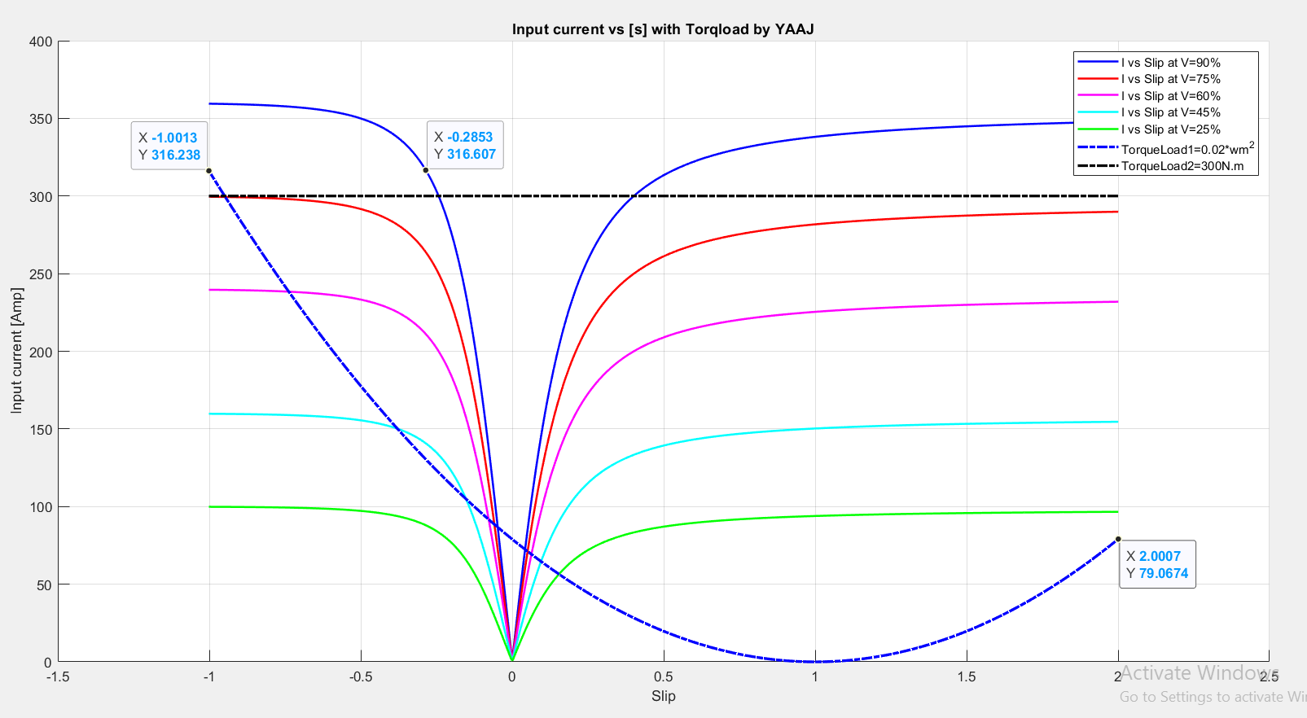
Figure 34: Input current vs [s] with Torqload at voltage change

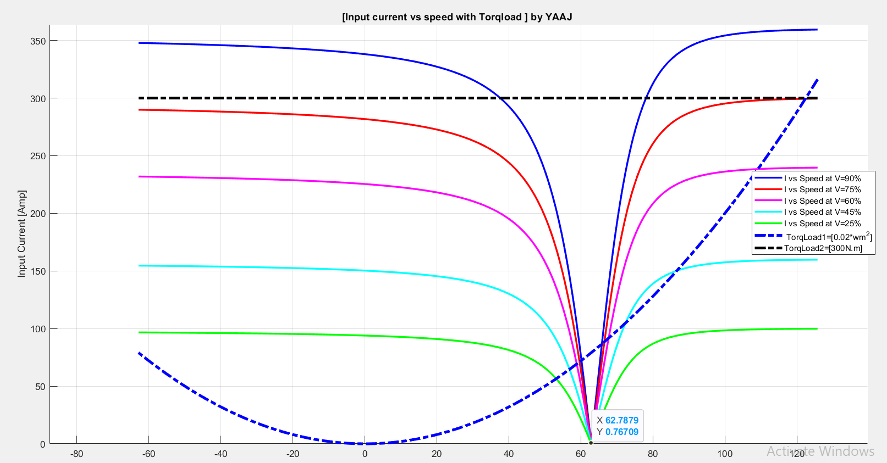
Figure 35: : Input current vs speed with Torqload at voltage change

Graphs show that the voltage rises, the input current also increases, while it decreases at low voltages, indicating how voltage affects motor performance. When handling torque loads, a parabolic load based on speed or slip results in a slow increase in current, while a constant torque load keeps the current constant. As the speed increases, the input current tends to decrease, but rises with higher slip, demonstrating how the motor reacts to changes in mechanical load and behavior,When increasing current, we note that with variable load, less current is needed at low voltages. With constant load, the motor will not run effectively at all voltages until the voltage exceeds 300 amperes to function properly.

Conclusions :

From very, very hard work above, we've gathered more ideas about the infographics we've created. The ideas in the branches show the links between induced torque, velocity and slippage, as well as the links between speed and slip, converted energy and slippage, input current, velocity, and slippage. We saw the effect of reducing the line voltage and the effect of increasing the resistance R2 on We also observed the effect of adding a constant torque load and a variable torque on the induced torque and other elements.
An efficiency of the machine, it decreases when the Slip increase When we reduces the value of the input Voltage, the Speed of the machine will decrease, and slip will increase,And the last of our prayers is that praise be to Allah, the Lord of the Worlds.

References:
Electrical Machines EE 2408 Lecture Note[1]
Electric Machinery Fundamentals Fifth Edition[2]

