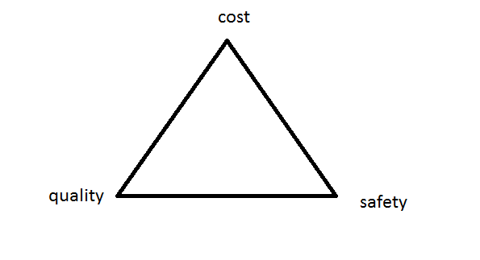

**Quality??**

**Safety ??**

**Cost ??**

**What is Materials Science and Engineering**

Material science is the investigation of the relationship among processing, structure, properties, and performance of materials.



**Structure**

**1)Subatomic level (Chapter 2)**

Electronic structure of individual

atoms that defines interaction among

atoms (interatomic bonding).

2) **Atomic level (Chapters 2 & 3)**

Arrangement of atoms in materials

(for the same atoms can have

different properties, e.g. two forms of

carbon: graphite and diamond)

3) **Microscopic structure (Ch. 4)**

Arrangement of small grains of

material that can be identified by

microscopy.

4)**Macroscopic structure**

Structural elements that may be

viewed with the naked eye

**Properties**

Properties are the way the material responds to the

environment and external forces.

**Mechanical** properties – response to mechanical forces, strength, etc.

**Electrical** and **magnetic** properties - response electrical and magnetic fields, conductivity, etc.

**Thermal** properties are related to transmission of heat and heat capacity.

**Optical** properties include to absorption, transmission and scattering of light.

**Chemical stability** in contact with the environment corrosion