Chapter 14 Other Business Processes

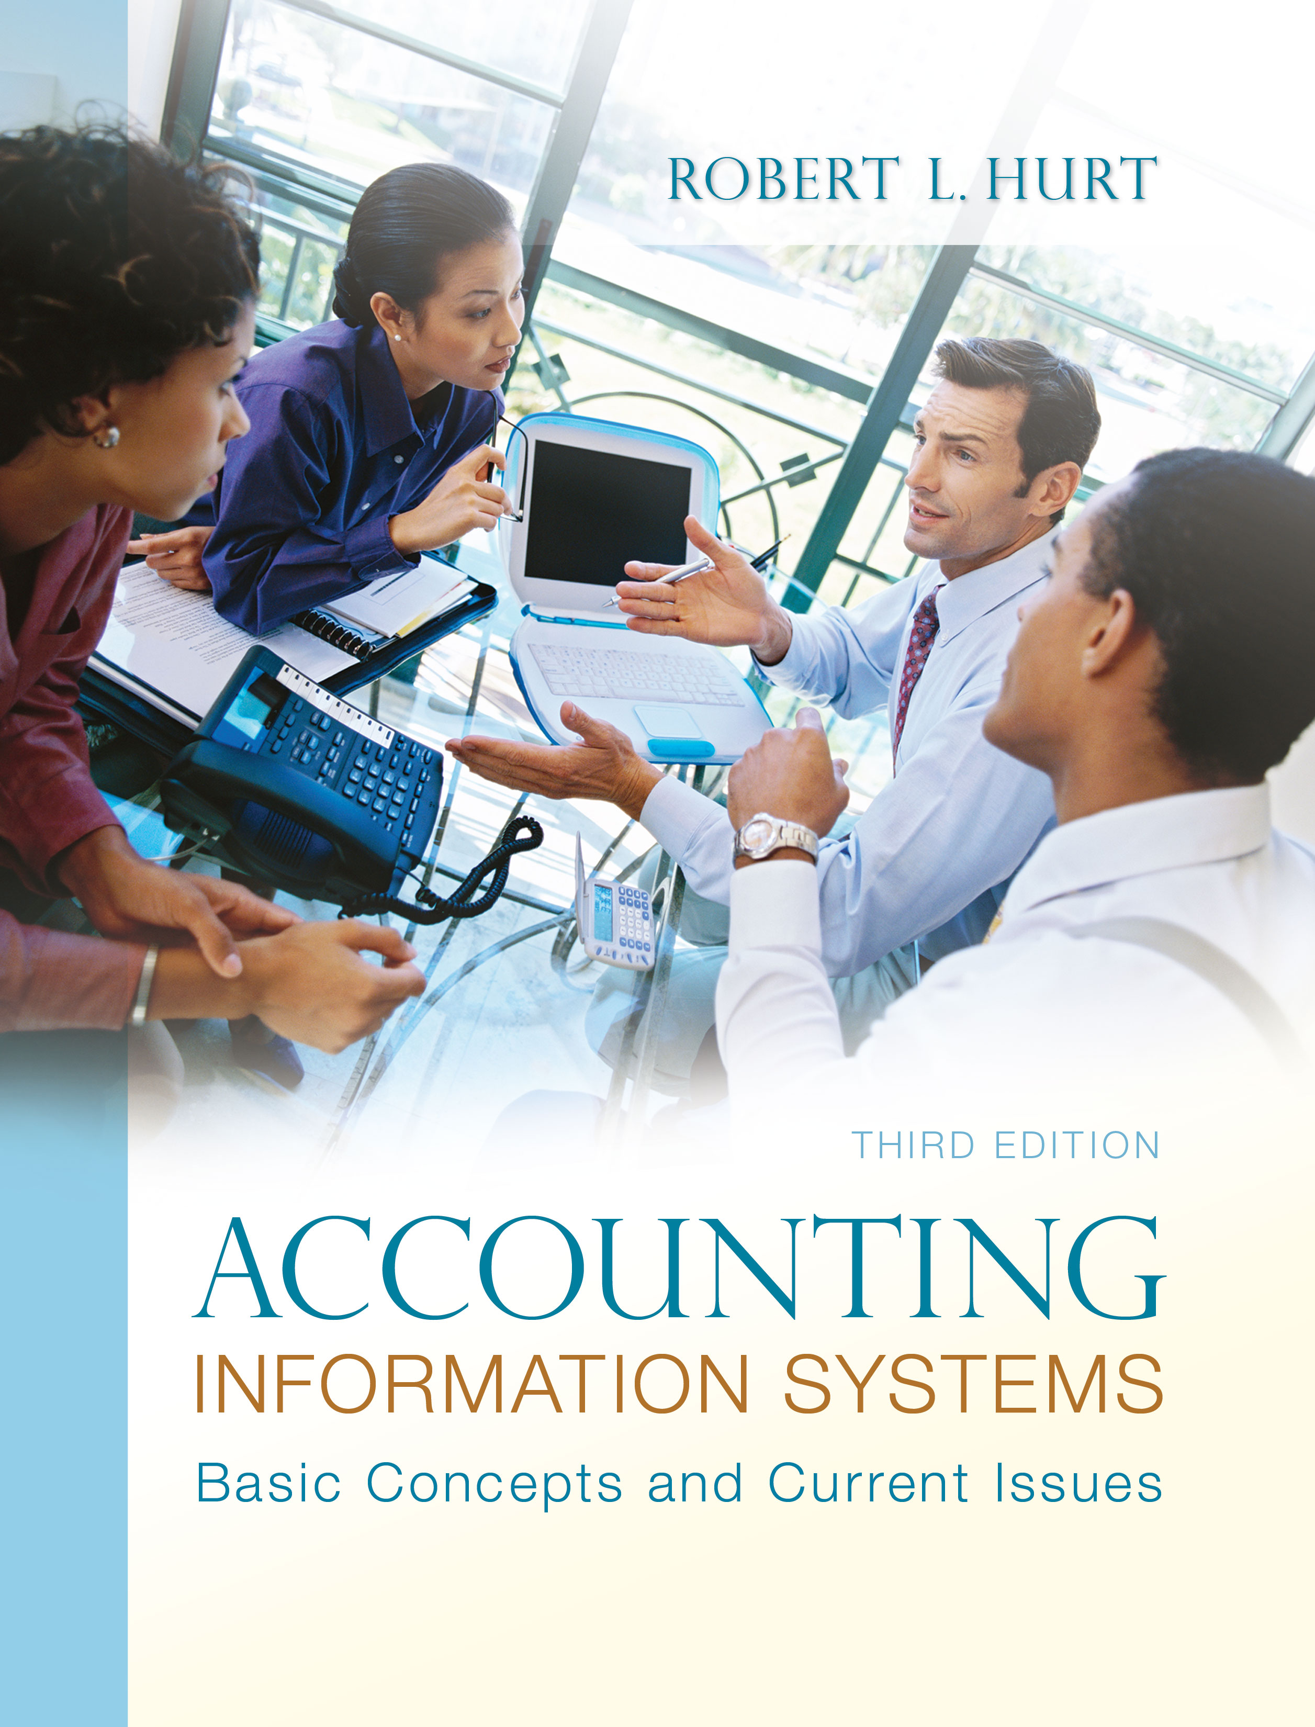
1. Reading review questions
a. What is the basic purpose of each business process discussed in this chapter (conversion, financing, human resources)? The conversion process is responsible for transforming material, labor and overhead into finished products. The financing process, a specialized case of acquisition / payment, deals with how an organization obtains and repays external funding (long-term debt, capital stock and the like). The human resources process comprises all the activities from hiring a new employee to termination.
b. What are the similarities and differences between job costing and process costing systems? How is each system reflected in the organization of the accounting information system? Both job and process costing are concerned with tracking material, labor and overhead from their raw states to finished products. In addition, both are systems used in manufacturing organizations. But, whereas job costing tracks the costs by “job,” process costing is more concerned with “processes.” Job costing systems are reflected in the AIS by maintaining ledger accounts for each job; process costing systems have ledger accounts organized by process.
c. What are the four common transactions associated with the financing business process? What information must be tracked for each transaction? The transactions (and associated data) are: (a) issuance of capital stock (number of shares, par value per share, market value per share, shareholder identification data), (b) purchase of treasury shares (number of shares, price per share, shareholder identification data), (c) long-term debt transactions (principal, coupon interest rate, market interest rate at time of issuance, time to repayment, number of annual interest payments, lender identification data) and (d) dividend distributions (type of dividend, shareholder identification data, amount of dividend, dates)
d. What forms are commonly used in processing payroll transactions? Forms discussed in the chapter include: W-4, W-2, payroll register, employee earnings record, Form 1099, Form 940 and Form 941.
e. How are the purposes of internal control fulfilled in each business process discussed in the chapter? In the conversion process, assets (material, work in process, finished goods) can be safeguarded through physical controls and monitoring. In the financing process, protecting cash is a primary concern; the usual controls (bank reconciliation, authorized signatures) apply. In the human resource process, the main concern is compliance with management directives; that objective can be attained through careful procedure development and periodic audits. All three processes produce data for the financial statements; internal and external audits help promote the reliability of financial statements.
f. Respond to the questions for this chapter’s “AIS in the Business World.” I was very fortunate to have three assistants available to prepare responses to the AIS in the Business World vignettes for the third edition; I’ve posted their responses on my AIS blog: www.bobhurtais.blogspot.com.

2. Reading review problem

a. How is the EMR system related to one or more of the business processes discussed in the chapter? The EMR system is primarily related to the “conversion” process. The system helps doctors and other medical professionals provide services more efficiently and effectively. In addition, the system is a time saving device for employees, which also relates it to the human resources process.

b. Why is it important for accounting professionals to understand organizations in a comprehensive way? An organization’s accounting information system is an outgrowth of its activities—not the other way around. Thus, understanding an organization in a comprehensive way allows accounting professionals to design, create and modify the AIS in a way that assists the organization.

c. How does the EMR software and process relate to the five generic AIS elements? The patient’s medical records are inputs to the system; the system itself is a processing tool as well as a storage tool. The software has internal controls, such as encryption, built in as well.

3. Multiple choice review questions. Answers to all of these questions appear at the end of the textbook itself.

4. Making choices and exercising judgment
The point of these exercises, which appear in every chapter throughout the third edition, is to encourage students to think critically and “outside the box.” Thus, I am not providing solutions to them, as doing so would likely discourage the purpose of these exercises.

5. Field exercises
Answers to these exercises will vary significantly; thus, like the previous set, I am not preparing published solutions for them.

6. Costing systems

a. job costing
b. job costing
c. job costing
d. job costing
e. process costing
f. job costing if the work is principally focused on design; process if focused on maintenance
g. process costing
h. process costing if the consultant specializes in a certain type of engagement (e.g., QuickBooks training)
i. process costing
j. process costing

7. Transactions and business processes

a. human resources

b. conversion

c. financing

d. financing

e. human resources

f. financing

g. conversion

h. financing

i. financing

j. conversion

8. Transaction explanations

a. paying the organization’s share of payroll taxes
b. recording depreciation on manufacturing equipment
c. purchasing treasury shares
d. issuing capital stock for cash
e. recording payroll
f. issuing a stock dividend (large)
g. allocating manufacturing overhead to work in process
h. paying interest on long-term debt
i. issuing long-term debt at a discount
j. recording the sale of finished goods

9. Payroll computations and analysis

10. Payroll forms data

a. 4, 5
b. 4, 5
c. 1 through 4
d. 4
e. 1 through 4
f. 4, 5
g. 5
h. 3 through 5
i. 4
j. 1

1. Form 940
2. Form 941
3. Form 1099
4. Form W-2
5. Form W-4

11. Risk analysis and internal controls
a. Lack of product demand (market research to determine price points, objective customer satisfaction surveys). Workplace accidents (worker training, workers’ compensation insurance). Poor quality goods (quality control inspections, pre-qualifying material suppliers).

b. Changes in technology leading to product obsolescence (market research, well-defined R & D processes). Price-level changes (market research, cost control processes). Inaccurate forecasts (customer surveys, independent verification of forecasts).
c. Insufficient capital for expansion (line of credit, independent budgeting process). Lack of FDA approval (verification of research results, independent review of proposals). Lack of response to IPO (IPO training, team approach for developing IPO).

d. Spoilage (climate control, low inventory levels). Equipment malfunctions (periodic maintenance, worker training for proper operation). Worker injury (training, workers’ compensation).

e. Excessive leasing costs (contracts with price caps, headcount control). Decreased worker motivation (employee satisfaction surveys, morale-boosting activities). Unreliable leasing firm (background research, qualification process).

f. Inaccurate forecast of cash needs (independent review, post-audits of test stores). Lack of ability to repay debt (sinking fund, debt covenant). Financial statement fraud (independent audits, internal audit department).

12. Systems documentation
a.

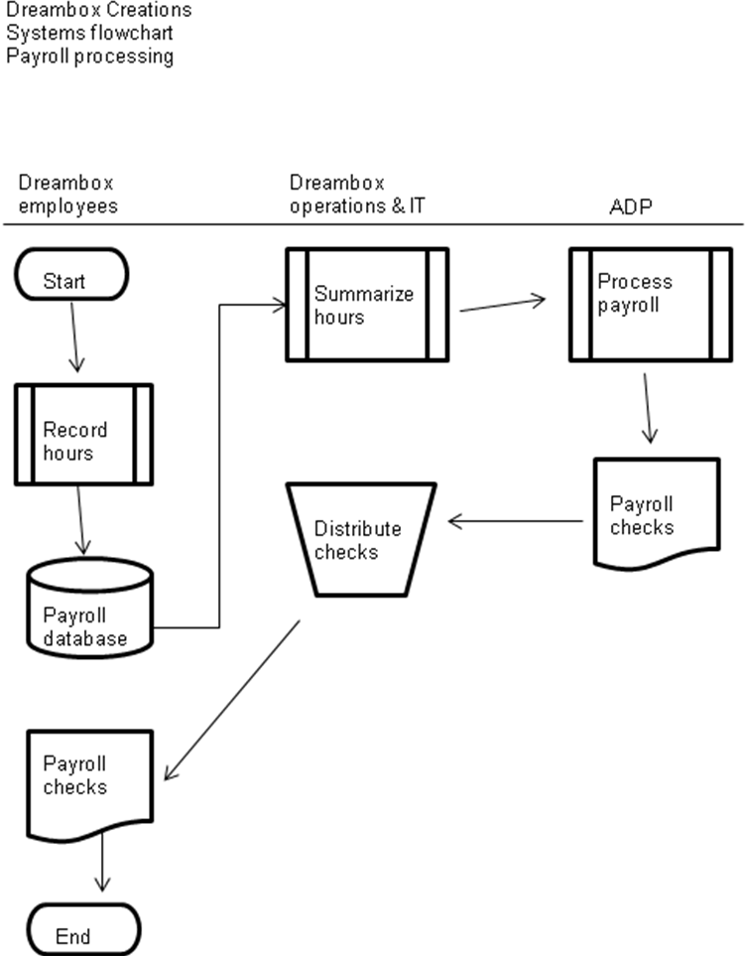

b.

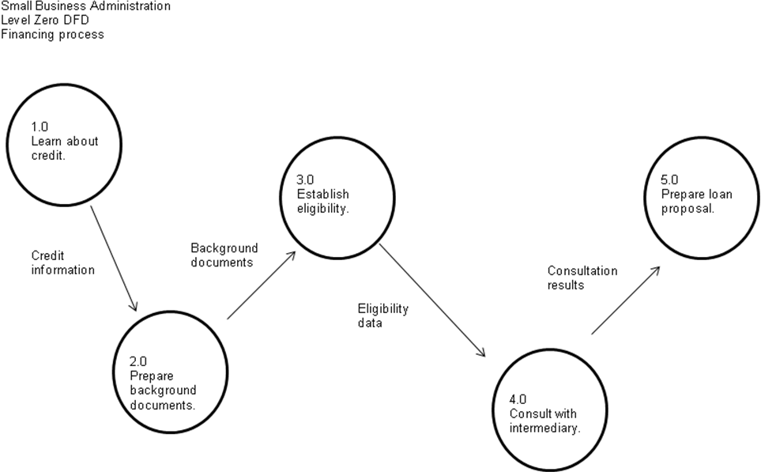

c.

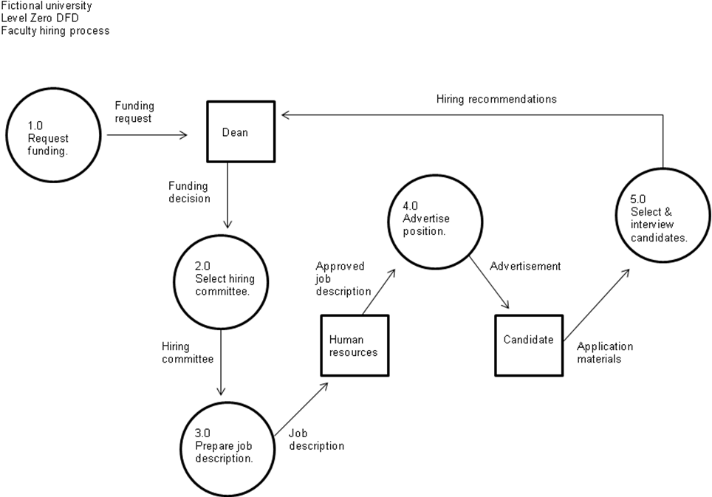

d.

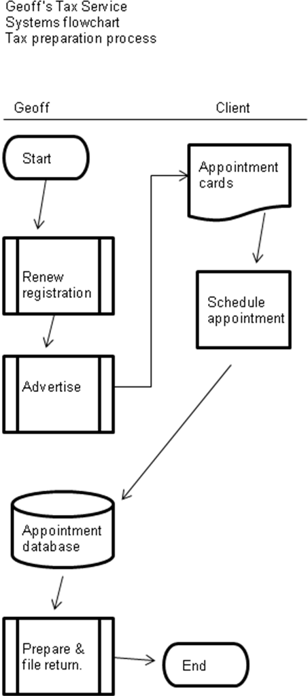

e.
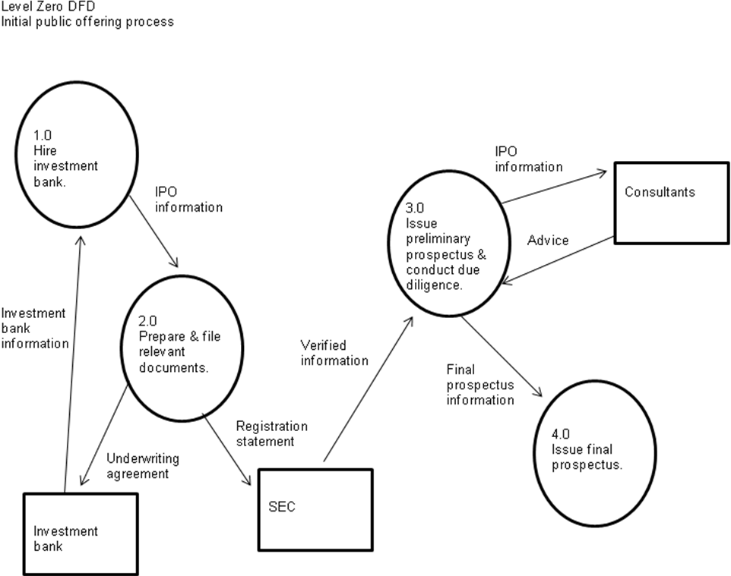
13. Database design
a. Last name, first name, address, phone, # of shares issued, date(s) issued

b. Employee database: last name, first name, address, phone, emergency contact, employee ID number, tax information

c. Dreambox Creations “hours” database: client ID, employee ID, hours worked, date, description

14. Terminology

1. D
2. A
3. J
4. C
5. G
6. I
7. E
8. F
9. H
10. B

15. Multiple choice questions
1. D
2. A
3. D
4. B
5. A

16. Statement evaluation
a. Sometimes true. All five processes may be required, depending on the nature of the organization.
b. Sometimes true. Many companies with long-term debt establish sinking funds as an internal control.
c. Sometimes true. Like most forms, they can be paper-based or electronic.
d. Always true.
e. Never true.
f. Always true.
g. Always true.
h. Never true.
i. Never true.
j. Never true.

17. Prior material application
a.

b.

ERM framework element | Heater Craft example
Internal environment | Management brings in a consultant to give seminars on the importance of enterprise risk management.
Objective setting | Increase sales revenue by 5% in the coming year.
Event identification | Lack of sales due to declines in the economy.
Risk assessment | High
Risk response | Accept, avoid
Control activities | Diversify product line
Information & communication | Post copies of ERM plan throughout the facility.
Monitoring | Make monitoring & updating the plan part of the CFO’s responsibilities.

c. Answers will vary considerably.

