Birzeit university– faculty of engineering and technology

Department of mechanical engineering

Fluid Mechanic Laboratory

ENME312

Section 1

**Experiment No.7**

**“Water Channel Applications”**

Instructors:

Dr. Adel Dweik

Eng. Alanoud Muadi

Group 5:

Majd Raddad 1201196

Qais Samara 1202956

Mohammad Abu Ayyash 1182690

**Prepared by: Majd Raddad- 1201196**

Date of performance: 18/03/2024

Date of performance: 25/03/2024

**Table of Content:**

**Abstract**……………………………………………………………………………3

**Objectives…………………... ….………………………………………………...**3

**Sample calculations …………... ...………………………………………………**.4

**Results …………………………………………….…………...……………….….**8

**Discussion of results ………….……………………………………………….….**11

**Conclusions ……………………………………………………………………….**13

**References ………….………………………………………………….…….…...**13

**Appendices ………….……………………………………………….…….…….**14

**Abstract**

The purpose of this experiment is to investigate the relationship between the upstream head and flow rate at a sluice gate's exits in a rectangular channel under free flow conditions (subject to atmospheric pressure). To calculate the discharge coefficient, raise the gate gradually to known heights (Yg), wait until the water stabilizes, take the value of Hc, and read the values of (Y0) and (Y1).

To determine the forces influencing the gate, principles like Bernoulli's were used. A roughly linear relationship was then plotted between the ratios of (Fg/Fh) and (Yg/Y0).

$$\frac{P_{2}}{ρ}+\frac{V_{2}^{2}}{2g}+0=\frac{P_{1}}{ρ}+\frac{V_{1}^{2}}{2g}-y_{o}$$

* The pressure at points 2 and 1 is the same and equal to the atmospheric pressure.

The second part of the experiment aims to measure the height of water over the V-notch and Q to examine the actual time flow of water via the V-notch (this part is more effective for low flow rate measurements). plotting Q^0.4 and H to calculate the discharge coefficient.

**Objectives**

* Studying the characteristics of the open channel flow.
* Measurements of water flow rates.
* Determination of discharge coefficient for a sluice gate and V- Notch weir.

**Sample calculation:**

**Part 1**

The Run NO.1 was chosen, and the calculations as follows:

$C_{v}=\sqrt{\frac{H_{c}}{y_{o}}}$ (1)

$C_{v}=\sqrt{\frac{145}{203}}$ = 0.845

Where:

$C_{v}$: velocity coefficient.

$H_{c}:$ Total head at discharge point.

$C_{c}=\frac{y_{1}}{y_{g}}$ (2)

$C_{c}=\frac{16}{20}$ = 0.8

Were:

Cc: coefficient of contraction.

Y1: Total depth of fluid after the gate.

Yg: Height of sluice gate opening.

$C_{d}=C_{c}C_{v}$ (3)

$C_{d}=0.8*0.845$ = 0.676

Where:

Cd: discharge coefficient.

The flow rate calculated using the following equation:

$Q=Cd y_{g} b\sqrt{2 g y_{o}}$ (4)

$Q=0.676*0.02* 0.3\sqrt{2*9.81*0.203}$ = 0.008

Where:

Q: Discharge beneath a sluice gate.

Cd: Discharge coefficient.

Yg: Height of sluice gate opening.

b: Width of channel (30cm).

Y0: Total depth of fluid before the gate.

g: acceleration due to Gravity (9.81 m/s^2).

$V_{1}=\sqrt{2 g y_{o}}$ (5)

$V_{1}=\sqrt{2*9.81*0.203}$ = 1.996 m/s.

Where:

V1: water velocity at inlet m/s.

Y0: Total depth of water before the gate.

g: acceleration due to gravity (9.81 m/s^2).

To calculate Fg which represent the resultant gate thrust in Newton:

$F_{g}=\frac{1}{2}ρgy_{1}^{2}\left[\frac{y_{o}^{2}}{y_{1}^{2}}-1\right]-\frac{ρQ^{2}}{b^{2}y_{1}}\left[1-\frac{y_{1}}{y_{o}}\right]$ (6)

$F_{g}=\frac{1}{2}*1000*9.81*{0.016}^{2}\left[\frac{{0.203}^{2}}{{0.016}^{2}}-1\right]-\frac{1000*{0.0081}^{2}}{{0.3}^{2}*0.016}\left[1-\frac{0.016}{0.203}\right]$ = 158. 944 N

Where:

Fg: the resultant gate thrust.

Y0: Total depth of fluid before the gate.

Y1: Total depth of fluid after the gate.

g: Gravity (9.81 m^2/sec).

Q: Discharge beneath a sluice gate.

b: Width of channel(30cm).

𝜌: Water density (1000kg/m^3).

To calculate $F_{H}$, which is the resultant hydrostatic thrust in Newton as follows:

$F_{H}=\frac{1}{2}ρg{\left(y_{o}-y_{g}\right)}^{2}$ (7)

$F_{H}=\frac{1}{2}*1000*9.81{\left(0.203-0.02\right)}^{2}$ = 164.26 N.

Where:

Fh: the resultant hydrostatic thrust.

Y0: Total depth of fluid before the gate.

Yg: Height of sluice gate opening.

g: acceleration due to Gravity (9.81 m/s^2).

**Part 2**

Using Run No.2, the calculation as follow:

To calculate the flow rate through the V- notch:

$Q={\frac{8}{15}C}_{d}\tan{\frac{θ}{2} H^{\frac{5}{2}}}\sqrt{2 g}$ (8)

0.00167 $={\frac{8}{15}C}_{d}\tan{\frac{90}{2}{0.063}^{\frac{5}{2}}}\sqrt{2*9.81}$

Cd= 0.708

Where:

Cd: Discharge coefficient.

𝛳/2: half the enclose angle of the V-notch (45 degree).

H: head above bottom of the V-notch.

g: acceleration due to Gravity (9.81 m/s^2).

**Results**

* **Part 1**

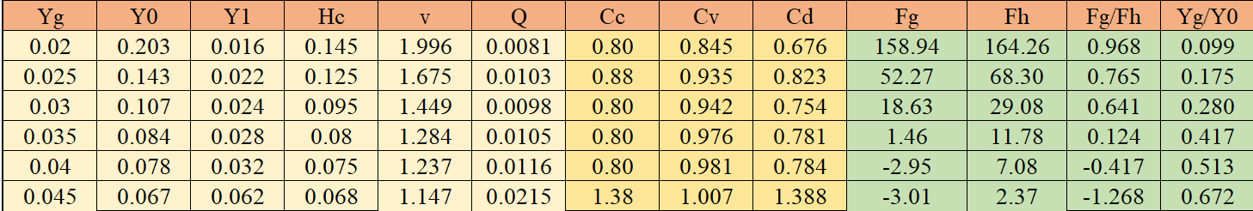Table (1): Measured and calculated data for Part 1

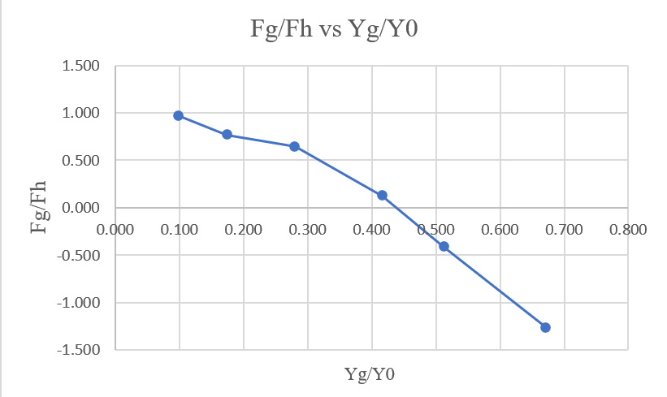

Figure (1): (Fg/Fh) Vs. (Yg/Y0).

* **Part 2**

Table (2): Measured and calculated data for part 2.

Figure (2): Cd vs. Q.

Figure (4): Q^ (2/5) vs. H (m).

**Discussion of results**

The experiment's primary objective was to use a sluice gate and a v-notch to examine the flow on an open channel. The experiment was accomplished by noting and calculating each of the previously mentioned parameters, in addition to illustrating the open channel flow system through the plotted graphs that show the relationship between the various parameters. Other related parameters such as Cd, Cv, and Cc (Discharge coefficient, Velocity coefficient, and Contraction coefficient), and terms such as forces (Hydrostatic force and the gate force) and their relationship with the flow through gates.

Table 1. in the results section shows the taken data additional to the resulted calculations for part (1) of the experiment, it can be noticed that as the gate opening increases gate thrust decreases, this is attributed to the fact that as the gate is raising the total depth of water behind the gate decreases, while the depth of the water through the rest of the channel that flow under the gate increases, the figure below illustrates the forces resulted from each side of the gate due to the depths of water, hence as Fg is the resultant of these forces it was expected to decrease in value. hydrostatic thrust also decreases, due to decrease in the total depth of water above the gate channel opening.

Figure (4): Sluice gate force analysis.

Figure.1 in the results shows the plotted relation between the ratio of the gate thrust to the hydrostatic thrust vs the ratio of Yg (gate height to the total depth of water behind the gate). it was shown to be a non-linear relationship.

Same table shows an inverse-relation between the height of the gate and the velocity, this matches the expectation of the continuity equation as it suggests the inverse relationship between the area the fluid pass (here it’s the area under the gate) and the velocity of the fluid that passes this area, values of Cd, Cv, Cc where all below 1, this doesn’t specifically assure the accuracy of the experiment but it’s logical. Cd did in fact followed a pattern when related to the value of flow, whereas the flow and the height of the gate increased Cd value decreased, hence the more the gate is opened the higher the losses are, although last run shows a distortion of the results, as Cd, Cc exceeded 1 and there was a sudden increase in the value of flow which shows an error might be In calculation, taking the readings, or following the instruction .

For part B of the experiment, table (2) shows the taken data along with the resulted calculations for the coefficient of discharge, and Figure(2) was plotted graph for (Cd vs Q) shows an inversely proportional relationship, but in addition to the V-notch there was a large drop for the value of Cd as the Flow increases, due to the nature of the apparatus which could have caused larger losses, lastly Figure(3) Shows the relation between Q^(2/5) and H, the slope of the best line for the figure is 0.6712, where the average value of Cd calculated is 0.624, which indicates an error of 7%.

**Conclusion:**

The experiment studies the flow rate through open channels under sluice gate. It consisted of two parts, the first part studies the flow under the sluice gate in a rectangular channel and the second part uses V- notch with free flow condition. The main goal of the experiment is to measure the thrust and hydrostatic forces acting on a sluice gate, also to measure the coefficient of discharge for the two parts.

The relationship was noticed through the experiment between the flow rate and the coefficient of discharge. Through the experiment multiple parameters were discussed such as the hydrostatic and gate thrust. It is essential to note that these values must be considered while building dams, gates, and other applications needed to store water.

The experiment overall results were acceptable, they fairly matches all the predicted based on the knowledge of the applied principle, from a civil engineering view such experiment illustrated a lot of important knowledges, starting from the analysis of a system of gate that reserves water, reaching to the comparison that were made for the flow across those gates, and as mentioned before, design point of view must strictly consider such forces (thrusts) for a higher efficiency for the designed structure.

There may be some errors in the experiment, due to several reasons, including blunder errors, lack of sufficient accuracy in the device, or taking the readings quickly and inaccurately.

**References**

* Fluid mechanics laboratory manual (2022, march).
* White, F. M. (1999, January 1). Fluid Mechanics.

**Appendices**