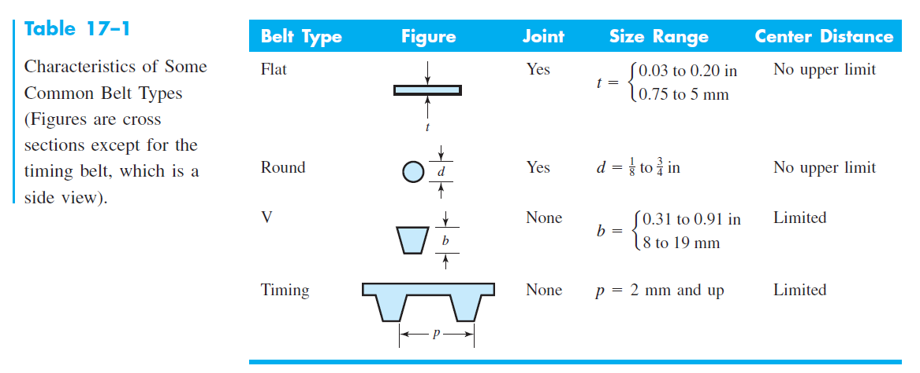

**FOR FLAT BELTS:**

**The velocity correction factor (Cv) for leather belts:**

**Cv = 1 for Urethane and Polymide**

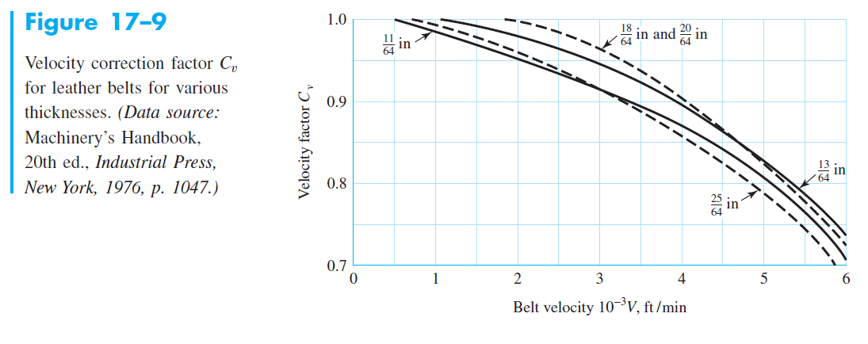

**The allowable belt tension (Fa) values in this table are based on speed 600 ft/min.**

**This table gives: (t, Fa, gama, f)**

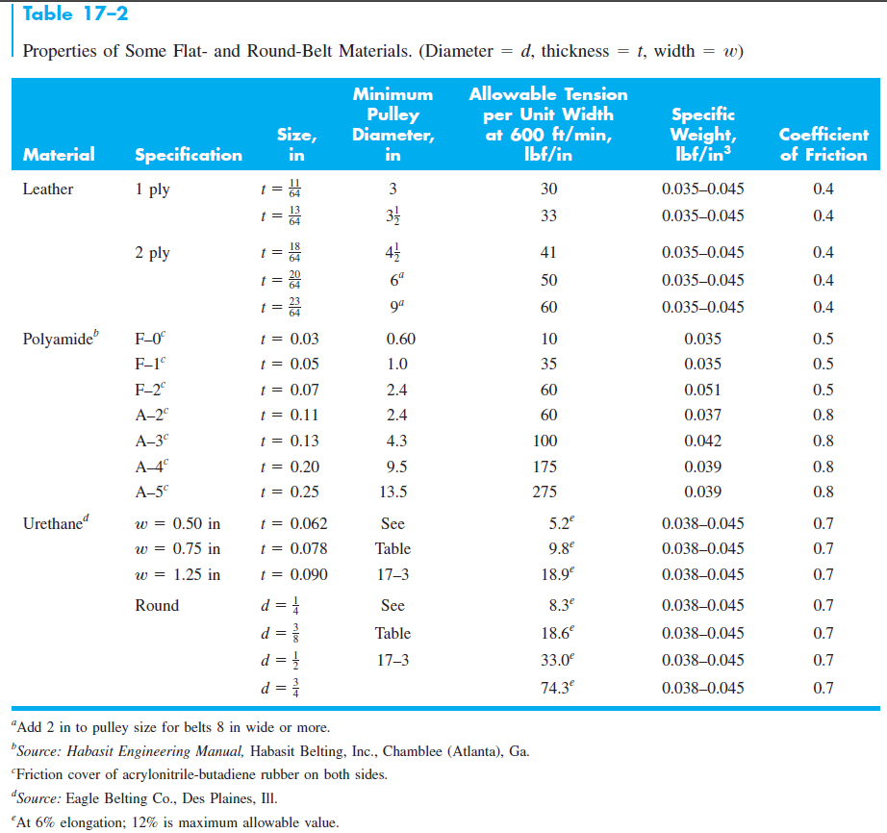

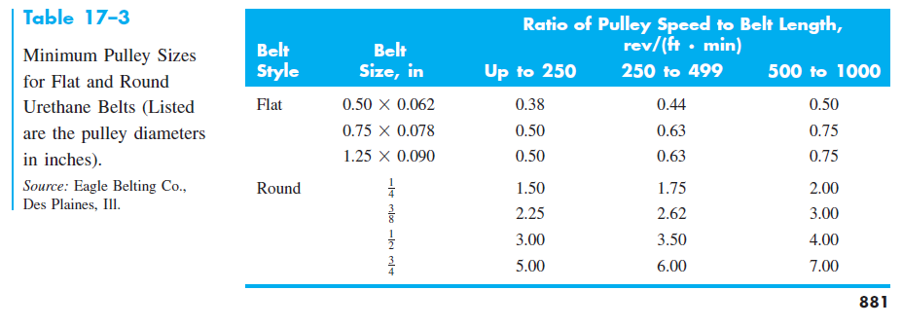

**Pulley correction factor for flat belts (Cp):**

**Use (Cp =1) for urethane belts.**

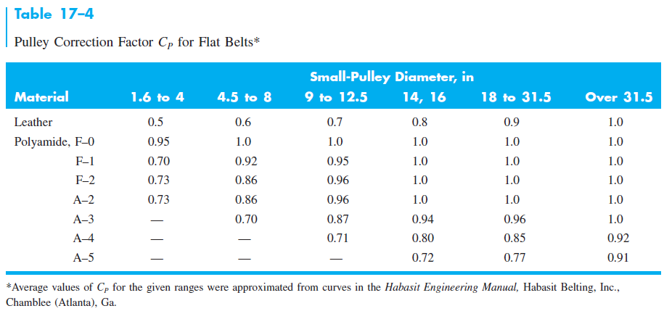

**Belt service factor (Ks) for flat and V-belt:**

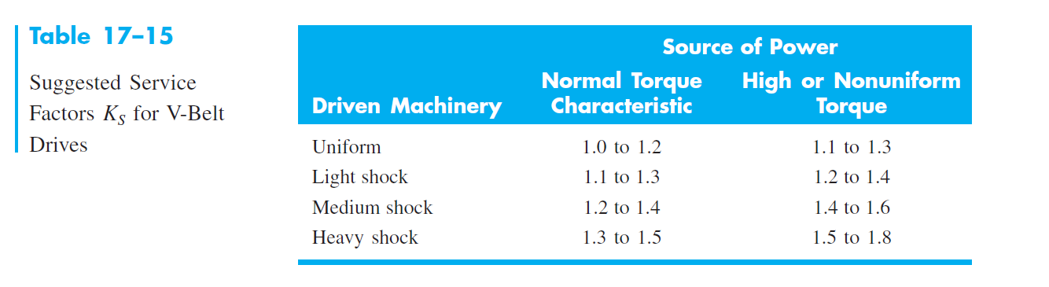

**FOR V-BELTS:**

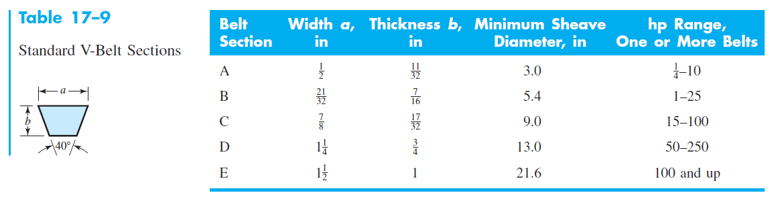

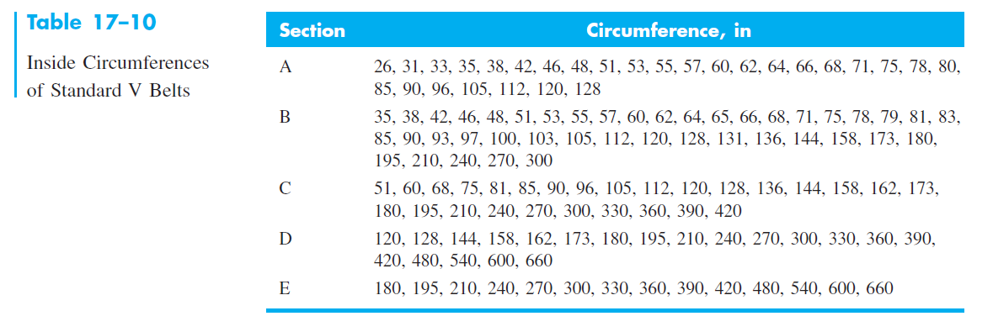

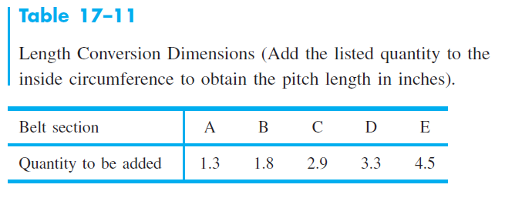

**The tabulated power values (Htab) for V-belts are:**

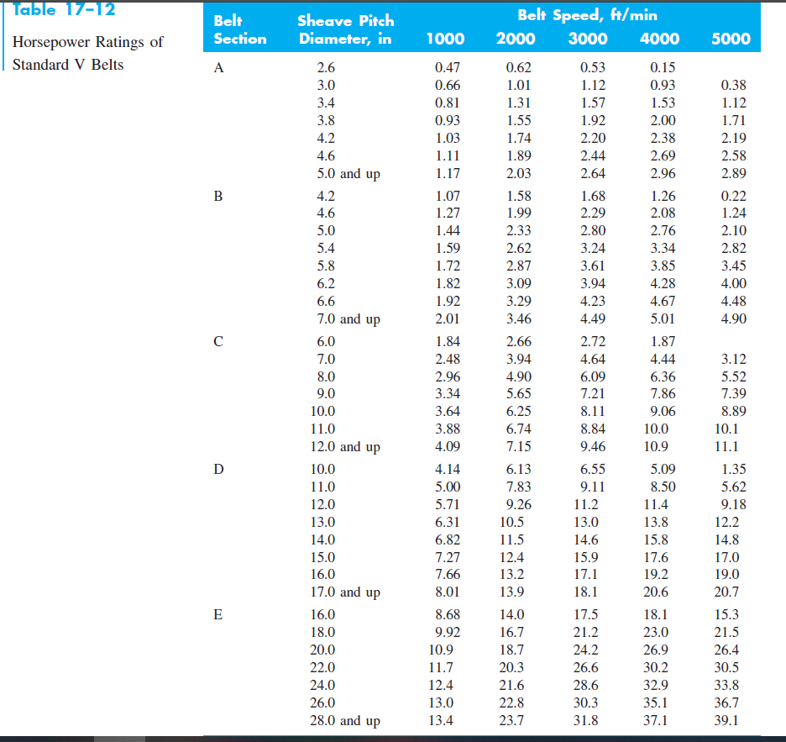

**The angle of contact correction factor (K1):**

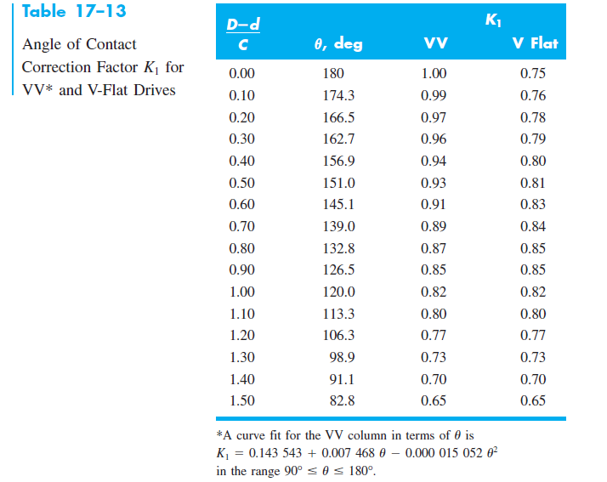

**The belt length correction factor (K2):**

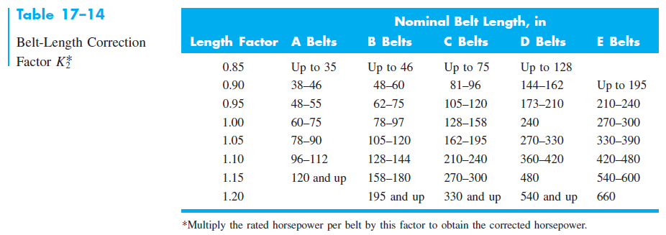

**The factor of the centrifugal tension (Kc) and the factor (Kb) for bending force:**

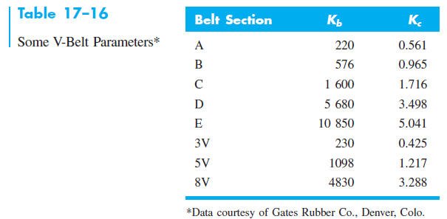

**The constants (K&b) to find the number of passes Np:**

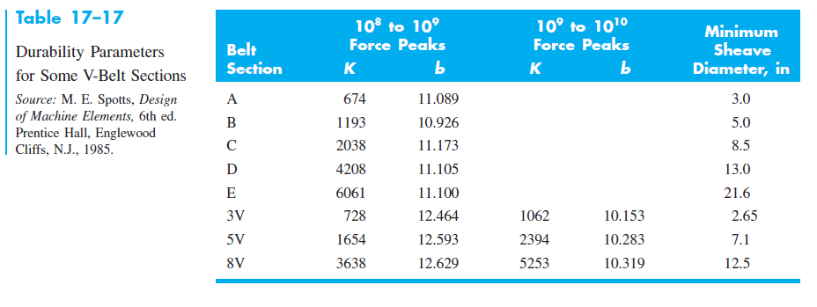

**FOR TIMING BELTS**

