

Birzeit University
Faculty of Engineering & Techonology
Department of Electrical & Computer Engineering
ENEE211

“Impedance and Sinusoidal Steady State”

Student :Mohamad Bornat #1130842

Instructor:Dr.Jasser Sa’ed

Date: 13\7\2016



1.To Calculate Vc(t) using PSpice , we need to find phase and magnitude of Vc(t) , to do that ; insert VPRINT2 between VA and the ground .to print the magnitude and phase of Vc(t) ,set VPRINT2 part names : AC ,Mag, and Phase to yes . To perform simulation at single-frequency, set Start Freq = 50Hz, and Final Freq = 50Hz in the AC sweep analysis part.
2. Vi (t) =4*cos (100*pi*t-90)(Phasor domain form), set ACMAG=4V, ACPHASE=-90
The circuit is as below with everything above taken into consideration
. 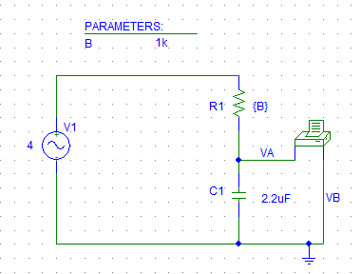
The output file of PSpice contains the following for every resistance from 1k to 10k ohms.
When Param B =1k
FREQ VM (VA,0) VP(VA,0)
5.000E+01 3.291E+00 -1.247E+02
Vc(t) = 3.291*cos(100*pi*t -124.7)= 3.291*sin(100*pi*t-34.7)
Phase difference = 34.7

When the PARAM B =2k ,the magnitude and phase for Vc(t) as appear in output File of PSpice are:
FREQ VM(VA,0) VP(VA,0)
5.000E+01 2.345E+00 -1.441E+02
Vc(t) = 2.345*cos(100*pi*t -144.1)= 2.345*sin(100*pi*t-54.1)
Phase difference = 54.1
When the PARAM B =3k, the magnitude and phase for Vc(t) as appear in output File of PSpice are:
FREQ VM(VA,0) VP(VA,0)
5.000E+01 1.738E+00 -1.543E+02
Vc(t) = 1.738*cos(100*pi*t -154.3)= 1.738*sin(100*pi*t-64.3)
Phase difference = 64.3
When the PARAM B =4k, the magnitude and phase for Vc(t) as appear in output File of PSpice are:
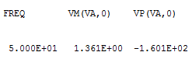
Vc(t) = 1.361*cos(100*pi*t -160.1)= 1.361*sin(100*pi*t-70.1)
Phase difference = 70.1
When the PARAM B =5k, the magnitude and phase for Vc(t) as appear in output File of PSpice are:
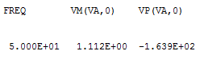
Vc(t) = 1.112*cos(100*pi*t -163.9)= 1.112*sin(100*pi*t-73.9) / Phase difference = 73.9
When the PARAM B =6k, the magnitude and phase for Vc(t) as appear in output File of PSpice are:
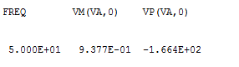
Vc(t) = 0.9377*cos(100*pi*t -166.4)= 1.361*sin(100*pi*t-76.4)
Phase difference = 76.4

When the PARAM B =7k, the magnitude and phase for Vc(t) as appear in output File of PSpice are:
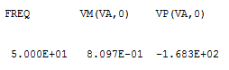
Vc(t) = 0.8097*cos(100*pi*t -168.3)= 0.8097*sin(100*pi*t-78.3)
Phase difference = 78.3

When the PARAM B =8k, the magnitude and phase for Vc(t) as appear in output File of PSpice are:
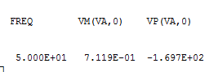
Vc(t) = 0.7119*cos(100*pi*t -169.7)= 0.7119*sin(100*pi*t-79.7)
Phase difference = 79.7

When the PARAM B =9k, the magnitude and phase for Vc(t) as appear in output File of PSpice are:
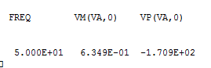
Vc(t) = 0.6349*cos(100*pi*t -170.9)= 0.6349*sin(100*pi*t-80.9)
Phase difference = 80.9

And finally when the PARAM B =10k, the magnitude and phase for Vc(t) as appear in output File of PSpice are:
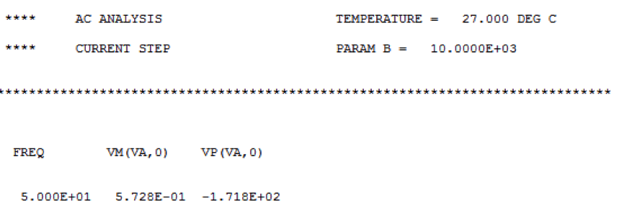
Vc(t) = 0.5728*cos(100*pi*t -171.8)= 0.5728*sin(100*pi*t-81.8)
Phase difference = 81.8

The waveforms are as shown below:-
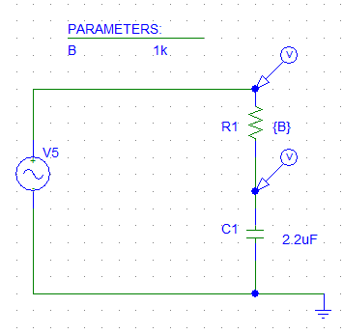

4. Like the previous setting exactly, but only change the magnitude of the input sinusoidal to 5V. And change c to L=100uH.Vi (t) =5*sin (2000*pi*t)
= 5*cos (2000*pi*t-90)
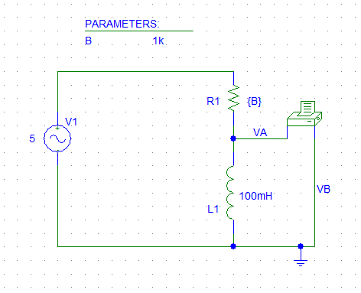
Using the output File, the Phase and Magnitude are as found below:-
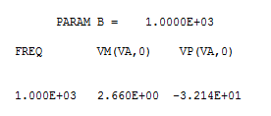
VL(t)= 2.66*cos(2000*pi*t-32.1) =2.66*sin(2000*pi+57.9)
$$∅=57.9$$

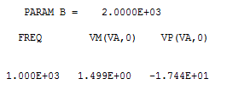
VL(t)= 1.499*cos(2000*pi*t-17.44) =1.499*sin(2000*pi+72.56)
$∅=$72.56
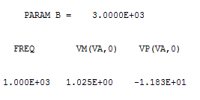
VL(t)= 1.02*cos(2000*pi*t-11.8) =1.02*sin(2000*pi+78.2)
$∅=$78.2
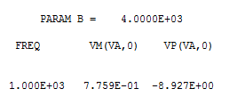
VL (t) =0.77 *cos(2000*pi*t-8.9) =0.77*sin(2000*pi+81.1)
$∅=$81.1
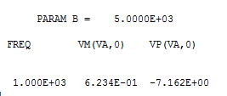
VL (t) = 0.62*cos(2000*pi*t-7.1) =0.62*sin(2000*pi+82.9)
$∅=$82.9
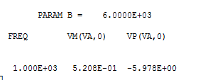
VL(t)= 0.52*cos(2000*pi*t-5.9) =0.52*sin(2000*pi+84.1)
$∅=$84.1
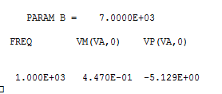
VL(t)= 0.44*cos(2000*pi*t-5.1) =0.44*sin(2000*pi+84.9)
$∅=$84.9
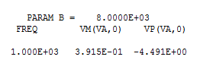
VL(t)= 0.39*cos(2000*pi*t-4.4) =0.39*sin(2000*pi+85.6)
$∅=$85.6
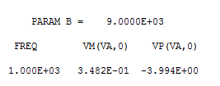
VL(t)= 0.34*cos(2000*pi*t-3.9) =0.34*sin(2000*pi+86.1)
$∅=$86.1

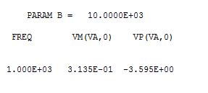
VL(t)= 0.31*cos(2000*pi*t-3.5) =0.31*sin(2000*pi+86.5)
$∅=$86.5
7)
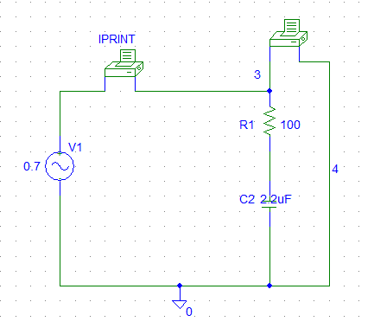
F=800Hz ,the output file has the magnitude of I and V.
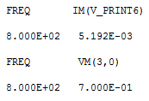
|Z|=|V|/|I|=0.7/5.192m=134.8ohm

F=1600Hz
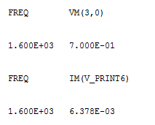
|Z|=|V|/|I|=0.7/6.378m=109.7ohm
F=3200Hz
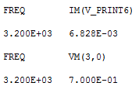
|Z|=|V|/|I|=0.7/6.828m=102.5ohm
F=6400Hz
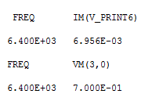
|Z|=|V|/|I|=0.7/6.956m=100.6ohm

Z Vs Freq
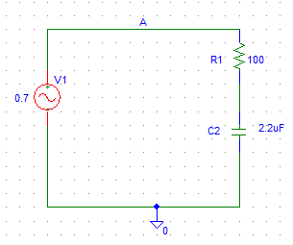

10.) 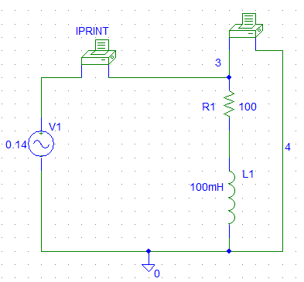
For f=50Hz, the Magnitude of current and voltage were obtained from the output file as below:-
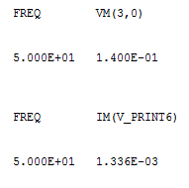
|Z|=|V|/|I| = 0.14/1.336m = 104.8 ohm

F=100Hz
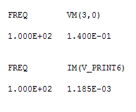
|Z|=|V|/|I|=0.14/1.185=118.1ohm
F=200Hz
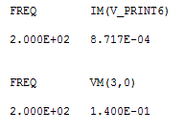
|Z|=|V|/|I|=0.14/0.8717m= 160.6ohm

F=400Hz
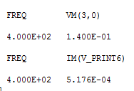
|Z|=|V|/|I|=0.14/0.5176m = 270 ohm

F=800Hz
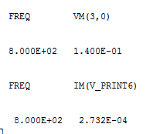
|Z|=|V|/|I|=0.14/0.2732m=512.4ohm
F=1600Hz
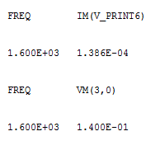

|Z|=|V|/|I|=0.14/0.0.1386m=1010ohm
Z Vs Freq

