Chapter 12 Sales/Collection Process

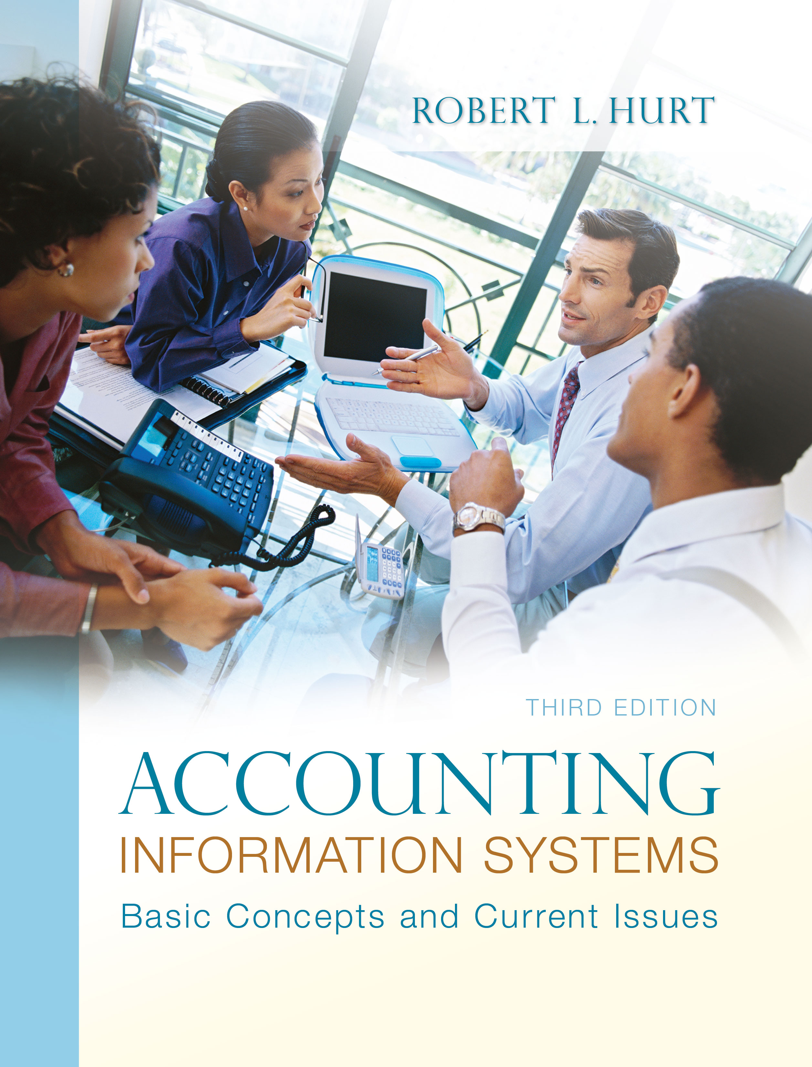
1. Reading review questions

a. What activities are accounted for in the sales / collection process? The sales / collection process accounts for activities associated with selling goods and services to clients, along with the related cash collections.

b. What are the steps in the sales / collection process? The process comprises seven steps: (1) Take a customer order. (2) Approve customer credit. (3) Fill the order based on approved credit. (4) Ship the product (if necessary). (5) Bill the customer. (6) Collect payment. (7) Process uncollectible receivables as necessary.

c. How are the five generic elements of the AIS exemplified in the sales / collection process? Inputs to the sales / collection process include customer orders. Processes include both the steps identified in (b) above, along with transaction processing steps in the accounting cycle. Outputs of the sales / collection process include invoices, accounts receivable aging reports and others. Data in the sales / collection process are stored in customer files, transaction files, inventory files and junction files.

d. What recordable transactions are commonly associated with the sales / collection process? How are they recorded in the AIS? Common transactions include: sales of inventory on account (debit accounts receivable and cost of goods sold, credit sales and inventory), cash collections on account (debit cash and credit accounts receivable), bad debt write-offs (debit allowance for bad debts, credit accounts receivable) and others.

e. What internal controls do organizations use in the sales / collection process? What risks do they address? Risks and related internal controls for the process include: granting credit to customers who are not creditworthy (separation of duties, established credit check procedures), inventory stock-outs (maintaining adequate inventory) and billing the customer incorrectly (document matching).

f. Respond to the questions for this chapter’s “AIS in the Business World.” I was very fortunate to have three assistants available to prepare responses to the AIS in the Business World vignettes for the third edition; I’ve posted their responses on my AIS blog: www.bobhurtais.blogspot.com.

2. Reading review problem

a. How does it align with the generic sales / collection process described in the chapter? The store “takes the customer’s order” when the customer brings in the package. Steps associated with credit approval and bad debts are irrelevant to this process, since the store does not extend credit directly. Filling the order is equivalent to preparing the shipment according to the customer’s wishes and choices. Dean does not have to bill the customer, but does collect payment via cash or credit card at the time of the transaction.

b. Which documents discussed in the chapter are exemplified? The written and / or electronic record of the transaction serves as the customer order; the store would fill out a bill of lading for the common carrier. When receipts are deposited, Dean would prepare a deposit slip for the bank.

c. What are AIM Mail Center’s risk exposures? What are Dean’s risk exposures? Corporate risk exposures include not collecting franchise fees from Dean, as well as potentially bad publicity if Dean and / or his employees make repeated mistakes. Dean, as a sole proprietor, has significant financial risk exposure since his business and personal finances are legally intertwined (although not intertwined for accounting purposes). He also runs the risks of: insufficient business, unhappy employees and product defects that result in damage to shipped goods.

d. What internal controls would you recommend to address the risks? Relevant internal controls include: proper training to avoid mistakes as much as possible, basing fees to the corporate office on revenues earned, insurance, a sound marketing plan and regular product inspections to detect and correct defects in shipping materials.

e. In a format specified by your instructor, document the business process.
A systems flowchart appears on the following page.
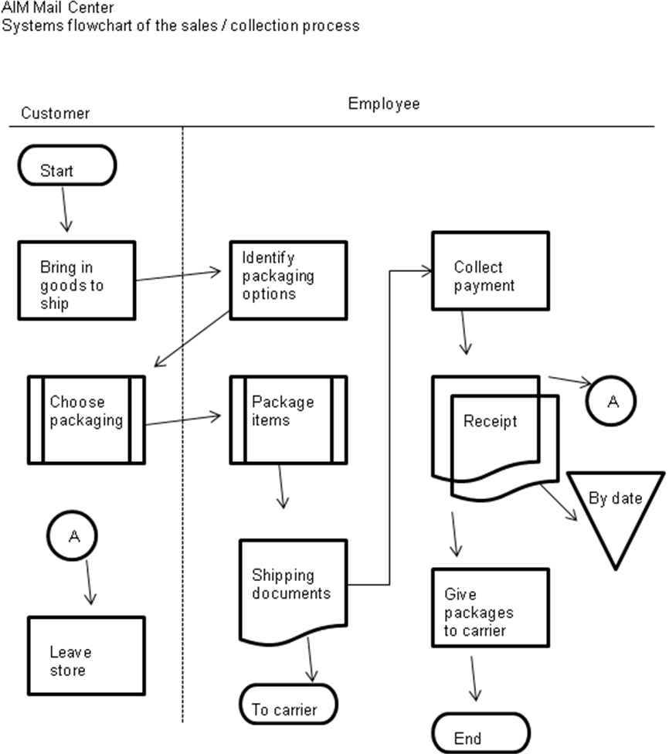

3. Multiple choice review questions. Answers to all of these questions appear at the end of the textbook itself.

4. Making choices and exercising judgment
The point of these exercises, which appear in every chapter throughout the third edition, is to encourage students to think critically and “outside the box.” Thus, I am not providing solutions to them, as doing so would likely discourage the purpose of these exercises.

5. Field exercises
Answers to these exercises will vary significantly; thus, like the previous set, I am not preparing published solutions for them.

6. Modeling sales / collection processes
a. Dave’s Pool Service

Dave
Client
Start
Perform services
Bill client
Invoice
Remit payment
Check
Deposit in bank
End

b. Nauertz Insurance

Assess needs
Write policy
Collect payment
Make bank deposit
Insurance options
Cash
Client
Owner
Employee
(1,1)
(1,*)
(1,1)
(1,*)
(1,1)
(0,*)
(1,1)
(1,*)
(1,1)
(1,1)
(1,1)
(1,*)
(1,1)
(1,*)
(0,*)
(1,1)
(0,*)
(1,1)
(1,1)
(1,*)
(1,*)
(0,*)
(1,1)
(1,1)
(1,*)
(1,1)

c. Answers will vary.

7. Transaction processing
a.

b. Net sales = ($1,000 + $900 + $2,000 + $1,100) - $20 = $4,980.
Cost of goods sold = $300 + $200 + $500 + $300 = $1,300.
Gross profit = $4,980 - $1,300 = $3,680.

c. All sales transactions would use a customer order and customer invoice. Cash collections on account would utilize a customer check and a remittance advice.

d. Additional database information would include: customer data (such as name and address) and inventory data (such as item names and quantities sold).

8. Internal controls

Item | Control | Nature | Purpose
a | Alarm system | Detective | Safeguard assets
 | Insurance | Corrective | Safeguard assets
b | Credit check | Preventive | Ensure reliable financial reporting
 | Conduct cash-only business | Preventive | Promote operating efficiency
c | Sprinkler system | Corrective | Safeguard assets
 | Insurance | Corrective | Safeguard assets
d | Echo check | Preventive / detective | Promote operating efficiency
 | Adequate supervision | Preventive / detective | Encourage compliance with management directives
e | Information technology | Preventive | Promote operating efficiency
 | Trial balance | Detective | Ensure reliable financial reporting
f | Independent checking | Detective / corrective | Safeguard assets
 | Adequate supervision | Detective / corrective | Safeguard assets
g | Adequate packing | Preventive | Safeguard assets
 | Insurance | Corrective | Safeguard assets
h | Adequate supervision | Preventive | Safeguard assets
 | Appropriate company policy | Preventive / corrective | Safeguard assets, encourage compliance with management directives
i | Lockbox system | Preventive | Safeguard assets; promote operating efficiency
 | Video surveillance | Preventive / detective | Safeguard assets
j | Document matching | Preventive | Promote operating efficiency
 | Adequate supervision | Preventive | Promote operating efficiency

9. Internal controls and risks
1. No.
2. Yes.
3. No.
4. Yes.
5. No.
6. Yes.
7. Yes.
8. No.
9. Yes.
10. No.

10. Internal controls
Internal control strengths include: follow-ups for delinquent accounts and the use of an external consultant to make recommendations for revision. The two main internal control weaknesses in this system are: the controller extends credit to customers (corrected by establishing a separate credit-granting function), differential credit arrangements based on highly subjective factors (establish a clear policy for granting credit).
Mooney’s actions are clearly in violation of the IMA Code of Ethics. Specific elements include: (a) provide decision support information and recommendations that are accurate, clear, concise, and timely, (b) recognize and communicate professional limitations or other constraints that would preclude responsible judgment or successful performance of an activity, (c) refrain from engaging in any conduct that would prejudice carrying out duties ethically, (d) abstain from engaging in or supporting any activity that might discredit the profession and (e) communicate information fairly and objectively.

11. Flowchart interpretation and internal controls analysis
The salesperson prepares four copies of a sales invoice, retaining one and sending three to the cashier. The cashier approves and processes the sale by assigning it a consecutive number and recording it in the cash register. The cashier sends the cash register tape to the assistant manager, who also has a copy of the validated invoice. The assistant manager uses the validated invoices, cash receipts and slips for return merchandise to prepare the bank deposit. The manager reviews the bank deposit and takes it to the bank. The manager also files the bank deposit documents by date. The assistant manager uses the cash register tape to prepare a report, which he reconciles with the other documents in his possession.
Internal control strengths in this system include: the use of serially-numbered documents, filing the bank deposit items by date and depositing cash in the bank. However, those strengths are minimal compared to the many weaknesses in the system. First, the cashier should not be approving the sale; approval should be delegated to a separate credit-granting department since the cashier is also handling the receipts. Second, the transaction number is assigned too late in the system. Under the current system, the salesperson and cashier could collude simply to remove invoices and receipts from the system; without consecutive numbering, there’d be virtually no way to detect that fraud. That problem would be easily corrected by assigning the transaction number automatically when invoices are created, or simply by using pre-numbered sales invoices from the start. In addition, the assistant manager has too much responsibility; handling the cash, invoices and return slips would facilitate theft, particularly since the assistant manager also prepares and reconciles the report regarding bank deposits. Correcting that issue would involve unbundling some of the assistant manager’s responsibilities, which would probably entail adding another person to the system.

12. Comprehensive problem
a. Here is a system’s flowchart of the case; it assumes the bank is outside the system boundary.

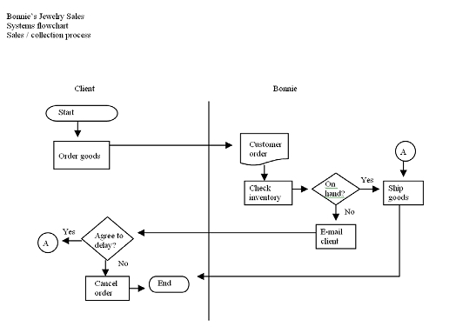

b. The following items are illustrative, not exhaustive:

Risk exposure | Existing control (if any) | Recommended control
Insufficient sales | None | Marketing plan
Damaged goods | Secure packing | Insurance
Failure to collect from clients | None | Require payment in advance and / or accept credit cards

c. Inventory table: inventory item number, item name, beginning quantity on hand, beginning date, beginning inventory cost per unit.

Customer table: customer ID, customer last name, customer first name, customer address, customer city, customer state, customer ZIP code, customer e-mail, customer area code, customer phone number, date of first order.

Sales / inventory table: Transaction ID, inventory item number, quantity sold, price per unit.

d. Responses will vary.

13. Terminology

1. B
2. E
3. C
4. G
5. A
6. D
7. H
8. F
9. I
10. J

14. Multiple choice questions
1. B
2. B
3. B
4. A
5. C

15. Statement evaluation
a. Sometimes true. If a company sells multiple products / services, a junction table would be required.
b. Never true.
c. Sometimes true. Many companies complete all the activities; some companies, however, specialize in a subset of the value chain activities. For example, Federal Express focuses on inbound & outbound logistics.
d. Sometimes true. Borrowing money is a good idea if the interest rate on debt is less than the implied interest rate from forgoing a cash discount.
e. Always true.
f. Always true.
g. Never true.
h. Sometimes true. In a well-designed internal control system, this statement is always true.
i. Sometimes true. A bill of lading is required if merchandise has to be shipped.
j. Sometimes true. Web sites can facilitate customer orders, but are not used in every firm.

16. Prior material application
a.
Framework element | ICE example
Internal environment | ICE’s executive board conducts a company retreat focused on ERM.
Objective setting | Generate revenue of at least $5,000.
Event identification | Too few people register to generate the required revenue.
Risk assessment | Moderate to high
Risk response | Reduce
Control activities | Conduct more seminars; increase the number of participants allowed in each seminar.
Information & communication | Publicize the plan among ICE employees via meetings and newsletters.
Monitoring | Create an executive board position specifically charged with monitoring the plan on a regular schedule.

b.
BPM principle | ICE example
Be open to alternatives. | Consider a more efficient method for processing registrations and payments, such as via the Internet.
Hire people who see the big picture. | Conduct periodic brainstorming sessions where employees can suggest new ideas for improving the process.
Avoid too much reliance on external consultants. | Create a digital “suggestion box” where employees can submit new ideas whenever they choose.
Communicate! | Provide feedback for suggestions not implemented, and acknowledge the source of those that are implemented.

c. Answers will vary significantly.

