

Faculty of Engineering – Mechanical Engineering Department

ENME436, MACHINE DESIGN 2

**Internal combustion engine**

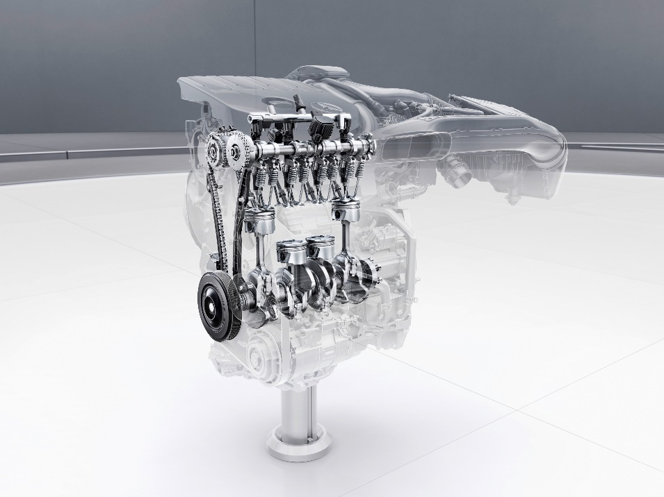

**Instructor: Dr. Rashad Mustafa**

Student name: Tayma Yasin 1142391

**Description**

An engine as machine designed one form of energy to mechanical energy , heat engines burn fuel to create heat which is then to do works it is a complex machine built up to convert from burning gas into the force that turn the wheels.

When the switch turn on the electric circuit between the battery and the starter motor is closed, the starter motor it’s an important for this charging system it allows the engine to reach the proper RPMs so as to initiate the engine’s operation under its own power the starter motor essentially transforms the electric energy into mechanical energy, its coupled to the flywheel which it turn to provide to transmit the motion to the crankshaft, now the combustion cycle takes place inside the engine cylinders so the starter motor is disconnected .

For four stroke engine it represents an example off efficiency and perfect synchronization it converts the explosions that occur inside its combustion chambers into motion the aim of this engine is to use this energy to provide movement and transfer it to the wheel so the vehicle can move it all takes place inside cylinders , the cylinder is basically the space through which the piston travels the purpose of the piston is to transfer force from expanding gas in the cylinder to crankshaft via piston rod or connecting rod so the back and forth linear motion the pistons is transformed into circular motion which can power the wheels.

The four stroke cycle, when a piston travels to the end of its range, whether up or down, that’s stroke. Car engines use a four stroke cycle, and it goes like this: first, intake. The piston descends, sucking an air-fuel mixture into the cylinder through the intake port, with both intakes valves open .next, compression. With all valves closed the piston comes buck up compressing the fuel and air mixture for more powerful combustion. Then, the power stroke, an electrical spark ignites the compressed fuel and air mixture, and the resulting combustion forces the piston to the bottom of the cylinder again. A connecting rod transfer this power to the crankshaft. Finally, exhaust. The piston comes back up, pushing the spent mixture out through open exhaust valves and exhaust port. Connecting multiple pistons, for smooth power delivery, piston take turns firing.

Camshafts with specially shaped cams push spring loaded valves open it turn.cm gears and the timing belt or chain links everything to the crank shaft, and all spins together, the crankshaft translates the piston out of the engine it has counter weight to balance the pistons for perfectly smooth revolution’s, this RPMs means, we are counting the number of full crankshaft revolutions per minute.

**Components**

Crank shaft

A crankshaft is a [shaft](https://en.wikipedia.org/wiki/Shaft_(mechanical_engineering)) driven by a [crank](https://en.wikipedia.org/wiki/Crank_(mechanism)) mechanism consisting of a series of cranks and [crankpins](https://en.wikipedia.org/wiki/Crankpin) to which the [connecting rods](https://en.wikipedia.org/wiki/Connecting_rod) of an engine is attached. It is a mechanical part able to perform a conversion between [reciprocating motion](https://en.wikipedia.org/wiki/Reciprocating_motion) and [rotational motion](https://en.wikipedia.org/wiki/Rotational_motion). In a [reciprocating engine](https://en.wikipedia.org/wiki/Reciprocating_engine), it translates [reciprocating motion](https://en.wikipedia.org/wiki/Reciprocating_motion) of the [piston](https://en.wikipedia.org/wiki/Piston) into rotational motion, whereas in a [reciprocating compressor](https://en.wikipedia.org/wiki/Reciprocating_compressor), it converts the rotational motion into reciprocating motion. In order to do the conversion between two motions, the crankshaft has "crank throws" or "crankpins"[[clarification needed](https://en.wikipedia.org/wiki/Wikipedia:Please_clarify)], additional bearing surfaces whose axis is offset from that of the crank, to which the "big ends" of the [connecting rods](https://en.wikipedia.org/wiki/Connecting_rod) from each cylinder attach.

It is typically connected to a [flywheel](https://en.wikipedia.org/wiki/Flywheel) to reduce the pulsation characteristic of the [four-stroke cycle](https://en.wikipedia.org/wiki/Four-stroke_cycle), and sometimes a [torsional](https://en.wikipedia.org/wiki/Torsion_(mechanics)) or vibrational damper at the opposite end, to reduce the [torsional vibrations](https://en.wikipedia.org/wiki/Torsional_vibration) often caused along the length of the crankshaft by the cylinders farthest from the output end acting on the torsional elasticity of the metal.

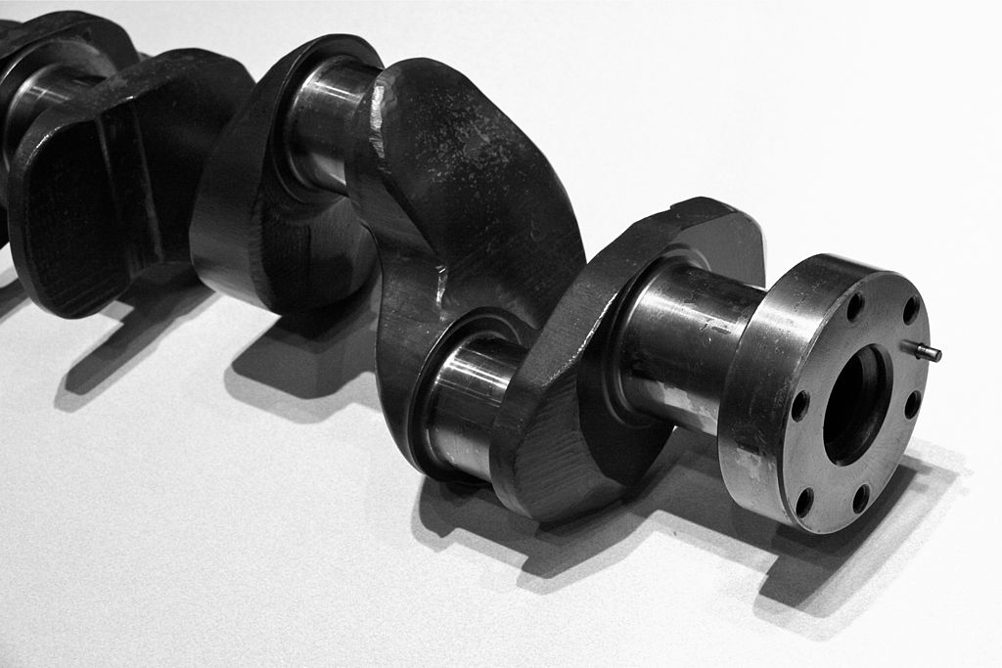

Figure crankshaft

Cam shaft

The camshaft is a rotating object— usually made of metal— that contains pointed [cams](https://en.wikipedia.org/wiki/Cam), which converts rotational motion to reciprocal motion. Camshafts are used in internal combustion engines (to operate the intake and exhaust valves). Mechanically controlled ignition systems and early electric motor speed controllers. Camshafts in automobiles are made from steel or cast iron, and are a key factor in determining the RPM range of an engine's [power band](https://en.wikipedia.org/wiki/Power_band).

The key parts of any camshaft are the lobes. As the camshaft spins, the lobes open and close the intake and exhaust valves in time with the motion of the piston. It turns out that there is a direct relationship between the shape of the cam lobes and the way the engine performs in different speed ranges.

To understand why this is the case, imagine that we are running an engine extremely slowly -- at just 10 or 20 revolutions per minute (RPM) -- so that it takes the piston a couple of seconds to complete a cycle. It would be impossible to actually run a normal engine this slowly, but let's imagine that we could. At this slow speed, we would want cam lobes shaped so that

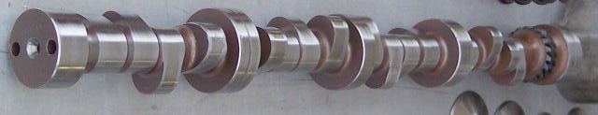

Figure camshaft

Piston

A piston is a component of [reciprocating engines](https://en.wikipedia.org/wiki/Reciprocating_engine), reciprocating [pumps](https://en.wikipedia.org/wiki/Pump), [gas compressors](https://en.wikipedia.org/wiki/Gas_compressor), [hydraulic cylinders](https://en.wikipedia.org/wiki/Hydraulic_cylinder) and [pneumatic cylinders](https://en.wikipedia.org/wiki/Pneumatic_cylinder), among other similar mechanisms. It is the moving component that is contained by a [cylinder](https://en.wikipedia.org/wiki/Cylinder_(engine)) and is made gas-tight by [piston rings](https://en.wikipedia.org/wiki/Piston_ring). In an engine, its purpose is to transfer force from expanding gas in the cylinder to the [crankshaft](https://en.wikipedia.org/wiki/Crankshaft) via a [piston rod](https://en.wikipedia.org/wiki/Piston_rod) and/or [connecting rod](https://en.wikipedia.org/wiki/Connecting_rod). In a pump, the function is reversed and force is transferred from the crankshaft to the piston for the purpose of compressing or ejecting the [fluid](https://en.wikipedia.org/wiki/Fluid) in the cylinder. In some engines, the piston also acts as a [valve](https://en.wikipedia.org/wiki/Valve) by covering and uncovering [ports](https://en.wikipedia.org/wiki/Porting_(engine)#Two-stroke_porting) in the cylinder.

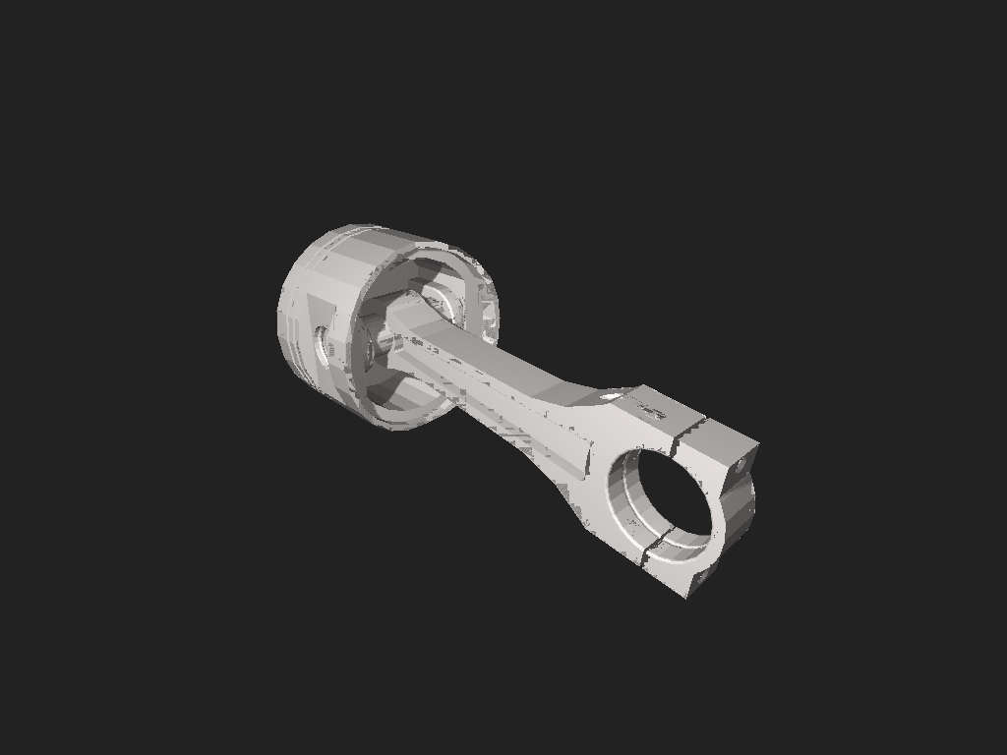

Figure piston

Head cylinder

In an [internal combustion engine](https://en.wikipedia.org/wiki/Internal_combustion_engine), the cylinder head (often abbreviated to simply "head") sits above the [cylinders](https://en.wikipedia.org/wiki/Cylinder_(engine))[[1]](https://en.wikipedia.org/wiki/Cylinder_head#cite_note-Wright_2015_p._310-1) and forms the roof of the [combustion chamber](https://en.wikipedia.org/wiki/Combustion_chamber).

In [side valve engines](https://en.wikipedia.org/wiki/Sidevalve_engine), the head is a simple sheet of metal; whereas in more modern [overhead valve](https://en.wikipedia.org/wiki/Overhead_valve_engine) and [overhead camshaft](https://en.wikipedia.org/wiki/Overhead_camshaft_engine) engines, the cylinder head is a more complicated block often containing inlet and exhaust passages, coolant passages, [valves](https://en.wikipedia.org/wiki/Poppet_valve#Usage_in_internal_combustion_engines), [camshafts](https://en.wikipedia.org/wiki/Camshaft), [spark plugs](https://en.wikipedia.org/wiki/Spark_plug) and [fuel injectors](https://en.wikipedia.org/wiki/Fuel_injection#Direct_injection).

Most [straight engines](https://en.wikipedia.org/wiki/Straight_engine) have a single cylinder head shared by all of the cylinders and most [V engines](https://en.wikipedia.org/wiki/V_engine) have two cylinder heads (one per bank of cylinders).

Most modern engines with a ["straight" (inline) layout](https://en.wikipedia.org/wiki/Straight_engine) today use a single cylinder head that serves all the cylinders. Engines with a ["V" layout](https://en.wikipedia.org/wiki/V_engine) or ["flat" layout](https://en.wikipedia.org/wiki/Flat_engine) typically use two cylinder heads (one for each [cylinder bank](https://en.wikipedia.org/wiki/Cylinder_bank)), however a small number of 'narrow-angle' V engines (such as the Volkswagen [VR5](https://en.wikipedia.org/wiki/VR5_engine) and [VR6](https://en.wikipedia.org/wiki/VR6_engine) engines use a single cylinder head spanning the two banks. Most [radial engines](https://en.wikipedia.org/wiki/Radial_engine) have one head for each cylinder, although this is usually of the [monobloc](https://en.wikipedia.org/wiki/Monobloc_engine#Cylinder_head) form wherein the head is made as an integral part of the cylinder. This is also common for motorcycles, and such head/cylinder components are referred to as barrels.

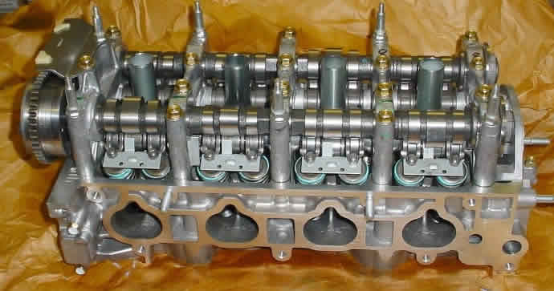

Figure cylinder head

**Selected components**

* Starter gear (pinion) with flywheel (gear).

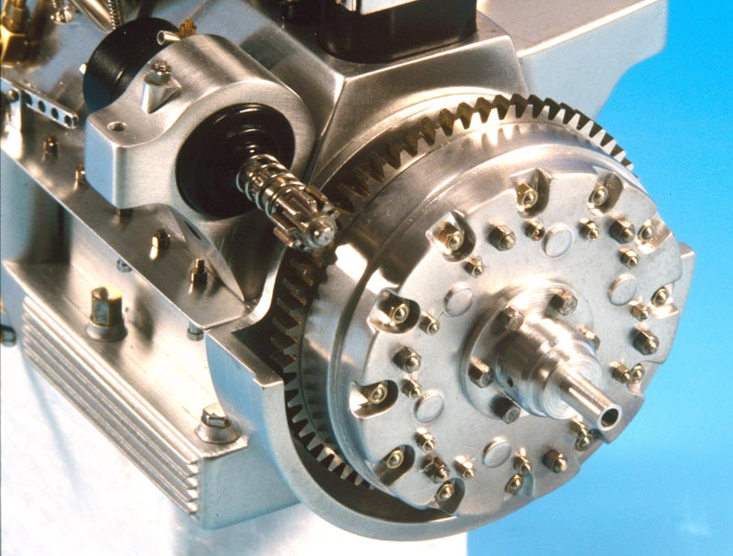

Figure starter gear with flywheel

**Calculation:**

Make the a priori decisions:

* Engine 282 (107hp, 1375rpm)
* Starter motor (12V)
* (Gear ratio)[1]
* Quality number $(Q_{v}=11)$
* Tooth system $∅n=20°,φ=30°$
* Design factor for unquantifiable $nd=2$
* (Reliability =0.99)

Pinion & gear are helical type:

To check interference and find number of teeth for pinion (NP) & number of teeth for gear (NG).

Apply case 2: mating gear has more teeth than the pinion.

The smallest number of teeth on a helical-spur pinion without interference (equation 13-22):

$$NP=\frac{2k \cos{φ}}{\left(1+2mg\right) \sin^{2}{∅t}} \left[mg+\sqrt{{mg}^{2}+\left(1+2mg\right)\sin^{2}{∅t}}\right]$$

Find $∅t$ (equation 13-19)

$∅t= \tan^{-1}\left(\frac{\tan{∅n}}{\cos{φ}}\right)=22.7°$

$$for k=1 full depth with normal pressure angle ∅n=20°, helix angle φ=30°$$

$$NP=\frac{2*1* \cos{30}}{\left(1+2*15\right) \sin^{2}{22.7}} \left[15+\sqrt{{15}^{2}+\left(1+2*15\right)\sin^{2}{22.7}}\right]=12.03≈12 teeth$$

(Equation 13-23)

$$NG=\frac{{NP}^{2}*\sin^{2}{∅t}-4k \cos^{2}{φ}}{4k \cos{φ-2NP}*\sin^{2}{∅t}}= \frac{{12}^{2}*\sin^{2}{22.7}-4 \cos^{2}{30}}{4 \cos{30-2*12}*\sin^{2}{22.7}}=164.83≈165 teeth$$

Design decisions:

Transverse Diametral pitch $Ptd=4.5 teeth/inch$

Assume normal diametral pitch $Pnd=5.19 teeth/inch$

From equation (13-1) find pitch diameter for pinion $dp$

$$Pd=\frac{Np}{dp} , from this dp=\frac{12}{4.5}=2.67 in$$

Find pitch diameter for gear (flywheel) $dg$

$$Pd=\frac{Ng}{dg} , from this dg=\frac{165}{4.5}=36.67in$$

From equation (13-34) find pitch-line velocity

$$V=\frac{π*dp*n}{12}$$

$$d=gear diameter, in$$

$$n=gear speed, rev/min$$

$$V=\frac{π*2.67*1375}{12}=925.71 ft/min$$

**Free body diagram for pinion:**

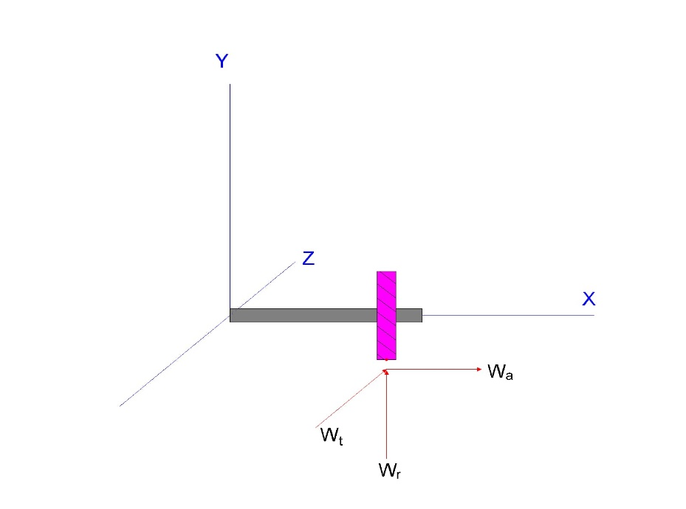

Figure forces analysis for pinion

From equation (13-35) find transmitted load

$$Wt=\frac{33000*H}{V}$$

$$H=power, hp$$

$$V= pitch-line velocity, ft/min$$

(Cold cranking amps (CCA). This is the amount of current the battery can put out while starting the car at 0 °C)[2]

The number of CCA and it takes 3 s to start the car, $P=CCA*T*V=12*800*3=28.8 Kw=38.6 hp$

$$Wt=\frac{33000*38.6}{925.71}=1376.02 ibf$$

From equation (13-40) find radial & axial component.

$$Wr=Wt \tan{∅t=}1376.02*\tan{22.7=575.6 ibf}$$

$$Wa=Wt \tan{φ=1376.02*\tan{30=794.44 ibf}}$$

**Factor of safety in bending (equation 14-41)**

$$Sf=\frac{{St*YN}/{KT*KR}}{σ}$$

Where

$$σ=bending stress.$$

$${St*YN}/{KT*KR}=fully corrected bending strength.$$

**Pinion bending stress equation (14–15)**

$$σ=Wt K_{o}K_{v}K_{s}\frac{Pd}{F}*\frac{K_{m }K_{B}}{J} (U.S customary units)$$

$$K_{o}=overload factor$$

So $(K_{o}=1.25 from table of overload factors )$

$$K_{v}=dynamic factor$$

From equation (14-27)

$$K_{v}=\frac{A+\sqrt{V}}{A}=\frac{92+\sqrt{925.71}}{92}=1.33$$

Find A&B from equation (14-28)

$$B=0.25*{\left(12-Q_{v}\right)}^{\frac{2}{3}}=0.25*{\left(12-11\right)}^{\frac{2}{3}}=0.25$$

$$A=50+56\left(1-B\right)=50+56\left(1-0.25\right)=92$$

$$K_{s}=size factor$$

From equation (a) in section 14-10

$$K_{s}=1.192{\left(\frac{F\sqrt{Y}}{Pd}\right)}^{0.0535}$$

$$Y=lewis factor from table (14-2)$$

$$F=face width narrowest member$$

$$Pd=diametral pitch$$

From the recommendation 3*p* ≤ *F* ≤ 5*p*

Select a median face width for this pitch $4.3π/Ptd$

$$F=3 in$$

$$Y=0.245 from (table 14-2) for pinion$$

$${\left(K_{s}\right)}_{P}=1.192{\left(\frac{3\sqrt{0.245}}{4.5}\right)}^{0.0535}=1.12$$

$$K_{m}=load-disrubation factor$$

$$K_{m}=1+C_{mc}(C_{pf}C_{pm}+C_{ma}C_{e})$$

$(C_{mc}=1)$ From equation (14-31)

From equation (14-32) when 1 < F ≤ 17 in

$$C_{pf}=\frac{F}{10*dP}-0.0375+0.0125F$$

$$C_{pf}=\frac{3}{10*2.67}-0.0375+0.0125*3=0.11$$

${(C}_{pm}=1.1)$ From equation (14-33)

$C_{ma}=A+BF+CF^{2}$, where A, B and C from table 14-9

$$(A=0.0675,B=0.0128,C=-0.926{*10}^{-4})$$

$$C_{ma}=0.127 +0.0158*3-0.930*{10}^{-4}*3^{2}=0.17$$

$$C_{e}=1 for all condition$$

So $$K_{m}=1+1*\left(0.11*1.1+0.17*1\right)=1.34$$

$$K_{B}=Rim Thickness Factor=1$$

(From equation (14-40), $mB≥1.2)$

$$J=geomtry factor$$

$Jp'=Jp*J'$

$$J^{'}=0.9 from figure \left(14-8\right),Jp=0.4 from figure (14-7)$$

$$Jp^{'}=0.9*0.4=0.36$$

$$St=Allowable bending stress.$$

(Grade 1 indication hardened with surface &bore hardness 320) [3]

Using figure (14-2)

(Choose equation: from figure (14-14))[4]

From table (14-10)

$$K_{R}=reliability factor=1$$

$${(K}_{T}=temprature factor=1)$$

**Solving for the face width *(F)* bend necessary to resist bending fatigue, we obtain**

$$F bend =ndWt K_{o}K_{v}K_{s}Pd\frac{KT*KR}{St*YN}*\frac{K_{m }K_{B}}{J}$$

$$F bend =2*1376.02*1.25*1.33* 1.12*4.5*\frac{1}{37536*0.937}*\frac{1.34*1}{0.36}=2.4inch$$

**Factor of safety in contact (equation 14-42)**

$$SH=\frac{{Sc*ZN*CH}/{KT*KR}}{σ_{C}}$$

Where

$$σc=contact stress.$$

$${Sc*ZN*CH}/{KT*KR}=fully corrected contact strength.$$

**Pinion contact stress equation (14–16)**

$$σc=Cp\sqrt{Wt K_{o}K_{v}K_{s}\frac{K_{m }}{dp*F}*\frac{Cf}{I}} (U.S customary units)$$

$$Cp=elastic coefficien$$

From table (14-8), $Cp=2300 psi$

$$K_{o}=1.25 ,K_{v}=1.33 , K_{m}=1.22 , dp=2.67 in , F=3 in , N={10}^{9} the same of previous$$

$$(Cf=surface condition factor=1 )$$

$$I=geomtry factor$$

From equation (14-23)

$$I=\frac{\cos{∅t \sin{∅t*mg }}}{2mN*(mg+1)}$$

$$mN=\frac{Pn}{0.95Z}$$

Used equation (14-25)

Where $Z=\sqrt{\left[{\left(rp+a\right)}^{2}-{rbp}^{2}\right]}+\sqrt{\left[{\left(rg+a\right)}^{2}-{rbg}^{2}\right]}-\left(rp+rg\right)\sin{∅t}$

$${\left(rb\right)}_{P}=rp*\cos{∅t=\frac{2.67}{2}}*\cos{22.7=1.23in}$$

$${\left(rb\right)}_{g}=rg*\cos{∅t=\frac{36.67}{2}}*\cos{22.7=16.91 in}$$

$$a=\frac{1}{Pn}=\frac{1}{5.19}=0.19 in$$

$$Z=\sqrt{\left[{\left(1.335+0.19\right)}^{2}-{1.23}^{2}\right]}+\sqrt{\left[{\left(18.335+0.19\right)}^{2}-{16.91}^{2}\right]}-\left(1.335+18.335\right)\sin{22.7}=0.90$$

$$so Z=0.90$$

$$mN=\frac{\frac{π}{5.196}\cos{20}}{0.95*0.90}=0.59$$

$$I=\frac{\cos{22.7 \sin{22.7*15 }}}{2*0.59*(15+1)}=0.28$$

Also $Sc=Allowable contact stress.$

(Grade 1 indication hardened with surface &bore hardness 320) [5]

From figure (14-5)

$$Sc=322*320+29100=322*250+29100=132140 psi$$

$$ZN=stress cycle factor$$

(Choose equation: $ZN=1.4488 N^{-0.023}$ from figure (14-14))[6]

From equation (14-36)

$$CH=1.0+A'(mg-1)$$

$$\frac{HBP}{HBG}=1 , <1.2 , where A^{'}=0$$

$$so CH=1$$

**Solving for the face width *(F)* bend necessary to resist contact fatigue, we obtain**

$$F contact=ndWt K_{o}K_{v}K_{s}{\left(\frac{CP*ZN}{Sc*KR*KT}\right)}^{2}*\frac{K_{m }Cf}{dp*I}$$

$$F contact=2*1376.02*1.25*1.33*{1.12*\left(\frac{2300*0.899}{132140*1}\right)}^{2}*\frac{1.22*1}{2.67*0.28}= 2.3 in$$

Make face width =2.5 in, recalculate $K_{m },K_{s}$

$$C_{pf}=\frac{2.5}{10*2.67}-0.0375+0.0125*2.5=0.087$$

${(C}_{pm}=1.1)$ From equation (14-33)

$C_{ma}=A+BF+CF^{2}$, where A, B and C from table 14-9

$$(A=0.0675,B=0.0128,C=-0.926{*10}^{-4})$$

$$C_{ma}=0.127 +0.0158*2.5-0.930*{10}^{-4}*{2.5}^{2}=0.17$$

$$C_{e}=1 for all condition$$

So $$K_{m}=1+1*\left(0.09*1.1+0.17*1\right)=1.26$$

$${\left(K_{s}\right)}_{P}=1.192{\left(\frac{2.5\sqrt{0.245}}{4.5}\right)}^{0.0535}=1.11$$

$$σ=1376.02*1.25*1.33*1.11\frac{4.5}{2.5}*\frac{1.26*1}{0.36}=15997.4 psi$$

$$Sf=\frac{{St*YN}/{KT*KR}}{σ}=\frac{{37536*0.937}/{1*1}}{15997.4}=2.19$$

**Factor of safety of bending for gear (flywheel) (equation 14-41)**

**Free body diagram for gear:**

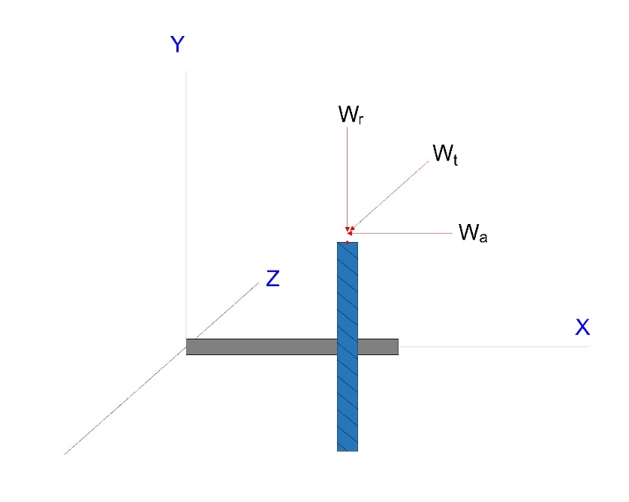

Figure forces analysis for gear

Bending stress for gear

$$σ=Wt K_{o}K_{v}K_{s}\frac{Ptd}{F}*\frac{K_{m }K_{B}}{J}$$

From table (14-12) Y=0.742 when N=300

Y=0.460 2hen N=150

Need interpolation to find Y for NG=165

$$Y=Y1+\frac{X-X1}{X2-X1}*(Y2-Y1)$$

$$Y=0.46+\frac{165-150}{300-150}*\left(0.472-0.46\right)=0.4612$$

$${\left(K_{s}\right)}_{G}=1.192{\left(\frac{2.5\sqrt{0.4612}}{4.5}\right)}^{0.0535}=1.13$$

$Jg'=Jg*J'$

$$J^{'}=1.0 from figure \left(14-8\right),Jp=0.85 from figure (14-7)$$

$$Jg^{'}=0.85*1.0=0.85$$

$$K_{m}=load-disrubation factor$$

$$K_{m}=1+C_{mc}(C_{pf}C_{pm}+C_{ma}C_{e})$$

$(C_{mc}=1)$ From equation (14-31)

From equation (14-32) when 1 < F ≤ 17 in

$$C_{pf}=\frac{F}{10*dP}-0.0375+0.0125F$$

$$C_{pf}=\frac{2.5}{10*2.67}-0.0375+0.0125*2.5=0.087$$

${(C}_{pm}=1.1)$ From equation (14-33)

$C_{ma}=A+BF+CF^{2}$, where A, B and C from table 14-9

$$(A=0.0675,B=0.0128,C=-0.926{*10}^{-4})$$

$$C_{ma}=0.0675+0.0128*2.5-0.926*{10}^{-4}*{2.5}^{2}=0.098$$

$$C_{e}=1 for all condition$$

So $$K_{m}=1+1*\left(0.087*1.1+0.098*1\right)=1.2$$

$$K_{v},K_{o},Pd, F,K_{B} the same of pinion$$

(Grade 1 indication hardened with surface &bore hardness 320) [7]

Using figure (14-2)

(Choose equation: from figure (14-14))[8]

The factor of safety of the gear in bending is

$$Sf=\frac{{37536*0.983}/{1*1}}{6569}=5.6$$

**Factor of safety of contact for gear (flywheel) (equation 14-41)**

$$σc=Cp\sqrt{Wt K_{o}K_{v}K_{s}\frac{K_{m }}{dp*F}*\frac{Cf}{I}}$$

$$Cp=elastic coefficien$$

From table (14-8), $Cp=2300 psi$

$$K_{o}=1.25 ,K_{v}=1.33 , K_{m}=1.2 , dp=2.67 in , F=2.5 in , N={10}^{9},I=0.28 the same of previous$$

$$(Cf=surface condition factor=1 )$$

$$ZN=1.4488 {({10}^{9}/15)}^{-0.023}=0.957$$

$$σc=2300\sqrt{1376.02*1.25*1.33*1.13*\frac{1.22}{2.67*2.5}*\frac{1}{0.28}}=94479.05$$

$$SH=\frac{{132140*0.957}/1}{94479.05}=1.33$$

* Design bearing of crankshaft

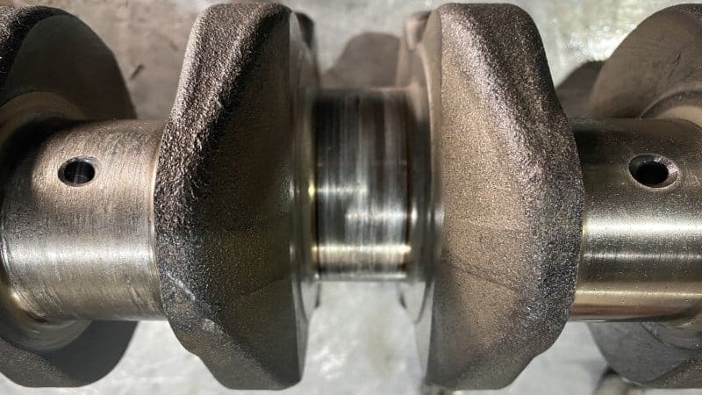

Figure 2 bearing in the crank shaft

**Free body diagram:**

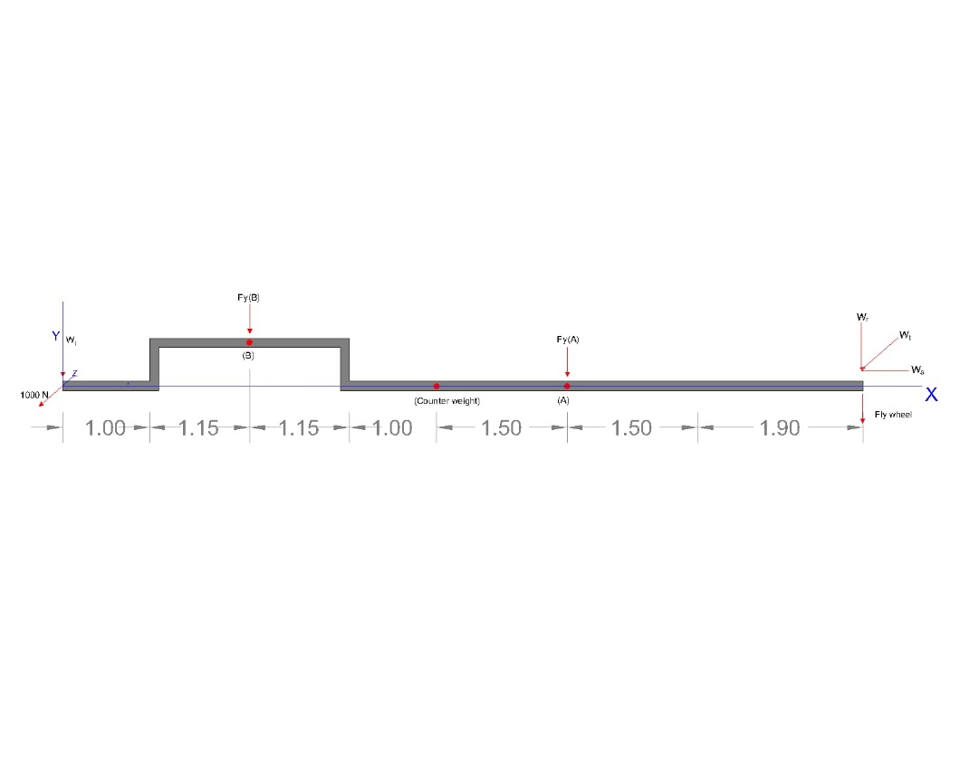

Figure free body diagram of bearings

**Calculation:**

**Force analysis**

Diameter of bearing A =3inch

Diameter of bearing A =2.3inch

Forces in flywheel $Wt=1376.02 ibf , Wr=575.6 ibf ,Wa=794.44 ibf$

Assume $force in sprocket =1000 ibf$

$$\sum{{MA}_{Y}=0 }$$

$${FB}_{y}*\left(1.9+1+1.5\right)=575.6\left(1.9+1.5\right)$$

$${FB}_{y}=536.17 ibf$$

$$\sum{F_{y}=0 }$$

$${FB}_{y}+{FA}_{y}+575.6=0$$

$${FA}_{y}=1111.77 ibf$$

$$\sum{{MA}_{Z}=0 }$$

$${FB}_{Z}*\left(1.9+1+1.15\right)=1376.02\left(3.4\right)+1000$$

$${FB}_{Z}=1555.7 ibf$$

$$\sum{F_{Z}=0 }$$

$${FB}_{Z}+{FA}_{Z}+1376.02=0$$

$${FA}_{Z}=2931.7 ibf$$

Assume On bearing B there’s force from piston (F1) =2000 ibf

**Select suitable single-row tapered roller Timken bearings:**

Radial force in bearing A

$$FrA={\left({{FA}_{y}}^{2}+{{FA}_{Z}}^{2}\right)}^{1/2}= {\left(({1111.7}^{2}+{2931.7}^{2}\right)}^{1/2}=3135.4ibf$$

Radial force in bearing B

$$FrB={\left({{FB}_{y}}^{2}+{{FB}_{Z}}^{2}\right)}^{1/2}= {\left({(536.17+2000)}^{2}+{1555.7}^{2}\right)}^{1/2}=2975.29 ibf$$

Trial 1*:* With direct mounting of the bearings and application of the external thrust to the shaft, the squeezed bearing is bearing *A,* Using *K* =1.5 as the initial guess:

$$FiA=\frac{0.47*FrA}{1.5}=\frac{0.47*3135.4}{1.5}=982.4 ibf$$

$$FiB=\frac{0.47*FrB}{1.5}=\frac{0.47*2975.29}{1.5}=932.25 ibf$$

$$Fae=794.44ibf$$

Since $FiA$ is clearly less than $FiB+Fae$, bearing A carries the net thrust load,

$$984.4<1726.69$$

From equation (11-17a), (11-17b)

$$FeB=0.4*FrB+KA \left(FiA-Fae\right)=0.4*2975.29+1.5 \left(982.4-794.44\right)=1472.056 ibf$$

$$FeA=FrA=3135.4 ibf$$

Priori decision:

* Design life is to be 10 kh and an application factor of 1 is appropriate.
* Reliability of the bearing set is to be 0.99.
* Timken life = $90*{10}^{6}$

$$To find speed of shaft = 2*3.2 *1375 *\frac{1revloation }{27π}= 1023.4 rpm$$

$$Life rating \left(XD\right)=\frac{LD}{LR}=\frac{lD*nD*60}{LR}=\frac{10*{10}^{3}*1023*60}{90*{10}^{6}}=6.82$$

$$For reliability of each bearing =0.995$$

To calculate load rating

$$C_{10}=af*FD {\left[\frac{XD}{xo+(θ-x0){(1-R)}^{1/b}}\right]}^{a}$$

From table (11-6)

$$θ=4.459 , xo=0.02, b=1,483$$

For roller bearing a=3/10

For bearing A

$$C_{10}=1*3135.4{\left[\frac{6.84}{0.02+\left(4.459-0.02\right){\left(1-0.995\right)}^{\frac{1}{1.483}}}\right]}^{\frac{3}{10}}=9970.5 ibf$$

For bearing B

$$C_{10}=1*1472.56 {\left[\frac{6.84}{0.02+\left(4.459-0.02\right){\left(1-0.995\right)}^{\frac{1}{1.483}}}\right]}^{\frac{3}{10}}=1671.09 ibf$$

From table (11-6)

For bearing B

From catalogue (cone 30205,Cup 30205)

* **Design flexible element (roller chain)**

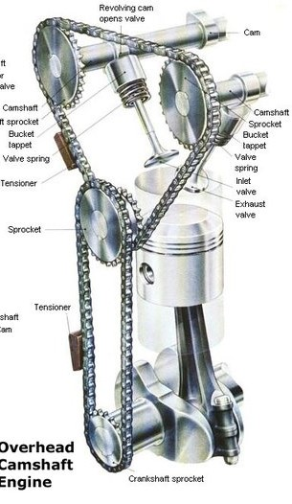

Figure (roller chain in IC)

**Calculation:**

Priori decisions:

* Velocity ratio 3:1 reduction
* N=1375rpm
* For the input power it’s not the same for output power of engine it will lost horse power in combustion , assume input sprocket =80hp
* Good lubrication
* Design factor $nd =2$

$$power nominal Hnom=80 hp$$

$$sprocket teeth N1=17 teeth , N2=51 teeth$$

From equation (17-37)

$power allowable Ha=K1*K2*Htab$

From equation (17-38)

$$design power Hd= Hn*Ks*nd$$

$$assume Hd=Ha$$

$$so Htab=\frac{nd*ks*Hn}{K1*K2}$$

$$K1 :correction factor for tooth number other than 17$$

$$so K1= 1$$

$$\left(Ks=1.3 \right)$$

$$Htab=\frac{2*1.3*80}{1*K2}=\frac{208}{K2}$$

From table (17-23)

$$K2 = strand correction , assume its single$$

$$so Htab=208$$

$$(For the speed of sprocket =\frac{Power output}{Torque }=\frac{100KW}{200}=500 rpm)$$

Used table (17-20) to select chain number

ANSI number =200 type C’

$$K2 = strand correction , assume its double$$

$$so Htab=\frac{208}{1.7}=122.3$$

ANSI number =180 type C’

$$K2 = strand correction , assume its tripple$$

$$so Htab=\frac{208}{2.5}=83.2$$

ANSI number =140 type C, this type is suitable because its oil steam lubrication, also type C’ galling region.

# References

* 1. [*"Racing Piston Technology – Piston Weight And Design – Circle Track Magazine"*](http://www.hotrod.com/articles/ctrp-0708-advanced-piston-technology/)*. Hot Rod Network. 2007-05-31. Retrieved 2018-04-22.*

1. Wright, G. (2015). [*Fundamentals of Medium/Heavy Duty Diesel Engines*](https://books.google.com/books?id=s5_OCwAAQBAJ&pg=PA310). Jones & Bartlett Learning. p. 310. [ISBN](https://en.wikipedia.org/wiki/ISBN_(identifier)) [978-1-284-06705-7](https://en.wikipedia.org/wiki/Special:BookSources/978-1-284-06705-7). Retrieved 2020-11-07.
2. *Bautista Paz, Emilio; Ceccarelli, Marco; Otero, Javier Echávarri; Sanz, José Luis Muñoz (2010). A Brief Illustrated History of Machines and Mechanisms. Springer (published May 12, 2010). p. 19.*[*ISBN*](https://en.wikipedia.org/wiki/ISBN_(identifier))[*978-9048125111*](https://en.wikipedia.org/wiki/Special:BookSources/978-9048125111)*.*
3. <https://auto.howstuffworks.com/camshaft.htm>
4. <https://www.wikiwand.com/en/Mercedes-Benz_M282_engine>

1. (The gear ratio between the driven pinion and the flywheel is usually about 15 to 1), *http://www.tpub.com/engine3/en32-93.htm.*
2. CCA =800A from catalogue , *https://www.batterypete.com/big-batteries/agm-batteries/agm-car-and-truck-batteries/exide-edge-flat-plate-agm-battery-fp-agml4-94r/*
3. Induction hardening is effective to harden tooth areas including tooth surface and the tip. That’s important for starter pinion, Grade 2 has high strength and core hardness, high precision components it important in this type of cars. Medium core &surface hardness.
4. Less conservative and more factor of safety important of engine.
5. Induction hardening is effective to harden tooth areas including tooth surface and the tip. That’s important for starter pinion, Grade 1 has high strength and core hardness, high precision components it important in this type of cars. Medium core &surface hardness.
6. Less conservative and more factor of safety important of engine.
7. Induction hardening is effective to harden tooth areas including tooth surface and the tip. That’s important for starter pinion, Grade 1 has high strength and core hardness, high precision components it important in this type of cars. Medium core &surface hardness.
8. Less conservative and more factor of safety important of engine.