Chapter 06 Flowcharting

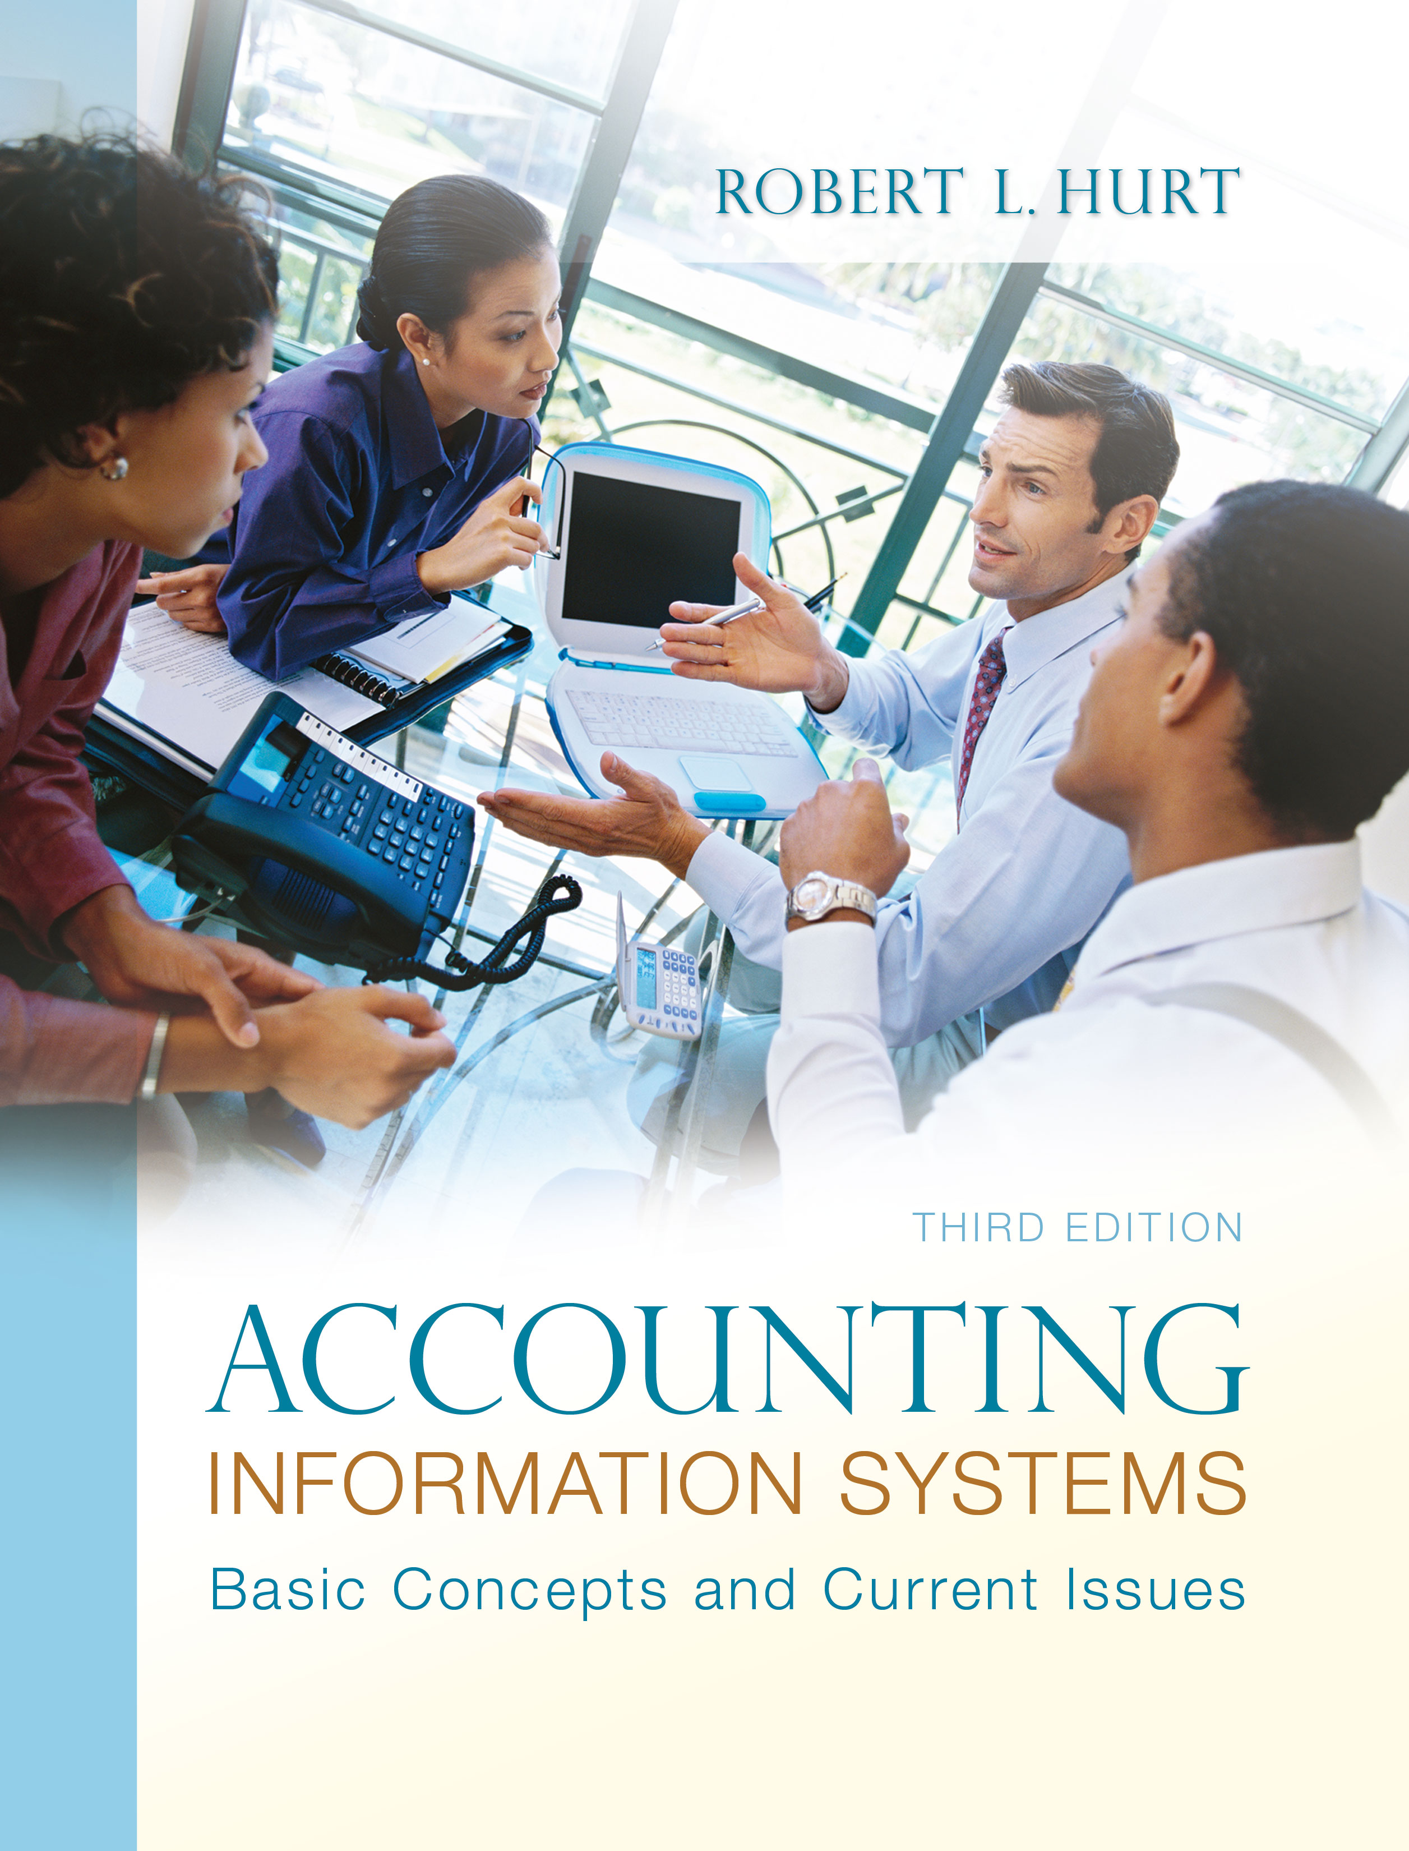

1. Reading review questions

a. What is a flowchart? Describe four different kinds of flowcharts and explain which are most often used in an accounting information system. A flowchart is one form of systems documentation used in accounting information systems. Flowcharts come in at least four varieties: systems (give a “big picture” look at a business process), document (show the flow of a document through a system), hardware (map the hardware components of a system along with their relationships to one another) and program (describe the rules and logic of a specific computer program). Systems flowcharts are widely used in AIS, with document and hardware flowcharts being used occasionally. Program flowcharts are rarely used in AIS work.

b. Summarize the rules and conventions commonly observed in the preparation of flowcharts. The conventions associated with flowcharting are meant to facilitate reading and interpretation. Flowcharts should be read from top to bottom and left to right; they should not be crowded. They should be organized in columns based on areas of responsibility, and should always have a complete title. Documents in a flowchart should always have clear points of origin and termination.

c. List and explain the meaning and use of 10 common flowcharting symbols. What sources would you consult for learning about additional symbols not on your list? The illustration below depicts common flowcharting symbols discussed and used throughout the text.

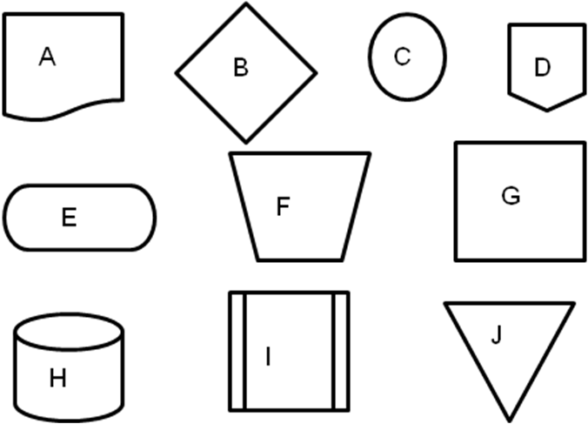

Symbol A is a document symbol, commonly used for items like purchase orders and sales invoices. Symbol B is a decision symbol; it should be used for decisions that have a binary outcome (yes or no). Symbols C and D are connectors; the former is an on-page connector, the latter is an off-page connector. Symbol E is a terminator; it should be used at the beginning and end of a flowchart. Symbol F is a manual process symbol, while Symbol G is a generic process symbol. Symbol H represents an electronic database. Symbol I is a predefined process symbol. Finally, Symbol J is a manual file symbol. Additional symbols can be found in a variety of software packages and online.

d. How are flowcharts used in working with accounting information systems? Flowcharts can be used to understand how a business process works. They can also be used to spot internal control deficiencies and to recommend business process improvements.

e. Respond to the questions for this chapter’s “AIS in the Business World.”
I was very fortunate to have three assistants available to prepare responses to the AIS in the Business World vignettes for the third edition; I’ve posted their responses on my AIS blog: www.bobhurtais.blogspot.com.

2. Reading review problem
a. Which type(s) of flowcharts discussed in the chapter would be relevant in this case? Explain your response. A systems flowchart would likely be the most useful here, as it gives a “big picture” look at a system. To the extent that the SOX compliance process involves documents (such as reports and certifications by the CEO and CFO), a document flowchart may also be useful.

b. SOX imposes serious requirements regarding internal control on publicly-traded corporations. Those requirements include the CEO and CFO personally reviewing the company's internal control system, identifying weaknesses and known cases of fraud. Suppose you were creating a systems flowchart depicting a typical SOX process; identify three or four symbols you would expect to use in that flowchart, and explain how you would use them. Such a flowchart would definitely incorporate terminator symbols to mark the start and end of the compliance process; terminators could also be used to indicate the flow of information across the system boundary, such as submitting required certifications to the SEC. Since the process of reviewing internal controls varies with the company, a systems flowchart for SOX compliance would almost certainly involve at least one predefined process symbol. Given the documents involved, a document symbol would also be relevant; either a file or database symbol could also be used to represent storage of the various reports associated with SOX compliance.

3. Multiple choice review questions. Answers to all of these questions appear at the end of the textbook itself.

4. Making choices and exercising judgment
The point of these exercises, which appear in every chapter throughout the third edition, is to encourage students to think critically and “outside the box.” Thus, I am not providing solutions to them, as doing so would likely discourage the purpose of these exercises.

5. Field exercises
Answers to these exercises will vary significantly; thus, like the previous set, I am not preparing published solutions for them.

6. Flowchart creation

a. Cori’s Catering Service

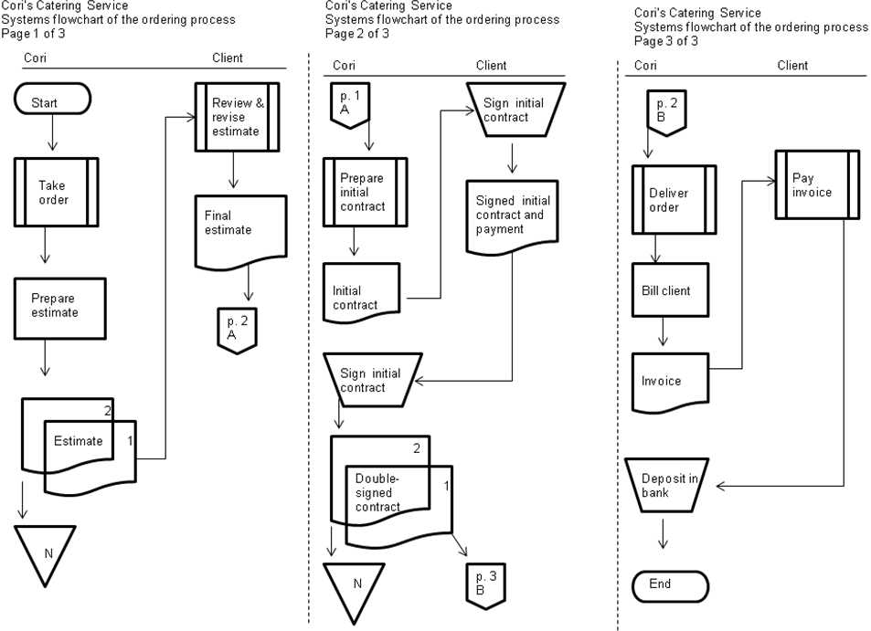
b. University Bookstore

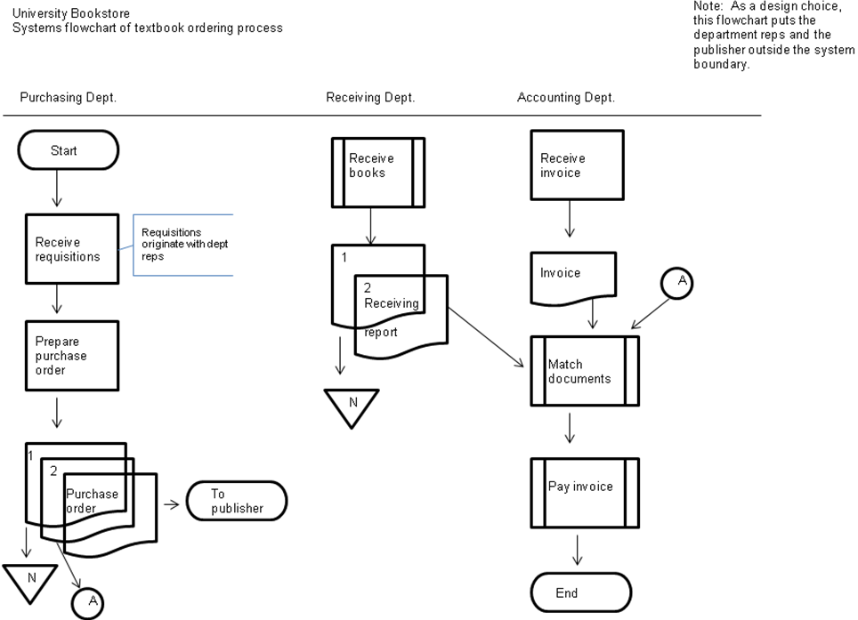

c. Horacio

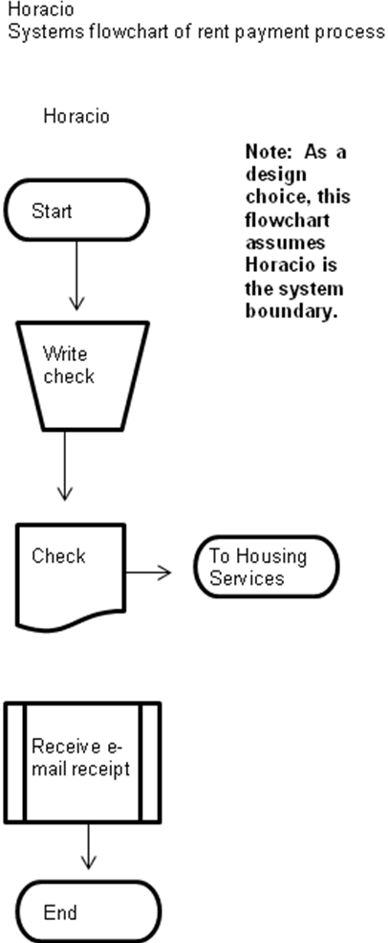

d. International Accounting Standards Board

International Accounting Standards Board
Systems flowchart of the standard development process

7. Narrative preparation from a flowchart
a. A salesperson for Richards Furniture Company manually prepares a sales invoice with four copies. The salesperson keeps one, and sends the other three to the cashier. The cashier approves and processes the sale; the invoice copies are distributed to the customer, the cashier’s file and the assistant manager. After approving the sale, the cashier assigns a consecutive transaction number and inputs the sale to the cash register. The assistant manager reconciles the cash register tape to the invoices. Someone (probably the manager) prepares, makes and reviews the bank deposit.

b. A customer at PriceRight Electronics submits an order to the marketing department, where it is input to the sales order system. Copies of the sales order go to the customer and the warehouse; the warehouse assembles the order. The credit department checks credit for new customers only. The warehouse, after assembling the order, sends a copy to the shipping and receiving department, where the order is packed and shipped. An additional copy of the sales order goes to the customer. The warehouse also maintains the inventory master file.

8. Flowchart and system critiques
a. Strengths of the flowchart: The flowchart is organized in columns depicting areas of responsibility. Some of the symbols are used correctly. Weaknesses of the flowchart: It does not include a proper heading, nor does it include appropriate terminator symbols. Strengths of the process depicted: Cash is deposited in the bank, although we cannot tell how often. Bank deposit documents are filed in case they are needed for later reference. Weaknesses of the process depicted: The cashier should not be approving the sale; as an improvement, a separate department should perform that function. The process of preparing the reconciled report, as well as its content, is very jumbled and confused; Richards should develop a stronger, more cohesive process to improve internal control.

b. Strengths of the flowchart: The flowchart is organized in columns depicting areas of responsibility. Some of the symbols are used correctly. Weaknesses of the flowchart: The lines do not have arrows, so it is impossible to tell which direction things are flowing. The system boundary is also poorly defined; the flowchart includes both information on the sales order process AND on the maintenance of the inventory master file. Strengths of the process depicted: The company maintains a master file of customer credit limits. Credit is checked and approved by the credit department, although not nearly often enough. Weaknesses of the process depicted: The credit department should check everyone’s credit—not just new customers. The sales order serves far too many purposes; the company should develop and use additional documents for things like packing and shipping.

9. Terminology
1. J
2. C
3. H
4. G
5. D
6. I
7. B
8. F
9. A
10. E

10. Multiple choice questions
1. B
2. A
3. B
4. C
5. A

11. Statement evaluation
1. Always true
2. Sometimes true. Document flowcharts are focused on documents; other flowchart types have a different focus.
3. Sometimes true. Off-page connectors may be needed if a flowchart is long or complex.
4. Never true.
5. Sometimes true. In most cases, flowcharts will require revision when processes change.
6. Always true
7. Always true
8. Never true.
9. Sometimes true. Although possible, this situation is highly unlikely.
10. Sometimes true. Visio is sometimes the best tool, but not always.

