

**Faculty of Engineering & Technology**

**Electrical & Computer Engineering Department**

**Digital Electronics and Computer Organization Lab ENCS 2110**

**Pre lap 5**

**Experiment No. 5-- Sequential Logic Circuits**

**Prepared by:** Alaa Moqade , 1211910

**Partners:** Amal Qadah (1221630) , 1170049

**Instructor :** Jamal Seyam

**Assistant:** Haleema Hmedan

**Section :** 1

**Date** : 29/10/24

**2. For each used IC (Integrated Circuits), search for its datasheet that explains exactly what a component does and how to use it.**

1)A **datasheet** is a technical document provided by the manufacturer of an electronic component, such as an integrated circuit (IC). It provides comprehensive information about the component, including:

1. **Pin layout** and functions.
2. **Electrical specs** (voltages, current limits).
3. **Operating conditions** (temperature, voltage range).
4. **Logic tables** and **diagrams** (showing inputs/outputs).
5. **Application examples** for circuit design.

2) **Circuit Components and Their Functions:**

**2.1) 7486 (Quad 2-Input XOR Gate):**

The XOR gate in the 7486 IC is often used for arithmetic operations, such as addition, because it produces a high output only when one of the inputs is high. In binary addition, XOR can serve as a half-adder, Usage Example: Key in adder circuits, such as in constructing a 1-bit adder when combined with an AND gate and your Datasheet is 7486 XOR Datasheet.

**2.2) 7400 (Quad 2-Input NAND Gate):**

The 7400 IC provides NAND gate functionality, which is a fundamental building block for implementing various logic operations. NAND gates can also be used to construct other gates (such as AND, OR, and NOT) by combining them in specific configurations.

Usage Example: Acts as a building block in digital decision-making circuits, forming part of larger logic sequences, and the Truth Table:

|  |  |  |
| --- | --- | --- |
| A | B | Output |
| 0 | 0 | 1 |
| 0 | 1 | 1 |
| 1 | 0 | 1 |
| 1 | 1 | 0 |

**2.3) 74138 (3-to-8 Line Decoder):**

**Datasheet**: 74138 Decoder Datasheet, the decodes 3-bit binary inputs to activate one of the 8 outputs, enabling specific circuits in multi-functional systems like microprocessors and memory selection.

Usage Example: Used in memory addressing where each output line selects a particular memory register and the Truth Table:

A B C Output

0 0 0 Y0

0 0 1 Y1

0 1 0 Y2

1 1 1 Y7

**So this example how to use IC to build this gate as circuits , now we tack how use IC in our Experiment By using laboratory equipment like the KL-31001 and KL-33008/09 models :**

1. **In SR latch with NAND gates:**

An SR latch is a basic memory element that stores one bit of information, constructed using two NAND gates and use 74HC00 - Quad 2-Input NAND Gate Datasheet.

Work like this:

**Set (S=1, R=0)**: Q = 1, Q' = 0

**Reset (S=0, R=1)**: Q = 0, Q' = 1

**Hold State (S=0, R=0)**: Retains previous state

**Invalid (S=1, R=1)**: Undefined state

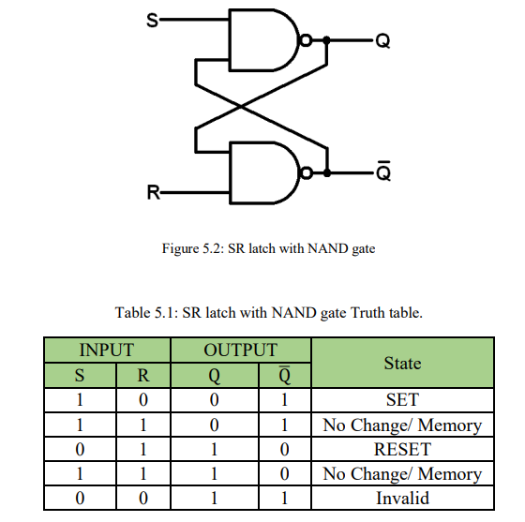

1. **In D Latch Using NAND Gates :**

A D latch (Data Latch) is a type of storage element that captures the input data (D) on the rising or falling edge of a clock signal. It is constructed using NAND gates and is commonly used for temporary data storage, and use **74HC00 - Quad 2-Input NAND Gate** Datasheet.

**It work like this:**

When **D = 1** and **Clock = 1**, Q becomes 1 and Q' becomes 0.

When **D = 0** and **Clock = 1**, Q becomes 0 and Q' becomes 1.

When the clock is 0, Q retains its previous state regardless of D.

The output changes only when the clock signal is active.

