

**Faculty of Engineering and Technology**

**Mechanical Engineering Department**

**Fluid Mechanics laboratory**

**ENME312**

**Experiment #1**

**The Center of Pressure**

**Instructors:**

**Dr. Adel Dweik**

**Eng. Alanood Moudai**

**Done by group 3:**

Khaled Wahdan 1191584

**Ahmad Sabobeh 1191922**

Aws Daraghmeh 1191856

**Date of performing the experiment: 16.5.2022**

**Date of submitting the experiment: 23.5.2022**

**Abstract**

Many of water retaining structures are being used everywhere around the globe for different purposes. In order to correctly design those structures, a very important value must be found which is the center of hydrostatic pressure. Knowing the location of this point help to reinforce and well-construct our structure, whether it is a dam, levee, or a gate.

The main **aim** of this experiment is to find out the center of hydrostatic pressure and the moment it creates around a point for Partially and Fully submerged surfaces. Also, to find the Unit Weight of Water and compare it against the true value. The main **principles** used were the *equilibrium of moments around a point*, and the *Pressure at a point with respect to water depth*. The figure below shows the set-up used by us to conduct our experiment.

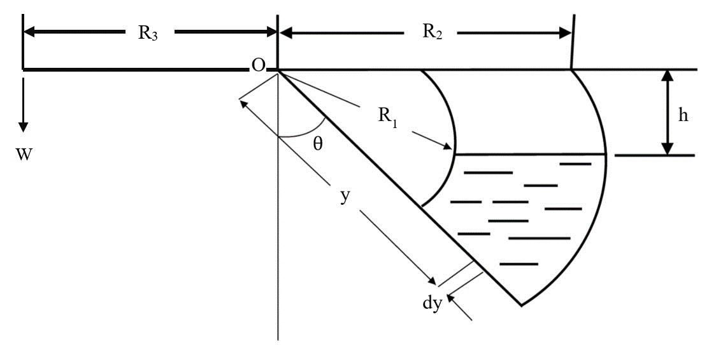

*Figure (1): Center of Pressure Apparatus.*

This quadrant-shaped of tank was first fixed on an angle and calibrated on it by adding weights on the other side of the hanger to balance it. Then weights were increased and water was allowed to fill the tank till our angle is restored again. This step was repeated multiple times for the same angle and readings of water height were recorded.

Then another calibration angle was taken and steps were repeated again. Moments are then calculated and figures were used to work out the values of the Unit Weight of Water. As a **result**, we got an average unit weight from fully-submerged surface **(γ = 9484.44 N/m3)**, and an average unit weight from partially submerged surface equation **(γ = 10841.78 N/m3).** Which gives a final answer of **(γ = 10212.61 N/m3).**

**Objectives**

To Measure:

* Starting calibration angle.
* Total mass added to the left-side of the hanger.
* Water depth reading (h) until the water balances the current mass placed left.

To Analyze:

* Moment at point O from the left side.
* Relationship of (Moment vs. Water Depth) for fully submerged surfaces. And average unit weight from the resulting trendlines.
* Relationship of (Moment vs. Water Depth) for Partially submerged surfaces. And average unit weight from the resulting trendlines.

To Determine:

* Width, inner radius, and outer radius of the tank.
* Arm length for the force produced by left-side weights.
* Equations of (M vs. H) graph.

**Sample Calculations**

$Moment \left(M\right)=Mass×9.81×Arm Raduis (R3)$-----(1)

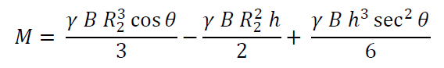

For Fully-Submerged: ----(2)

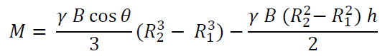

For Partially-Submerged: ---(3)

***Note: B, R1, R2, R3 values will be introduced later.***

**Results**

Table (1): Data and Calculations for Calibration Angle ϴ = 0 ° (Mass, Depth of Water, Moment, and Depth of Water in meters).

|  |  |  |  |
| --- | --- | --- | --- |
| **ϴ = 0°** | | | |
| **Mass (g)** | **h (mm)** | **M (N.m)** | **h (m)** |
| 50 | 155 | 0.12 | 0.155 |
| 70 | 148 | 0.17 | 0.148 |
| 90 | 142 | 0.22 | 0.142 |
| 110 | 135 | 0.27 | 0.135 |
| 130 | 128 | 0.32 | 0.128 |
| 150 | 122 | 0.37 | 0.122 |
| 180 | 114 | 0.44 | 0.114 |
| 200 | 110 | 0.49 | 0.11 |
| 250 | 98 | 0.61 | 0.098 |
| 270 | 94 | 0.66 | 0.094 |
| 290 | 90 | 0.71 | 0.09 |
| 310 | 85 | 0.76 | 0.085 |
| 330 | 80 | 0.81 | 0.08 |
| 350 | 74 | 0.86 | 0.074 |
| 380 | 70 | 0.93 | 0.07 |
| 400 | 64 | 0.98 | 0.064 |

Table (2): Data and Calculations for Calibration Angle ϴ = 20° (Mass, Depth of Water, Moment, and Depth of Water in meters).

|  |  |  |  |
| --- | --- | --- | --- |
| **ϴ = 20°** | | | |
| **Mass (g)** | **h (mm)** | **M (N.m)** | **h(m)** |
| 20 | 152 | 0.05 | 0.152 |
| 40 | 144 | 0.10 | 0.144 |
| 60 | 138 | 0.15 | 0.138 |
| 90 | 128 | 0.22 | 0.128 |
| 110 | 122 | 0.27 | 0.122 |
| 160 | 110 | 0.39 | 0.11 |
| 180 | 105 | 0.44 | 0.105 |
| 200 | 100 | 0.49 | 0.1 |
| 220 | 94 | 0.54 | 0.094 |
| 240 | 88 | 0.59 | 0.088 |
| 260 | 84 | 0.64 | 0.084 |
| 290 | 78 | 0.71 | 0.078 |
| 310 | 72 | 0.76 | 0.072 |
| 360 | 62 | 0.88 | 0.062 |
| 380 | 58 | 0.93 | 0.058 |
| 400 | 52 | 0.98 | 0.052 |

Table (3): Given Parameters (Inner Radius, Outer Radius, Width, Arm Length).

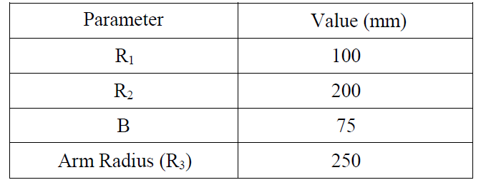

For Fully-Submerged Surfaces:

*Figure (2): Moment M (N.m) Vs. Water Depth h (m) [Dark line for 20°, and Light line for 0°] for Fully submerged Plate.*

Table (4): Unit Weight Calculations for Fully Submerged Plate.

|  |  |
| --- | --- |
| **Parameter** | **Value** |
| slope for (ϴ = 0) | -10.714 |
| slope for (ϴ = 20) | -10.851 |
| Average Slope | -10.7825 |
| B (R22 -R12) | 0.00113 |
| Unit Weight (**γ1**) | 9584.44 |

For Partially-Submerged Surfaces:

*Figure (3): Moment M (N.m) Vs. Water Depth h (m) [Dark line for 20°, and Light line for 0°] for Partially Submerged Plate.*

Table (5): Unit Weight Calculations for Partially Submerged Plate.

|  |  |
| --- | --- |
| **Parameter** | **Value** |
| Eq. Constant for (ϴ = 0) | 2.0041 |
| Eq. Constant for (ϴ = 20) | 2.0707 |
| Average Value | 2.0374 |
| B (R23) (cos 20°)/3 | 0.000188 |
| Unit Weight (**γ2**) | 10840.78 |

$$Total Unit Weight \left(γ_{total}\right)= \frac{γ_{1}+ γ_{2}}{2}= \frac{10840.78+ 9584.44}{2}=10212.61 N/m^{3}$$

**Discussion of Results**

The aim of this experiment was achieved, since we were able to obtain a close value for the unit weight of water from analyzing our readings which was close to the theoretical one. Also, the moments were successfully calculated so that we can use them for finding y (see figure (1)) which is the distance from the axis of rotation to the center of pressure.

Table (1) shows us the values read when we calibrated the angle of the quadrant at 0 degrees. The weights added were recorded alongside with the height of water needed to retrieve initial angle. Following, the moment was calculated for each run. Table (2) contains the same information for a calibration angle of 20 degrees.

In order to obtain the equations of the moments for Fully and Partially submerged plates we graphed the moment with height (h), Figures (2) & (3) shows the fore-mentioned graphs. Equations of the trendlines were found, hence we were able to use the slope of the solid lines and the constants of the quadratic equations in order to work out the values of the unit weight. Other constants values can be found in Table (3).

Unit Weight calculations were done and demonstrated in Tables (4) & (5). The average of the Unit weights produced by the partially-submerged and the fully-submerged analyses represent our final result for the Unit Weight of Water which was 10212.61 N/m3.

The Trends noticed in this experiment where between the Moment and the height (h). Since they are inversely proportional (linear) in fully submerged analysis. However, they follow a quadratic curve in partially submerged analysis (also inverse relationship).

**Conclusions**

Afterall, we got an average value for Unit Weight of (**γ = 10212.61 N/m3**). By comparing it to the True Theoretical Value (**γ = 9810 N/m3**), we get a 4% error in our value. Which can be considered an Acceptable Value since the main reason why our value was this far is the component coming from the Partially-Submerged Analysis, because the equation estimated is quadratic and we do not have enough points to get a precise Quadratic curve to rely on its values.

**Applications**

Determining the location of the center of pressure of a certain structure to know how to design our structure correctly. Especially in dams to hold back the hydrostatic pressure of water.

**References**

1. Fluid Lab Manual.
2. Attached Data Sheets.