**Birzeit University**

**Physics department**

**Physics 211**

**Student’s name: Ahmad Hammouri Student’s number: 1071811**

**Partners name: Anas Abu halaweh partner number:**

**Partner’s name: Mariana Mosallam partners number: 1100343**

**Experiment number: (1)**

**Experiment name: static equilibrium of forces**

**Date: 9/04/2012**

**Instructor: Dr. Wael .Q**

**Abstract:**

**The aim of this eperemint was to study the concepts of force and torque ,the conditions for translational and rotational equilibrium ,and to learn the analytical and graphical methods for the addition of vector quant .**

**Avrage U1=** 0.76N

**Avrage U2=** 1.60N

Tensions =**1.325 N, 2.225N**

**Theory:**

**A rigid body is a body which its part move together under influence of external force and torque . such body is under equilibrium when the sum of the forces acting on it is zero and the sum of the torque is zero too**

**Where the forces some of it oppose each other to cancel giving a zero force .**

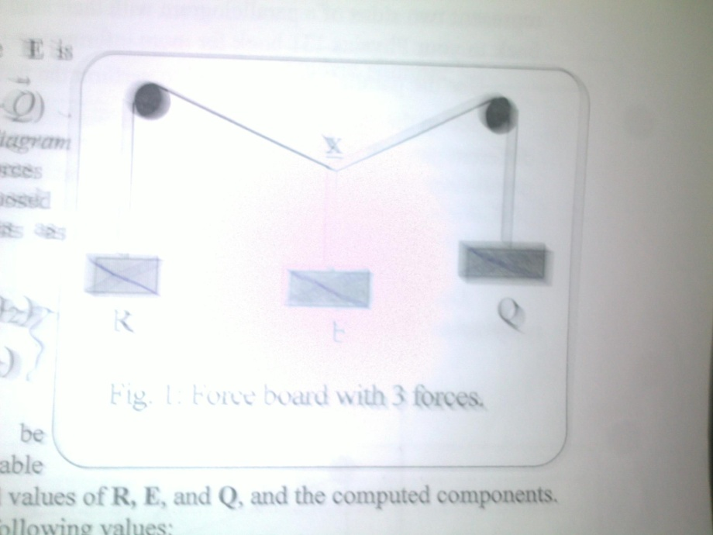**Procedure:**

1. **Install the apparatus as in the figure .**
2. **Place appropriate weights on pans R and Q .**
3. **While holding string at point x place enough weights on pan E until equilibrium is reached .**
4. **Draw lines tracing the pieces of the string and record the weights in each pan.**

**Data:**

**Part 1:**

|  |  |  |  |  |  |  |  |  |  |
| --- | --- | --- | --- | --- | --- | --- | --- | --- | --- |
| No | E(Newtons) | R(Newtons) | Q (Newtons) | Ѳ1 (degres) | Ѳ2  (degrees) | Rcos(Ѳ1)+Qcos (Ѳ2) | Rsin(Ѳ1)-Qsin(Ѳ2) | U1 | U2 |
| 1.00 | 0.98 | 0.49 | 0.88 | 59.00 | 29.00 | -1.04 | 0.90 | 0.90 | 2.02 |
| 2.00 | 0.98 | 0.98 | 0.88 | 63.00 | 53.00 | 0.16 | -0.19 | -0.19 | 0.82 |
| 3.00 | 1.27 | 0.98 | 0.88 | 48.00 | 49.00 | -0.36 | 0.09 | 0.09 | 1.64 |
| 4.00 | 1.27 | 1.27 | 0.88 | 40.00 | 75.00 | -0.04 | 1.29 | 1.29 | 1.31 |
| 5.00 | 1.77 | 1.27 | 1.57 | 66.00 | 45.00 | -0.45 | -1.37 | -1.37 | 2.22 |

**Part 2 :the parallelogram method:**

**R= 0.49 N**

**S=1.78 N**

**Ѳ=150**

**T=1.325 N**

**Q=1.78N**

**P=1.372N**

**Ѳ=134**

**T=2.225 N**

**the parallelogram method is a graphical method.**

**in this part we found the resultant of the first parallelogram that consists from P and Q with Ѳ=134 ,this resultant should equal the second resultant of the parallelogram that consist from R and S with Ѳ=150. We find this resultant to find the tension due to P,and due to Q**

**Resultant from first parallelogram= 1.325 N**

**Resultant of the second parallelogram =2.225 N**

**So the tension is too =1.325N,2.225N respectively**

**Data analysis :**

**The values of U1 and U2 are very close to zero ranging from -1 to 3 this ranging indicates that the data obtained were not taken at exact equilibrium but may be at Instanouse stoppage caused by friction between the string and the apparatus .**

**Main results:**

**Avrage U1=** 0.76N

**Avrage U2=** 1.60N

Tensions =**1.325 N, 2.225N**

**Discussion of results:**

**The results acquired were very far from the theoretically expected values which might be due to friction between the strings and the apparatus or because the when we drew on the paper the recording of the data wasn’t accurate since we didn’t use the mirror as instructed .**

**Sources of error:**

* **Friction forces .**
* **Air resistance .**

**Conclusion :**

**Further investigation is needed to acquire the right results.**