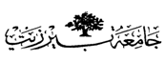

Organic –Chem. 221 Lab

Instructor name: Dr. Adi Qamhieh Exp. date: 12.3.2018

Experiment title

Extraction

Student Name
Muhammad Ibrahim Musleh
Student No
1162595
Partner Name
Fairouz Zayed
Partner No
1160750

Experiment No
4

Submission date: 26.3.2018

