

**Faculty of Engineering & Technology**

**Electrical & Computer Engineering Department**

**ENEE3103**

**Prelab Experiment #10**

**Zener Diodes and Voltage Regulators**

**Name:Tayma yasin**

**Id:1142391**

**Instructor :Dr.nasser ismail**

**Eng.Bilal ismail**

**Section 1**

**I.ZENER DIODE:**

**1)**

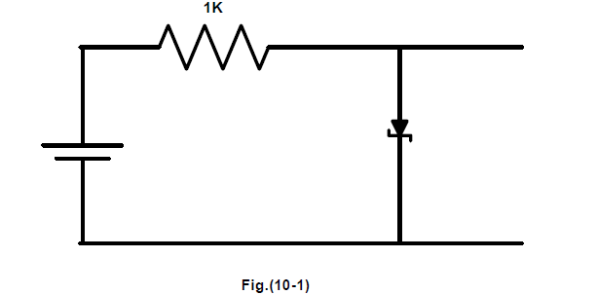

**Pispice:**

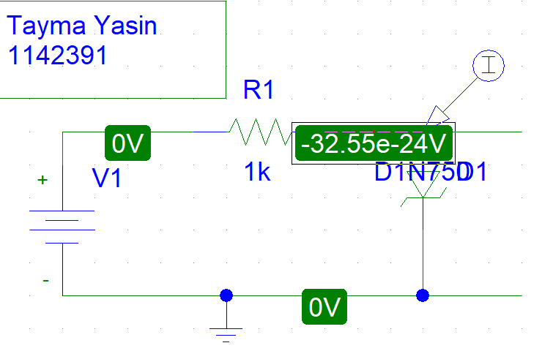

The voltage across the diode :

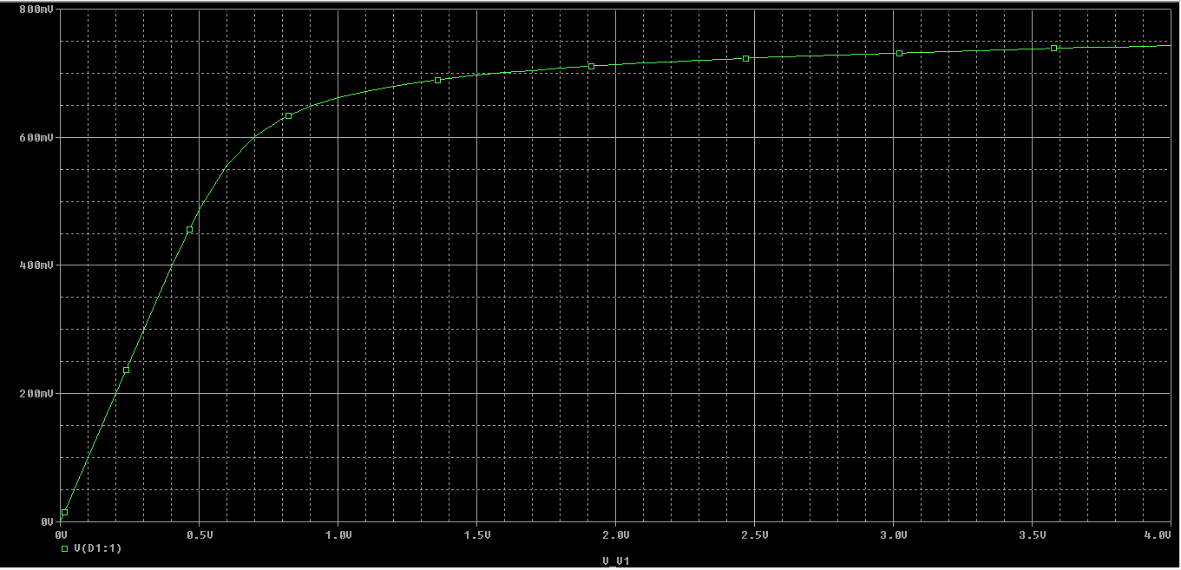

The voltage across the resistor :

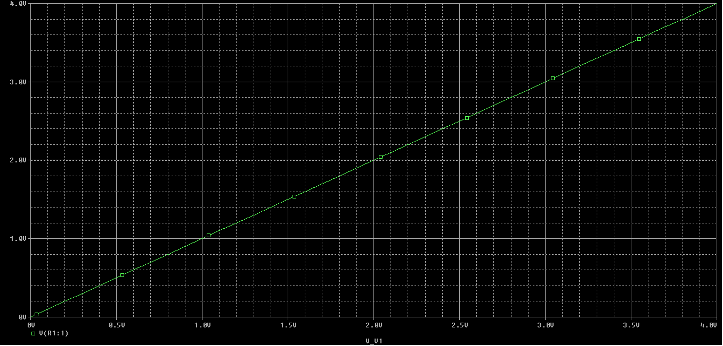

The current in the circuit :

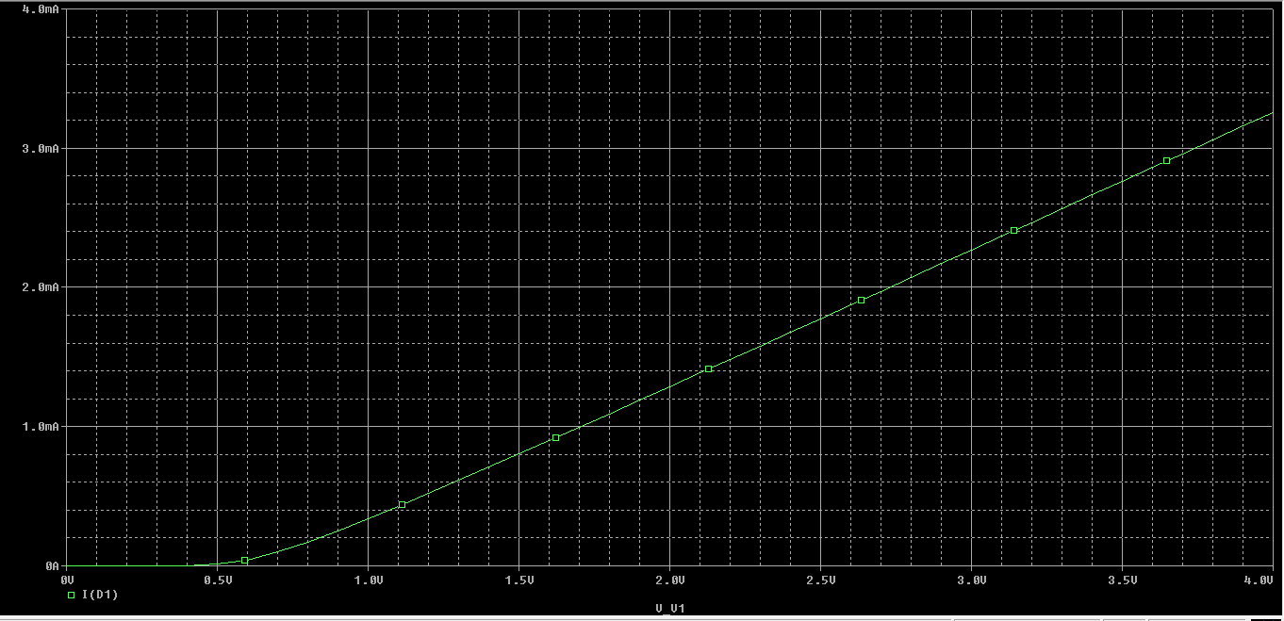

|  |  |  |  |
| --- | --- | --- | --- |
| **E(V)** | **Vr(V)** | **Vz(V)** | **I(mA)** |
| 0.1 | 0.091 | 0.009 | 0.000 |
| 0.2 | 0.001 | 0.199 | 0.000 |
| 0.3 | 0.001 | 0.299 | 0.000 |
| 0.4 | 0.003 | 0.397 | 0.006 |
| 0.5 | 0.014 | 0.486 | 0.013 |
| 0.6 | 0.044 | 0.556 | 0.043 |
| 0.7 | 0.099 | 0.601 | 0.098 |
| 0.8 | 0.171 | 0.629 | 0.170 |
| 0.9 | 0.252 | 0.648 | 0.251 |
| 1 | 0.339 | 0.661 | 0.338 |
| 2 | 1.287 | 0.713 | 1.287 |
| 3 | 2.268 | 0.732 | 2.268 |
| 4 | 3.257 | 0.743 | 3.257 |

**2)**

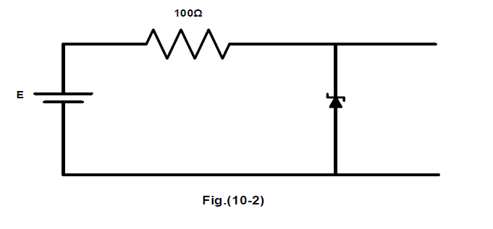

**Pispice:**

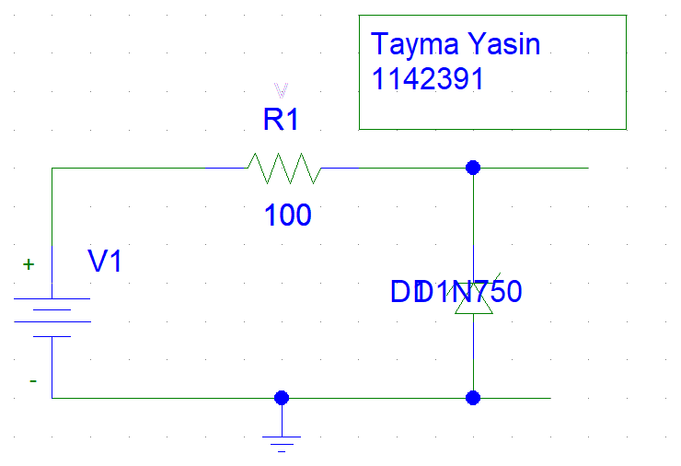

The voltage across the diode :

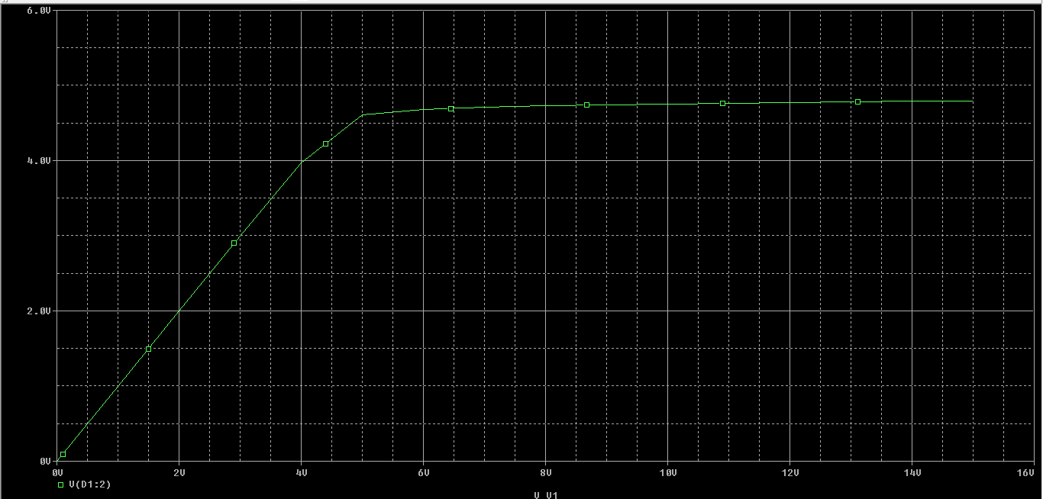

The voltage across the resistor :

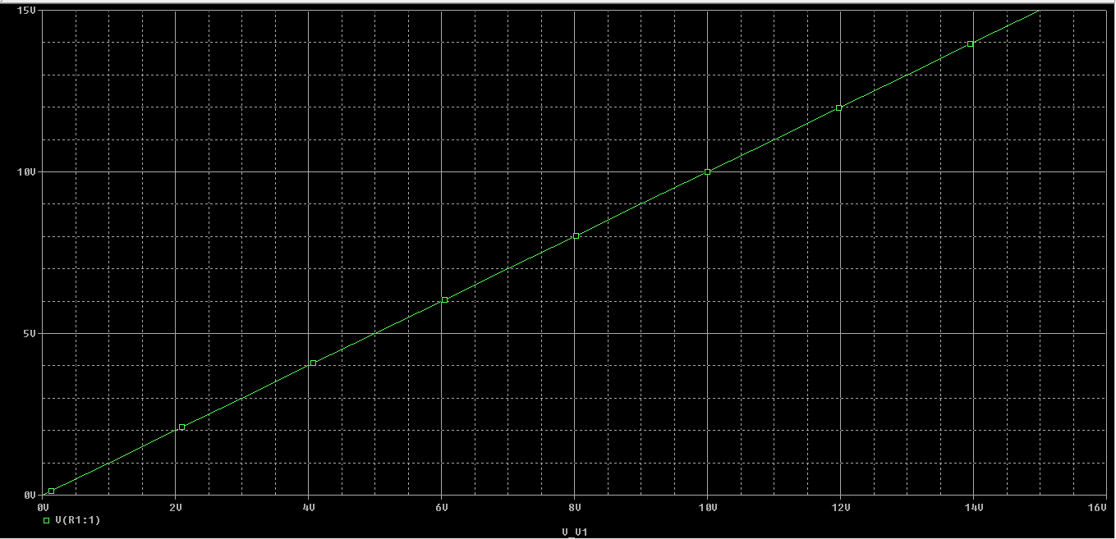

The current in the circuit :

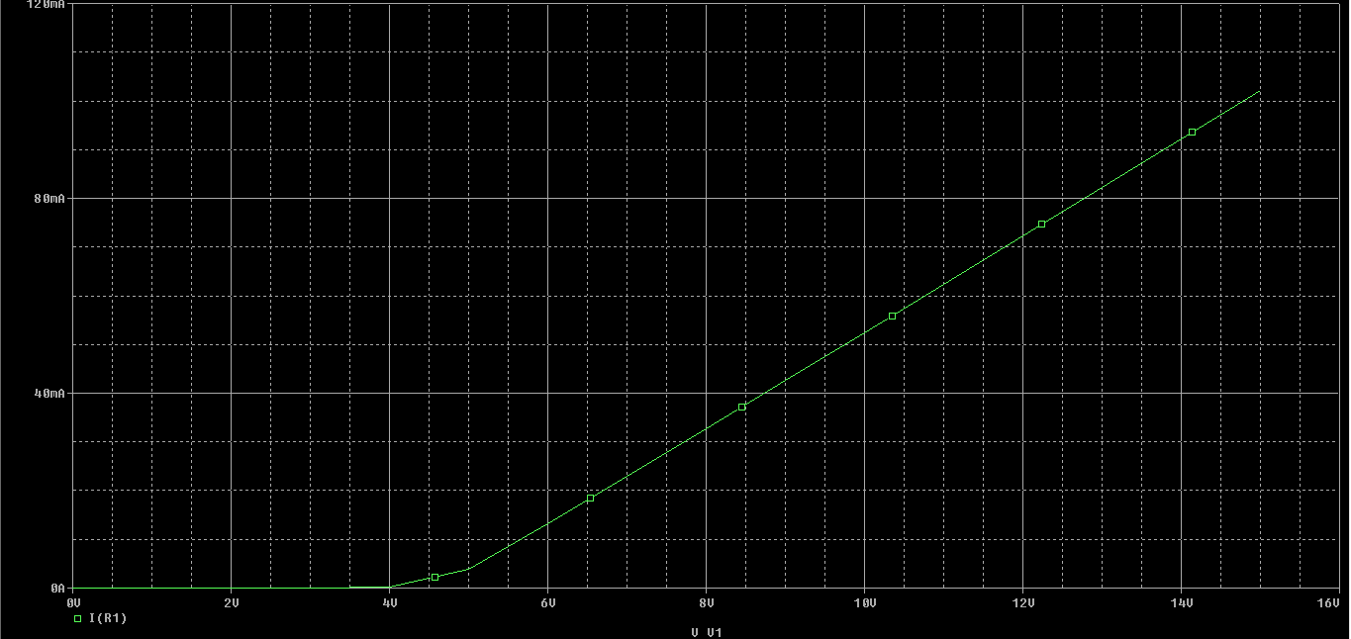

|  |  |  |
| --- | --- | --- |
| **E(V)** | **Vz(V)** | **I(mA)** |
| 0.1 | 0.100 | 0.006 |
| 0.5 | 0.500 | 0.040 |
| 1 | 1.000 | 0.141 |
| 2 | 2.000 | 0.008 |
| 3 | 2.998 | 0.024 |
| 4 | 3.970 | 0.297 |
| 5 | 4.607 | 3.928 |
| 6 | 4.678 | 13.220 |
| 7 | 4.707 | 22.930 |
| 8 | 4.707 | 22.930 |
| 9 | 4.707 | 52.470 |
| 10 | 4.753 | 52.470 |
| 11 | 4.763 | 62.370 |
| 12 | 4.773 | 72.270 |
| 13 | 4.781 | 82.190 |
| 14 | 4.789 | 92.120 |
| 15 | 4.796 | 102.040 |

**3)**

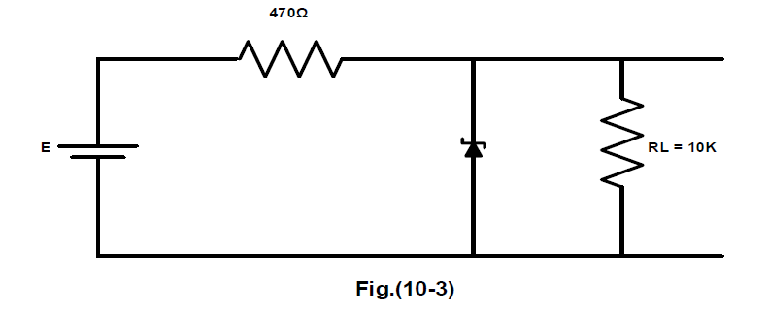

**Pispice:**

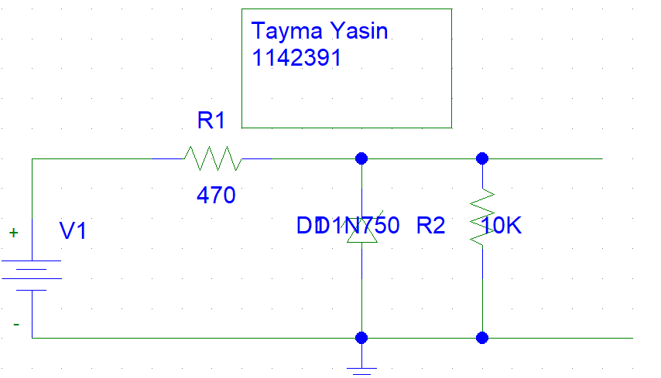

|  |  |  |  |  |  |
| --- | --- | --- | --- | --- | --- |
| E | 10 | 11 | 12 | 13 | 14 |
| Vl | 4.7 | 4.7 | 4.7 | 4.7 | 4.7 |

|  |  |  |  |  |
| --- | --- | --- | --- | --- |
| Rl | 8.2k | 6.8k | 4.7k | 2.2k |
| Vl | 4.667 | 4.667 | 4.667 | 4.667 |

**II. THE VOLTAGE REGULATED POWER SUPPLY:**

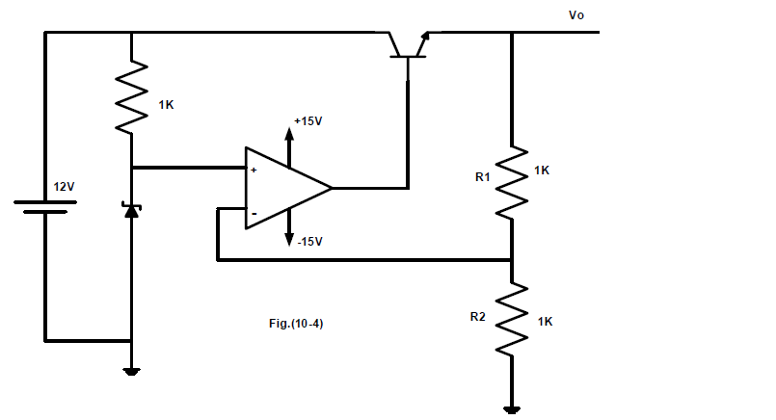

**Pispice:**

**1.**

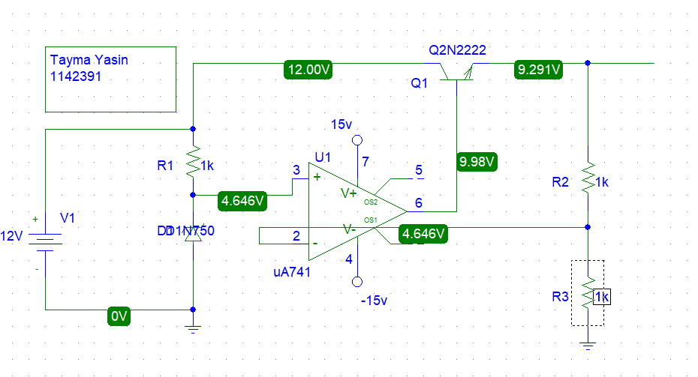

Vo= 9.298volts

Io=0.

2.after 1k is attached :

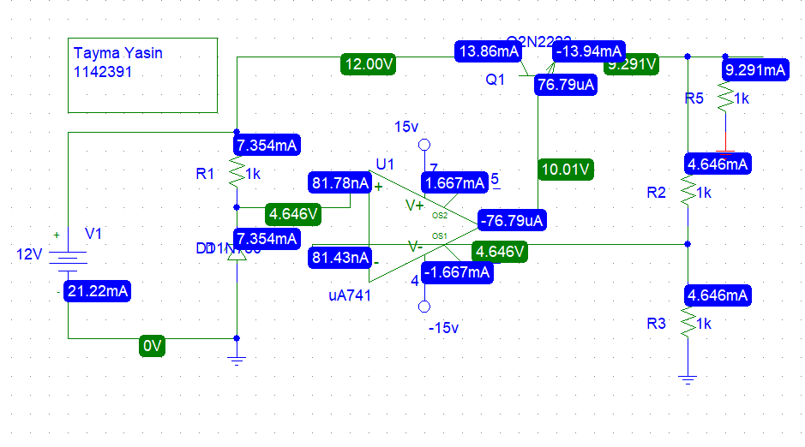

|  |  |  |  |  |  |  |
| --- | --- | --- | --- | --- | --- | --- |
| **Rl** | **open** | **1k** | **680 ohm** | **470 ohm** | **220 ohm** | **100 ohm** |
| **Vo** | **9.298** | **9.298** | **9.298** | **9.298** | **9.298** | **9.298** |
| **Io** | **0** | **9.298mA** | **13.67m** | **19.78m** | **42.26m** | **92.98m** |

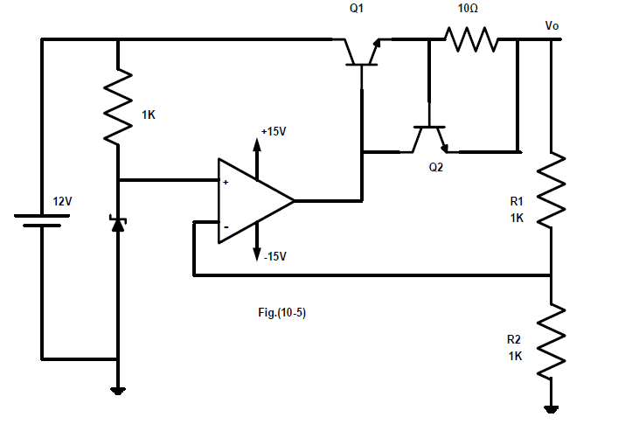

**Pispice:**

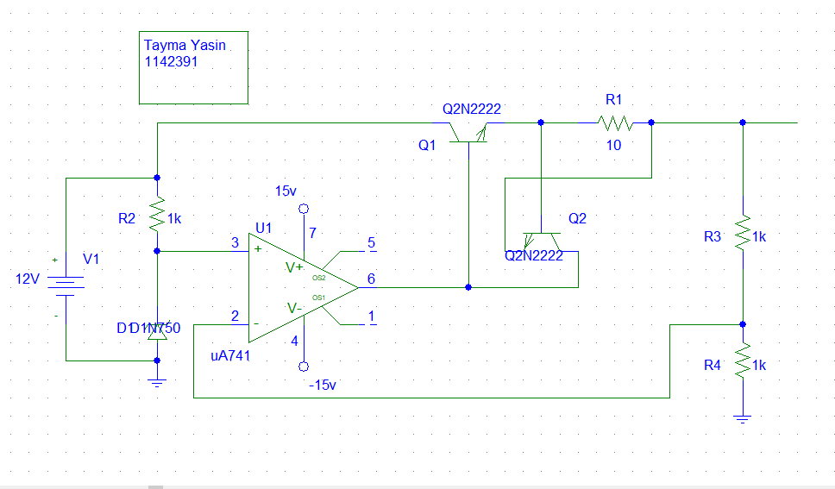

|  |  |  |  |  |  |  |  |
| --- | --- | --- | --- | --- | --- | --- | --- |
| Rl | Open | 1k | 680 ohm | 470 ohm | 220 ohm | 100 ohm | 50 ohm |
| Vo | 9.298 | 9.299 | 9.299 | 9.299 | 9.299 | 9.299 | 5.614 |
| Io | 0 | 9.299m | 13.67m | 19.78m | 42.27m | 92.99m | 112.28m |

**II. THREE TERMINAL FIXED VOLTAGE REGULATOR 7805:**

|  |  |  |
| --- | --- | --- |
| Rl(ohm) | Vl(V) | Il(mA) |
| 25 | 5 | 200 |
| 50 | 5 | 100 |
| 100 | 5 | 50 |
| 200 | 5 | 25 |
| 400 | 5 | 12.5 |
| 600 | 5 | 8.33 |
| 800 | 5 | 6.25 |
| 1000 | 5 | 5 |

|  |  |  |
| --- | --- | --- |
| Vi(v) | Vl(V) | IL(m) |
| 8 | 5 | 50 |
| 9 | 5 | 50 |
| 10 | 5 | 50 |
| 11 | 5 | 50 |
| 12 | 5 | 50 |
| 13 | 5 | 50 |
| 14 | 5 | 50 |
| 15 | 5 | 50 |

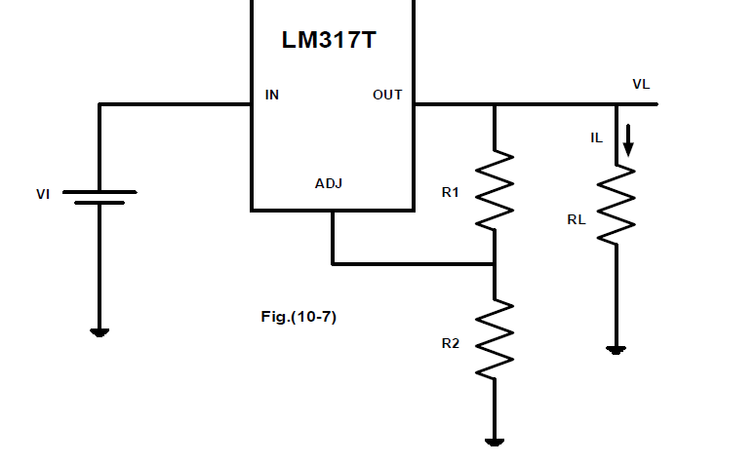

|  |  |  |
| --- | --- | --- |
| R2(ohm) | Vl(v) | Il(m) |
| 0 | 1.25 | 1.25 |
| 100 | 2.25 | 2.25 |
| 200 | 3.785 | 3.7 |
| 300 | 5 | 5 |
| 500 | 7.514 | 7.5 |
| 700 | 8.236 | 8.2 |

|  |  |  |
| --- | --- | --- |
| Vi(v) | Vl(v) | Il(m) |
| 10 | 4 | 4 |
| 12 | 4 | 4 |
| 14 | 4 | 4 |
| 15 | 4 | 4 |
| 16 | 4 | 4 |
| 17 | 4 | 4 |

|  |  |  |
| --- | --- | --- |
| Rl(ohm) | Vl(v) | Il(m) |
| 100 | 4 | 4 |
| 200 | 4 | 4 |
| 400 | 4 | 4 |
| 500 | 4 | 4 |
| 600 | 4 | 4 |
| 700 | 4 | 4 |
| 1000 | 4 | 4 |