

**Faculty of Engineering & Technology – Electrical & Computer Engineering Department**

**Second Semester 2021 – 2022**

Communication Laboratory - ENEE4113

***Experiment 3 - Prelab***

**Name: Ahmaide Al-Awawdah.**

**ID: 1190823**

**Section: 8**

**Instructor: Dr. Ashraf Al-Rimawi**

**TA: Eng. Ruba Eid**

**Date: 8th April 2022**

Consider the frequency modulated signal: S(t) = cos [2π(17)t + 4sin(2πt)]

1. **Find the message signal m(t).**

The formula for frequency modulated signal is: *SFM(t) = Ac cos (2π $\int_{0}^{t}{f\left(τ\right)dτ}$)*

*= Ac cos (2π $\int_{0}^{t}{[fc +fΔ.xm(τ) ]dτ}$), (fΔ = kf Am)*

*= Ac cos (2π fc t + 2π fΔ )*

*= Ac cos (2π fc t + $β$ sin [2πfmt]), (β = $\frac{fΔ }{fm}$)*

Since *Ac cos (2π fc t + $β$ sin [2πfmt]) = cos [2π(17)t + 4sin(2πt)]*

It is noticeable that: Ac = 1v, Fc = 17hz, $β$ = 4, and Fm = 1hz

* fΔ =  *= = 4,* assuming ka = 1 🡪 Am = 4hz

So, the message signal that has the form: Am cos (2πfmt) 🡪 m(t) = 4 cos (2πt), and its plotted as shown in figure 1.

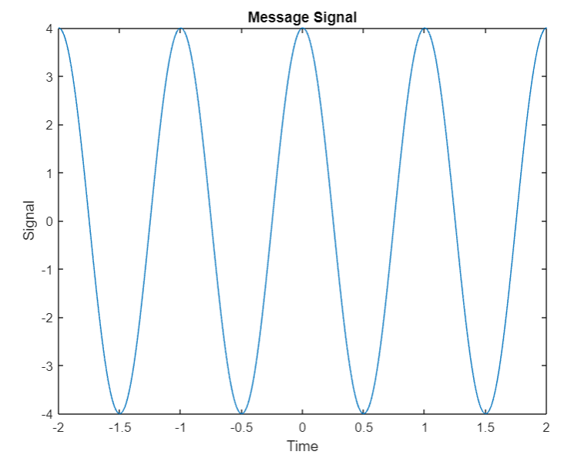

Figure 1: Message signal plot

The MATLAB code can be found in **Appendix 1**.

**B. Plot s(t) versus t for -1 ≤ t ≤ 1.**

The figure below shows the plot of the modulated signal

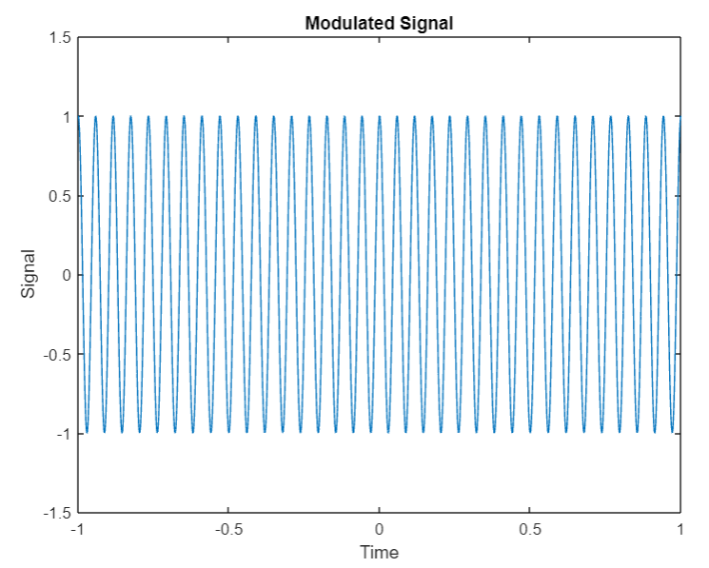

Figure 2: Modulated signal plot

The MATLAB code can be found in **appendix 2**.

**C. Differentiate s(t) with respect to t and plot ds(t)/dt for -1 ≤ t ≤ 1. Notice how this operation transforms an FM waveform into an AM waveform.**

S(t) = cos [2π(17)t + 4sin(2πt)]

The differentiation of the modulated signal is: [34π + 8πcos (2πt)] × sin [2π17t + 4sin(2πt)]

The signal is plotted in the figure below:

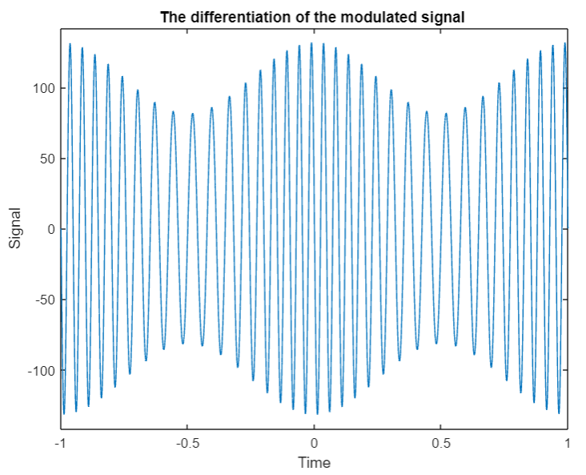

Figure 3: The plot of the differentiation of the modulated signal

As shown in figure 3 this operation did transform the FM waveform into an AM waveform, the MATLAB code can be found in **appendix 3**.

**d. Apply ds(t)/dt to an ideal envelope detector, subtract the dc term and show that the detector’s output is linearly proportional to m(t).**

In order to pass the signal into an ideal envelope detector, its absolute value will be taken, then the Hilbert transformation to remove the negative part, and the dc term (which is equal to 34π) will be removed in order to have the original signal back using the Hilbert function on MATLAB, then in order to compare the output of the detector with the original message signal it will be plotted with the message signal on the x-axis and the detector output on the y-axis to see the proportion between them, so the figure below will show 2 graphs the top one is for the output signal of the envelop detector and the bottom one is for the proportion between it and the message signal.

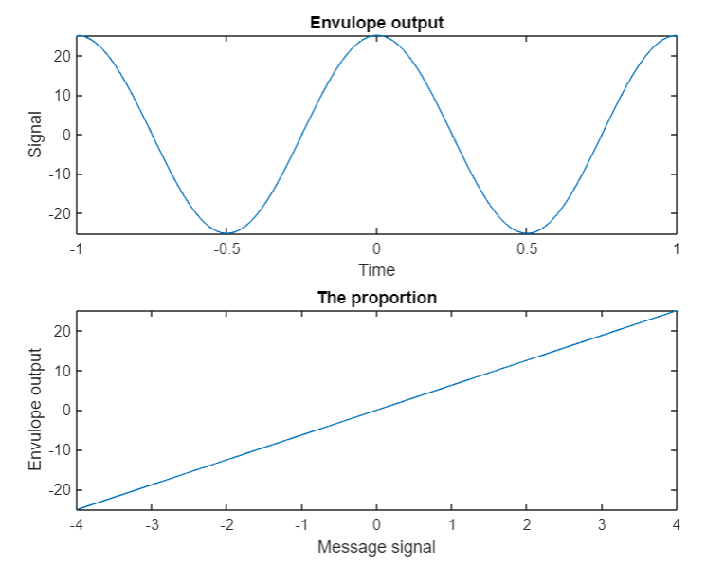

Figure 4: The envelope detector output

The message signal has been retrieved as shown in the first graph, and the proportion with the original signal is linear as shown in the bottom graph, the MATLAB code can be found in **appendix 4**.

**Appendix**

Appendix 1:

Am = 4;

fm = 1;

t=-2:0.00001:2;

m = fm.*cos(2*pi*fm*t);

plot(t, m,'-');

xlabel("Time"), ylabel("Signal");

title("Message Signal");

Appendix2:

Am = 4;

fm = 1;

Ac = 1;

Fc = 17;

Ka = 1;

t=-1:0.00001:1;

B = (Ka.*Am)\fm;

s = Ac.*cos(2*pi*Fc*t + B*sin(2*pi*fm*t));

plot(t, s,'-');

axis([-1,1,-1.5,1.5]);

xlabel("Time"), ylabel("Signal");

title("Modulated Signal");

Appendix 3:

Am = 4;

fm = 1;

Ac = 1;

Fc = 17;

Ka = 1;

t=-1:0.00001:1;

B = (Ka.*Am)\fm;

Ds = (34.*pi + 8.*pi.*cos(2*pi*t)).*-1.*sin ((2*pi*17*t) + 4*sin(2*pi*t));

lim = pi.*(34+8) + 10;

plot(t, Ds,'-');

axis([-1,1,-lim,lim]);

xlabel("Time"), ylabel("Signal");

title("The differentiation of the modulated signal ");

Appendix 4:

Am = 4;

fm = 1;

Ac = 1;

Fc = 17;

Ka = 1;

m = Am.*cos(2*pi*fm*t);

t=-1:0.00001:1;

B = (Ka.*Am)\fm;

Ds = (34.*pi + 8.*pi.*cos(2*pi*t)).*-1.*sin ((2*pi*17*t) + 4*sin(2*pi*t));

hilp = hilbert(Ds);

env = abs(hilp) - 34.*pi;

subplot(2,1,1), plot(t, env,'-');

xlabel("Time"), ylabel("Signal");

title("Envulope output");

subplot(2,1,2), plot(m, env,'-');

xlabel("Message signal"), ylabel("Envulope output");

title("The proportion");