Pre lab experiment 9

Std: Omar Nazal

Nm:1200629

Eng; Shadi Banhoura

Part A

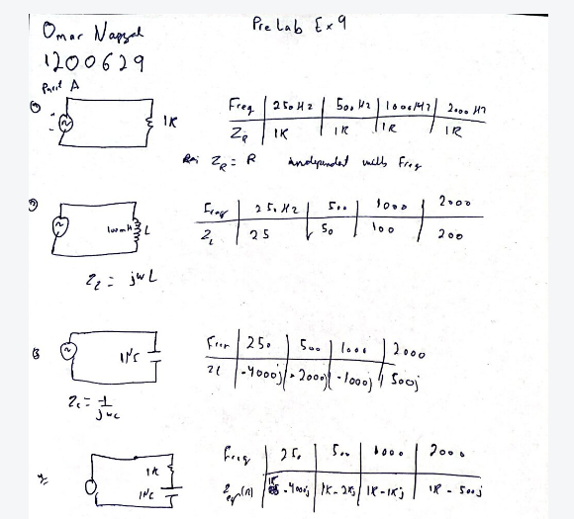

Part b

-1



Delta t = (5-2.573)ms=2.427ms

Delta $ϕ$ = 3600 \* f\* delta t = 87.3750

-2



Delta t = 1.2259ms-984.772us=0.24ms

Delta $ϕ$ = 3600 \* f\* delta t = 86.80