Faculty of Engineering and Technology

Electrical and Computer Engineering

Department

ENEE3102

Electronics Laboratory

Prelab Exp #2

Diode Characteristic and Applications.

Student name :Dalal Bawatneh (1170329)

1-

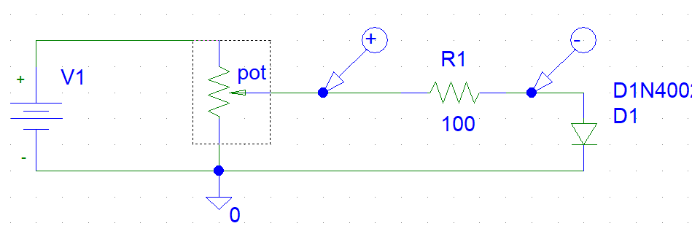



2-

2.1-

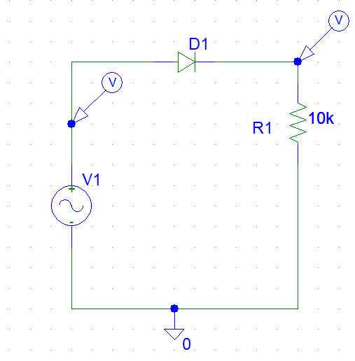

T =1/frequency =1/200=5msec

\*\* Vout p=vin p –VD=5-0.7=4.3volt

Dc component =Vp/pi =5/3.14=1.59volt

V rms =vp/2^(0.5)=3.54volt .

I dc =Vdc/R=1.59/10k=1.59\*10^-4 amp

Answer the Questions:

The peak value of output is differ by 0.7 is a voltage drop in a diode

The output of simulation :







2.2-with c

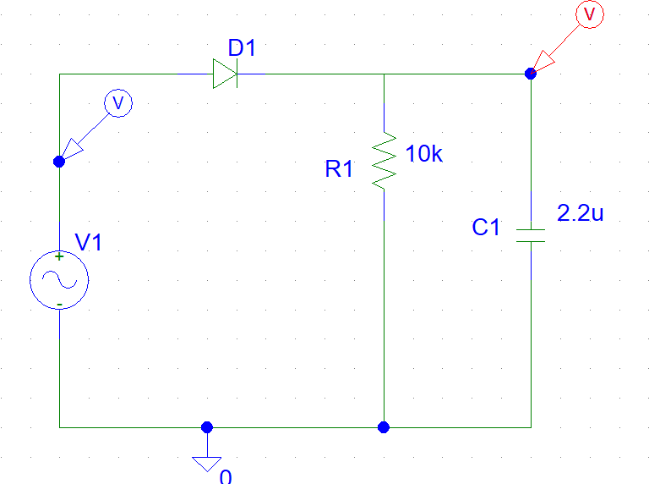

C=2.2uf



C=47uf



Therfor when c is great the ripple will be less

3-

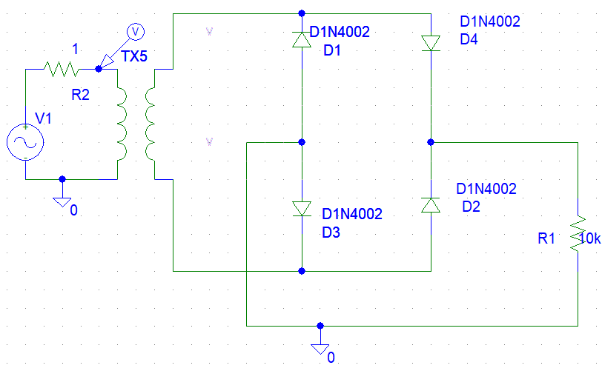



When we add c



Vdc=2Vmax/pi =0.637 Vmax =6.37volt .

Vrms =Vmax/2^(0.5)=7.07volt.

Ripple factor =((vrms/Vdc)^(2)-1)^(0.5)=0.48

\*\* When the capacitor connected, what is the change on the waveform, why?

Capacitor is improve the average dc output voltage of the rectifier .

\*\* Does the ripple voltage change with frequency?

The ripple voltage depends on the value of capacitor ,frequency and load current

Vripple =Iload /(freq\*c).

4-

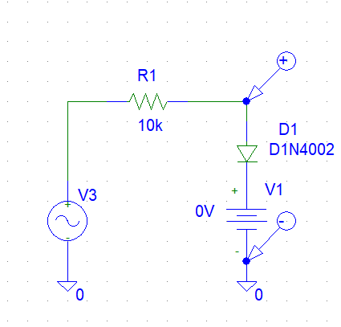



vdc =2v

Clamping

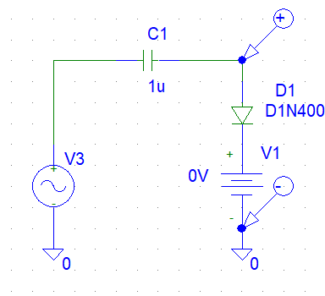



Vdc=2 volt



4-

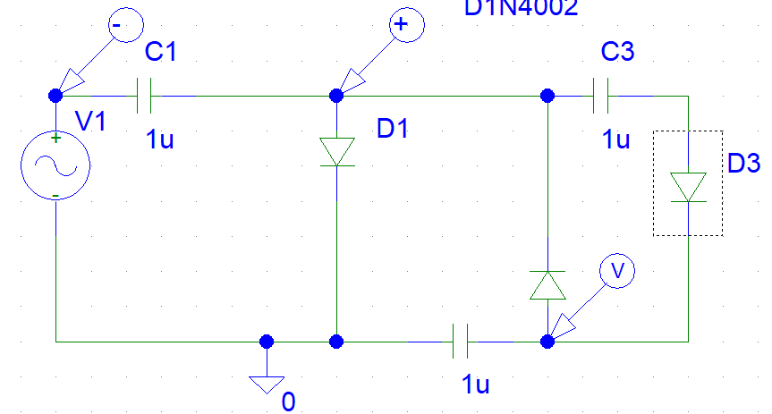

Vc1=2.5 volt

Vc3=4.9volt



Vc2=4.9volt



vab=4.9 Vcd

