476 - The fall of the Roman Empire. Rome had ruled much of Europe. Now much of the land would fall into confusion as local kings and rulers tried to grab power. This is the start of the Dark Ages or the Middle Ages.

1066 - William of Normandy, a French Duke, conquers England in the Battle of Hastings. He became King of England and changed the country forever.

*Beowulf*

* "Beowulf" is an epic poem that was likely composed in the Anglo-Saxon period, sometime between the 7th and 10th centuries. It is one of the most important works of Anglo-Saxon literature, and reflects many of the cultural values and beliefs of the time. The poem is set in Scandinavia, but it was likely written down by an Anglo-Saxon scribe, and it reflects many of the themes and ideas that were important to Anglo-Saxon culture, such as the importance of loyalty, bravery, and heroism.
* Characters:

1) Beowulf: The hero of the epic. Brave and known for his strength and courage in fighting monsters to protect people.

2) Hrothgar: King of Danes. Wise and known for his generosity and his hospitality.

3) Wealhtheow: Queen of Hrothgar and the hostess of Heorot. She’s known for her beauty and her appearance.

4) Hygelac: King of Geats. Strong and known for his bravery and loyalty to his people.

5) Hygd: Queen of Hygelac. Wise and capable of taking good decisions.

6) Wiglaf: Beowulf’s loyal warrior who helped him to fight the dragons.

7) Unferth: A warrior of Hrothgar. He challenged Beowulf at first, then he has him his sword.

8) Aesohere: A trusted friend of Hrothgar. He was killed by Grendel’s mother.

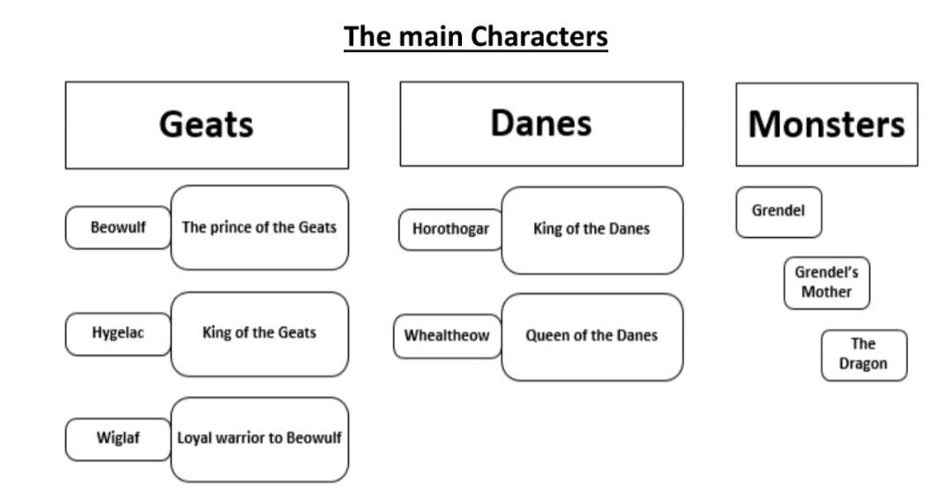

The monsters:

1) Grendel: Huge, violent creature. Symbolizes Evil. Threat to King Hrothgar.

2) Grendel’s mother: huge creature, has every right to revenge.

3) The dragon: Evil monster, obsesses with gold.

* ***TERROR AT KING HROGHFAR’S HALL***:

King Hrothgar grows powerful and has many loyal followers, he’s been shown favor because of his leadership and decides to reward that favor by building a lavish feasting hall called (Herot). Soon however, the house of Hrothgar is attacked by an evil force (Grendel). Grendel becomes enraged by the loud banquets and by the poets of the Hall who profess the goodness of God. He storms the castle, takes thirty of Hrothgar’s men to his lair and returns them tortured. For 12 winters Grendel continuous his rampage. King Hrothgar gets distressed and desperate and turns to his trusted advisors for help. The advisors recommend a shrine and offering to the heathen gods. (Heorot) is important because all great kings must have a Hall in which to take refuge after long bouts of war. The Heorot Hall signifies: *Security. *Prosperity. *Community.

---------------------------------------------------------------

* ***Beowulf in Heorot:***

- Beowulf sail with his men to the Danish coast, when they arrive, Beowulf explains to the armed guardians’ men his mission to defeat Grendel. The guards lead Beowulf and his men to Heorot Hall where Beowulf again states his cause to King Hrothgar and reminds him of the friendship that he and Beowulf’s father shared. Beowulf presents many of his accomplishments, he fought numerous beasts, raided a nest of trolls, took on several sea monsters. He declares that he plans to defeat Grendel without any weapons in order to make him his equal. Hrothgar’s prophet (Unferth) is jealous of the praise Beowulf receives; he makes a speech to discredit him. Beowulf defends himself and rebukes Unferth for his less than moral actions. Queen Wealhtheow comes in and thanks Beowulf for coming to their aid.

---------------------------------------------------------------

* ***The Battle:***

- Beowulf and Grendel meet. Grendel plans his murderous rampage, he breaks into Heorot Hall where Beowulf waits. Before Beowulf can attack, Grendel kills one of Beowulf’s fellow warriors. Grendel then reaches for Beowulf and the two enter into a great battle. Beowulf’s warriors try to fight Grendel with swords, but that doesn’t work. Beowulf fatally injures Grendel by tearing his arm from his body. Wounded and close to death, Grendel returns to his home and dies. Reveals Beowulf’s superhuman power. The battle shows the theme (Good vs. Evil).



* ***Danger Returns:***

- Grendel’s mother comes to revenge her son’s death. After the long and ceremonial evening, Hrothgar and Beowulf leave Heorot Hall to get some rest, when Grendel’s mother attacks and kills one of Hrothgar’s closest advisors. Beowulf is summoned and grandly proclaims that he will kill Grendel’s mother, Unferth gives Beowulf his sword. Beowulf leaves to hunt down Grendel’s mother and they battle. Beowulf swings his sword but it has no effect on Grendel’s mother. Seeing a sword meant for a giant, he tears it from the wall beheads Grendel’s mother.

* The Geats needs some sign of their hero. Beowulf sees Grendel’s body laying below and takes his head as a trophy. The blade of the sword melts away once it touches Grendel’s poisonous blood. Beowulf returns to Heorot Hall with the hilt of the sword and Grendel’s head as trophies.

--------------------------------------------------------

* ***Beowulf’s last battle (the dragon):***

- Beowulf and his men enter the barrow, and Beowulf calls for the dragon, after seeing the dragon everyone escapes except for Beowulf and one of his men (Wiglaf), Wiglaf aids Beowulf in his battle with the dragon. Beowulf delivers the final blow with a knife in the dragon’s abdomen, but not before the dragon bites Beowulf’s neck with his fangs. Beowulf lays dying while Wiglaf brings him water, He asks Wiglaf to enter the barrow and show him the treasure. Beowulf is pleased that he left something for his people. He gives Wiglaf his armor and says his final goodbye.

*Beowulf’s gift his armor to Wiglaf is a significant act, handing down armor was very meaningful. Which leads one to believe that Beowulf would entrust Wiglaf with the crown.



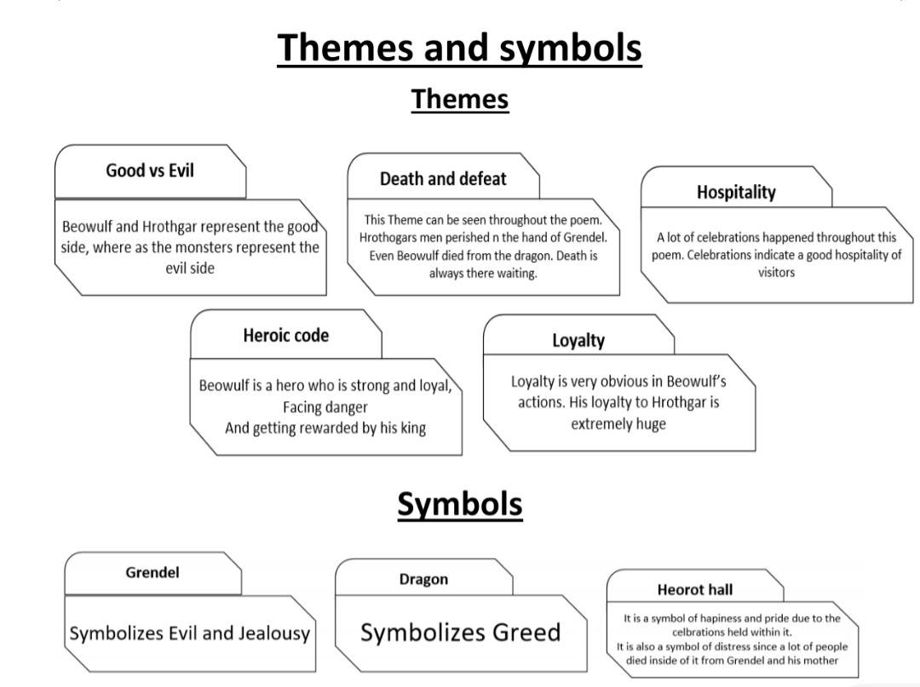--------------------------------------------------------------------------------------------------

* Kenning: A type of figurative language that was commonly used in Old English and Norse poetry. It involves using a two-word phrase to describe a person, place, or thing in a metaphorical or imaginative way. For example, "whale-road" is a kenning used in "Beowulf" to describe the sea, and "ring-giver" is a kenning used to describe a king. Kenning is a creative and poetic way of describing things that was popular in medieval literature.