

**Faculty of Engineering & Technology – Electrical & Computer Engineering Department**

**Second Semester 2021 – 2022**

Communication Laboratory ENEE4113

***Experiment 2 - Prelab***

**Name: Ahmaide Al-Awawdah.**

**ID: 1190823**

**Section: 9**

**Instructor: Dr. Ashraf Al-Rimawi**

**TA: Eng. Ruba Eid**

**Date: 1st April 2022**

***m(t) = $\cos{(2π1500t)}$, c(t) = 4 $\cos{(2π100000t)}$***

* ***SSB-SC modulated signal = Ac m(t) cos (ωc t) – Ac mh(t) sin (ωc t)***

***mh(t) = $\cos{(2π1500t + \frac{π}{2})}$,***

* The figure below shows the plotted signal using MATLAB software.

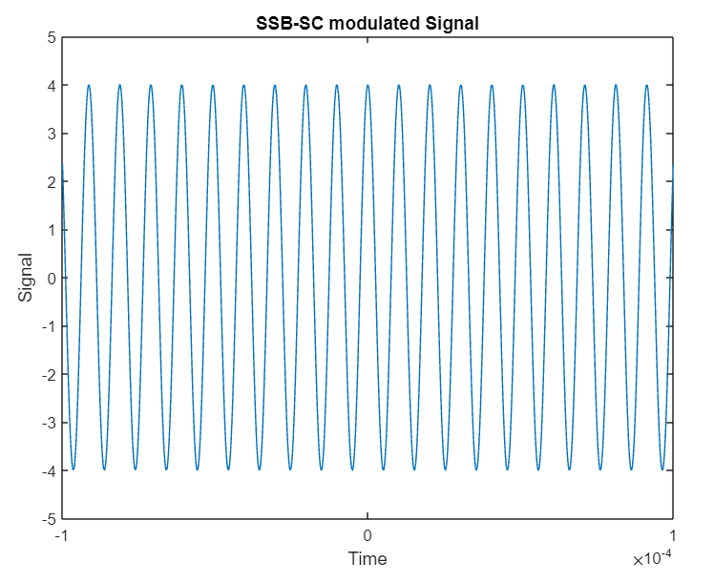

### Figure 1: SSB-SC modulated signal

**The code**

Am = 1;

fm = 1500;

Ac = 4;

Fc = 100000;

t=-0.0001:0.00000001:0.0001;

m = Am.*cos(2*pi*fm*t);

d90 = pi.*0.5;

M_shift = Am.*cos(2*pi*fm*t + d90);

s = Ac.*m.*cos(2*pi*Fc*t) - Ac.*M_shift.*sin(2*pi*Fc*t);

plot(t, s,'-');

axis([-0.0001, 0.0001, -5, 5]);

xlabel("Time"), ylabel("Signal");

title("SSB-SC modulated Signal");

**The block diagram**

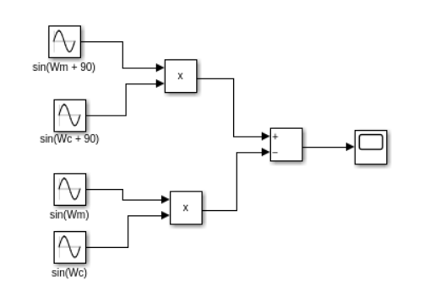

### Figure 2: SSB-SC modulated signal block diagram