

Faculty of Engineering & Technology – Electrical & Computer Engineering Department
Second Semester 2021 – 2022

Communication Laboratory ENEE4113

Experiment 2 - Prelab

Name: Ahmaide Al-Awawdah.

ID: 1190823

Section: 9

Instructor: Dr. Ashraf Al-Rimawi
TA: Eng. Ruba Eid

Date: 1st April 2022

m(t) = $\cos{(2π1500t)}$, c(t) = 4$\cos{(2π100000t)}$
- SSB-SC modulated signal = A_{c} m(t) cos (ω_{c} t) – A_{c} m_{h}(t) sin (ω_{c} t)
m_{h}(t) = $\cos{(2π1500t + \frac{π}{2})}$,

- The figure below shows the plotted signal using MATLAB software.
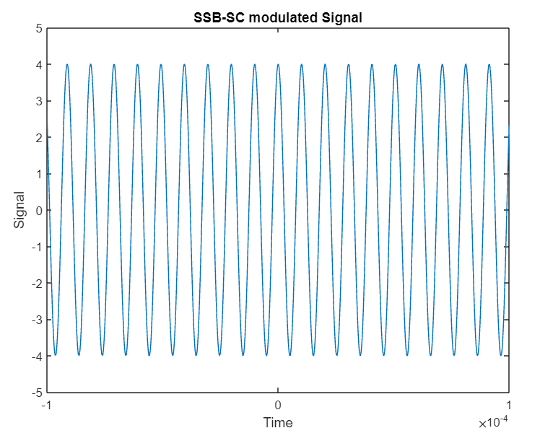

Figure 1: SSB-SC modulated signal

The code
Am = 1;
fm = 1500;
Ac = 4;
Fc = 100000;
t=-0.0001:0.00000001:0.0001;
m = Am.*cos(2*pi*fm*t);
d90 = pi.*0.5;
M_shift = Am.*cos(2*pi*fm*t + d90);
s = Ac.*m.*cos(2*pi*Fc*t) - Ac.*M_shift.*sin(2*pi*Fc*t);
plot(t, s,'-');
axis([-0.0001, 0.0001, -5, 5]);
xlabel("Time"), ylabel("Signal");
title("SSB-SC modulated Signal");
The block diagram
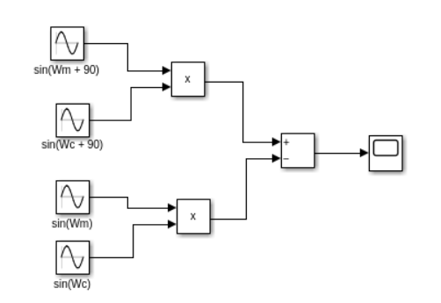

Figure 2: SSB-SC modulated signal block diagram

