

**Electrical & Computer Engineering Department**

**Electronics Lab ENEE3102**

**Report for Experiment :**

### Oscillators

**Prepared for:**

**Dr.Mohammed Al-Ju'ba**

**Student name:Dalal bawatneh**

**NO:1170329**

**Sec:1**

**Abstract :**

**The aim of experiment:**

To connect the some of oscillator circuit for example the wien bridge oscillator, the RC phase-shift oscillator, the colpitts oscillator and the RC a stable multivibrator by Pspise and to determine the frequency on each circuit with variable resistance and capacitor.

**Method used :**

Pspise

Lab manual

**Theory**

Oscillator:

An *oscillator*is an electronic circuit that generates repeated waveforms. The exact waveform generated depends on the type of circuit used to create the oscillator. One of the most commonly used oscillator circuits is made from a pair of transistors that are rigged up to alternately turn on and off.

Energy needs to move back and forth from one form to another for an oscillator to work. You can make a very simple oscillator by connecting a [capacitor](https://electronics.howstuffworks.com/capacitor.htm) and an [inductor](https://electronics.howstuffworks.com/inductor.htm) together. If you've read [How Capacitors Work](https://electronics.howstuffworks.com/capacitor.htm) and [How Inductors Work](https://electronics.howstuffworks.com/inductor.htm), you know that both capacitors and inductors **store energy**. A capacitor stores energy in the form of an electrostatic field, while an inductor uses a magnetic field.

If you charge up the capacitor with a [battery](https://electronics.howstuffworks.com/battery.htm) and then insert the inductor into the circuit, here's what will happen:

* The capacitor will start to discharge through the inductor. As it does, the inductor will create a magnetic field.
* Once the capacitor discharges, the inductor will try to keep the current in the circuit moving, so it will charge up the other plate of the capacitor.
* Once the inductor's field collapses, the capacitor has been recharged (but with the opposite polarity), so it discharges again through the inductor.

­ This oscillation will continue until the circuit runs out of energy due to **resistance** in the wire. It will oscillate at a frequency that depends on the size of the inductor and the capacitor.

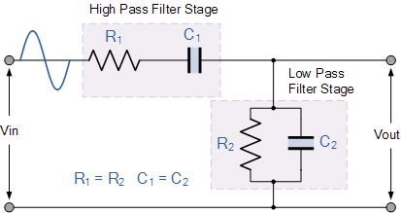In part one we use the wien bridge oscillator, The Wien Bridge Oscillator uses uses two RC networks connected together to produce a sinusoidal oscillator

In the RC Oscillator tutorial we saw that a number of resistors and capacitors can be connected together with an inverting amplifier to produce an oscillating circuit.

One of the simplest sine wave oscillators which uses a RC network in place of the conventional LC tuned tank circuit to produce a sinusoidal output waveform, is called a **Wien Bridge Oscillator**.

The **Wien Bridge Oscillator** is so called because the circuit is based on a frequency-selective form of the Wheatstone bridge circuit. The Wien Bridge oscillator is a two-stage RC coupled amplifier circuit that has good stability at its resonant frequency, low distortion and is very easy to tune making it a popular circuit as an audio frequency oscillator but the phase shift of the output signal is considerably different from the previous phase shift **RC Oscillator**.

The **Wien Bridge Oscillator** uses a feedback circuit consisting of a series RC circuit connected with a parallel RC of the same component values producing a phase delay or phase advance circuit depending upon the frequency. At the resonant frequency ƒr the phase shift is 0o. Consider the circuit below.

### RC Phase Shift Network

The above RC network consists of a series RC circuit connected to a parallel RC forming basically a High Pass Filter connected to a Low Pass Filter producing a very selective second-order frequency dependant Band Pass Filter with a high Q factor at the selected frequency, ƒr.

At low frequencies the reactance of the series capacitor (C1) is very high so acts a bit like an open circuit, blocking any input signal at Vin resulting in virtually no output signal, Vout. Likewise, at high frequencies, the reactance of the parallel capacitor, (C2) becomes very low, so this parallel connected capacitor acts a bit like a short circuit across the output, so again there is no output signal.

So there must be a frequency point between these two extremes of C1 being open-circuited and C2 being short-circuited where the output voltage, VOUT reaches its maximum value. The frequency value of the input waveform at which this happens is called the oscillators *Resonant Frequency*, (ƒr).

At this resonant frequency, the circuits reactance equals its resistance, that is: Xc = R, and the phase difference between the input and output equals zero degrees. The magnitude of the output voltage is therefore at its maximum and is equal to one third (1/3) of the input voltage as shown.

### Oscillator Output Gain and Phase Shift

It can be seen that at very low frequencies the phase angle between the input and output signals is “Positive” (Phase Advanced), while at very high frequencies the phase angle becomes “Negative” (Phase Delay). In the middle of these two points the circuit is at its resonant frequency, (ƒr) with the two signals being “in-phase” or 0o. We can therefore define this resonant frequency point with the following expression.

The second type of ocsillator the RC phase-shift oscillator, RC Oscillators use a combination of an amplifier and an RC feedback network to produce output oscillations due to the phase shift between the stages.

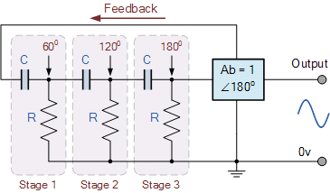

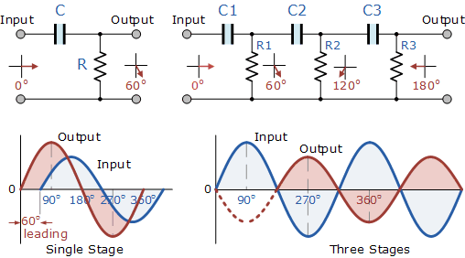In an **RC Oscillator** circuit the input is shifted 180o through the feedback circuit returning the signal out-of-phase and 180o again through an inverting amplifier stage to produces the required positive feedback. This then gives us “180o + 180o = 360o” of phase shift which is effectively the same as 0o, thereby giving us the required positive feedback. In other words, the total phase shift of the feedback loop should be “0” or any multiple of 360o to obtain the same effect.

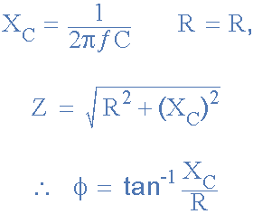In a **Resistance-Capacitance Oscillator** or simply known as an **RC Oscillator**, we can make use of the fact that a phase shift occurs between the input to a RC network and the output from the same network by using interconnected RC elements in the feedback branch, for example.

### RC Phase Angle

* 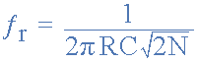Where:
* ƒr  is the oscillators output frequency in Hertz
* R   is the feedback resistance in Ohms
* C   is the feddback capacitance in Farads
* N   is the number of RC feedback stages.

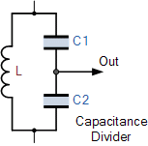The third type of oscillator the colpitts oscillator , The Colpitts Oscillator design uses two centre-tapped capacitors in series with a parallel inductor to form its resonance tank circuit producing sinusoidal oscillations

The Colpitts oscillator uses a capacitive voltage divider network as its feedback source. The two capacitors, C1 and C2 are placed across a single common inductor, L as shown. Then C1, C2 and L form the tuned tank circuit with the condition for oscillations being: XC1 + XC2 = XL, the same as for the Hartley oscillator circuit.

The advantage of this type of capacitive circuit configuration is that with less self and mutual inductance within the tank circuit, frequency stability of the oscillator is improved along with a more simple design.

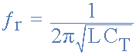 The frequency of oscillations for a Colpitts oscillator is determined by the resonant frequency of the LC tank circuit and is given as:

Then the amount of feedback developed by the Colpitts oscillator is based on the capacitance ratio of C1 and C2 and is what governs the the excitation of the oscillator. This ratio is called the “feedback fraction” and is given simply as:

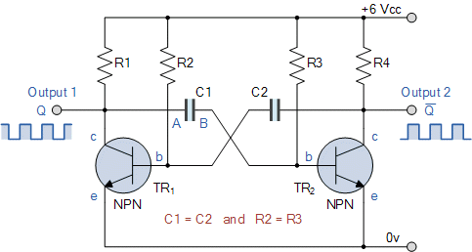The final type RC a stable multivibrator , Astable Multivibrators are free running oscillators which oscillate between two states continually producing two square wave output waveforms

The **Astable Multivibrator** is another type of cross-coupled transistor switching circuit that has **NO** stable output states as it changes from one state to the other all the time. The astable circuit consists of two switching transistors, a cross-coupled feedback network, and two time delay capacitors which allows oscillation between the two states with no external triggering to produce the change in state.

In electronic circuits, astable multivibrators are also known as **Free-running Multivibrator** as they do not require any additional inputs or external assistance to oscillate. Astable oscillators produce a continuous square wave from its output or outputs, (two outputs no inputs) which can then be used to flash lights or produce a sound in a loudspeaker.

### AstableMultivibrator Waveforms

**Procedure :**

Part one :

Connect the circuit by Pspise of Fig. (11-1).

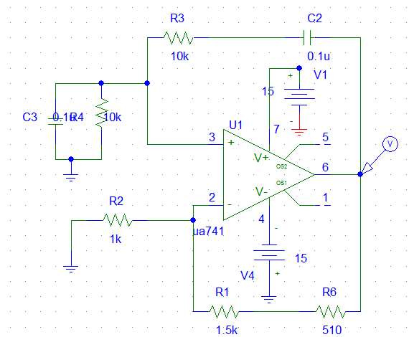

Fig. (11-1).

The output voltage by simulation :



then take frequency by Pspise:



Then F = 144Hz

Then replaced capacitor value to C1 = c2 = .33u



Amp=14.6v

then take frequency by Pspise:



Freq= 47 hz

Then replaced the value of R1 = R2 = 1K



For amplitude



Amp=47.3mv

then take frequency by Pspise:



Freq=480 hz

**Part two**

Connect the circuit of Fig(11-2).

**When change c=0.33u**

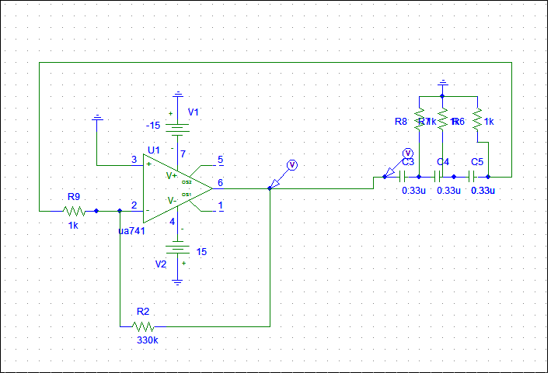

Fig(11-2).

The output voltage by simulation:



**Amp=14.6v**

then take frequency by Pspise



**Freq=145.08hz**

**Then when c=0.47u**

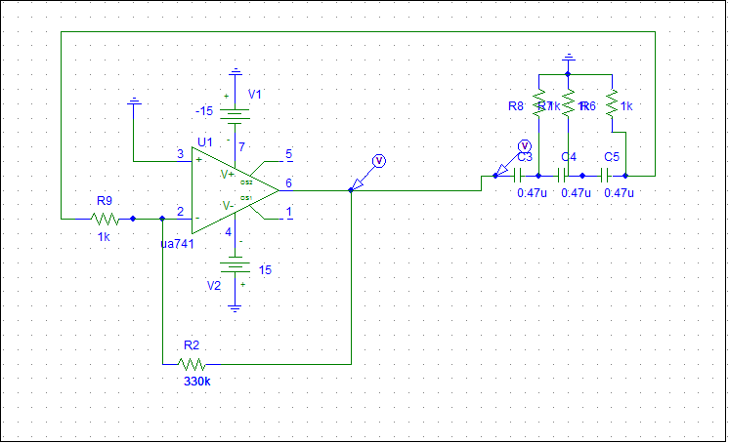

The output voltage by simulation:





Amp=14.6v

then take frequency by Pspise



Freq=102hz

* Then when R1 = R2 = R3 = 470

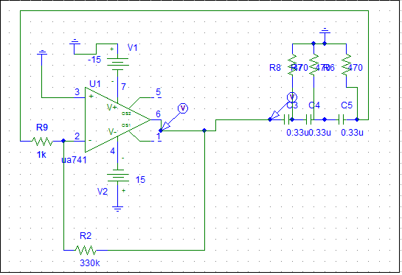

The output voltage by simulation



Amp=14.6v

then take frequency by Pspise



Freq=275.055hz

**Part three :**

Connect the circuit of Fig.( 11-3) .

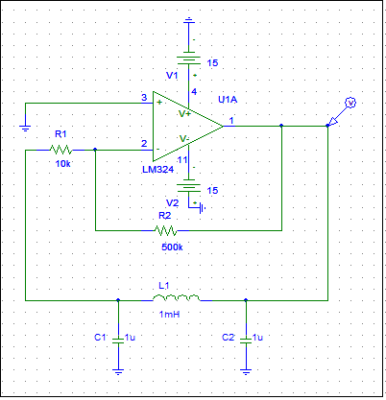

Fig.( 11-3)

The output voltage by simulation



The amp=1.8 v

then take frequency by Pspise



freq=6.801khz

when output signal disappear (no oscillations).R=2K

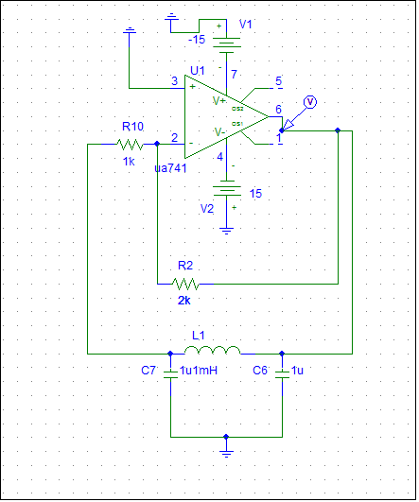

The output voltage by simulation



When L=10mh,R=500k



then take frequency by Pspise



Freq=2.2khz

When L=10mh ,R=5k



Part 4:

Connect the circuit of Fig.(11-4).

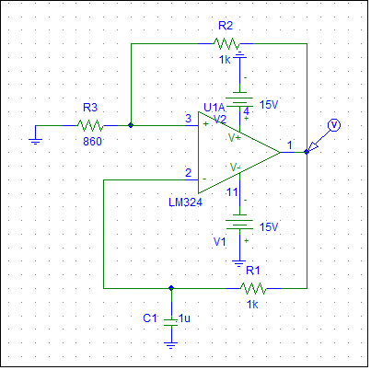

Fig.(11-4).

The output voltage by simulation



Amp=14.5v

then take frequency by Pspise



Freq=480 hz

When c=0.1u

The output voltage by simulation



Amp=14.5v

then take frequency by Pspise



Freq=3.428khz

Part 5:

Connect the circuit shown in Fig.(11-5).

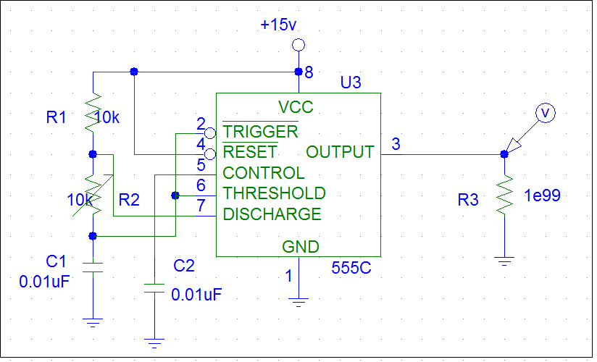

Fig.(11-5).

When R2=10K

The output voltage by simulation



Vc



Duty cycle = (1.617m- 1.4676m)/( 1.617m- 1.3844m)=0.643

then take frequency by Pspise



Freq=4.5khz

At R =20k

The output voltage by simulation



vc



Duty cycle = (1.4717m- 1.2488m)/( 1.4717m- 1.0922m)=0.58

then take frequency by Pspise



Freq=2.8k

R = 30K

The output voltage by simulation



vc



Duty cycle = (1.4926m- 1.2001m)/( 1.4926m- 970.947u)=0.56

then take frequency by Pspise



Freq=2.04khz

R = 40K

The output voltage by simulation



Vc



Duty cycle = (1.892m- 1.5218m)/( 1.892m- 1.2278m)=0.55

then take frequency by Pspise



Freq=1.47khz

R = 50k

The output voltage by simulation



Vc



Duty cycle = (2.2887m- 1.8505m)/( 2.2887m- 1.4818m)=0.543

then take frequency by Pspise



Freq=1.25khz

|  |  |  |
| --- | --- | --- |
| R(Khom) | Freq(khz) | Duty cycle |
| 10 | 4.5khz | 0.643 |
| 20 | 2.8k | 0.58 |
| 30 | 2.04khz | 0.56 |
| 40 | 1.47khz | 0.55 |
| 50 | 1.25khz | 0.543 |

**Conclusion:**

We conclude ,when we connect the circuits of oscillator, we must satisfy the Brekhausen criterial for sustained oscillation ,also the feedback must be positive, this means that the feedback signal must be phased so that it adds to the amplifiers input signal, and the loop gain (AB) must be greater than unity to allow oscillation to build up and equal to unity to sustain the oscillation.

We conclude the wien bridge oscillator employs a lead –lag network, and at one particular frequency ,the phase shift across the network is zero, therefore the feedback network is connected to the Op.amp noninverting input terminal. Also we can using active negative feedback and single potentiometer to adjust the frequency of the wien bridge oscillator.

To obtain high frequency harmonic oscillator, we connect LC oscillators for example colpitts use as inverting amplifier.

The 555 timer use as an oscillator it can be used to provide time delays, as an [oscillator](https://en.wikipedia.org/wiki/Oscillator), and as a [flip-flop element](https://en.wikipedia.org/wiki/Flip-flop_element).