Abstract:-

The objectives from this experiment are to synthesis Nerolin(Ingredient in many perfumes) and to understand how the perfumes are produced. This reactions occur by S_{N}2(Bimolecular Nucleophilic Substitution Mechanism-One step reaction). After heat the mixture for 2 hours and cool it, we have got Nerolin in its solid state(Like powder) by suction filtration.

Chemicals:-
Name | Methanol | B-Naphthol | Potassium Hydroxide | Ethyl Iodide | Boiling chips
Structure | CH₃OH | C₁₀H₈O | KOH | CH₃CH₂I | CaCO₃ / SiC
Table 1: Chemicals Used
Glassware:-
Round bottom flask | Graduated Cylinder | Bunsen burner | Condenser | Beaker | Buchner Funnel | Filter Flask
Table 2: Tools Used

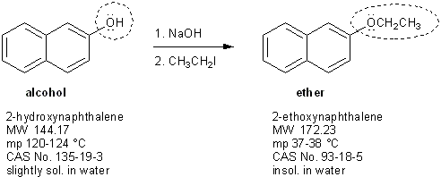
Reactions and Mechanisms:
KOH
Figure 1 : Reaction of synthesis Nerolin
β -Naphthol
Nerolin

Experimental Procedure:-
Step | #
40ml of Methanol, 5.8g of B-Naphthol, and 3.26g of Potassium hydroxide are added into 100ml round bottomed flask | 1
The contents of the flask are shaken for few minutes(Until all dissolve), then 3.6ml of Ethyl iodide and a couple of boiling chips are added to the round bottomed flask. | 2
A reflux condenser is attached. (Have your instructor approved your setup). The mixture is boiled for two hours. | 3
The reaction mixture is cooled to room temperature. The mixture is poured(after cooled at R.T) into a 250ml beaker and 100ml of ice cold water are added. The mixture is cooled in an ice bath in order to effect crystallization of Nerolin. | 4
The crystallized Nerolin is collected by suction filtration. | 5
Table 3: Procedure of synthesis Nerolin

Data:-
Volume of methanol: 40 ml.
Mass of β-Naphthol: 5.80 g.
Mass of KOH: 3.26 g.
Volume of ethyl iodide: 3.6 ml
Mass of Nerolin: 0.82 g.

Calculation and results:-

Discussion & Comments:-

Nerolin is used I perfumery and as a fixative in soaps; fixative reduce the evaporation rate of other added volatile scents.

The percentage yield is very low(12%) and this indicate that there is a huge error in our experiment. This may be because of the lost material stay in the glassware, or steric hindrance plays a part as the β-Naphthol anion is quite bulky.

Questions:-

Q1.(2) Because Nerolin sublimate, from solid to gas.

Q2.(5) By extraction. Mix Nerolin and β-Naphthol with organic solvent(CH₂Cl₂). Add KOH to mixture, then Potassium β-Naphthol will dissolve in aqueous layer and Nerolin will remain in organic layer. We take aqueous layer and acidify it with HCl to reform β-Naphthol. Note: Now organic layer contain Pure Nerolin.( Then heat to get the pure Nerolin)

Q3.(6) In our experiment we mix β-Naphthol with KOH and CH₃OH and wait for the reaction to take place and Potassium β-Naphthol cannot retain to β-Naphthol , then we add CH₃CH₂I. This procedure help us to insure that no side reaction occur, thus CH₃CH₂OH will not produce.

Good Luck

