

**Faculty of Engineering and Technology**

**Mechanical Engineering Department**

**Fluid Mechanics laboratory**

**ENME312**

**Experiment #7**

**Discharge Beneath a Sluice Gate and a ‘V’ Notch**

**Instructors:**

**Dr. Adel Dweik**

**Eng. Alanood Moudai**

**Done by group 3:**

Khaled Wahdan 1191584

**Ahmad Sabobeh 1191922**

Aws Daraghmeh 1191856

**Date of performing the experiment: 25.4.2022**

**Date of submitting the experiment: 12.5.2022**

**Abstract**

Measuring water flow rate in a one-dimensional free flow channel is a very important topic, but it cannot be done using previous methods used in pressurized systems such as placing a Venturi, Rotameter, or Orifice Meter. Hence, a Sluice Gate or a ‘V’ Notch is mounted on the water channel flow in order to control the amount of water passing through and measuring the amount of flow rate and the adjacent values.

Both ‘V’ Notch and Sluice Gate have different apparatus and set-up, but they both follow the same **principles,** which are the Continuity Equation and Bernoulli’s Formula. Also, a pitot tube was placed in order to measure the dynamic head exerted by our water flow.

By measuring the hydraulic heads at specified locations using manometers and other parameters, the **aim** of calculating the flow rate for a free flow can be reached. The coefficients of Discharge, contraction, and velocity were found through calculation to determine how the behavior of water changes as the flow rate is increased.

As a **Result**, flow rates for all runs for the two gates were found. And Discharge Coefficients were calculated and showed better values for the sluice gate over the ‘V’ Notch, since the average for Sluice Gate Readings was (0.7) whereas the average for the ‘V’ Notch readings was (0.4). Also, graphs showing the relations will be introduced in following pages.

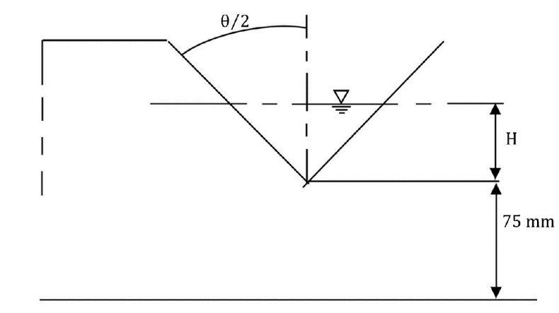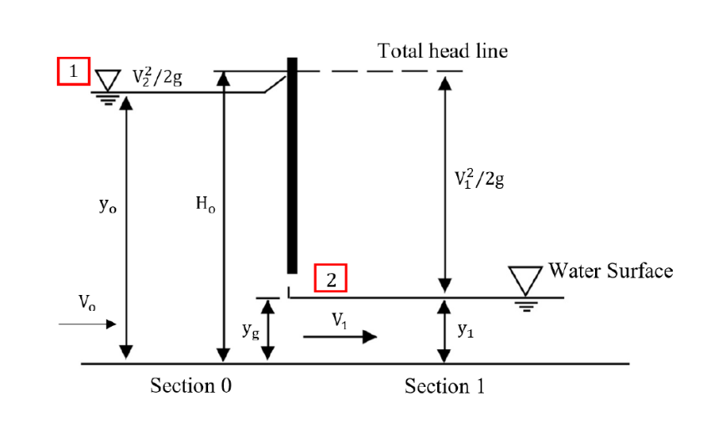

*Figure (1): Cross-Section of the Sluice Gate (on the left) and the ‘V’ Notch (on the right) showing shape and parameters.*

**Objectives**

To measure:

Sluice Gate

* Sluice Gate height Yg.
* Manometer Readings before and after the gate Y0 and Y1.
* Total Head reading Hc.

V Notch

* Water Flow Rate (Q) through a digital device.
* Water Head by a ruler.

To Analyze:

* Flow Rate Values for all readings.
* Coefficients of Discharge for all values.
* Plotting the curve relating the Discharge Coefficient with the flow rate.
* Plotting other curves showing related parameters, like the head and flow rate.

To Determine:

* Cross-Sectional Area.
* Constant height of the ‘V’ notch.
* Slopes of the linear graphs for comparing values.
* Forces acting on the sluice gate.

**Sample Calculations**

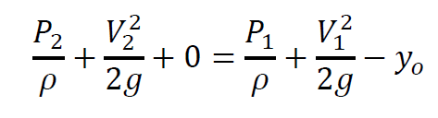Sluice:

From the Continuity: , and Bernoulli’s:

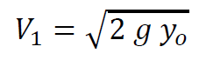we can derive:

* velocity: --------------------(1)

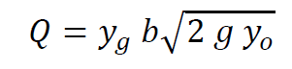

* Flow Rate: -------(2)



For the area: -------------------------(3)

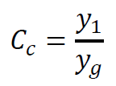

Coefficient: ------------------------ (4)

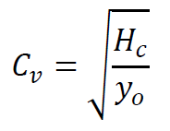

--------------(5)



------------(6)

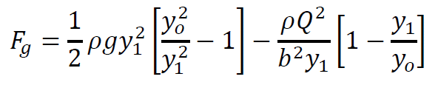

Thrust: ----(7)

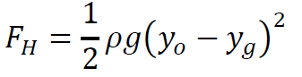

Hydraulic thrust: -------(8)

**Results**

Sluice Gate results:

Table (1): Measure values for the Sluice Gate. (*Locations shown on Figure (1)*)

|  |  |  |  |
| --- | --- | --- | --- |
| **Yg (mm)** | **Y0 (mm)** | **Y1**  **(mm)** | **Hc (mm)** |
| 20 | 237 | 17 | 186 |
| 25 | 175 | 19 | 152 |
| 30 | 130 | 22 | 116 |
| 35 | 100 | 26 | 92 |
| 40 | 84 | 30 | 83 |
| 45 | 72 | 36 | 71 |

Table (2): Calculations for the Sluice Gate (Velocity, Flow Rate, Coefficients of velocity, contraction, discharge; Forces on the gate)

|  |  |  |  |  |  |  |  |  |
| --- | --- | --- | --- | --- | --- | --- | --- | --- |
| **V1**  **(m/s)** | **Q (m3/s)** | **Cv** | **Cc** | **Cd** | **F1 (N)** | **F2 (N)** | **Fg (N)** | **Fh (N)** |
| 2.156 | 0.013 | 0.89 | 0.85 | 0.75 | 273.27 | 101.26 | 172.01 | 230.28 |
| 1.853 | 0.014 | 0.93 | 0.76 | 0.71 | 148.00 | 100.38 | 47.62 | 110.03 |
| 1.597 | 0.014 | 0.94 | 0.73 | 0.69 | 80.28 | 86.42 | -6.15 | 48.90 |
| 1.401 | 0.015 | 0.96 | 0.74 | 0.71 | 45.60 | 68.20 | -22.60 | 20.66 |
| 1.284 | 0.015 | 0.99 | 0.75 | 0.75 | 30.10 | 56.34 | -26.23 | 9.47 |
| 1.189 | 0.016 | 0.99 | 0.80 | 0.79 | 19.01 | 39.61 | -20.60 | 3.57 |

Table (3): Graph-related calculations (ratios between forces and heights)

|  |  |
| --- | --- |
| **fg/fh** | **yg/y0** |
| 0.746971 | 0.084388 |
| 0.432786 | 0.142857 |
| -0.12567 | 0.230769 |
| -1.094 | 0.35 |
| -2.77066 | 0.47619 |
| -5.77778 | 0.625 |

*Figure (2): graph of (Thrust Fg over Resultant Hydrostatic Thrust Fh) vs. (height of gate Yg over water depth behind it).*

‘V’ Notch results:

Table (4): Measurements and Calculations for the V Notch (Flow Rate, hydraulic Head, Discharge Coefficient).

|  |  |  |  |  |
| --- | --- | --- | --- | --- |
| **Q (m3/h)** | **H (m)** | **Q**  **(m3/s)** | **Cd** | **Q(2/5)** |
| 7 | 0.07 | 0.00194 | 0.6349 | 0.0823 |
| 9 | 0.09 | 0.00250 | 0.4355 | 0.0910 |
| 14 | 0.106 | 0.00389 | 0.4500 | 0.1086 |
| 17 | 0.119 | 0.00472 | 0.4092 | 0.1174 |
| 19 | 0.128 | 0.00528 | 0.3811 | 0.1227 |

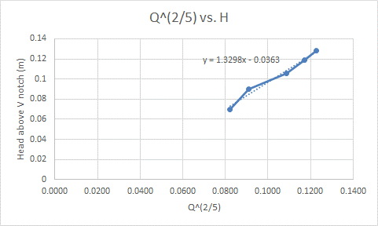

*Figure (3): Graph of Flow rate to the power of 0.4 Vs. Head above V Notch (Slope = Discharge Coefficient).*

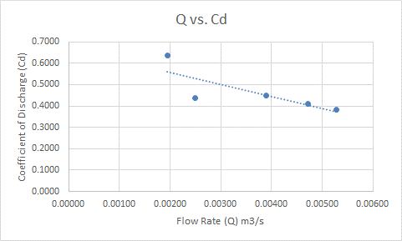

*Figure (4): Graph of Water Flow Rate Vs. Coefficient of Discharge.*

**Discussion of Results**

As mentioned in the abstract, the main purpose was to find the flow rates of a free channel flow by a Sluice gate then a V Notch. The Tables and Calculations showed how we had gotten our values and what other parameters we had to measure. It can be noticed that the procedure was different from that used in tubes and pipes.

Table (1) contains the measurements for the sluice gate that were recorded in the lab. These values were used to find quantities in Table (2) for the sluice gate. And to help plot Figure (2), which plot the ration of forces to heights, values in Table (3) were calculated.

For the V Notch, all our values and calculations are present in Table (4). Since the flow rate was measured digitally and the coefficient of discharge was the only remaining thing to find. Out of these values we were able to plot figure (3) and figure (4).

A clear Relationship we noticed, is the linear relation between the difference in forces and the difference in heights in the sluice gate. This relationship is visible in Figure (2). Also, in the V Notch an important trend to highlight was the slope of the graph relating (flow rate to the power of 0.4) and the (hydraulic Head). This trend’s slope represents a constant value that equals the Discharge coefficient as shown in Figure (3).

Lastly, Figure (4) shows the relation of the discharge coefficient and the flow rate. This curve in addition to figure (3) helped us to spot an error in the second reading we calculated during our lab work. And by testing numbers we found that the error was in the reading of the digital flow rate. Since the value of flow rate needs to be (11 m3/hour) in order to get in line with other values. This could be of a misreading of the lab technician for the digital flow rate or an error in recording it.

**Conclusion**

Afterall, it can be noticed that the values of the discharge coefficients for the Sluice Gate are higher than those for the ‘V’ Notch. However, this doesn’t mean that the later mentioned is worse, it’s useful when dealing with low water flow rate. Our calculations are all *Acceptable*, but we can exclude the second run in the V notch by referring to Graph (3) & (4) to get better accuracy or correct it as discussed.

**Applications**

Both parts are efficient methods for calculating the water Flow Rate in a free flow channel, and this is needed for various applications like:

* Rivers.
* Canals.
* Waste-water Treatment.

**References**

1. Fluid Lab Manual.
2. Attached data sheet.