Chapter 04 Management Concepts

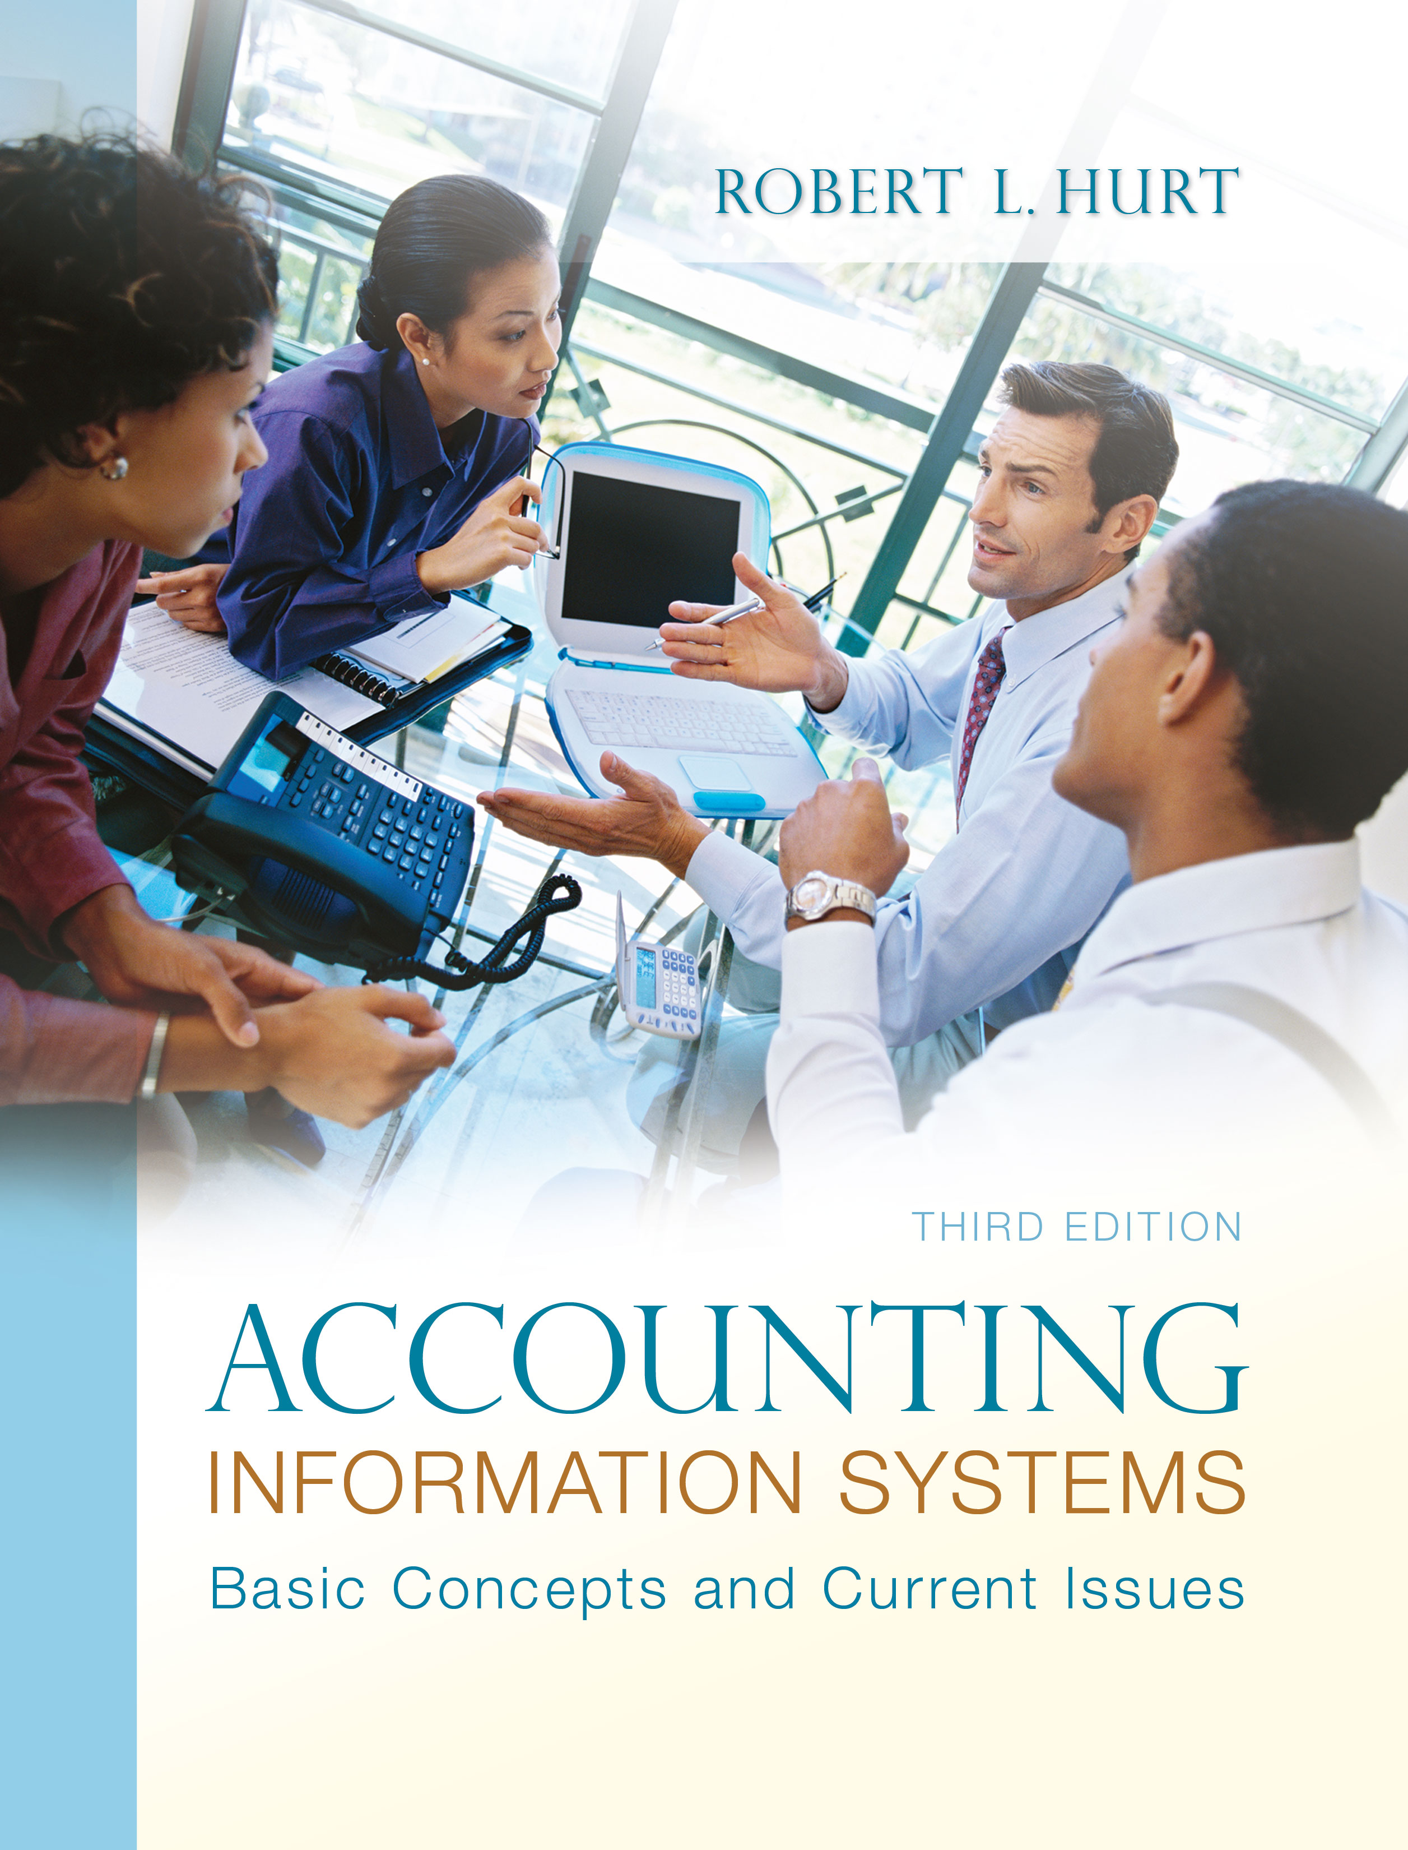
1. Reading review questions

a. What are the elements of COSO’s enterprise risk management framework? COSO’s ERM framework comprises eight elements: internal environment, objective setting, event identification, risk assessment, risk response, control activities, information and communication, and monitoring.

b. What is business process management? List and discuss the steps managers often use to change a business process. Business process management, as the name implies, is a way organizations can make their business processes more effective and efficient. By doing so, organizations can create value for their stakeholders. The generalized model of BPM discussed in the chapter comprises seven steps: Select the process and define its boundaries. Observe document, and map the process steps and flow. Collect process-related data. Analyze the collected data. Identify and prioritize potential process improvements. Optimize the process. Implement and monitor process improvements.

c. List and discuss seven principles of business process management. Eppele suggested seven principles to keep in mind in a BPM project: Understand how business processes interact with / support organizational strategy. Move away from the “we’ve always done it this way” mentality. Enlist top management support. Managing business processes is fundamentally about people, not technology / documents. Don’t rely on external consultants to the exclusion of internal employees. When using consultants, make sure the task is well defined, with specific deliverables defined by the company. Communicate early; communicate often.

d. What are the elements of expectancy theory? Give examples of each one. Vroom suggested that motivation depends on three factors: expectancy, instrumentality and valence. Expectancy is the strength of someone’s belief that effort will lead to accomplishment; for example, a student may believe that completing all their accounting homework will lead to passing the course. Instrumentality is the strength of someone’s belief that achieving a goal will lead to a reward; for example, a student may believe that graduating with a 4.0 GPA will lead to a good job. Finally, valence is the extent to which a reward is valued; for example, a student may really want a good job.

e. In a format specified by your instructor, respond to the questions for this chapter’s “AIS in the Business World.” I was very fortunate to have three assistants available to prepare responses to the AIS in the Business World vignettes for the third edition; I’ve posted their responses on my AIS blog: www.bobhurtais.blogspot.com.

2. Reading review problem

a. Use COSO’s enterprise risk management framework to create an ERM plan for AOL. AOL’s management would first need to create an appropriate internal environment by discussing and demonstrating the importance of managing enterprise risk. As part of the company’s strategic planning process, AOL would set objectives for its performance; for example, they might have a goal of increasing subscribers by 1% within 12 months. In risk assessment, AOL determines the risks that could interfere with achieving their goals. For example, competing companies (such as Google) might offer better services, causing customers to drop AOL in favor of something else. Each risk requires at least one of four generic risk responses: accept, reduce, avoid, share. AOL might decide to reduce the risk of losing customers to other services by expanding its own range of services based on customer feedback. Control activities are the specific ways a company enacts the generic risk response; in the AOL case, surveying a random sample of customers and analyzing the results would be a specific way to operationalize the generic risk response. In information and communication, as with the COSO internal control framework, AOL must communicate its ERM plan to relevant stakeholders, such as by making it available on the corporate intranet. Finally, AOL must monitor the ERM plan, adjusting it to new risks as they arise.

b. How might AOL’s management apply the steps and principles of business process management to develop their EFTS? The first step in BPM is to define the process and establish its boundaries; the relevant process in this case would be the EFTS itself. AOL would then describe the EFTS process, perhaps with a flowchart or some other form of systems documentation. The next step is to capture data on the current system; those data might include transaction processing times and an activity-based analysis of costs. The data must be analyzed after they are collected; such analysis could be accomplished via discussions and various forms of information technology. Next, AOL would brainstorm ways to improve their current process; considering the costs and benefits of each alternative, they would develop a plan for process improvement. Finally, they would implement and monitor the chosen alternatives.

c. Consider an AOL employee who was fully supportive of the EFTS. Use expectancy theory to explain the employee’s support. Expectancy theory comprises three elements. An employee supportive of the EFTS might express their expectancy through a belief that working on the EFTS implementation team will lead to success in the EFTS project. That employee’s instrumentality could focus on the belief that success in the EFTS project would lead to a promotion or pay increase, as well as streamlined operations for AOL. Finally, the employee’s valence is the extent to which the employee values the anticipated reward.

d. In expectancy theory, all three elements must be present to provide motivation. Based on AOL’s EFTS project, suggest a scenario in which one or more of the elements is not present. A jaded / disillusioned employee might make statements like these with regard to the EFTS project: “I don’t know why I should devote a lot of effort to this project; it’s not likely to change anything.” (expectancy) “Even if the project is successful, I don’t think I will benefit from it.” (instrumentality) “Suppose the project is successful and I get promoted. I don’t really want to be promoted, since it would mean an increase in my responsibilities.” (valence)

3. Multiple choice review questions. Answers to all of these questions appear at the end of the textbook itself.

4. Making choices and exercising judgment
The point of these exercises, which appear in every chapter throughout the third edition, is to encourage students to think critically and “outside the box.” Thus, I am not providing solutions to them, as doing so would likely discourage the purpose of these exercises.

5. Field exercises
Answers to these exercises will vary significantly; thus, like the previous set, I am not preparing published solutions for them.

6. Enterprise risk management
Which element of the COSO ERM framework is most closely associated with each of the following?
a. ALG Corporation bonds key employees. Control activities

b. Based on previous experience, TRG Corporation’s management believes the risk of inventory shortages is moderate. Risk assessment

c. BPC Corporation implements a profit sharing plan as a way to motivate managers to control costs. Control activities

d. BRN Corporation’s board of directors hires a consultant to explain ERM. Internal environment

e. CNV Corporation’s managers accept the risk of stock price decreases. Risk response

f. DTI Corporation holds quarterly staff lunches where employees discuss how they manage risk. Information and communication

g. EIV Corporation’s president organizes monthly meetings for managers to discuss books and articles related to ERM. Internal environment

h. FLM Corporation operates manufacturing plants on three continents. Event identification

i. FPO Corporation follows a top-down model for strategic planning. Objective setting

j. HRP Corporation’s internal audit department assesses and tracks the effectiveness of its ERM plan. Monitoring

k. Management at CNV Corporation determines the probability of a decrease in stock value is very high. Risk assessment

l. MGG Corporation occasionally hires a consultant to provide feedback on its ERM plan. Monitoring

m. RCH Corporation’s enterprise risk management department prepares and distributes a monthly ERM newsletter. Information and communication

n. SSO Corporation reviews and revises its strategic plan annually. Objective setting

o. TRG Corporation’s managers want to avoid inventory shortages. Risk response

p. WRL Corporation does not use data encryption in its wireless network. Event identification

7. Expectancy theory elements
Which element of expectancy theory is described in each of the following independent scenarios?
a. Anh completed the steps for licensure as a Certified Public Accountant and received a pay raise. Instrumentality. Achieving licensure (accomplishment) leads to reward (pay raise).

b. Claudia completed a BPM project early; her boss said she could either have extra time off or a small pay raise. Claudia chose the pay raise. Valence. Claudia values the pay raise over the time off.

c. Ethan put in many extra hours in January, and was pleased to be named “employee of the month.” Instrumentality. Effort (extra hours) leads to reward (employee of the month).

d. Lupe believes her company’s new general ledger software is too complex to master. Expectancy. Effort will not lead to accomplishment.

e. Mark changed his major from finance to accounting because he heard jobs are more plentiful in accounting. Valence. Mark values having a good job.

f. Richard has stopped suggesting business process improvements because his ideas are never implemented. Expectancy. Effort (suggestions) did not lead to accomplishment (ideas are never implemented).

8. Expectancy theory and employee motivation
In the previous problem, you identified one relevant element of expectancy theory. Consider each scenario again; “fill in” the other two elements. Here’s an example:
Expectancy: Anh studied hard and took a review course that enabled her to pass the CPA exam on her first attempt. Instrumentality: Anh completed the steps for licensure as a Certified Public Accountant and received a pay raise. Valence: Anh celebrated her pay raise with her family and close friends.

Case | Expectancy | Instrumentality | Valence
a | Anh studied hard and took a review course that enabled her to pass the CPA exam on her first attempt. | Anh completed the steps for licensure as a Certified Public Accountant and received a pay raise. | Anh celebrated her pay raise with her family and close friends
b | Claudia believed that completing the BPM project early would “get her noticed” by her boss. | Claudia believed that being noticed would result in some sort of reward. | Claudia chose the pay raise.
c | Ethan believed that putting in extra hours would go a long way toward being recognized as employee of the month. | Ethan put in extra hours and was named employee of the month. | Ethan was very proud to be named employee of the month.
d | Lupe believed the general ledger software was too complex to master. | Lupe believed that, even if she mastered the software, she wouldn’t be rewarded for her effort. | Lupe was content with her present job, salary and responsibilities; she was not interested in any change to them.
e | Changing his major would lead to success in the new major. | Success in the new major would lead to a better job. | Mark values having a good job, so he changed majors.
f | Richard stopped making suggestions because his ideas were never implemented. | Even if his ideas were implemented, Richard was uncertain he would benefit. | Richard was happy as he was, and didn’t want any changes in his position at work.

9. Business process management principles
Which of Eppele’s seven principles is violated in each of the following independent cases? Justify your responses. (Each case may violate more than one principle.)
a. Amanda objected to her company’s new approach to training because they had never used it before. Be open to alternatives.

b. Esther started a BPM project by looking for appropriate information technology tools. Managing business processes is fundamentally about people, not about technology or documents.

c. Eugene, an entry-level employee, implemented a new system for taking inventory. Understand how business processes interact with / support organizational strategy. Enlist top management support.

d. Jeff decided to change his company’s purchasing process because their current process seemed too cumbersome. Understand how business processes interact with / support organizational strategy. Enlist top management support

e. Minh told the consultants for a BPM project to prepare and submit reports as they felt it appropriate. Don’t rely on external consultants to the exclusion of internal employees. When using external consultants, make sure the task is well defined, with specific deliverables defined by the company.

f. Molly told employees that all their concerns would be addressed at the end of the BPM project. Communicate early; communicate often. Deal immediately with objections / issues as they arise.

g. Raul argued strongly that a proposed BPM project be managed by a consulting firm. Don’t rely on external consultants to the exclusion of internal employees.

10. ERM plan
Here is an ERM plan for Verizon Communications:

COSO element | Verizon example
Internal environment | The CEO and CFO of Verizon conduct a webinar emphasizing the importance of risk management and giving an overview of upcoming activities.
Objective setting | One of Verizon’s goals could be to increase its dividend payouts to shareholders.
Event identification | Verizon might have insufficient cash flow to increase its dividend payouts.
Risk assessment | The ERM team assesses the risk as moderate to high on both inherent and residual levels.
Risk response | Verizon might choose to reduce the risk of insufficient cash flow.
Control activities | One way to reduce the risk of insufficient cash flow is setting aside cash or other assets specifically to pay dividends.
Information and communication | The ERM plan would be publicized throughout Verizon, perhaps through another webinar.
Monitoring | Verizon might create a “risk management” department, specifically charged with monitoring the ERM plan.

11. Terminology

1. B
2. F
3. A
4. G
5. H
6. J
7. E
8. D
9. I
10. C

12. Multiple choice questions

1. B

2. C

3. C

4. D

5. C

13. Statement evaluation

1. Sometimes true. Depending upon the project / goal, someone outside the accounting department might be in the best position to determine valence.

2. Always true.

3. Always true.

4. Sometimes true. Not all BPM projects use information technology.

5. Never true.

6. Sometimes true. The usefulness of cost variances would depend on the nature of the BPM project.

7. Never true.

8. Sometimes true. Whether production workers are in the best position depends upon the BPM project.

9. Never true.

10. Always true.

