Lexical Cohesion

Discourse Analysis – Lecture 4

Definition

* Lexical cohesion refers to the ties created between lexical elements, such as words and phrases.
* These lexical ties can occur over long passages of text or discourse.
* The primary types of lexical cohesion are**: reiteration** and **collocation**.

1 2

A) Reiteration

* Includes *repetition, synonymy, antonymy, hyponymy, meronymy…*

A.1. Repetition

* Using the same word over again, but not restricted to the same morphological form:

E.g. using *run* (V), *run* (N), *ran, running, runner,* etc., all within the same text.

3 4

A.1. Repetition

* Example 2:

The key to good, healthy studying is having **breaks.** Even short **breaks** can be very beneficial. A student ought to have a five minute **break** every hour. He can spend it watching TV, eating, drinking, relaxing or even taking a bath to stress out. Regular **breaks** are an important method for successful studying.

A.1. Repetition

* Example 3:

*Pick up a handful of soil in your* ***garden****. Ordinary, unexciting earth. Yet it is one of nature’s miracles and one of her most complex products. Your success as a* ***gardener*** *will largely depend on its condition, so take the first step in* ***gardening****. Get to know your soil.*

Repetition chain 1: garden, gardener, gardening Repetition chain 2: soil, soil

5 6

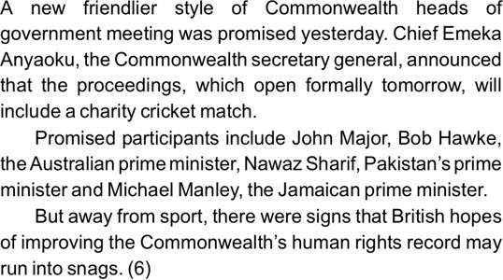

Exercise

* **Find the most important repeated words and phrases in the text:**

R. chain 1: Commonwealth (x3); R. chain 2: prime minister (x3)

A.2. Synonymy

* Synonym is used to mean ‘sameness of meaning’.
* Lexical cohesion results from the choice of a lexical item that is in some sense synonymous or nearly synonymous with a preceding one;

E.g. *sound* with *noise, cavalary* with *horses* in:

*He was just wondering which road to take when he was started by a*  ***noise*** *from behind him. It was the noise of trotting horses… He dismounted and led his horse as quickly as he could along the right-hand road. The* ***sound*** *of the cavalry grew rapidly nearer …*

7 8

A.2. Synonymy

* *Last year, my school made that day to introduce us to the*  ***laws*** *and to respect the* ***regulations****…*
* *A* ***conference*** *will be held on national environmental policy. This environmental* ***symposium*** *will be primarily a conference dealing with water.*

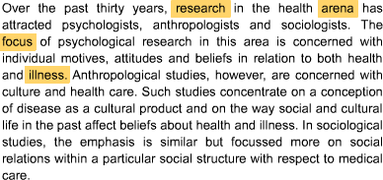

Exercise 1

* **Find near-synonyms in the text for the**

**highlighted words:**

**Synonym chain 1: research – studies Synonym chain 2: arena – area Synonym chain 3: focus – concentrate Synonym chain 4: illness – disease**

9 10

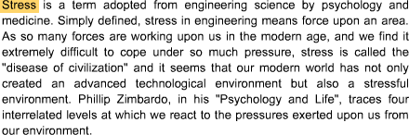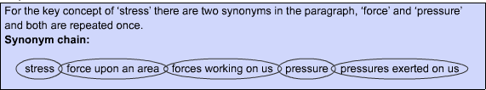

Exercise 2

* **Find near-synonyms in the text for the highlighted word:**

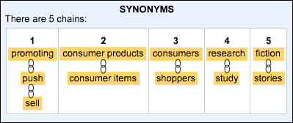

Exercise 3

* **Find synonyms in the text:**

advertisement

11 12

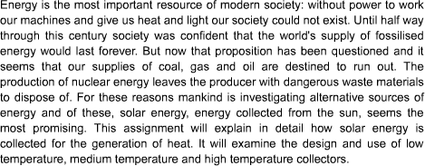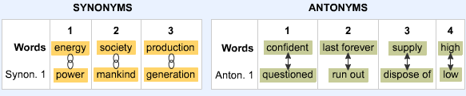

* **Find synonyms and antonyms in the text:**

4. Solar energy, energy collected from the sun;

A.3. Antonymy

* A relational antonym is one of a pair of words with opposite meanings, where opposite makes sense only in the context of the relationship between the two meanings.

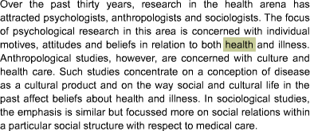

* **Find antonyms in the text for the highlighted word:**

13 14



* **Find a pair of antonyms in the text:**

**High – Low; Buy – Sell**

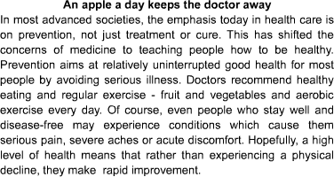

**Let’s find synonyms and antonyms in the following text:**

15 16

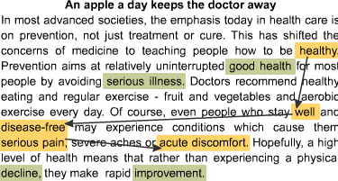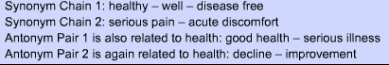

**, severe aches**

17 18

A.4. Taxonomy

* One way to develop ideas and information in an academic text is to show hierarchical meaning relationships amongst vocabulary across the text.
* This is a more complex type of lexical cohesion than lexical chains.
* When content word meanings are similar and related but at different levels of generality, their relationship is hierarchical. In a text, words related hierarchically link more specific meanings to the most general meaning.

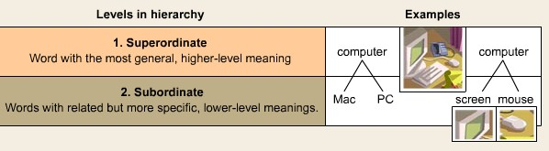

A.4. Taxonomy

19 20

* **What is the superordinate word for the following related words?**

*cover, chapter, foreword, title, footnotes*

**Answer: BOOK**

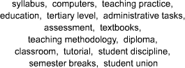

* **Find the superordinate word amongst these related words:**

**Superordinate: education; all other words are subordinates**

21 22

A.4. Taxonomy

* There are two main types of hierarchies -

**classification** and **composition**.

* **Classification** shows the relationship between a general class (of a thing or idea) and its members or types.
* **Composition** shows the relationship between a complete whole (of a thing or idea) and its parts or aspects.

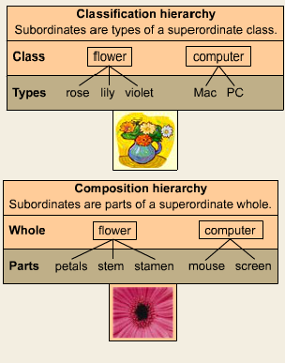

**Hypernym Hyponyms**

**Holonym Meronym**

23 24

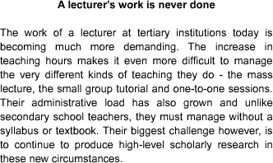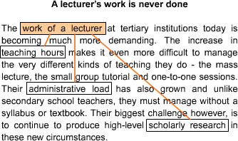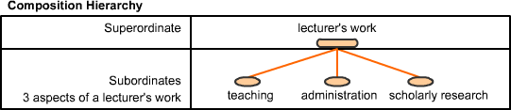

25 26

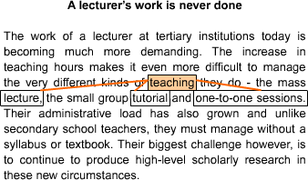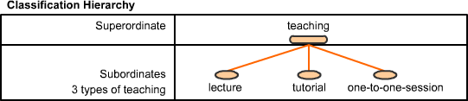

* Why is taxonomy so important in texts?
  + Because the process of analysis depends on it.
* Which is more important - a wide vocabulary or good analysis skills?
  + You need both.
* How can you ensure good vocabulary use in writing?
  + Analyse/taxonomise information and ideas before writing.
* What is the best way to analyse/taxonomise?
  + Draw diagrams. Organise your ideas/information in diagrams before writing. Then select vocabulary.

27 28

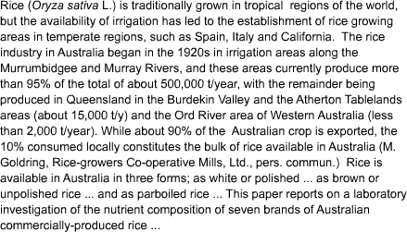

Exercise 1

* **How many hierarchies can you find here?**

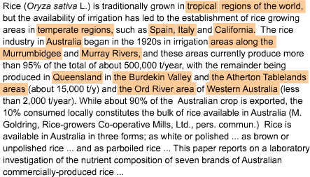

**The deepest hierarchy in the text is the second one.** The superordinate *regions of the world* has 14 subordinates. It is a composition hierarchy (temperate and tropical).

29 30

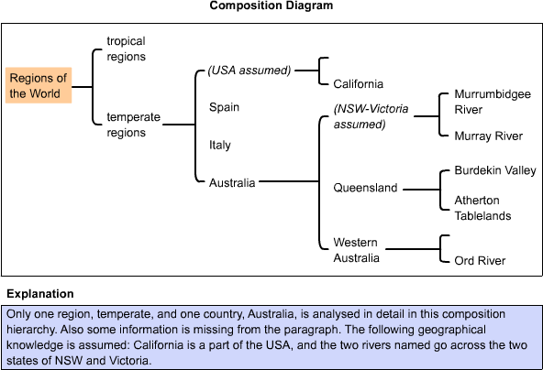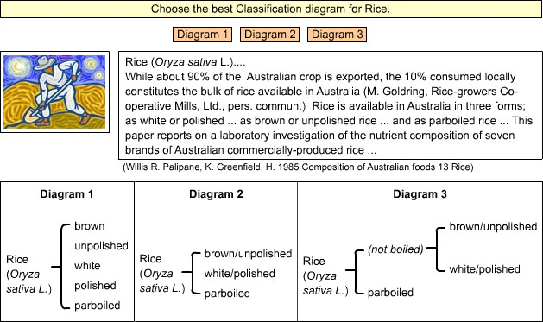

31 32

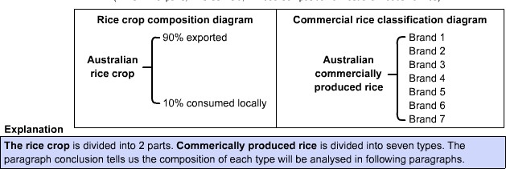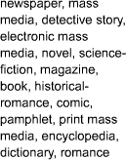

* **Make a classification diagram. What is the superordinate word?**

33 34

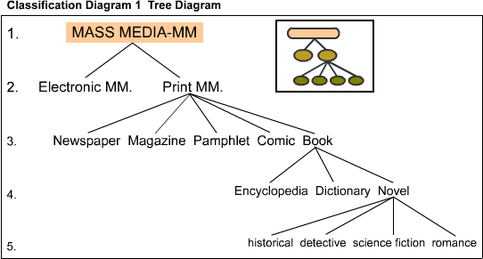

Key

**Connecting or overlapping taxonomies**

* In paragraphs and texts, there are often meaning relations between words in two or more different taxonomies. So, there are not only relations between words in one hierarchy, but also amongst words across two or more hierarchies. These overlapping hierarchies may be in one or two paragraphs and across whole texts.

35 36

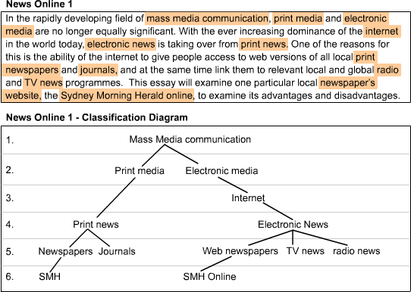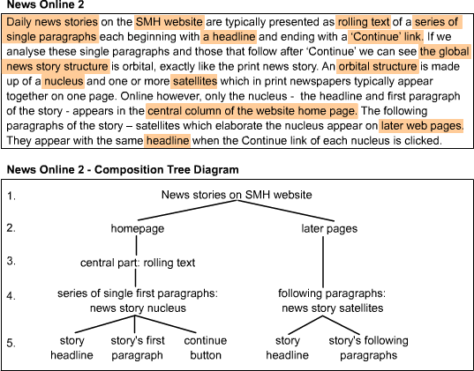

37 38

B. Collocation

* **Collocation** is lexical cohesion which depends upon the tendency of some words to co-occur in texts.
* For example, when one sees the noun *pipe* in a sentence, it is more probable that the verb *to smoke* will also appear in the sentence. In another example, the noun *bicycle* could more likely occur with the verb *to ride* then any random verb.

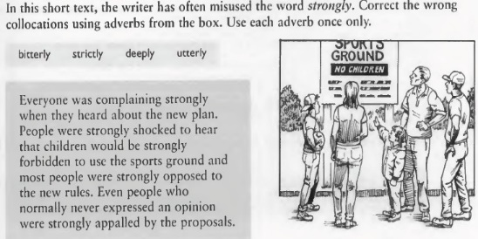

Exercise 1

Key: complaining bitterly, deeply shocked, strictly forbidden, utterly appalled

39 40

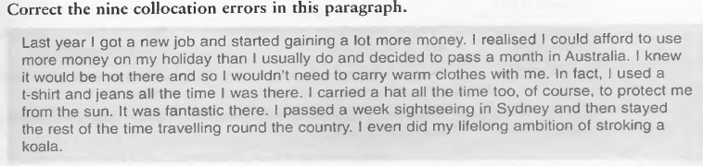

Exercise 2

**Key: earning/making money, spend money, spend a month, take warm clothes, wore a t-shirt, wore a hat, spent a week, spent the rest of the time, achieved ambition**

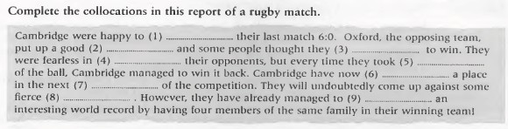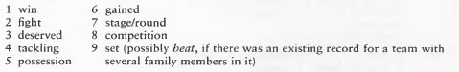

Exercise 3

41 42

Consolidation exercise

**I have a dream – Martin Luther King**

I have a dream that my four little children will one day live in a nation where they will not be judged by the color of their skin but by the content of their character.

I have a dream today!

I have a dream that one day, down in Alabama, with its vicious racists, with its governor having his lips dripping with the words of "interposition" and "nullification" -- one day right there in Alabama little black boys and black girls will be able to join hands with little white boys and white girls as sisters and brothers.

I have a dream today!

I have a dream that one day every valley shall be exalted, and every hill and mountain shall be made low, the rough places will be made plain, and the crooked places will be made straight; "and the glory of the Lord shall be revealed and all flesh shall see it together."



**Cohesion**

**Grammatical Cohesion**

**Lexical Cohesion**

***Repetition Synonymy Antonymy Taxonomy Collocation***

***Reference Substitution Ellipsis***

***Conjunction***

43 44

Grammatical cohesion – Reference, Ellipsis, Conjunctions

I have a dream that my four little children will one day live in a nation where they will not be judged by the color of their skin **but Ø** by the content of their character.

I have a dream today!

I have a dream that one day, down in Alabama, with its vicious racists, with its governor having his lips dripping with the words of "interposition" and "nullification" – one day right there in Alabama little black boys and black girls will be able to join hands with little white boys and white girls as sisters and brothers.

I have a dream today!

I have a dream that one day every valley shall be exalted, **and** every hill and mountain shall be made low, the rough places will be made plain, **and** the crooked places will be made straight; "**and** the glory of the Lord shall be revealed **and** all flesh shall see it together.“

(**endophoric – anaphoric in all cases except for: *the Lord* – exophoric, and *I, my -* exophoric*)***



Lexical cohesion - Repetition

I have a dream that my four little children will one day live in a nation where they will not be judged by the color of their skin but by the content of their character.

I have a dream today!

I have a dream that one day, down in Alabama, with its vicious racists, with its governor having his lips dripping with the words of "interposition" and "nullification" -- one day right there in Alabama little *black* boys and *black* girls will be able to join hands with little *white* boys and *white* girls as sisters and brothers.

I have a dream today!

I have a dream that one day every valley shall be exalted, and every hill and mountain shall be made low, the rough PLACES will be made plain, and the crooked PLACES will be made straight; "and the glory of the Lord shall be revealed and all flesh shall see it together."

45 46

Antonyms

I have a dream that my four little children will one day live in a

nation where they will not be judged by the color of their skin but by the content of their character.

I have a dream today.

I have a dream that one day, down in Alabama, with its vicious

racists, with its governor having his lips dripping with the

words of interposition and nullification, one day right there

in Alabama, little **black** boys and **black** girls will be able to

and brothers.

I have a dream today.

join hands with little **white** boys and **white** girls as sisters

I have a dream that one day every valley shall be **exalted**,

every hill and mountain shall be made **low**, the **rough**

places will be made **plain**, and the **crooked** places will be

made **straight**, and the glory of the Lord shall be revealed,

and all flesh shall see it together.

Taxonomy

I have a dream that my four little children will one day live in a

nation where they will not be judged by the color of their skin but by the content of their character.

I have a dream today.

I have a dream that one day, down in Alabama, with its vicious

racists, with its governor having his lips dripping with the

words of interposition and nullification, one day right there

in Alabama, little black boys and black girls will be able to

and brothers.

I have a dream today.

join hands with little white boys and white girls as sisters

I have a dream that one day every valley shall be exalted,

every hill and mountain shall be made low, the rough places will be made plain, and the crooked places will be

made straight, and the glory of the Lord shall be revealed,

and all flesh shall see it together.

47 48

Collocation

I have a dream that my four little children will one day live in a

nation where they will not be judged by the color of their skin but by the content of their character.

I have a dream today.

I have a dream that one day, down in Alabama, with its vicious

racists, with its governor having his lips dripping with the

words of interposition and nullification, one day right there

in Alabama, little black boys and black girls will be able to

and brothers.

I have a dream today.

join hands with little white boys and white girls as sisters

I have a dream that one day every valley shall be exalted,

every hill and mountain shall be made low, the rough places will be made plain, and the crooked places will be

made straight, and the glory of the Lord shall be revealed,

and all flesh shall see it together.

49