Chapter 13 Acquisition/Payment Process

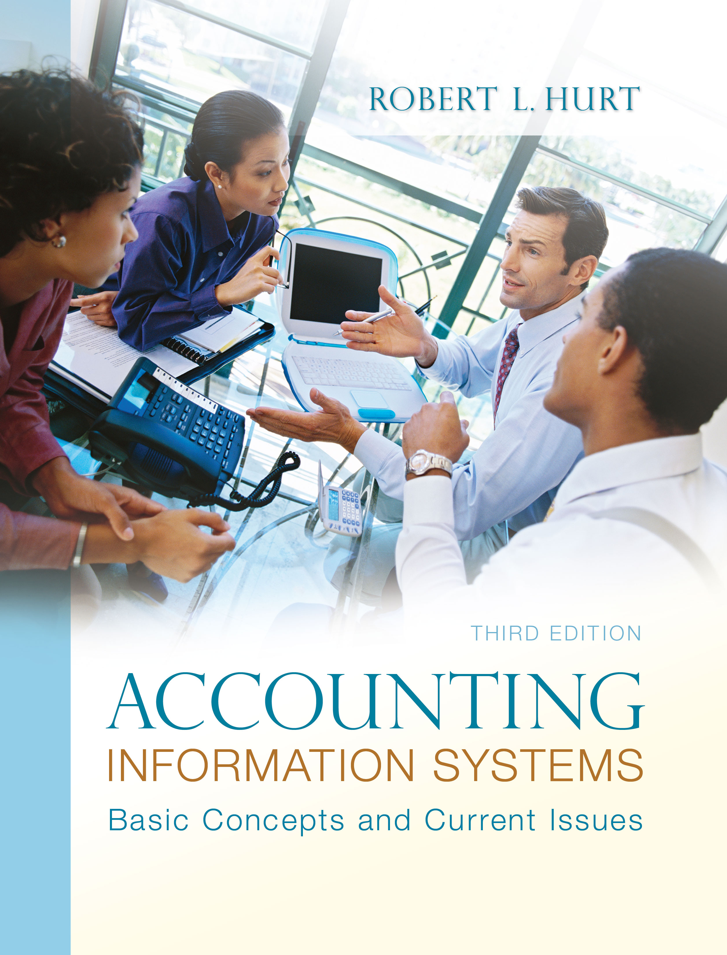
1. Reading review questions

a. What is the basic purpose of the acquisition/payment process? The acquisition / payment process focuses on the activities an organization uses to acquire and pay for needed resources. Although its generalized process can apply to virtually any asset, it is most often used for inventory; other assets (such as cash) may be considered in separate business processes (such as the financing process).

b. What steps do companies commonly complete as part of the acquisition/payment process? The acquisition / payment process comprises six steps: (1) Request goods and services based on monitored need. (2) Authorize a purchase. (3) Purchase goods / services. (4) Receive goods and services. (5) Disburse cash. (6) Process purchase returns as necessary.

c. What documents are important in the acquisition/payment process? At least five documents are typically used to complete the steps in the acquisition / payment process: purchase requisition, purchase order, receiving report, vendor invoice and check.

d. What risks do managers face as part of the acquisition/payment process? What internal controls help reduce exposure to those risks? Process risks (and related controls) include the following: ordering unneeded goods (inventory monitoring), purchasing from inappropriate vendors (conflict of interest policy), receiving defective goods (inspection prior to acceptance) and theft of inventory (internal audit).

f. Respond to the questions for this chapter’s “AIS in the Business World.” I was very fortunate to have three assistants available to prepare responses to the AIS in the Business World vignettes for the third edition; I’ve posted their responses on my AIS blog: www.bobhurtais.blogspot.com.

2. Reading review problem

a. What is RFID technology? How is it used in the acquisition / payment process? RFID stands for Radio Frequency Identification. It is a technology used to quickly and efficiently account for inventory. Inventory items are tagged with a radio sensor; the sensor is scanned to determine the amount and type of inventory.

b. RFID is a form of internal control. Which of the four purposes of internal control does it help Wal-Mart achieve? RFID helps achieve at least two of the four purposes. First, it helps safeguard assets by monitoring inventory levels more closely. Additionally, RFID helps promote operating efficiency.

c. What documents would Wal-Mart likely use in its acquisition / payment process? Which journal entries, if any, are triggered by each document? Wal-Mart would likely use a purchase requisition to request the purchasing department order goods. Based on purchase requisitions, the purchasing department would prepare a purchase order. Receipt of ordered goods is indicated by a receiving report, which generates a journal entry for the purchase of inventory. After appropriate document matching, a vendor invoice would be paid with a check, leading to a journal entry for cash payments.

3. Multiple choice review questions. Answers to all of these questions appear at the end of the textbook itself.

4. Making choices and exercising judgment
The point of these exercises, which appear in every chapter throughout the third edition, is to encourage students to think critically and “outside the box.” Thus, I am not providing solutions to them, as doing so would likely discourage the purpose of these exercises.

5. Field exercises
Answers to these exercises will vary significantly; thus, like the previous set, I am not preparing published solutions for them.

6. Modeling acquisition / payment processes

a. Big State University
Big State University Library
Acquisition / payment process
Level Zero DFD
Requestors
1.0
Record request
Request info
Request database
Recorded request
Merchandise to order
2.0
Order merchandise
E-mail notification
Vendor
Purchase order
Ordered items
3.0
Match p.o. & receiving report
4.0
Match documents
Receiving report
Invoice
Purchase order
Purchase order
5.0
Pay vendor
Payment
Matched documents

b. Goodkind Corporation
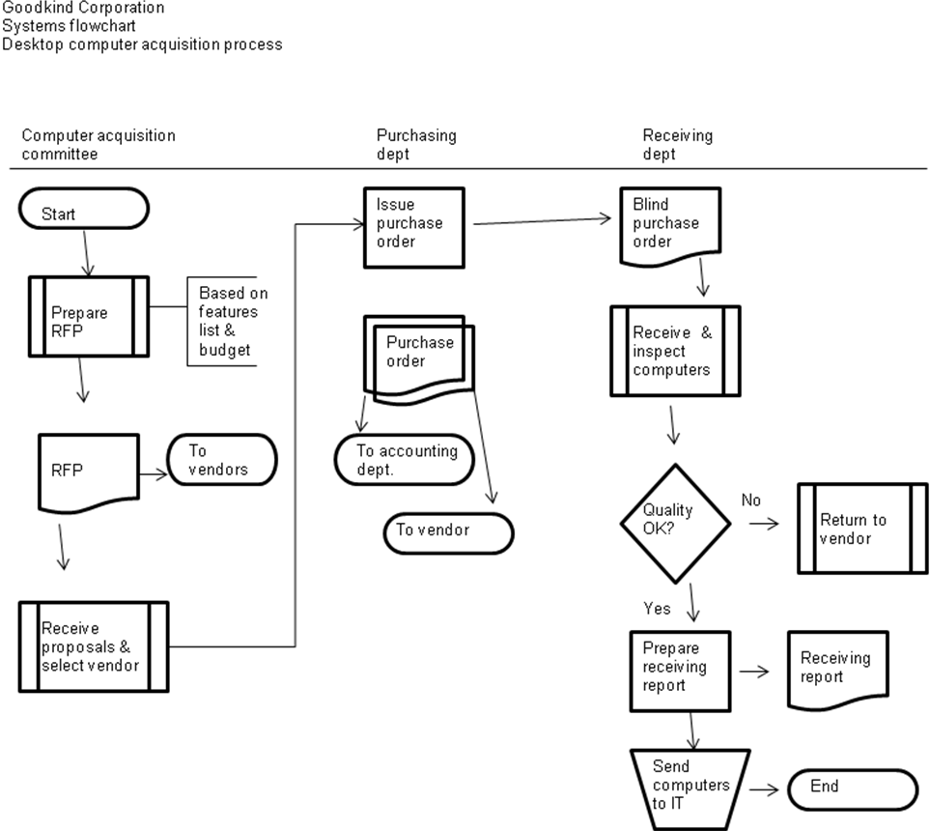
c. Buying a home
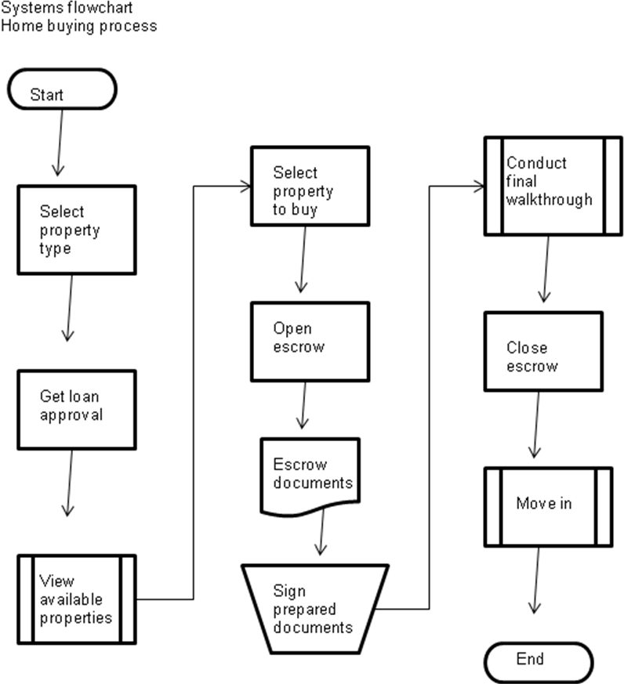
d. Brooks Corporation
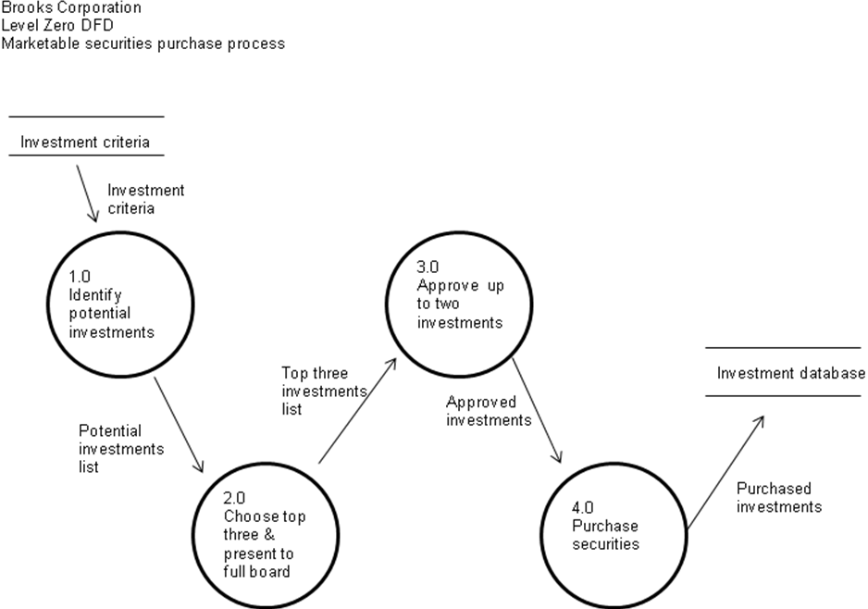

7. Acquisition / payment process transactions

c. Information about the vendor (name, address, and so on), information about items purchased (quantities, cost per unit, item names and IDs), information that connects the purchase transaction with the items purchased (as in a purchases / inventory table).

8. Document information

1. B, C, D, E
2. A, B
3. B, C, D
4. B
5. A
6. A through E
7. B, D
8. D, E
9. B, D, E
10. E

9. Internal controls
While the proposed system may cut down on errors, employees are likely to feel resentful at such a radical change. Effectively, the system is moving toward a “Theory X” model, which assumes that employees are inherently lazy and must be closely supervised to ensure optimal results. Many of the internal controls discussed in the chapter would be very helpful in this system: increased use of information technology, stamping documents “paid” when checks are written, inventory monitoring systems, document matching and assigning employees to specific vendors.

10. Internal control analysis
A review of purchase orders, receiving reports and cash payments, coupled with periodic inventory counts, would establish a correlation between what “is” on hand and what “should be” on hand. If the documents supported the allegations of fraud, an internal auditor might determine which employees had access to the inventory, and proceed to interview them. Internal controls that could prevent similar problems in the future include: video surveillance systems, electronic tagging on tools (such as those used in high-end retail stores), keeping tools physically secure and limiting the employees authorized to access them.

11. Terminology

1. J
2. C
3. F
4. I
5. D
6. G
7. A
8. B
9. E
10. H

12. Multiple choice questions
1. A
2. C
3. C
4. C
5. C

13. Statement evaluation
a. Sometimes true. A bill of lading is required if the goods need to be shipped.
b. Sometimes true. The number of processes will vary between organizations.
c. Never true.
d. Sometimes true. A conflict of interest policy alone does not ensure strong internal control.
e. Never true.
f. Sometimes true. The form of documents will vary across organizations.
g. Always true.
h. Sometimes true. Events such as purchasing insurance can be triggered by the passage of time.
i. Always true.
j. Never true.

14. Process relationships
The proper order is: a, g, h, f, j, i, c, b, d, e.

15. Prior material application
a. Answers will vary based on the packages selected, criteria and weights chosen.

b. Expectancy: “I can probably figure out a way to steal inventory.” Instrumentality: “If I steal inventory, I can probably sell it or find another way to profit from it.” Valence: “I really need to make some extra money.”

c. Inventory is denoted with a variety of tags, the broadest of which is InventoryNet. Accounts Payable is labeled Accounts Payable, Total. Cost of Goods Sold is simply labeled with its name. Gross profit is also labeled with its name.

