

Faculty of Engineering and Technology

Electrical and Computer Engineering Department

ENEE2110

ELECTRIC CIRCUITS LAB

Experiment.4 Prelab

**NETWORK THEOREMS**

**Prepared by:**

Nermin Aqra 1212126

**Supervised by:**

Dr. Jaser Sa'ed

**Teacher assistance:**

Eng.Mohammad AL-Battat

March2025

**Part A: Proportionality**

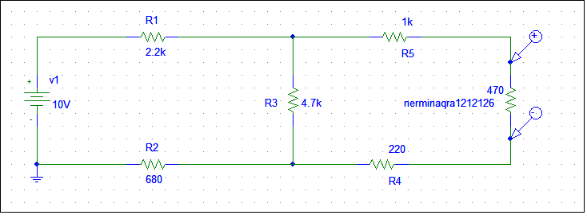

**Figure 1:4.1**



**Figure 2:Vo FOR A Vin SWAAP FROM 0 to 15**

**Part B:Superposition**

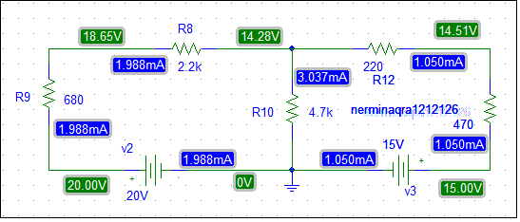

**Figure 3:4.2**

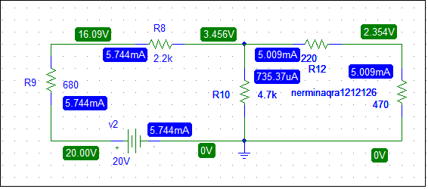

**Figure 4:4.3**

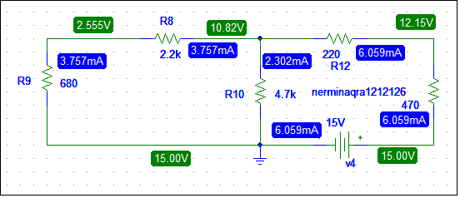

**Figure 5:4.4**

**Part C: Thevenin’sTheorem**

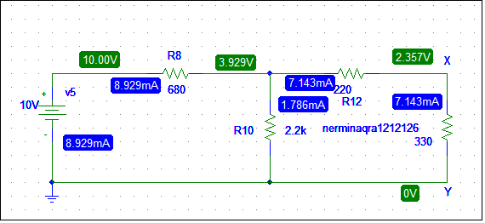

**Figure 6:4.5**

Voltage around the resistor 330 = 2.357volt

Current around the resistor 330=7.143mA

* Find the Thevenin equivalent
* To Find Vth using voltage divider
$$Vth=\frac{R10}{R10+R8}×V5$$

$$Vth=\frac{2.2K}{2.2K+680ohm}×10volt$$

$$Vth=7.638volt$$

* To Find Rth killing DC voltage source

$$Rth =R12+\frac{R8×R10}{R8+R10}$$

$$Rth=220+\frac{680×2200}{680+2200}$$

$$Rth=739.44ohm$$

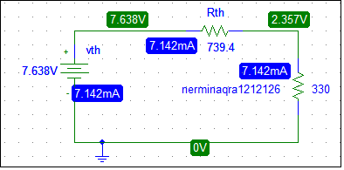

**Figure 7:4.7**

Voltage around the resistor 330 = 2.357volt

Current around the resistor 330 = 7.142mA

**Patr D:** **∆-Y Transformation**

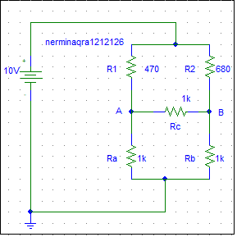

$$R1=\frac{\left(Ra×Rc\right)}{\left(Ra+Rb+Rc\right)}=\frac{\left(1K×1K\right)}{\left(1K+1K+1K\right)}=333.333ohm$$

$$R2=\frac{\left(Rb×Rc\right)}{\left(Ra+Rb+Rc\right)}$$

$$R3=\frac{\left(Ra×Rb\right)}{\left(Ra+Rb+Rc\right)}$$

We note that Ra=Rc=Rb=1K so R1=R2=R3=333.333ohm

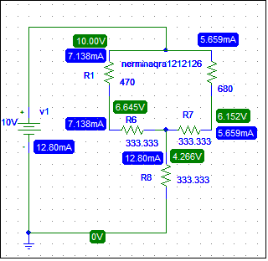

**Figure 8:Y transformation**

the voltage Vab=0.493volt && the current I=12.80mA

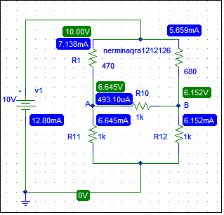

**Figure 9: ∆ transformation**

**Part E:Reciprocity Theorem**

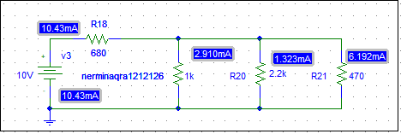

**Figure 10:4.8**

the current I=2.910mA

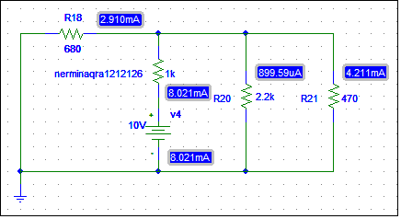

**Figure 11:4.9**

the current I=2.910mA