Introduction to communication disorders

Study material and notes

Important definitions:

* Communication; the process of delivering and receiving a message between a sender and a receiver, which must occur in a media and it also involves continuity
* Stimulus: the message that is needed to be delivered
* Sender: the person who sends the message
* Media: the environment in which the message is delivered
* Receiver: the person who receives the message
* There must be certain factors such as focusing, calmness or quietness, etc. in order for the message to be sent and interoperated clearly.

Definition of communication in the book;

* Communication: communication is an exchange of ideas between sender(s) and receiver(s). It involves message transmission and response or feedback.
* Effective communication: the process of delivering and receiving a message with the least amount of effort (from both sender and receiver) without the existence of obstacles and obstructions in the environment or in both the sender and the receiver.
* Possible Obstacles that can be present:
* Noise or damage in the media
* A cognitive disability or disorder in either/both the sender or receiver
* Lack of concentration during communication
* Damage in the processing the information due to cognitive damages or other damages in the media.
* A communication disorder in both/either the sender or receiver.
* communication disorder: a disability to both receive and send, and also process and comprehend concepts or verbal, nonverbal and graphic information.
* A communication disorder may affect hearing, language, and/or speech processes; may range from mild to profound severity; and may be developmental or acquired.
* One or a combination of communication disorders may be presented by an individual and may result in a primary disability or may be secondary to other disabilities.

Types of Communication Disorders:

* Speech Disorders: the atypical production of speech sounds, interruption in the flow of speaking, or abnormal production and absences of voice quality, including pitch, loudness, resonance, and/​or duration.
* language disorder: an impairment in comprehension and/​or use of spoken, written, and/​or other symbol systems.
* hearing disorder: a result of impaired sensitivity of the auditory or hearing system.
* Communication Chain:

1. The sender(s) sends a stimulus (a message)
2. The stimulus travels through the media/environment
3. The receiver(s) receives the message
4. The message is delivered to the brain where it will be interoperated and processed
5. The receiver sends a feedback or response according to the message
6. The receiver is now the sender
7. And the sender is now the receiver
8. The same steps will be followed with continuity in order for communication to occur.

* Language: is a socially shared code that is used to represent concepts. This code uses arbitrary symbols that are combined in rule governed ways (Owens, 2012).

-the Characteristics of language:

* Language is Generative: the ability of a speaker to present his own ideas based on the language he/she learned or knows
* Language is dynamic: it has the ability to change over time and can be influenced by environmental and historical events.
* Grammar: the rules in which the language is governed by
* Linguistic intuition: recognizing the right from wrong in a language

-Components of language:

* Form; consists of morphology, phonology, and syntax
* Content: mainly revolves around semantics or the idea that the spoken language or sentence must have a proper meaning
* Use: social and cultural factors influence the use of language
* Speech: The process of producing acoustic representations of language.

-Features of Speech:

* Articulation: the way in which speech sounds are formed
* Fluency: is the smooth, forward flow of communication.

- It is influenced by the rhythm and rate of speech.

* Rhythm of speech: the sense of movement in speech
* Rate of speech: the speed at which we talk
* Voice: the sound produced at the larynx and uttered through the mouth

-features of sounds;

* Pitch: a listener’s perception of how high or low a sound is; it can be physically measured as frequency or cycles per second, called hertz.

-Habitual pitch: is the basic tone that an individual uses most of the time.

* Intonation: Pitch movement within an utterance

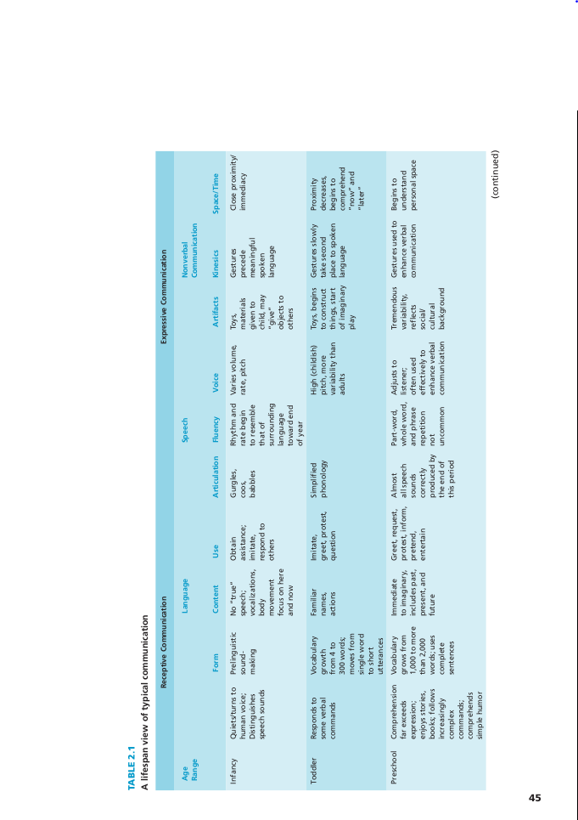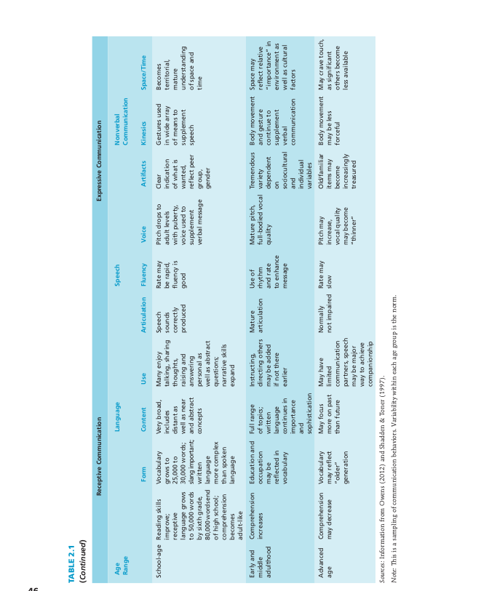

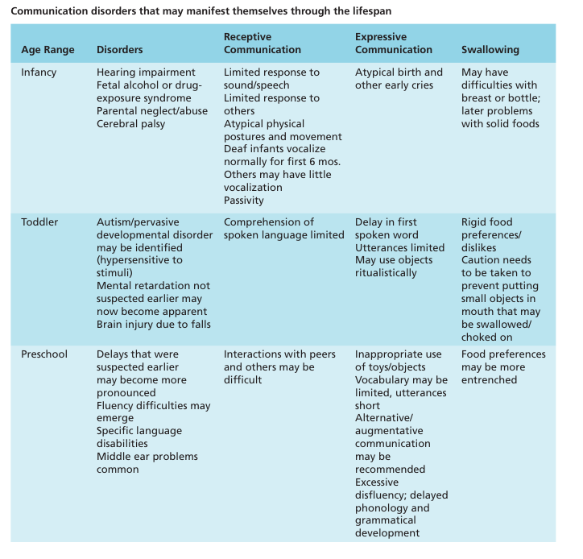Communication disorders through lifespan:

