Birzeit university– faculty of engineering and technology

Department of mechanical engineering

Fluid Mechanic Laboratory

ENME312

Section 1

**Experiment No.8**

**“**Centrifugal Pump Power Measurements & Positive Displacment Pumps-Pistonand Gear Pumps**”**

Instructors:

Dr. Adel Dweik

Eng. Alanoud Muadi

Group 5:

Majd Raddad 1201196

Qais Samara 1202956

Mohammad Abu Ayyash 1182690

**Prepared by: Majd Raddad- 1201196**

Date of performance: 25/03/2024

Date of performance: 1/04/2024

**Table of Content:**

**Abstract**……………………………………………………………………………1

**Objectives…………………... …..………………………………………………...**2

**Sample calculations …………... ...………………………………………………**.2

**Results …………………………………………….…………...……………….….**4

**Discussion of results ………….………………………………………………..….**8

**Conclusions ……………………………………………………………………….**10

**References ………….………………………………………………….……..…...**10

**Appendices ………….………………………………………………..……..…….**11

**Abstract**

Pumps are widely recognized for their critical role in fluid mechanics, belong to the domain of turbomachinery and are primarily divided into two categories: reciprocating pumps like the positive displacement pump, and rotary pumps such as the centrifugal pump. Their principal function is to move fluids from one point to another, enhancing the speed and flow of the fluid in the process. This experiment focuses on examining and understanding the behavior of both centrifugal and positive displacement pumps. To ensure the optimal match between a pump and the system it serves, it is essential to analyze each pump's characteristics. This analysis aids in the engineering and selection process for the appropriate pump type needed.

centrifugal Pumps operate on the principle of creating a pressure differential at the inlet, subject to atmospheric pressure, through rotational movement, thereby utilizing centrifugal force to propel fluid into the pump and transforming kinetic energy into pressure energy. Conversely, the principle behind a positive displacement pump is to enclose a specific volume of fluid and then discharge it at an elevated pressure.

Positive displacement pumps excel in generating high pressure with a limited flow rate range at a constant speed, and their efficiency remains stable across various fluid viscosities. In contrast, centrifugal pumps are better suited for high flow rates and fluids with low viscosity, outperforming in efficiency where positive displacement pumps maintain consistent performance despite expected losses.

In part A of the experiment, the apparatus was set to operate at 2500 RPM, with the flow rate being incrementally adjusted. For each trial, measurements from the voltmeter, ammeter, flow rate, and force were recorded. These readings were then utilized to determine the pump's efficiency and various other performance metrics.

Part B of the experiment was divided into two segments. Initially, the speed was maintained constant at 1600 revolutions per minute, with the delivery pressure being progressively adjusted to monitor the primary alterations and relationships. Subsequently, the delivery pressure was held steady at 15 bars, while the speed was varied systematically to assess its impact on the system's parameters.

**Objectives**

* Study pumping system.
* Determining the pump's performance across varying flow rates.
* Identifying the behavior of operating two pumps in both series and parallel configurations.

**Sample calculation:**

**Part 1:**

Run No.1 was taken:

* To calculate the electrical power:

$P_{Ele}=V I$ (1)

$$P_{Ele}=185*2.7=499.5 W$$

Where:

$P_{Ele}$: Electrical Power needed to drive the pump [W].

$V$: Voltage [V].

$I$: Current [A].

* To calculate the mechanical power that pumps generates:

$P_{Mech}=\frac{2 π N T}{60}=\frac{2 π N (0.165 F)}{60}$ (2)

$P_{Mech}=\frac{2 π*2500 (0.165*8)}{60}$ = 345.6 W

Where:

Pmech: the mechanical power in watt.

$N$: Angular speed of the pump [RPM].

*T*: Pump’s Torque [0.165F N.m].

$F:$ Pump’s Force [N].

* To measure the head of water:

$H= (P2-P1)/ρ g$ (3)

$H=\frac{180000-0}{1000*9.81}$ = 18.35 m.

Where:

H: head of water (m).

P: Pressure (pascal).

ρ: Water density (1000 kg/m^3).

g: acceleration due to Gravity (9.81 m/s^ 2).

* To calculate the hydraulic power by taking run No. 2:

$Phydr= Q(P2-P1$) (4)

$Phydr= \frac{1*(179000—0)}{1000}$ = 179 W

Where:

Wh: The hydraulic power (Watt).

Q: Volume flow rate in (m^3 /s).

* To calculate the overall efficiency for run No.2:

$η_{overall}=\frac{ρ g Q H}{P_{Ele}}= \frac{Phydr}{P_{Ele}}$ (5)

$η=\frac{179}{766.7}$*100% = 23.35%

Where:

$η$: overall efficiency of the pump

* To calculate the mechanical efficiency for run No.2:

$η_{mech}$ = $\frac{P mech}{P elec}$*100% (6)

$η_{mech}$ = $\frac{570.2}{766.7}$*100% = 74.37%

Where:

$η$: mechanical efficiency of the pump.

* To calculate hydraulic efficiency:

$η_{hyd.}$ == $\frac{P hyd.}{P mech}$*100% (7)

= $\frac{179}{570.2}$*100 = 31.39 %

Where:

$η$: hydraulic efficiency of the pump.

**Results**

**Part A**

Table.1 Readings for each run.

Table.2 Resulted Calculations

Figure 1: Efficiency and head against flow

Figure 2: Electrical, mechanical, and hydraulically power against flow rate

Figure 3: Electrical, mechanical, and hydraulically Efficiencies against flow rate

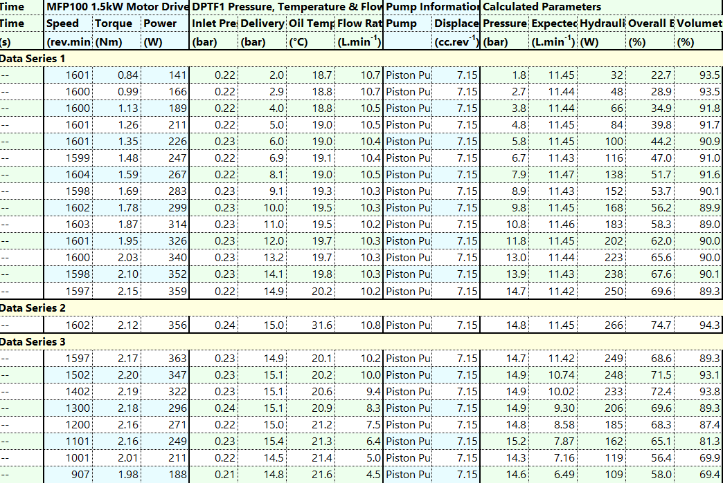 **Part B**

Table 3 Data and results of part B

Figure 3 Relation between the flow rate (m^3/s), power shaft (W), Volumetric and overall efficiency against pressure difference (Pa)

Fig 4 Relation between flow rate (left axis) (m^3/s), overall and volumetric efficiencies, shaft power (right axis) (W) against speed (rev/min).

**Discussion of results**

Part A of the experiment is designed to familiarize participants with the operational principles of a centrifugal pump through hands-on testing and observation. It seeks to highlight key parameters including electrical, mechanical, and hydraulic powers, along with their efficiencies. The objectives were met by calculating these parameters, plotting various related graphs and curves, and thereby gaining insights into the characteristics of the centrifugal pump under study.

Table 1 presents the data collected from the centrifugal pump station, while Table 2 displays calculations for electrical, mechanical, and hydraulic powers, as well as head, pressure, and efficiencies. These tables were utilized to generate Figure 1, depicting the relationship between head and overall efficiency against discharge (flow). This plot reveals two key relationships: a nearly linear decline in head with discharge, suggesting a consistent head value for each flow rate and an efficiency peaking curve. Post-peak, efficiency declines due to expected losses like friction and leakage, exacerbated by potential turbulent fluid behavior at higher flow rates, leading to decreased pump efficiency.

Figure 2 in the results illustrates the plotted correlation between electrical, mechanical, and hydraulic power against discharge. Electrical power represents the power propelling the pump, while mechanical power denotes the power generated by the pump itself. Both plots exhibit a direct proportional relationship with discharge until reaching a plateau. When Figures 1 and 2 are juxtaposed, it becomes evident that these power values plateau after the pump achieves its maximum efficiency, reflecting the reduced efficiency of the pump at higher flow rates. Hydraulic power increases with flow rate until the pump efficiency peaks, after which a slight decrease is observed. Generally, once the pump reaches its maximum efficiency, any further increase in flow rate does not correspondingly increase power.

In part B of the experiment, the objective was to examine a positive displacement pump using a pump operator to transfer recorded data and important parameters to programmed software on a PC. The data was then analyzed through charts to delineate the primary characteristics of positive displacement pumps. This objective was fulfilled by conducting the necessary analysis as outlined.

Table 3 displays results obtained from the software, featuring two main sections: one where speed was held constant at 1600 rev/min and delivery pressure gradually increased from 1 to 15 bar. Figure 4, an analysis chart for this section, depicts an inversely proportional relationship between pressure difference and flow rate. Although flow rate is expected to be independent of pressure difference, a slight decrease is observed as pressure difference increases, possibly due to the pump's pulsation mechanism affecting flow rate. Moreover, overall efficiency increases with pressure difference, indicating efficient pump operation regardless of pressure difference or flow rate. Volumetric efficiency remains relatively constant against pressure difference, while overall efficiency shows a direct increase with pressure difference, suggesting positive displacement pumps are unaffected by fluid conditions, making them preferable for viscous liquids.

In the second part of this experiment segment, the delivery pressure was held constant at 15 bar while the speed was adjusted in 100 rev/min increments for each trial. Both the plotted figure and the accompanying table reveal a direct proportional relationship between flow and speed. It's notable that as speed decreases (since it's plotted in descending order), there's a significant reduction in flow values, indicating the dependence of flow on speed for a positive displacement pump. Shaft power demonstrates a direct proportionality to speed, increasing with any speed increment. Additionally, both volumetric efficiency and overall efficiency exhibit a pattern of increasing until reaching a maximum efficiency, followed by a reduction. This behavior differs from that of a centrifugal pump, as efficiencies do not exhibit a rapid decline post-peak value.

**Conclusion**

The experiment was comprised of two segments: Part (A) focused on experimenting and analyzing a centrifugal pump, while Part (B) aimed to do the same for a positive displacement pump. Both pump types were assessed for their efficiencies concerning discharge, speed, and pressure difference. Centrifugal pumps exhibited flow dependency on pressure difference, whereas positive displacement pumps showed flow dependency on speed. However, centrifugal pumps demonstrated less efficient behavior at higher flow rates due to friction, whereas positive displacement pumps' efficiencies remained relatively stable. This suggests that each pump type has its distinct advantages and is better suited for circumstances. For instance, when there's a need to produce a higher flow rate at low pressure, a centrifugal pump might be more suitable since positive displacement pumps require speed adjustments to meet such requirements. Conversely, for fluids with higher viscosity and greater losses, positive displacement pumps are preferable as they operate efficiently irrespective of losses.

While conducting the experiment, some errors may have occurred, including challenges in accurately controlling the RPM setting at 1600 and manually adjusting the pressure to 15 bar due to rapid fluctuations in the numbers, particularly noted in part B. Though these errors may have impacted the precise accuracy of the measured values, they did not significantly affect the overall outputs and conclusions drawn from the experiment.

**References**

* Fluid mechanics laboratory manual (2022, march).
* White, F. M. (1999, January 1). Fluid Mechanics.

**Appendices**

