
ENGL331 English Literature II

Summer Session 2: 2020

Dr. Lloyd Precious

S, M  T  W  R | 13:00 - 14:50  13:00 - 14:20  13:00 - 14:50  13:00 - 14:20
This online course will be conducted via ZOOM and consist of lecture and discussion. Vigorous class participation is extremely important. In order to actively participate, students should come to class having thoroughly read the material assigned for that day. This kind of preparation will significantly increase your ability to understand the material, facilitate interesting and constructive class discussions and help you fulfil the course requirements.
Romanticism Assignment 30%
Midterm 30%
Final 40%
Total: 100%

Class attendance and preparation
You are expected to attend all classes on time, come prepared, and participate in class discussion. Student attendance policy stipulates that any student with absences double the number of weekly class sessions (meaning 4 sessions) risks failing the course. Missed lecture notes and handouts are your responsibility to obtain. Please have your course with you for all online sessions. Zoom will automatically monitor all attendance.

Academic plagiarism
All academic pursuit depends on trust. Signs of plagiarism will be severely penalized and will result in failure of the assignment. Plagiarism is commonly defined as copying the ideas or words of another, without the use of a proper form of academic documentation. There are essentially two kinds of plagiarism: deliberate plagiarism and accidental plagiarism. One may sound more acceptable than the other, but the fact is that both are equally serious academic offenses. In this class, accidental and deliberate plagiarism will be treated the same. You will be given a 0 for the first assignment found to contain plagiarism. A second offense will result in a failing grade for the course.

MLA Style an introduction:
https://www.ulm.edu/library/documents/mlastyle.pdf

Ritaj (Birzeit Academic Portal)

I will post class updates on Ritaj; therefore, please make sure to check your Ritaj account at least once a week. Students can communicate with the instructor through Ritaj or email directly.
Moodle

All graded material must be uploaded as Word Documents to Moodle via the Ritaj system.

Office hours

I will arrange face-to-face office hours as necessary.

OVERVIEW

STUDENTS ARE RESPONSIBLE FOR ALL THE MATERIAL CONTAINED IN THIS PACK

ENGL331 English Literature II This course continues the historical and critical overview of the development of English literature from the eighteenth century to the present with emphasis on major authors and movements.

Pre-requisite: ENGL330

The Romantic Period (1785–1832)
The beginning date for the Romantic period is often debated. Some claim it is 1785, immediately following the Age of Sensibility. Others say it began in 1789 with the start of the French Revolution, and still, others believe that 1798, the publication year for William Wordsworth and Samuel Taylor Coleridge’s book "Lyrical Ballads," is its true beginning. The time period ends with the passage of the Reform Bill (which signaled the Victorian Era) and with the death of Sir Walter Scott. American literature has its own Romantic period, but typically when one speaks of Romanticism, one is referring to this great and diverse age of British literature, perhaps the most popular and well-known of all literary ages. This era includes the works of such juggernauts as Wordsworth, Coleridge, William Blake, Lord Byron, John Keats, Charles Lamb, Mary Wollstonecraft, Percy Bysshe Shelley, Thomas De Quincey, Jane Austen, and Mary Shelley. There is also a minor period, also quite popular (between 1786–1800), called the Gothic era.

The Victorian Period (1832–1901)
This period is named for the reign of Queen Victoria, who ascended to the throne in 1837, and it lasts until her death in 1901. It was a time of great social, religious, intellectual, and economic issues, heralded by the passage of the Reform Bill, which expanded voting rights. The period has often been divided into “Early” (1832–1848), “Mid” (1848–1870) and “Late” (1870–1901) periods or into two phases, that of the Pre-Raphaelites (1848–1860) and that of Aestheticism and Decadence (1880–1901). This period is in strong contention with the Romantic period for being the most popular, influential, and prolific period in all of English (and world) literature. Poets of this time include Robert and Elizabeth Barrett Browning, Christina Rossetti, Alfred Lord Tennyson, and Matthew Arnold, among others. Thomas Carlyle, John Ruskin, and Walter Pater were advancing the essay form at this time. Finally, prose fiction truly found its place under the auspices of Charles Dickens, Charlotte and Emily Bronte, Elizabeth Gaskell, George Eliot (Mary Ann Evans), Anthony Trollope, Thomas Hardy, William Makepeace Thackeray, and Samuel Butler.
Edwardian Period (1901 – 1910)
This period is named for King Edward VII and covers the period between Victoria’s death and the outbreak of World War I. Although a short period (and a short reign for Edward VII), the era includes incredible classic novelists such as Joseph Conrad, Ford Madox Ford, Rudyard Kipling, H.G. Wells, and Henry James (who was born in America but who spent most of his writing career in England), notable poets such as Alfred Noyes and William Butler Yeats, as well as dramatists such as James Barrie, George Bernard Shaw, and John Galsworthy.

The Georgian Period (1910–1936)
The Georgian period usually refers to the reign of George V (1910–1936) but sometimes also includes the reigns of the four successive Georges from 1714–1830. Here, we refer to the former description as it applies chronologically and covers, for example, the Georgian poets, such as Ralph Hodgson, John Masefield, W.H. Davies, and Rupert Brooke. Georgian poetry today is typically considered to be the works of minor poets anthologized by Edward Marsh. The themes and subject matter tended to be rural or pastoral in nature, treated delicately and traditionally rather than with passion (like was found in the previous periods) or with experimentation (as would be seen in the upcoming modern period).

William Blake
Songs of Innocence


The Lamb

Little Lamb who made thee
Dost thou know who made thee
Gave thee life & bid thee feed.
By the stream & o'er the mead;
Gave thee clothing of delight,
Softest clothing wooly bright;
Gave thee such a tender voice,
Making all the vales rejoice!
Little Lamb who made thee
Dost thou know who made thee

Little Lamb I'll tell thee,
Little Lamb I'll tell thee!
He is called by thy name,
For he calls himself a Lamb:
He is meek & he is mild,
He became a little child:
I a child & thou a lamb,
We are called by his name.
Little Lamb God bless thee.
Little Lamb God bless thee.

The Little Black Boy
My mother bore me in the southern wild,
And I am black, but O! my soul is white;
White as an angel is the English child:
But I am black as if bereav'd of light.

My mother taught me underneath a tree
And sitting down before the heat of day,
She took me on her lap and kissed me,
And pointing to the east began to say.

Look on the rising sun: there God does live
And gives his light, and gives his heat away.
And flowers and trees and beasts and men receive
Comfort in morning joy in the noonday.

And we are put on earth a little space,
That we may learn to bear the beams of love,
And these black bodies and this sun-burnt face
Is but a cloud, and like a shady grove.

For when our souls have learn'd the heat to bear
The cloud will vanish we shall hear his voice.
Saying: come out from the grove my love & care,
And round my golden tent like lambs rejoice.

Thus did my mother say and kissed me,
And thus I say to little English boy.
When I from black and he from white cloud free,
And round the tent of God like lambs we joy:

Ill shade him from the heat till he can bear,
To lean in joy upon our fathers knee.
And then I'll stand and stroke his silver hair,
And be like him and he will then love me.

The Chimney Sweeper: When my mother died I was very young
When my mother died I was very young,
And my father sold me while yet my tongue
Could scarcely cry " 'weep! 'weep! 'weep! 'weep!"
So your chimneys I sweep & in soot I sleep.

There's little Tom Dacre, who cried when his head
That curled like a lamb's back, was shaved, so I said,
"Hush, Tom! never mind it, for when your head's bare,
You know that the soot cannot spoil your white hair."

And so he was quiet, & that very night,
As Tom was a-sleeping he had such a sight!
That thousands of sweepers, Dick, Joe, Ned, & Jack,
Were all of them locked up in coffins of black;

And by came an Angel who had a bright key,
And he opened the coffins & set them all free;
Then down a green plain, leaping, laughing they run,
And wash in a river and shine in the Sun.

Then naked & white, all their bags left behind,
They rise upon clouds, and sport in the wind.
And the Angel told Tom, if he'd be a good boy,
He'd have God for his father & never want joy.

And so Tom awoke; and we rose in the dark
And got with our bags & our brushes to work.
Though the morning was cold, Tom was happy & warm;
So if all do their duty, they need not fear harm.

Holy Thursday: 'Twas on a Holy Thursday, their innocent faces clean
Twas on a Holy Thursday their innocent faces clean
The children walking two & two in red & blue & green
Grey-headed beadles walkd before with wands as white as snow,
Till into the high dome of Pauls they like Thames waters flow

O what a multitude they seemd these flowers of London town
Seated in companies they sit with radiance all their own
The hum of multitudes was there but multitudes of lambs
Thousands of little boys & girls raising their innocent hands

Now like a mighty wind they raise to heaven the voice of song
Or like harmonious thunderings the seats of Heaven among
Beneath them sit the aged men wise guardians of the poor
Then cherish pity, lest you drive an angel from your door

Songs of Experience

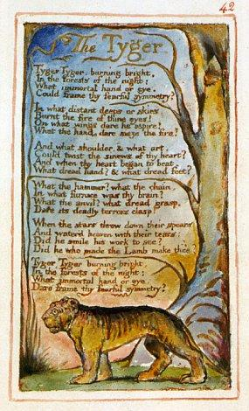

Holy Thursday: Is this a holy thing to see
Is this a holy thing to see,
In a rich and fruitful land,
Babes reducd to misery,
Fed with cold and usurous hand?

Is that trembling cry a song?
Can it be a song of joy?
And so many children poor?
It is a land of poverty!

And their sun does never shine.
And their fields are bleak & bare.
And their ways are fill'd with thorns.
It is eternal winter there.

For where-e'er the sun does shine,
And where-e'er the rain does fall:
Babe can never hunger there,
Nor poverty the mind appall.
The Chimney Sweeper: A little black thing among the snow.

A little black thing among the snow,
Crying "weep! 'weep!" in notes of woe!
"Where are thy father and mother? say?"
"They are both gone up to the church to pray.

Because I was happy upon the heath,
And smil'd among the winter's snow,
They clothed me in the clothes of death,
And taught me to sing the notes of woe.

And because I am happy and dance and sing,
They think they have done me no injury,
And are gone to praise God and his Priest and King,
Who make up a heaven of our misery."

The Sick Rose

O Rose thou art sick.
The invisible worm,
That flies in the night
In the howling storm:

Has found out thy bed
Of crimson joy:
And his dark secret love
Does thy life destroy.

The Tyger
Tyger Tyger, burning bright,
In the forests of the night;
What immortal hand or eye,
Could frame thy fearful symmetry?

In what distant deeps or skies.
Burnt the fire of thine eyes?
On what wings dare he aspire?
What the hand, dare seize the fire?

And what shoulder, & what art,
Could twist the sinews of thy heart?
And when thy heart began to beat,
What dread hand? & what dread feet?

What the hammer? what the chain,
In what furnace was thy brain?
What the anvil? what dread grasp,
Dare its deadly terrors clasp!

When the stars threw down their spears
And water'd heaven with their tears:
Did he smile his work to see?
Did he who made the Lamb make thee?

Tyger Tyger burning bright,
In the forests of the night:
What immortal hand or eye,
Dare frame thy fearful symmetry?

William Wordsworth

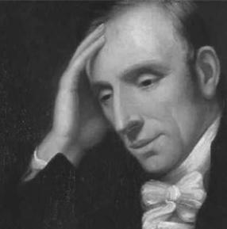

Preface to Lyrical Ballads (1802)

Full Text
https://www.english.upenn.edu/~jenglish/Courses/Spring2001/040/preface1802.html

Preface to the Lyrical Ballads Analysis

Introduction
Preface to the Lyrical Ballads, written by William Wordsworth, is a landmark essay in the history of English Literature. Considered to be the Romantic Manifesto on poetry and society, the Preface is a work that is crucial to our understanding of the progress of the Romantic literary thought, originating in 18th century Europe, which has been immortalized in our view of poetry and how we think of it today.

Historical Background
The Preface to the Lyrical Ballads first appeared in the 2nd edition of the poetry collection Lyrical Ballads (1801) and later expanded in the 3rd edition (1802). It would be helpful for us to first familiarize ourselves with this historical context of 18th century

Europe:
i.) Massive industrialization and urbanization – During this period, London became the urban centre of industrial development and huge masses of people migrated to the cities in search of jobs.
ii.) The Backdrop of the Neoclassicals – Neoclassical works were known for their adherence to rules and regulations of satire and their strict definitions of what is poetry. Their language was far from what people used in daily conversations and they spoke of extraordinary subjects. Neoclassicism was followed by Romanticism.
iii.) Rise of Romanticism – Romanticism is different from romanticism (notice the capital ‘R’ vs. the lower-case ‘r’) Romanticism was a movement which sought to break away from old norms and beliefs by revolutionizing the way people thought about society in 18th century Europe.
Inspired by the ideals of the French Revolution – to shake up the foundations of old hierarchical structures – and distressed by the rise of the choking city life, the Romantic Wordsworth set out to challenge old notions regarding poetry.

Main Ideas in Preface to Lyrical Ballads
Wordsworth’s relation to Nature/Countryside Wordsworth is celebrated as the nature poet because of his beautiful descriptions of nature and rural/countryside areas. However, to reduce his work to just an imitation of trees and flowers would be immature.
Wordsworth admired nature/countryside not only because it looked beautiful, but because of the simplicity and beauty that nature/countryside provided allowed people to be in touch with their soul and experience true beauty in life. Wordsworth believed that the city life made the masses dull and stagnant – it had reduced them to overworked machines who failed to appreciate the simple beauty of life. He called this state of mental stagnancy as savage torpor.

What inspires poetry?
Tired of the highly elevated topics of neoclassical poets and their over-complicated language, Wordsworth wanted “to make the ordinary extraordinary”. Wordsworth found inspiration from everyday figures of everyday life. Whether it be the famous Solitary Reaper or the Daffodils – Wordsworth’s poetry flows to admire the simple beauty that exists in daily life.

Who is a poet?
For Wordsworth, a poet is simply “a man speaking to men” – a fellow human just like all of us trying to communicate his perception and experience of truth and beauty. However, the poet differs from regular people because of his higher sensitivity to the happenings around him and a deeper connection with his own feelings, moods and emotions as they arise in response to these outer happenings.

What is a poem?
Wordsworth famously defined poetry as “a spontaneous overflow of powerful feelings which are recollected in tranquillity”. Simply speaking, the highly sensitive poet is able to experience the beauty of ordinary life, capture his own emotions as they arise and is finally able to sit in a calm, peaceful space to use his imagination to recollect these emotions and finally write about them.

What is the language in which a poem should be written?
Wordsworth believed that the “real language of men” – ordinary daily language – should be used to write poetry. However, Wordsworth refined this common language to a purer form without losing the essence of its simplicity.

The Egotistical Sublime
The Egotistical Sublime is a concept which simply means that a poet’s own subjective view of truth and beauty is extremely attached to his work. The poems they produce are filled with their own imagination and perspective on how they perceive things around them. Wordsworth’s works are often said to be examples of the Egotistical Sublime since his own experience of things is what he believes to be everyone’s experience of things.
In Conclusion, it’ll be safe to say those modern-day poets who hold ideas like self-expression and sensitivity so dear to their hearts truly owe it to Wordsworth’s works to reinforce ideas so simple yet so revolutionary.
–Rahul Chaudhary
From Preface to Lyrical Ballads
“EMOTION RECOLLECTED IN TRANQUILITY”
I have said that poetry is the spontaneous overflow of powerful feelings: it takes its origin from emotion recollected in tranquillity: the emotion is contemplated till, by a species of reaction, the tranquillity gradually disappears, and an emotion, kindred to that which was before the subject of contemplation, is gradually produced, and does itself actually exist in the mind. In this mood successful composition generally begins, and in a mood similar to this it is carried on; but the emotion, of whatever kind, and in whatever degree, from various causes, is qualified by various pleasures, so that in describing any passions whatsoever, which are voluntarily described, the mind will, upon the whole, be in a state of enjoyment. If Nature be thus cautious to preserve in a state of enjoyment a being so employed, the Poet ought to profit by the lesson held forth to him, and ought especially to take care, that, whatever passions he communicates to his Reader, those passions, if his Reader’s mind be sound and vigorous, should always be accompanied with an overbalance of pleasure. Now the music of harmonious metrical language, the sense of difficulty overcome, and the blind association of pleasure which has been previously received from works of rhyme or metre of the same or similar construction, an indistinct perception perpetually renewed of language closely resembling that of real life, and yet, in the circumstance of metre, differing from it so widely—all these imperceptibly make up a complex feeling of delight, which is of the most important use in tempering the painful feeling always found intermingled with powerful descriptions of the deeper passions. This effect is always produced in pathetic and impassioned poetry; while, in lighter compositions, the ease and gracefulness with which the Poet manages his numbers are themselves confessedly a principal source of the gratification of the Reader. All that it is necessary to say, however, upon this subject, may be effected by affirming, what few persons will deny, that, of two descriptions, either of passions, manners, or characters, each of them equally well executed, the one in prose and the other in verse, the verse will be read a hundred times where the prose is read once.

The French Revolution as It Appeared to Enthusiasts at Its Commencement
Oh! pleasant exercise of hope and joy!
For mighty were the auxiliars which then stood
Upon our side, we who were strong in love!
Bliss was it in that dawn to be alive,
But to be young was very heaven!—Oh! times,
In which the meagre, stale, forbidding ways
Of custom, law, and statute, took at once
The attraction of a country in romance!
When Reason seemed the most to assert her rights,
When most intent on making of herself
A prime Enchantress—to assist the work
Which then was going forward in her name!
Not favoured spots alone, but the whole earth,
The beauty wore of promise, that which sets
(As at some moment might not be unfelt
Among the bowers of paradise itself )
The budding rose above the rose full blown.
What temper at the prospect did not wake
To happiness unthought of? The inert
Were roused, and lively natures rapt away!
They who had fed their childhood upon dreams,
The playfellows of fancy, who had made
All powers of swiftness, subtilty, and strength
Their ministers,—who in lordly wise had stirred
Among the grandest objects of the sense,
And dealt with whatsoever they found there
As if they had within some lurking right
To wield it;—they, too, who, of gentle mood,
Had watched all gentle motions, and to these
Had fitted their own thoughts, schemers more wild,
And in the region of their peaceful selves;—
Now was it that both found, the meek and lofty
Did both find, helpers to their heart's desire,
And stuff at hand, plastic as they could wish;
Were called upon to exercise their skill,
Not in Utopia, subterranean fields,
Or some secreted island, Heaven knows where!
But in the very world, which is the world
Of all of us,—the place where in the end
We find our happiness, or not at all!

The Tables Turned
Up! up! my Friend, and quit your books;
Or surely you'll grow double:
Up! up! my Friend, and clear your looks;
Why all this toil and trouble?

The sun above the mountain's head,
A freshening lustre mellow
Through all the long green fields has spread,
His first sweet evening yellow.

Books! 'tis a dull and endless strife:
Come, hear the woodland linnet,
How sweet his music! on my life,
There's more of wisdom in it.

And hark! how blithe the throstle sings!
He, too, is no mean preacher:
Come forth into the light of things,
Let Nature be your teacher.

She has a world of ready wealth,
Our minds and hearts to bless—
Spontaneous wisdom breathed by health,
Truth breathed by cheerfulness.

One impulse from a vernal wood
May teach you more of man,
Of moral evil and of good,
Than all the sages can.

Sweet is the lore which Nature brings;
Our meddling intellect
Mis-shapes the beauteous forms of things:—
We murder to dissect.

Enough of Science and of Art;
Close up those barren leaves;
Come forth, and bring with you a heart
That watches and receives

The Solitary Reaper
Behold her, single in the field,
Yon solitary Highland Lass!
Reaping and singing by herself;
Stop here, or gently pass!
Alone she cuts and binds the grain,
And sings a melancholy strain;
O listen! for the Vale profound
Is overflowing with the sound.

No Nightingale did ever chaunt
More welcome notes to weary bands
Of travellers in some shady haunt,
Among Arabian sands:
A voice so thrilling ne'er was heard
In spring-time from the Cuckoo-bird,
Breaking the silence of the seas
Among the farthest Hebrides.

Will no one tell me what she sings?—
Perhaps the plaintive numbers flow
For old, unhappy, far-off things,
And battles long ago:
Or is it some more humble lay,
Familiar matter of to-day?
Some natural sorrow, loss, or pain,
That has been, and may be again?

Whate'er the theme, the Maiden sang
As if her song could have no ending;
I saw her singing at her work,
And o'er the sickle bending;—
I listened, motionless and still;
And, as I mounted up the hill,
The music in my heart I bore,
Long after it was heard no more.

The World Is Too Much With Us
The world is too much with us; late and soon,
Getting and spending, we lay waste our powers;—
Little we see in Nature that is ours;
We have given our hearts away, a sordid boon!
This Sea that bares her bosom to the moon;
The winds that will be howling at all hours,
And are up-gathered now like sleeping flowers;
For this, for everything, we are out of tune;
It moves us not. Great God! I’d rather be
A Pagan suckled in a creed outworn;
So might I, standing on this pleasant lea,
Have glimpses that would make me less forlorn;
Have sight of Proteus rising from the sea;
Or hear old Triton blow his wreathèd horn.

Composed upon Westminster Bridge, September 3, 1802
Earth has not any thing to show more fair:
Dull would he be of soul who could pass by
A sight so touching in its majesty:
This City now doth, like a garment, wear
The beauty of the morning; silent, bare,
Ships, towers, domes, theatres, and temples lie
Open unto the fields, and to the sky;
All bright and glittering in the smokeless air.
Never did sun more beautifully steep
In his first splendour, valley, rock, or hill;
Ne'er saw I, never felt, a calm so deep!
The river glideth at his own sweet will:
Dear God! the very houses seem asleep;
And all that mighty heart is lying stil

Samuel Taylor Coleridge



Kubla Khan

Or, a vision in a dream. A Fragment.
In Xanadu did Kubla Khan
A stately pleasure-dome decree:
Where Alph, the sacred river, ran
Through caverns measureless to man
Down to a sunless sea.
So twice five miles of fertile ground
With walls and towers were girdled round;
And there were gardens bright with sinuous rills,
Where blossomed many an incense-bearing tree;
And here were forests ancient as the hills,
Enfolding sunny spots of greenery.

But oh! that deep romantic chasm which slanted
Down the green hill athwart a cedarn cover!
A savage place! as holy and enchanted
As e’er beneath a waning moon was haunted
By woman wailing for her demon-lover!
And from this chasm, with ceaseless turmoil seething,
As if this earth in fast thick pants were breathing,
A mighty fountain momently was forced:
Amid whose swift half-intermitted burst
Huge fragments vaulted like rebounding hail,
Or chaffy grain beneath the thresher’s flail:
And mid these dancing rocks at once and ever
It flung up momently the sacred river.
Five miles meandering with a mazy motion
Through wood and dale the sacred river ran,
Then reached the caverns measureless to man,
And sank in tumult to a lifeless ocean;
And ’mid this tumult Kubla heard from far
Ancestral voices prophesying war!
The shadow of the dome of pleasure
Floated midway on the waves;
Where was heard the mingled measure
From the fountain and the caves.
It was a miracle of rare device,
A sunny pleasure-dome with caves of ice!

A damsel with a dulcimer
In a vision once I saw:
It was an Abyssinian maid
And on her dulcimer she played,
Singing of Mount Abora.
Could I revive within me
Her symphony and song,
To such a deep delight ’twould win me,
That with music loud and long,
I would build that dome in air,
That sunny dome! those caves of ice!
And all who heard should see them there,
And all should cry, Beware! Beware!
His flashing eyes, his floating hair!
Weave a circle round him thrice,
And close your eyes with holy dread
For he on honey-dew hath fed,
And drunk the milk of Paradis

George Gordon Byron, Lord Byron.

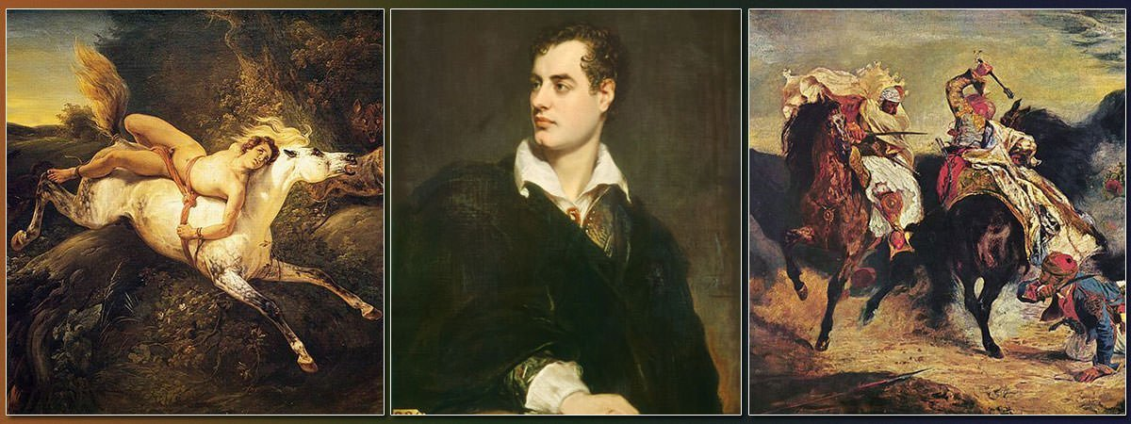
The Isles of Greece

THE isles of Greece! the isles of Greece
Where burning Sappho loved and sung,
Where grew the arts of war and peace,
Where Delos rose, and Phoebus sprung!
Eternal summer gilds them yet, | 5
But all, except their sun, is set.
The Scian and the Teian muse,
The hero's harp, the lover's lute,
Have found the fame your shores refuse:
Their place of birth alone is mute | 10
To sounds which echo further west
Than your sires' 'Islands of the Blest.
The mountains look on Marathon—
And Marathon looks on the sea;
And musing there an hour alone, | 15
I dream'd that Greece might still be free;
For standing on the Persians' grave,
I could not deem myself a slave.
A king sate on the rocky brow
Which looks o'er sea-born Salamis; | 20
And ships, by thousands, lay below,
And men in nations;—all were his!
He counted them at break of day—
And when the sun set, where were they?
And where are they? and where art thou, | 25
My country? On thy voiceless shore
The heroic lay is tuneless now—
The heroic bosom beats no more!
And must thy lyre, so long divine,
Degenerate into hands like mine? | 30
'Tis something in the dearth of fame,
Though link'd among a fetter'd race,
To feel at least a patriot's shame,
Even as I sing, suffuse my face;
For what is left the poet here? | 35
For Greeks a blush—for Greece a tear.
Must we but weep o'er days more blest?
Must we but blush?—Our fathers bled.
Earth! render back from out thy breast
A remnant of our Spartan dead! | 40
Of the three hundred grant but three,
To make a new Thermopylæ!
What, silent still? and silent all?
Ah! no;—the voices of the dead
Sound like a distant torrent's fall, | 45
And answer, 'Let one living head,
But one, arise,—we come, we come!'
'Tis but the living who are dumb.
In vain—in vain: strike other chords;
Fill high the cup with Samian wine! | 50
Leave battles to the Turkish hordes,
And shed the blood of Scio's vine:
Hark! rising to the ignoble call—
How answers each bold Bacchanal!
You have the Pyrrhic dance as yet; | 55
Where is the Pyrrhic phalanx gone?
Of two such lessons, why forget
The nobler and the manlier one?
You have the letters Cadmus gave—
Think ye he meant them for a slave? | 60
Fill high the bowl with Samian wine!
We will not think of themes like these!
It made Anacreon's song divine:
He served—but served Polycrates—
A tyrant; but our masters then | 65
Were still, at least, our countrymen.
The tyrant of the Chersonese
Was freedom's best and bravest friend;
That tyrant was Miltiades!
O that the present hour would lend | 70
Another despot of the kind!
Such chains as his were sure to bind.
Fill high the bowl with Samian wine!
On Suli's rock, and Parga's shore,
Exists the remnant of a line | 75
Such as the Doric mothers bore;
And there, perhaps, some seed is sown,
The Heracleidan blood might own.
Trust not for freedom to the Franks—
They have a king who buys and sells; | 80
In native swords and native ranks
The only hope of courage dwells:
But Turkish force and Latin fraud
Would break your shield, however broad.
Fill high the bowl with Samian wine! | 85
Our virgins dance beneath the shade—
I see their glorious black eyes shine;
But gazing on each glowing maid,
My own the burning tear-drop laves,
To think such breasts must suckle slaves. | 90
Place me on Sunium's marbled steep,
Where nothing, save the waves and I,
May hear our mutual murmurs sweep;
There, swan-like, let me sing and die:
A land of slaves shall ne' | 95

Percy Bysshe Shelley

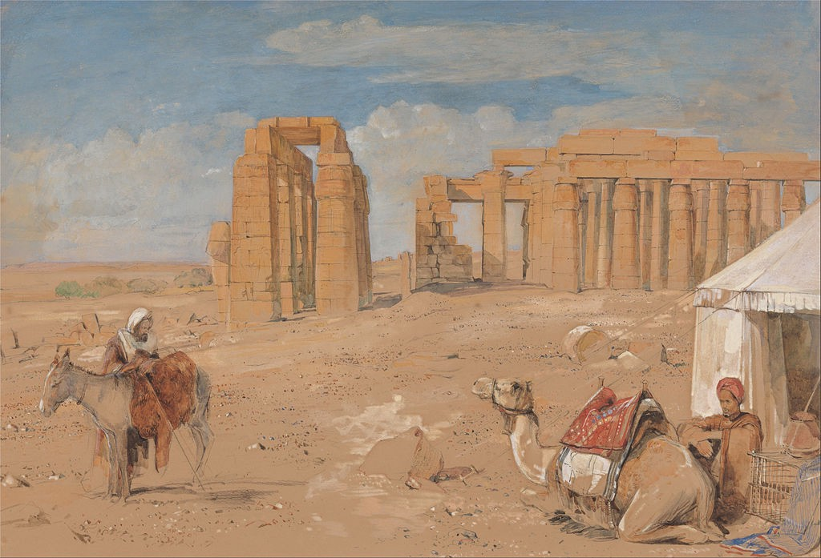

Ozymandias
I met a traveller from an antique land,
Who said—“Two vast and trunkless legs of stone
Stand in the desert. . . . Near them, on the sand,
Half sunk a shattered visage lies, whose frown,
And wrinkled lip, and sneer of cold command,
Tell that its sculptor well those passions read
Which yet survive, stamped on these lifeless things,
The hand that mocked them, and the heart that fed;
And on the pedestal, these words appear:
My name is Ozymandias, King of Kings;
Look on my Works, ye Mighty, and despair!
Nothing beside remains. Round the decay
Of that colossal Wreck, boundless and bare
The lone and level sands stretch far away.”

John Keats

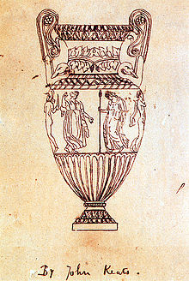

Ode on a Grecian Urn
Thou still unravish'd bride of quietness,
Thou foster-child of silence and slow time,
Sylvan historian, who canst thus express
A flowery tale more sweetly than our rhyme:
What leaf-fring'd legend haunts about thy shape
Of deities or mortals, or of both,
In Tempe or the dales of Arcady?
What men or gods are these? What maidens loth?
What mad pursuit? What struggle to escape?
What pipes and timbrels? What wild ecstasy?

Heard melodies are sweet, but those unheard
Are sweeter; therefore, ye soft pipes, play on;
Not to the sensual ear, but, more endear'd,
Pipe to the spirit ditties of no tone:
Fair youth, beneath the trees, thou canst not leave
Thy song, nor ever can those trees be bare;
Bold Lover, never, never canst thou kiss,
Though winning near the goal yet, do not grieve;
She cannot fade, though thou hast not thy bliss,
For ever wilt thou love, and she be fair!

Ah, happy, happy boughs! that cannot shed
Your leaves, nor ever bid the Spring adieu;
And, happy melodist, unwearied,
For ever piping songs for ever new;
More happy love! more happy, happy love!
For ever warm and still to be enjoy'd,
For ever panting, and for ever young;
All breathing human passion far above,
That leaves a heart high-sorrowful and cloy'd,
A burning forehead, and a parching tongue.

Who are these coming to the sacrifice?
To what green altar, O mysterious priest,
Lead'st thou that heifer lowing at the skies,
And all her silken flanks with garlands drest?
What little town by river or sea shore,
Or mountain-built with peaceful citadel,
Is emptied of this folk, this pious morn?
And, little town, thy streets for evermore
Will silent be; and not a soul to tell
Why thou art desolate, can e'er return.

O Attic shape! Fair attitude! with brede
Of marble men and maidens overwrought,
With forest branches and the trodden weed;
Thou, silent form, dost tease us out of thought
As doth eternity: Cold Pastoral!
When old age shall this generation waste,
Thou shalt remain, in midst of other woe
Than ours, a friend to man, to whom thou say'st,
"Beauty is truth, truth beauty,—that is all
Ye know on earth, and all ye need to know."

Alfred, Lord Tennyson

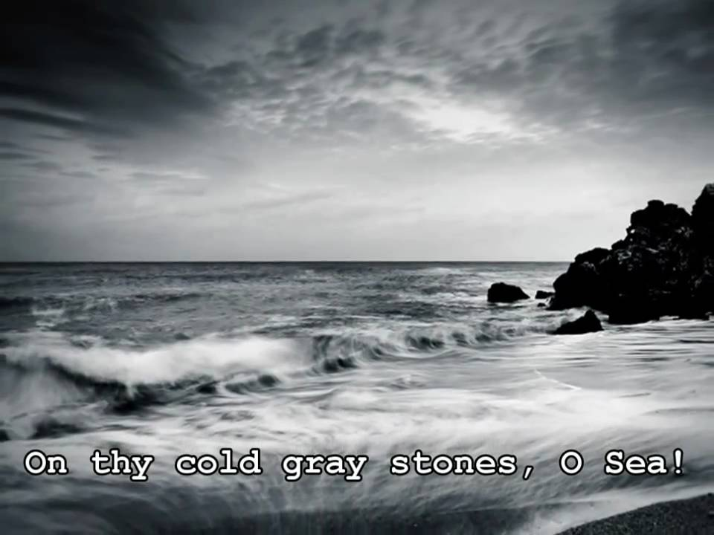

Break, Break, Break
Break, break, break,
On thy cold gray stones, O Sea!
And I would that my tongue could utter
The thoughts that arise in me.

O, well for the fisherman's boy,
That he shouts with his sister at play!
O, well for the sailor lad,
That he sings in his boat on the bay!

And the stately ships go on
To their haven under the hill;
But O for the touch of a vanish'd hand,
And the sound of a voice that is still!

Break, break, break
At the foot of thy crags, O Sea!
But the tender grace of a day that is dead
Will never come back to me.

Midterm Exam:

Film review of the movie based on the novel by E. M. Forster's Where Angels Fear to Tread

https://www.youtube.com/watch?v=tvUX-plzYPE

Summary
The story begins in London as Lilia, the young widow of Charles Herriton departs for an extended tour of Italy, taking with her a companion (Caroline Abbott), who is supposed to keep her our of trouble. Lilia leaves her 8-year-old daughter Irma home with the Herritons. The Herritons are a snobbish upper middle class family ruled by an iron-willed matriarch, who has never approved of her daughter-in-law's unassuming and spontaneous nature.
The trouble begins when word arrives from the small town of Monteriano that Lilia has gotten engaged to an Italian man. Mrs. Herriton sends her son Philip to buy off the "wretched Italian" and bring Lilia home. But he arrives too late. The 32-year-old Lilia has already married Gino Carella, who is the unemployed son of a dentist and a decade younger than she is. Gino is charming and seems guileless, although he has no intention of adopting an English attitude toward marriage. Indeed, he has married Lilia for her money and expects her to become a proper Italian wife.
Later, Lilia dies in childbirth, but the baby survives. At first the Herritons intend to sever contact and not acknowledge the child. However, nudged by Miss Abbott, the unsuccessful chaperone, they decide to "save" the child from becoming an Italian. Once again, Philip goes to Italy to buy off Gino and bring the boy to England. Once again, he fails.
But this time, his aggressive sister Harriet intervenes; when all else fails, she steals the baby. Unfortunately, a mishap occurs, and the baby dies. Meanwhile, Philip has fallen in love with Miss Abbott who, in turn, has fallen for the recently remarried Gino. In the end it looks like Phillip and Miss Abbott will become "just good friends."

Commentary
Snobbishness and cultural insensitivity form the tablet upon which this story is writ. First, you have the English social class difference that leads the Herriton family to patronize (and be embarrassed by) the young harebrained widow in their midst. Then there is the general belief in English superiority over the popish Italians. Finally, you have the total unacceptability of Gino himself, a poor, provincial, and poorly educated Italian.
The lack of cultural awareness extends to Lilia herself, who expects an Italian husband to adopt her English middle class values, and the Italian neighbors to transform themselves into an English community. (It is notable, though, to observe the social oppression of women in provincial Italian society of the time.)
The two characters that to some extent come to terms with cultural difference are Philip Herriton and Caroline Abbott, in both cases because they are open enough to respond to Gino as a person, rather than accepting a stereotype. Philip likes the Italian and understands his love for the baby. Caroline falls in love with the man. Thus, Gino in a sense returns to England with the two of them--as a barrier preventing their own happiness.


Charles Dickens (Boz is a pseudonym of Charles Dickens)
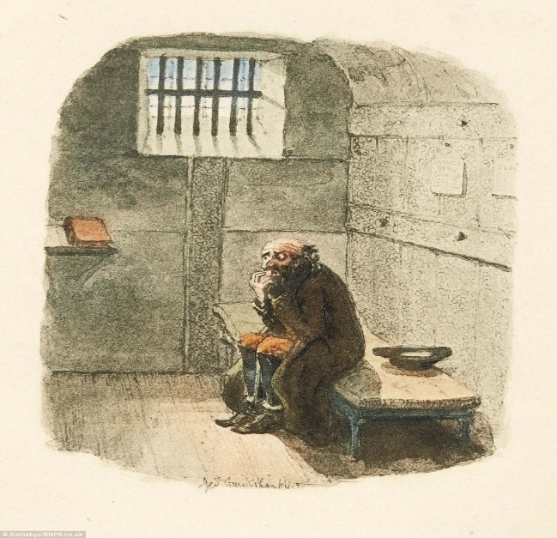

Sketches by Boz
CHAPTER XXV—A VISIT TO NEWGATE
‘The force of habit’ is a trite phrase in everybody’s mouth; and it is not a little remarkable that those who use it most as applied to others, unconsciously afford in their own persons singular examples of the power which habit and custom exercise over the minds of men, and of the little reflection they are apt to bestow on subjects with which every day’s experience has rendered them familiar. If Bedlam could be suddenly removed like another Aladdin’s palace, and set down on the space now occupied by Newgate, scarcely one man out of a hundred, whose road to business every morning lies through Newgate-street, or the Old Bailey, would pass the building without be- stowing a hasty glance on its small, grated windows, and a transient thought upon the condition of the unhappy beings immured in its dismal cells; and yet these same men, day by day, and hour by hour, pass and repass this gloomy depository of the guilt and misery of London, in one perpetual stream of life and bustle, utterly unmindful of the throng of wretched creatures pent up within it— nay, not even knowing, or if they do, not heeding, the fact, that as they pass one particular angle of the massive wall with a light laugh or a merry whistle, they stand within one yard of a fellow- creature, bound and helpless, whose hours are numbered, from whom the last feeble ray of hope has fled for ever, and whose miserable career will shortly terminate in a violent and shameful death. Contact with death even in its least terrible shape, is solemn and appalling. How much more awful is it to reflect on this near vicinity to the dying—to men in full health and vigour, in the flower of youth or the prime of life, with all their faculties and perceptions as acute and perfect as your own; but dying, nevertheless—dying as surely—with the hand of death imprinted upon them as indelibly—as if mortal disease had wasted their frames to shadows, and corruption had already be- gun!
It was with some such thoughts as these that we determined, not many weeks since, to visit the interior of Newgate—in an amateur capacity, of course; and, having carried our intention into effect, we proceed to lay its results before our readers, in the hope—founded more upon the nature of the subject, than on any presumptuous confidence in our own descriptive powers—that this pa- per may not be found wholly devoid of interest. We have only to premise, that we do not intend to fatigue the reader with any statistical accounts of the prison; they will be found at length in numerous reports of numerous committees, and a variety of authorities of equal weight. We took no notes, made no memoranda, measured none of the yards, ascertained the exact number of inches in no particular room: are unable even to report of how many apartments the gaol is composed.
We saw the prison, and saw the prisoners; and what we did see, and what we thought, we will tell at once in our own way.
Having delivered our credentials to the servant who answered our knock at the door of the governor’s house, we were ushered into the ‘office;’ a little room, on the right-hand side as you enter, with two windows looking into the Old Bailey: fitted up like an ordinary attorney’s office, or merchant’s counting house, with the usual fixtures—a wainscoted partition, a shelf or two, a desk, a couple of stools, a pair of clerks, an almanack, a clock, and a few maps. After a little delay, occasioned by sending into the interior of the prison for the officer whose duty it was to conduct us, that functionary arrived; a respectable-looking man of about two or three and fifty, in a broad- brimmed hat, and full suit of black, who, but for his keys, would have looked quite as much like a clergyman as a turnkey. We were disappointed; he had not even top-boots on. Following our conductor by a door opposite to that at which we had entered, we arrived at a small room, without any other furniture than a little desk, with a book for visitors’ autographs, and a shelf, on which were a few boxes for papers, and casts of the heads and faces of the two notorious murderers, Bishop and Williams; the former, in particular, exhibiting a style of head and set of features, which might have afforded sufficient moral grounds for his instant execution at any time, even had there been no other evidence against him. Leaving this room also, by an opposite door, we found our- self in the lodge which opens on the Old Bailey; one side of which is plentifully garnished with a choice collection of heavy sets of irons, including those worn by the redoubtable Jack Shep- pard—genuine; and those SAID to have been graced by the sturdy limbs of the no less celebrated Dick Turpin—doubtful. From this lodge, a heavy oaken gate, bound with iron, studded with nails of the same material, and guarded by another turnkey, opens on a few steps, if we remember right, which terminate in a narrow and dismal stone passage, running parallel with the Old Bailey, and leading to the different yards, through a number of tortuous and intricate windings, guarded in their turn by huge gates and gratings, whose appearance is sufficient to dispel at once the slightest hope of escape that any new-comer may have entertained; and the very recollection of which, on eventually traversing the place again, involves one in a maze of confusion.
It is necessary to explain here, that the buildings in the prison, or in other words the different wards—form a square, of which the four sides abut respectively on the Old Bailey, the old College of Physicians (now forming a part of Newgate-market), the Sessions- house, and Newgate-street. The intermediate space is divided into several paved yards, in which the prisoners take such air and exercise as can be had in such a place. These yards, with the exception of that in which prisoners under sentence of death are confined (of which we shall presently give a more detailed description), run parallel with Newgate-street, and consequently from the Old Bailey, as it were, to Newgate-market. The women’s side is in the right wing of the prison nearest the Sessions-house. As we were introduced into this part of the building first, we will adopt the same order, and introduce our readers to it also.
Turning to the right, then, down the passage to which we just now adverted, omitting any mention of intervening gates—for if we noticed every gate that was unlocked for us to pass through, and locked again as soon as we had passed, we should require a gate at every comma—we came to a door composed of thick bars of wood, through which were discernible, passing to and fro in a narrow yard, some twenty women: the majority of whom, however, as soon as they were aware of the presence of strangers, retreated to their wards. One side of this yard is railed off at a consider- able distance, and formed into a kind of iron cage, about five feet ten inches in height, roofed at the top, and defended in front by iron bars, from which the friends of the female prisoners communicate with them. In one corner of this singular-looking den, was a yellow, haggard, decrepit old woman, in a tattered gown that had once been black, and the remains of an old straw bonnet, with faded ribbon of the same hue, in earnest conversation with a young girl—a prisoner, of course—of about two-and-twenty. It is impossible to imagine a more poverty-stricken object, or a creature so borne down in soul and body, by excess of misery and destitution, as the old woman. The girl was a good-looking, robust female, with a profusion of hair streaming about in the wind— for she had no bonnet on—and a man’s silk pocket-handkerchief loosely thrown over a most ample pair of shoulders. The old woman was talking in that low, stifled tone of voice which tells so forcibly of mental anguish; and every now and then burst into an irrepressible sharp, abrupt cry of grief, the most distressing sound that ears can hear. The girl was perfectly unmoved. Hardened beyond all hope of redemption, she listened doggedly to her mother’s entreaties, whatever they were: and, beyond inquiring after ‘Jem,’ and eagerly catching at the few halfpence her miserable parent had brought her, took no more apparent interest in the conversation than the most unconcerned spectators. Heaven knows there were enough of them, in the persons of the other prisoners in the yard, who were no more concerned by what was passing before their eyes, and within their hearing, than if they were blind and deaf. Why should they be? Inside the prison, and out, such scenes were too familiar to them, to excite even a passing thought, unless of ridicule or contempt for feelings which they had long since forgotten.
A little farther on, a squalid-looking woman in a slovenly, thick- bordered cap, with her arms muffled in a large red shawl, the fringed ends of which straggled nearly to the bottom of a dirty white apron, was communicating some instructions to HER visitor—her daughter evidently. The girl was thinly clad, and shaking with the cold. Some ordinary word of recognition passed between
her and her mother when she appeared at the grating, but neither hope, condolence, regret, nor affection was expressed on either side. The mother whispered her instructions, and the girl received them with her pinched-up, half-starved features twisted into an expression of careful cunning. It was some scheme for the woman’s defence that she was disclosing, perhaps; and a sullen smile came over the girl’s face for an instant, as if she were pleased: not so much at the probability of her mother’s liberation, as at the chance of her ‘getting off’ in spite of her prosecutors. The dialogue was soon concluded; and with the same careless indifference with which they had approached each other, the mother turned towards the inner end of the yard, and the girl to the gate at which she had entered.
The girl belonged to a class—unhappily but too extensive—the very existence of which, should make men’s hearts bleed. Barely past her childhood, it required but a glance to discover that she was one of those children, born and bred in neglect and vice, who have never known what child- hood is: who have never been taught to love and court a parent’s smile, or to dread a parent’s frown. The thousand nameless endearments of childhood, its gaiety and its innocence, are alike unknown to them. They have entered at once upon the stern realities and miseries of life, and to their better nature it is almost hopeless to appeal in after-times, by any of the references which will awaken, if it be only for a moment, some good feeling in ordinary bosoms, however corrupt they may have become. Talk to THEM of parental solicitude, the happy days of childhood, and the merry games of infancy! Tell them of hunger and the streets, beggary and stripes, the gin-shop, the station-house, and the pawnbroker’s, and they will understand you.
Two or three women were standing at different parts of the grating, conversing with their friends, but a very large proportion of the prisoners appeared to have no friends at all, beyond such of their old companions as might happen to be within the walls. So, passing hastily down the yard, and pausing only for an instant to notice the little incidents we have just recorded, we were conducted up a clean and well-lighted flight of stone stairs to one of the wards. There are several in this part of the building, but a description of one is a description of the whole.
It was a spacious, bare, whitewashed apartment, lighted, of course, by windows looking into the interior of the prison, but far more light and airy than one could reasonably expect to find in such a situation. There was a large fire with a deal table before it, round which ten or a dozen women were seated on wooden forms at dinner. Along both sides of the room ran a shelf; below it, at regular intervals, a row of large hooks were fixed in the wall, on each of which was hung the sleeping mat of a prisoner: her rug and blanket being folded up, and placed on the shelf above. At night, these mats are placed on the floor, each beneath the hook on which it hangs during the day; and the ward is thus made to answer the purposes both of a day-room and sleeping apartment. Over the fireplace, was a large sheet of pasteboard, on which were displayed a variety of texts from
Scripture, which were also scattered about the room in scraps about the size and shape of the copy- slips which are used in schools. On the table was a sufficient provision of a kind of stewed beef and brown bread, in pewter dishes, which are kept perfectly bright, and displayed on shelves in great order and regularity when they are not in use.
The women rose hastily, on our entrance, and retired in a hurried manner to either side of the fireplace. They were all cleanly—many of them decently—attired, and there was nothing pecu- liar, either in their appearance or demeanour. One or two resumed the needlework which they had probably laid aside at the commencement of their meal; others gazed at the visitors with listless curiosity; and a few retired behind their companions to the very end of the room, as if desirous to avoid even the casual observation of the strangers. Some old Irish women, both in this and other wards, to whom the thing was no novelty, appeared perfectly indifferent to our presence, and remained standing close to the seats from which they had just risen; but the general feeling among the females seemed to be one of uneasiness during the period of our stay among them: which was very brief. Not a word was uttered during the time of our remaining, unless, indeed, by the ward-swoman in reply to some question which we put to the turnkey who accompanied us. In every ward on the female side, a ward-swoman is appointed to preserve order, and a similar regulation is adopted among the males. The wardsmen and wardswomen are all prisoners, selected for good conduct. They alone are allowed the privilege of sleeping on bedsteads; a small stump bedstead being placed in every ward for that purpose. On both sides of the gaol, is a small receiving-room, to which prisoners are conducted on their first reception, and whence they cannot be removed un- til they have been examined by the surgeon of the prison. (2)
Retracing our steps to the dismal passage in which we found ourselves at first (and which, by the-bye, contains three or four dark cells for the accommodation of refractory prisoners), we were led through a narrow yard to the ‘school’—a portion of the prison set apart for boys under fourteen years of age. In a tolerable- sized room, in which were writing-materials and some copy-books, was the schoolmaster, with a couple of his pupils; the remainder having been fetched from an adjoining apartment, the whole were drawn up in line for our inspection. There were fourteen of them in all, some with shoes, some without; some in pinafores without jackets, others in jackets without pinafores, and one in scarce anything at all. The whole number, without an exception we believe, had been committed for trial on charges of pocket-picking; and fourteen such terrible little faces we never beheld.—There was not one redeeming feature among them—not a glance of honesty—not a wink expressive of anything but the gallows and the hulks, in the whole collection. As to anything like shame or contrition, that was entirely out of the question. They were evidently quite gratified at being thought worth the trouble of looking at; their idea appeared to be, that we had come to see Newgate as a grand affair, and that they were an indispensable part of the show; and every boy as
he ‘fell in’ to the line, actually seemed as pleased and important as if he had done something excessively meritorious in getting there at all. We never looked upon a more disagreeable sight, be- cause we never saw fourteen such hopeless creatures of neglect, before.
On either side of the school-yard is a yard for men, in one of which—that towards Newgate street—prisoners of the more respectable class are confined. Of the other, we have little description to offer, as the different wards necessarily partake of the same character. They are provided, like the wards on the women’s side, with mats and rugs, which are disposed of in the same manner during the day; the only very striking difference between their appearance and that of the wards inhabited by the females, is the utter absence of any employment. Huddled together on two oppo- site forms, by the fireside, sit twenty men perhaps; here, a boy in livery; there, a man in a rough great-coat and top boots; farther on, a desperate-looking fellow in his shirt-sleeves, with an old Scotch cap upon his shaggy head; near him again, a tall ruffian, in a smock frock; next to him, a miserable being of distressed appearance, with his head resting on his hand;—all alike in one respect, all idle and listless. When they do leave the fire, sauntering moodily about, lounging in the window, or leaning against the wall, vacantly swinging their bodies to and fro. With the exception of a man reading an old newspaper, in two or three instances, this was the case in every ward we entered.
The only communication these men have with their friends, is through two close iron gratings, with an intermediate space of about a yard in width between the two, so that nothing can be handed across, nor can the prisoner have any communication by touch with the person who visits him. The married men have a separate grating, at which to see their wives, but its construction is the same.
The prison chapel is situated at the back of the governor’s house: the latter having no windows looking into the interior of the prison. Whether the associations connected with the place— the knowledge that here a portion of the burial service is, on some dreadful occasions, performed over the quick and not upon the dead—cast over it a still more gloomy and sombre air than art has imparted to it, we know not, but its appearance is very striking. There is something in a silent and deserted place of worship, solemn and impressive at any time; and the very dissimilarity of this one from any we have been accustomed to, only enhances the impression. The meanness of its appointments—the bare and scanty pulpit, with the paltry painted pillars on either side—the women’s gallery with its great heavy curtain—the men’s with its unpainted benches and dingy front—the tottering little table at the altar, with the commandments on the wall above it, scarcely legible through lack of paint, and dust and damp—so unlike the velvet and gilding, the marble and wood, of a modern church—are strange and striking. There is one object, too, which rivets the attention and fascinates the gaze, and from which we may turn horror-stricken in vain, for the recollection of it
will haunt us, waking and sleeping, for a long time afterwards. Immediately below the reading- desk, on the floor of the chapel, and forming the most conspicuous object in its little area, is THE CONDEMNED PEW; a huge black pen, in which the wretched people, who are singled out for death, are placed on the Sunday preceding their execution, in sight of all their fellow-prisoners, from many of whom they may have been separated but a week before, to hear prayers for their own souls, to join in the responses of their own burial service, and to listen to an address, warning their recent companions to take example by their fate, and urging themselves, while there is yet time—nearly four-and-twenty hours—to ‘turn, and flee from the wrath to come!’ Imagine what have been the feelings of the men whom that fearful pew has enclosed, and of whom, between the gal- lows and the knife, no mortal remnant may now remain! Think of the hopeless clinging to life to the last, and the wild despair, far exceeding in anguish the felon’s death itself, by which they have heard the certainty of their speedy transmission to another world, with all their crimes upon their heads, rung into their ears by the officiating clergyman!
At one time—and at no distant period either—the coffins of the men about to be executed, were placed in that pew, upon the seat by their side, during the whole service. It may seem in- credible, but it is true. Let us hope that the increased spirit of civilisation and humanity which abolished this frightful and degrading custom, may extend itself to other usages equally barbarous; usages which have not even the plea of utility in their defence, as every year’s experience has shown them to be more and more inefficacious.
Leaving the chapel, descending to the passage so frequently alluded to, and crossing the yard before noticed as being allotted to prisoners of a more respectable description than the generality of men confined here, the visitor arrives at a thick iron gate of great size and strength. Having been admitted through it by the turnkey on duty, he turns sharp round to the left, and pauses before an- other gate; and, having passed this last barrier, he stands in the most terrible part of this gloomy building—the condemned ward.
The press-yard, well known by name to newspaper readers, from its frequent mention in ac- counts of executions, is at the corner of the building, and next to the ordinary’s house, in Newgate- street: running from Newgate-street, towards the centre of the prison, parallel with Newgate- market. It is a long, narrow court, of which a portion of the wall in Newgate-street forms one end, and the gate the other. At the upper end, on the left hand—that is, adjoining the wall in Newgate street—is a cistern of water, and at the bottom a double grating (of which the gate itself forms a part) similar to that before described. Through these grates the prisoners are allowed to see their friends; a turnkey always remaining in the vacant space between, during the whole interview. Immediately on the right as you enter, is a building containing the press-room, day-room, and cells;
the yard is on every side surrounded by lofty walls guarded by CHEVAUX DE FRISE; and the whole is under the constant inspection of vigilant and experienced turnkeys.
In the first apartment into which we were conducted—which was at the top of a staircase, and immediately over the press-room—were five-and twenty or thirty prisoners, all under sentence of death, awaiting the result of the recorder’s report—men of all ages and appearances, from a hardened old offender with swarthy face and grizzly beard of three days’ growth, to a handsome boy, not fourteen years old, and of singularly youthful appearance even for that age, who had been condemned for burglary. There was nothing remarkable in the appearance of these prisoners. One or two decently dressed men were brooding with a dejected air over the fire; several little groups of two or three had been engaged in conversation at the upper end of the room, or in the windows; and the remainder were crowded round a young man seated at a table, who appeared to be en- gaged in teaching the younger ones to write. The room was large, airy, and clean. There was very little anxiety or mental suffering depicted in the countenance of any of the men;—they had all been sentenced to death, it is true, and the recorder’s report had not yet been made; but, we question whether there was a man among them, notwithstanding, who did not KNOW that although he had undergone the ceremony, it never was intended that his life should be sacrificed. On the table lay a Testament, but there were no tokens of its having been in recent use.
In the press-room below, were three men, the nature of whose offence rendered it necessary to separate them, even from their companions in guilt. It is a long, sombre room, with two windows sunk into the stone wall, and here the wretched men are pinioned on the morning of their execution, before moving towards the scaffold. The fate of one of these prisoners was uncertain; some mitigatory circumstances having come to light since his trial, which had been humanely rep- resented in the proper quarter. The other two had nothing to expect from the mercy of the crown; their doom was sealed; no plea could be urged in extenuation of their crime, and they well knew that for them there was no hope in this world. ‘The two short ones,’ the turnkey whispered, ‘were dead men.’
The man to whom we have alluded as entertaining some hopes of escape, was lounging, at the greatest distance he could place between himself and his companions, in the window nearest to the door. He was probably aware of our approach, and had assumed an air of courageous indifference; his face was purposely averted towards the window, and he stirred not an inch while we were present. The other two men were at the upper end of the room. One of them, who was im- perfectly seen in the dim light, had his back towards us, and was stooping over the fire, with his right arm on the mantel-piece, and his head sunk upon it. The other was leaning on the sill of the farthest window. The light fell full upon him, and communicated to his pale, haggard face, and disordered hair, an appearance which, at that distance, was ghastly. His cheek rested upon his
hand; and, with his face a little raised, and his eyes wildly staring before him, he seemed to be un- consciously intent on counting the chinks in the opposite wall. We passed this room again after- wards. The first man was pacing up and down the court with a firm military step—he had been a soldier in the foot- guards—and a cloth cap jauntily thrown on one side of his head. He bowed respectfully to our conductor, and the salute was returned. The other two still remained in the positions we have described, and were as motionless as statues. (3)
A few paces up the yard, and forming a continuation of the building, in which are the two rooms we have just quitted, lie the condemned cells. The entrance is by a narrow and obscure stair- case leading to a dark passage, in which a charcoal stove casts a lurid tint over the objects in its immediate vicinity, and diffuses something like warmth around. From the left-hand side of this passage, the massive door of every cell on the story opens; and from it alone can they be approached. There are three of these passages, and three of these ranges of cells, one above the other; but in size, furniture and appearance, they are all precisely alike. Prior to the recorder’s re- port being made, all the prisoners under sentence of death are removed from the day room at five o’clock in the afternoon, and locked up in these cells, where they are allowed a candle until ten o’clock; and here they remain until seven next morning. When the warrant for a prisoner’s execution arrives, he is removed to the cells and confined in one of them until he leaves it for the scaffold. He is at liberty to walk in the yard; but, both in his walks and in his cell, he is constantly at- tended by a turnkey who never leaves him on any pretence.
We entered the first cell. It was a stone dungeon, eight feet long by six wide, with a bench at the upper end, under which were a common rug, a bible, and prayer-book. An iron candlestick was fixed into the wall at the side; and a small high window in the back admitted as much air and light as could struggle in between a double row of heavy, crossed iron bars. It contained no other furniture of any description.
Conceive the situation of a man, spending his last night on earth in this cell. Buoyed up with some vague and undefined hope of reprieve, he knew not why—indulging in some wild and visionary idea of escaping, he knew not how—hour after hour of the three preceding days allowed him for preparation, has fled with a speed which no man living would deem possible, for none but this dying man can know. He has wearied his friends with entreaties, exhausted the attendants with importunities, neglected in his feverish restlessness the timely warnings of his spiritual consoler; and, now that the illusion is at last dispelled, now that eternity is before him and guilt behind, now that his fears of death amount almost to madness, and an overwhelming sense of his helpless, hopeless state rushes upon him, he is lost and stupefied, and has neither thoughts to turn to, nor power to call upon, the Almighty Being, from whom alone he can seek mercy and forgiveness, and before whom his repentance can alone avail.
Hours have glided by, and still he sits upon the same stone bench with folded arms, heedless alike of the fast decreasing time before him, and the urgent entreaties of the good man at his side. The feeble light is wasting gradually, and the deathlike stillness of the street without, broken only by the rumbling of some passing vehicle which echoes mournfully through the empty yards, warns him that the night is waning fast away. The deep bell of St. Paul’s strikes—one! He heard it; it has roused him. Seven hours left! He paces the narrow limits of his cell with rapid strides, cold drops of terror starting on his forehead, and every muscle of his frame quivering with agony. Seven hours! He suffers himself to be led to his seat, mechanically takes the bible which is placed in his hand, and tries to read and listen. No: his thoughts will wander. The book is torn and soiled by use—and like the book he read his lessons in, at school, just forty years ago! He has never be- stowed a thought upon it, perhaps, since he left it as a child: and yet the place, the time, the room— nay, the very boys he played with, crowd as vividly before him as if they were scenes of yesterday; and some forgotten phrase, some childish word, rings in his ears like the echo of one uttered but a minute since. The voice of the clergyman recalls him to himself. He is reading from the sacred book its solemn promises of pardon for repentance, and its awful denunciation of obdurate men. He falls upon his knees and clasps his hands to pray. Hush! what sound was that? He starts upon his feet. It cannot be two yet. Hark! Two quarters have struck; —the third—the fourth. It is! Six hours left. Tell him not of repentance! Six hours’ repentance for eight times six years of guilt and sin! He buries his face in his hands, and throws himself on the bench.
Worn with watching and excitement, he sleeps, and the same unsettled state of mind pursues him in his dreams. An insupportable load is taken from his breast; he is walking with his wife in a pleasant field, with the bright sky above them, and a fresh and boundless prospect on every side— how different from the stone walls of Newgate! She is looking—not as she did when he saw her for the last time in that dreadful place, but as she used when he loved her—long, long ago, before mis- ery and ill-treatment had altered her looks, and vice had changed his nature, and she is leaning upon his arm, and looking up into his face with tenderness and affection—and he does NOT strike her now, nor rudely shake her from him. And oh! how glad he is to tell her all he had forgotten in that last hurried interview, and to fall on his knees before her and fervently beseech her pardon for all the unkindness and cruelty that wasted her form and broke her heart! The scene suddenly changes. He is on his trial again: there are the judge and jury, and prosecutors, and witnesses, just as they were before. How full the court is—what a sea of heads—with a gallows, too, and a scaffold—and how all those people stare at HIM! Verdict, ‘Guilty.’ No matter; he will escape.
The night is dark and cold, the gates have been left open, and in an instant he is in the street, flying from the scene of his imprisonment like the wind. The streets are cleared, the open fields are gained and the broad, wide country lies before him. Onward he dashes in the midst of dark-
ness, over hedge and ditch, through mud and pool, bounding from spot to spot with a speed and lightness, astonishing even to himself. At length he pauses; he must be safe from pursuit now; he will stretch himself on that bank and sleep till sunrise.
A period of unconsciousness succeeds. He wakes, cold and wretched. The dull, gray light of morning is stealing into the cell, and falls upon the form of the attendant turnkey. Confused by his dreams, he starts from his uneasy bed in momentary uncertainty. It is but momentary. Every ob- ject in the narrow cell is too frightfully real to admit of doubt or mistake. He is the condemned felon again, guilty and despairing; and in two hours more will be dead.
Christina Rossetti



Remember
Remember me when I am gone away,
Gone far away into the silent land;
When you can no more hold me by the hand,
Nor I half turn to go yet turning stay.
Remember me when no more day by day
You tell me of our future that you plann'd:
Only remember me; you understand
It will be late to counsel then or pray.
Yet if you should forget me for a while
And afterwards remember, do not grieve:
For if the darkness and corruption leave
A vestige of the thoughts that once I had,
Better by far you should forget and smile
Than that you should remember and be sad

Rudyard Kipling

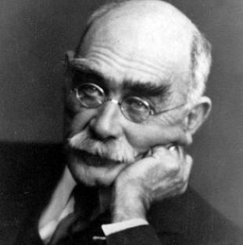

If—
(‘Brother Square-Toes’—Rewards and Fairies)
If you can keep your head when all about you
Are losing theirs and blaming it on you,
If you can trust yourself when all men doubt you,
But make allowance for their doubting too;
If you can wait and not be tired by waiting,
Or being lied about, don’t deal in lies,
Or being hated, don’t give way to hating,
And yet don’t look too good, nor talk too wise:

If you can dream—and not make dreams your master;
If you can think—and not make thoughts your aim;
If you can meet with Triumph and Disaster
And treat those two impostors just the same;
If you can bear to hear the truth you’ve spoken
Twisted by knaves to make a trap for fools,
Or watch the things you gave your life to, broken,
And stoop and build ’em up with worn-out tools:

If you can make one heap of all your winnings
And risk it on one turn of pitch-and-toss,
And lose, and start again at your beginnings
And never breathe a word about your loss;
If you can force your heart and nerve and sinew
To serve your turn long after they are gone,
And so hold on when there is nothing in you
Except the Will which says to them: ‘Hold on!’

If you can talk with crowds and keep your virtue,
Or walk with Kings—nor lose the common touch,
If neither foes nor loving friends can hurt you,
If all men count with you, but none too much;
If you can fill the unforgiving minute
With sixty seconds’ worth of distance run,
Yours is the Earth and everything that’s in it,
And—which is more—you’ll be a Man, my son!

Rupert Brooke

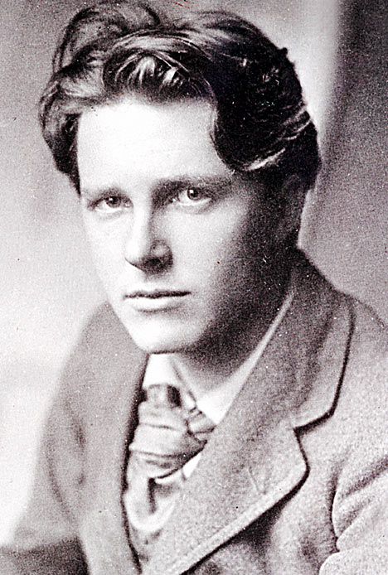

The Soldier
If I should die, think only this of me:
That there’s some corner of a foreign field
That is for ever England. There shall be
In that rich earth a richer dust concealed;
A dust whom England bore, shaped, made aware,
Gave, once, her flowers to love, her ways to roam;
A body of England’s, breathing English air,
Washed by the rivers, blest by suns of home.

And think, this heart, all evil shed away,
A pulse in the eternal mind, no less
Gives somewhere back the thoughts by England given;
Her sights and sounds; dreams happy as her day;
And laughter, learnt of friends; and gentleness,
In hearts at peace, under an English heaven.

Wilfred Owen

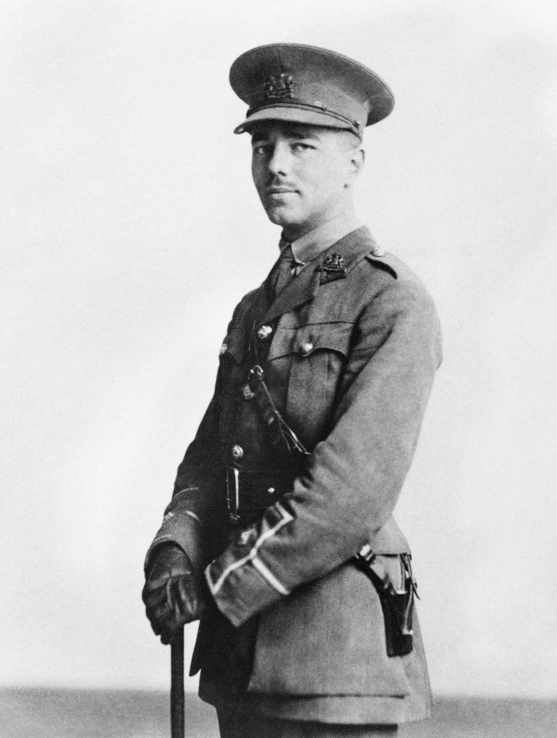

Anthem for Doomed Youth
What passing-bells for these who die as cattle?
— Only the monstrous anger of the guns.
Only the stuttering rifles' rapid rattle
Can patter out their hasty orisons.
No mockeries now for them; no prayers nor bells;
Nor any voice of mourning save the choirs,—
The shrill, demented choirs of wailing shells;
And bugles calling for them from sad shires.

What candles may be held to speed them all?
Not in the hands of boys, but in their eyes
Shall shine the holy glimmers of goodbyes.
The pallor of girls' brows shall be their pall;
Their flowers the tenderness of patient minds,
And each slow dusk a drawing-down of blinds.

Dulce et Decorum Est
Bent double, like old beggars under sacks,
Knock-kneed, coughing like hags, we cursed through sludge,
Till on the haunting flares we turned our backs,
And towards our distant rest began to trudge.
Men marched asleep. Many had lost their boots,
But limped on, blood-shod. All went lame; all blind;
Drunk with fatigue; deaf even to the hoots
Of gas-shells dropping softly behind.

Gas! GAS! Quick, boys!—An ecstasy of fumbling
Fitting the clumsy helmets just in time,
But someone still was yelling out and stumbling
And flound’ring like a man in fire or lime.—
Dim through the misty panes and thick green light,
As under a green sea, I saw him drowning.

In all my dreams before my helpless sight,
He plunges at me, guttering, choking, drowning.

If in some smothering dreams, you too could pace
Behind the wagon that we flung him in,
And watch the white eyes writhing in his face,
His hanging face, like a devil’s sick of sin;
If you could hear, at every jolt, the blood
Come gargling from the froth-corrupted lungs,
Obscene as cancer, bitter as the cud
Of vile, incurable sores on innocent tongues,—
My friend, you would not tell with such high zest
To children ardent for some desperate glory,
The old Lie: Dulce et decorum est
Pro patria mori.

Katherine Mansfield

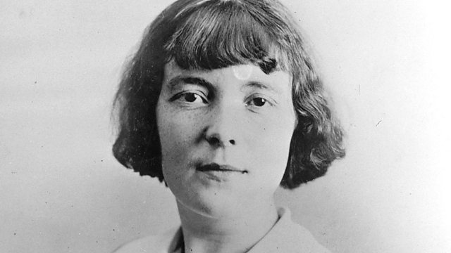

The Fly
'Y'are very snug in here,' piped old Mr. Woodifield, and peered out of the great, green-leather armchair by his friend the boss's desk as a baby peers out of its pram. His talk was over; it was time for him to be off. But he did not want to go. Since he had retired, since his ... stroke, the wife and the girls kept him boxed up in the house every day of the week except Tuesday. On Tuesday he was dressed and brushed and allowed to cut back to the City for the day. Though what he did there the wife and girls couldn't imagine. Made a nuisance of himself to his friends, they supposed....Well, perhaps so. All the same, we cling to our last pleasures as the tree clings to its last leaves. So there sat old Woodifield, smoking a cigar and staring almost greedily at the boss, who rolled in his office chair, stout, rosy, five years older than he, and still going strong, still at the helm. It did one good to see him.
Wistfully, admiringly, the old voice added, 'It's snug in here, upom my word!'
'Yes, it's comfortable enough,' agreed the boss, and he flipped the Financial Times with a paper-knife. As a matter of fact he was proud of his room; he liked to have it admired, especially by old Woodifield. It gave him a feeling of deep, solid satisfaction to be planted there in the midst of it in full view of that frail old figure in the muffler.
'I've had it done up lately,' he explained, as he had explained for the past how many weeks.
'New carpet,' and he pointed to the bright red carpet with a pattern of large white rings. 'New furniture,' and he nodded towards the massive bookcase and the table with legs like twisted treacle. 'Electric heating!' He waved almost exultantly towards the five transparent, pearly sausages glowing so softly in the tilted copper pan.
But he did not draw old Woodifield's attention to the photograph over the table of a grave-looking boy in uniform standing in one of those spectral photographers' parks with photographers' storm-clouds behind him. It was not new. It had been there for over six years.
'There was something I wanted to tell you,' said old Woodifield, and his eyes grew dim remembering. 'Now what was it? I had it in my mind when I started out this morning.' His hands began to tremble, and patches of red showed above his beard.
Poor old chap, he's on his last pins, thought the boss. And, feeling kindly, he winked at the old man, and said jokingly,
'I tell you what. I've got a little drop of something here that'll do you good before you go out into the cold again. It's beautiful stuff. It wouldn't hurt a child.' He took a key off his watch-chain, unlocked a cupboard below his desk, and drew forth a dark, squat bottle. 'That's the medicine,' said he. 'And the man from whom I got it told me on the strict Q.T. it came from the cellars at Windsor Castle.'
Old Woodifield's mouth fell open at the sight. He couldn't have looked more surprised if the boss had produced a rabbit.
'It's whisky, ain't it?' he piped feebly.
The boss turned the bottle and lovingly showed him the label. Whisky it was.
'D'you know,' said he, peering up at the boss wonderingly, 'they won't let me touch it at home.' And he looked as though he was going to cry.
'Ah, that's where we know a bit more than the ladies,' cried the boss, swooping across for two tumblers that stood on the table with the water-bottle, and pouring a generous finger into each. 'Drink it down. It'll do you good. And don't put any water with it. It's sacrilege to tamper with stuff like this. Ah!' He tossed off his, pulled out his handkerchief, hastily wiped his moustaches, and cocked an eye at old Woodifield, who was rolling his in his chaps.
The old man swallowed, was silent a moment, and then said faintly, 'It's nutty!'
But it warmed him; it crept into his chill old brain he remembered.
'That was it,' he said, heaving himself out of his chair.
'I thought you'd like to know. The girls were in Belgium last week having a look at poor Reggie's grave, and they happened to come across your boy's. They're quite near each other, it seems.'
Old Woodifield paused, but the boss made no reply. Only a quiver in his eyelids showed that he heard.
'The girls were delighted with the way the place is kept,' piped the old voice. 'Beautifully looked after. Couldn't be better if they were at home. You've not been across, have yer?'
'No, no!' For various reasons the boss had not been across.
'There's miles of it,' quavered old Woodifield, 'and it's all as neat as a garden. Flowers growing on all the graves. Nice broad paths.' It was plain from his voice how much he liked a nice broad path.
The pause came again. Then the old man brightened wonderfully.
'D'you know what the hotel made the girls pay for a pot of jam?' he piped. 'Ten francs! Robbery, I call it. It was a little pot, so Gertrude says, no bigger than a half-crown. And she hadn't taken more than a spoonful when they charged her ten francs. Gertrude brought the pot away with her to teach 'em a lesson. Quite right, too; it's trading on our feelings. They think because we're over there having a look round we're ready to pay anything. That's what it is.' And he turned towards the door.
'Quite right, quite right!' cried the boss, though what was quite right he hadn't the least idea. He came round by his desk, followed the shuffling footsteps to the door, and saw the old fellow out. Woodifield was gone.
For a long moment the boss stayed, staring at nothing, while the grey-haired office messenger, watching him, dodged in and out of his cubby-hole like a dog that expects to be taken for a run. Then: 'I'll see nobody for half an hour, Macey,' said the boss. 'Understand! Nobody at all.'
'Very good, sir.'
The door shut, the firm heavy steps recrossed the bright carpet, the fat body plumped down in the spring chair, and leaning forward, the boss covered his face with his hands. He wanted, he intended, he had arranged to weep....
It had been a terrible shock to him when old Woodifield sprang that remark upon him about the boy's grave. It was exactly as though the earth had opened and he had seen the boy lying there with Woodifield's girls staring down at him. For it was strange. Although over six years had passed away, the boss never thought of the boy except as lying unchanged, unblemished in his uniform, asleep for ever. "My son!" groaned the boss. But no tears came yet. In the past, in the first months and even years after the boy's death, he had only to say those words to be overcome by such grief that nothing short of a violent fit of weeping could relieve him. Time, he had declared then, he had told everybody, could make no difference. Other men perhaps might recover, might live their loss down, but not he. How was it possible! His boy was an only son. Ever since his birth the boss had worked at building up this business for him; it had no other meaning if it was not for the boy. Life itself had come to have no other meaning. How on earth could he have slaved, denied himself, kept going all those years without the promise for ever before him of the boy's stepping into his shoes and carrying on where he left off?
And that promise had been so near being fulfilled. The boy had been in the office learning the ropes for a year before the war. Every morning they had started off together; they had come back by the same train. And what congratulations he had received as the boy's father! No wonder; he had taken to it marvellously. As to his popularity with the staff, every man jack of them down to old Macey couldn't make enough of the boy. And he wasn't in the least spoilt. No, he was just his bright natural self, with the right word for everybody, with that boyish look and his habit of saying, 'Simply splendid!'
But all that was over and done with as though it never had been. The day had come when Macey had handed him the telegram that brought the whole place crashing about his head. 'Deeply regret to inform you ...' And he had left the office a broken man, with his life in ruins.
Six years ago, six years.... How quickly time passed! It might have happened yesterday. The boss took his hands from his face; he was puzzled. Something seemed to be wrong with him. He wasn't feeling as he wanted to feel. He decided to get up and have a look at the boy's photograph. But it wasn't a favourite photograph of his; the expression was unnatural. It was cold, even stern-looking. The boy had never looked like that.
At that moment the boss noticed that a fly had fallen into his broad inkpot, and was trying feebly but desperately to clamber out again. Help! Help! said those struggling legs. But the sides of the inkpot were wet and slippery; it fell back again and began to swim. The boss took up a pen, picked the fly out of the ink, and shook it on to a piece of blotting-paper. For a fraction of a second it lay still on the dark patch that oozed round it. Then the front legs waved, took hold, and, pulling its small, sodden body up, it began the immense task of cleaning the ink from its wings. Over and under, over and under, went a leg along a wing as the stone goes over and under the scythe. Then there was a pause, while the fly, seeming to stand on the tips of its toes, tried to expand first one wing and then the other. It succeeded at last, and, sitting down, it began, like a minute cat, to clean its face. Now one could Imagine that the little front legs rubbed against each other lightly, joyfully. The horrible danger was over; it had escaped; it was ready for life again.
But just then the boss had an idea. He plunged his pen back into the ink, leaned his thick wrist on the blotting-paper, and as the fly tried its wings down came a great heavy blot. What would it make of that! What indeed! The little beggar seemed absolutely cowed, stunned, and afraid to move because of what would happen next. But then, as if painfully, it dragged itself forward. The front legs waved, caught hold, and, more slowly this time, the task began from the beginning.
He's a plucky little devil, thought the boss, and he felt a real admiration for the fly's courage. That was the way to tackle things; that was the right spirit. Never say die; it was only a question of... But the fly had again finished its laborious task, and the boss had just time to refill his pen, to shake fair and square on the new-cleaned body yet another dark drop. What about it this time? A painful moment of suspense followed. But behold, the front legs were again waving; the boss felt a rush of relief. He leaned over the fly and said to it tenderly, "You artful little b..." And he actually had the brilliant notion of breathing on it to help the drying process. All the same, there was something timid and weak about its efforts now, and the boss decided that this time should be the last, as he dipped the pen deep into the inkpot.
It was. The last blot fell on the soaked blotting-paper, and the draggled fly lay in it and did not stir. The back legs were stuck to the body; the front legs were not to be seen.
'Come on,' said the boss.'Look sharp!' And he stirred it with his pen in vain. Nothing happened or was likely to happen. The fly was dead.
The boss lifted the corpse on the end of the paper-knife and flung it into the waste-paper basket. But such a grinding feeling of wretchedness seized him that he felt positively frightened. He started forward and pressed the bell for Macey.
'Bring me some fresh blotting-paper,' he said sternly,'and look sharp about it.' And while the old dog padded away he fell to wondering what it was he had been thinking about before. What was it? It was... He took out his handkerchief and passed it inside his collar. For the life of him he could not remember.

George Orwell

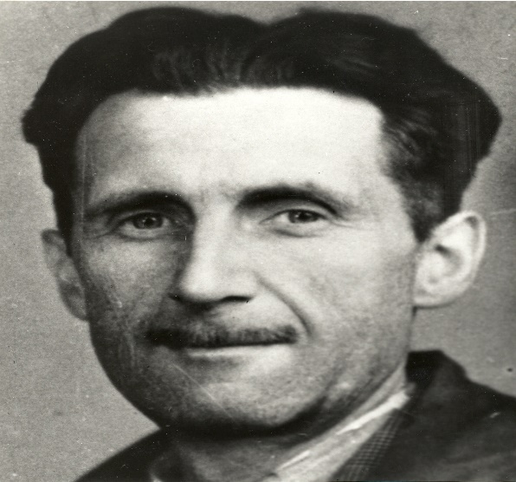

Shooting an Elephant
In Moulmein, in Lower Burma, I was hated by large numbers of people — the only time in my life that I have been important enough for this to happen to me. I was sub-divisional police officer of the town, and in an aimless, petty kind of way anti-European feeling was very bitter. No one had the guts to raise a riot, but if a European woman went through the bazaars alone somebody would probably spit betel juice over her dress. As a police officer I was an obvious target and was baited whenever it seemed safe to do so. When a nimble Burman tripped me up on the football field and the referee (another Burman) looked the other way, the crowd yelled with hideous laughter. This happened more than once. In the end the sneering yellow faces of young men that met me everywhere, the insults hooted after me when I was at a safe distance, got badly on my nerves. The young Buddhist priests were the worst of all. There were several thousands of them in the town and none of them seemed to have anything to do except stand on street corners and jeer at Europeans.
All this was perplexing and upsetting. For at that time I had already made up my mind that imperialism was an evil thing and the sooner I chucked up my job and got out of it the better. Theoretically — and secretly, of course — I was all for the Burmese and all against their oppressors, the British. As for the job I was doing, I hated it more bitterly than I can perhaps make clear. In a job like that you see the dirty work of Empire at close quarters. The wretched prisoners huddling in the stinking cages of the lock-ups, the grey, cowed faces of the long-term convicts, the scarred buttocks of the men who had been flogged with bamboos — all these oppressed me with an intolerable sense of guilt. But I could get nothing into perspective. I was young and ill-educated and I had had to think out my problems in the utter silence that is imposed on every Englishman in the East. I did not even know that the British Empire is dying, still less did I know that it is a great deal better than the younger empires that are going to supplant it. All I knew was that I was stuck between my hatred of the empire I served and my rage against the evil-spirited little beasts who tried to make my job impossible. With one part of my mind I thought of the British Raj as an unbreakable tyranny, as something clamped down, in saecula saeculorum, upon the will of prostrate peoples; with another part I thought that the greatest joy in the world would be to drive a bayonet into a Buddhist priest's guts. Feelings like these are the normal by-products of imperialism; ask any Anglo-Indian official, if you can catch him off duty.
One day something happened which in a roundabout way was enlightening. It was a tiny incident in itself, but it gave me a better glimpse than I had had before of the real nature of imperialism — the real motives for which despotic governments act. Early one morning the sub-inspector at a police station the other end of the town rang me up on the phone and said that an elephant was ravaging the bazaar. Would I please come and do something about it? I did not know what I could do, but I wanted to see what was happening and I got on to a pony and started out. I took my rifle, an old .44 Winchester and much too small to kill an elephant, but I thought the noise might be useful in terrorem. Various Burmans stopped me on the way and told me about the elephant's doings. It was not, of course, a wild elephant, but a tame one which had gone ‘must’. It had been chained up, as tame elephants always are when their attack of ‘must’ is due, but on the previous night it had broken its chain and escaped. Its mahout, the only person who could manage it when it was in that state, had set out in pursuit, but had taken the wrong direction and was now twelve hours’ journey away, and in the morning the elephant had suddenly reappeared in the town. The Burmese population had no weapons and were quite helpless against it. It had already destroyed somebody's bamboo hut, killed a cow and raided some fruit-stalls and devoured the stock; also it had met the municipal rubbish van and, when the driver jumped out and took to his heels, had turned the van over and inflicted violences upon it.
The Burmese sub-inspector and some Indian constables were waiting for me in the quarter where the elephant had been seen. It was a very poor quarter, a labyrinth of squalid bamboo huts, thatched with palmleaf, winding all over a steep hillside. I remember that it was a cloudy, stuffy morning at the beginning of the rains. We began questioning the people as to where the elephant had gone and, as usual, failed to get any definite information. That is invariably the case in the East; a story always sounds clear enough at a distance, but the nearer you get to the scene of events the vaguer it becomes. Some of the people said that the elephant had gone in one direction, some said that he had gone in another, some professed not even to have heard of any elephant. I had almost made up my mind that the whole story was a pack of lies, when we heard yells a little distance away. There was a loud, scandalized cry of ‘Go away, child! Go away this instant!’ and an old woman with a switch in her hand came round the corner of a hut, violently shooing away a crowd of naked children. Some more women followed, clicking their tongues and exclaiming; evidently there was something that the children ought not to have seen. I rounded the hut and saw a man's dead body sprawling in the mud. He was an Indian, a black Dravidian coolie, almost naked, and he could not have been dead many minutes. The people said that the elephant had come suddenly upon him round the corner of the hut, caught him with its trunk, put its foot on his back and ground him into the earth. This was the rainy season and the ground was soft, and his face had scored a trench a foot deep and a couple of yards long. He was lying on his belly with arms crucified and head sharply twisted to one side. His face was coated with mud, the eyes wide open, the teeth bared and grinning with an expression of unendurable agony. (Never tell me, by the way, that the dead look peaceful. Most of the corpses I have seen looked devilish.) The friction of the great beast's foot had stripped the skin from his back as neatly as one skins a rabbit. As soon as I saw the dead man I sent an orderly to a friend's house nearby to borrow an elephant rifle. I had already sent back the pony, not wanting it to go mad with fright and throw me if it smelt the elephant.
The orderly came back in a few minutes with a rifle and five cartridges, and meanwhile some Burmans had arrived and told us that the elephant was in the paddy fields below, only a few hundred yards away. As I started forward practically the whole population of the quarter flocked out of the houses and followed me. They had seen the rifle and were all shouting excitedly that I was going to shoot the elephant. They had not shown much interest in the elephant when he was merely ravaging their homes, but it was different now that he was going to be shot. It was a bit of fun to them, as it would be to an English crowd; besides they wanted the meat. It made me vaguely uneasy. I had no intention of shooting the elephant — I had merely sent for the rifle to defend myself if necessary — and it is always unnerving to have a crowd following you. I marched down the hill, looking and feeling a fool, with the rifle over my shoulder and an ever-growing army of people jostling at my heels. At the bottom, when you got away from the huts, there was a metalled road and beyond that a miry waste of paddy fields a thousand yards across, not yet ploughed but soggy from the first rains and dotted with coarse grass. The elephant was standing eight yards from the road, his left side towards us. He took not the slightest notice of the crowd's approach. He was tearing up bunches of grass, beating them against his knees to clean them and stuffing them into his mouth.
I had halted on the road. As soon as I saw the elephant I knew with perfect certainty that I ought not to shoot him. It is a serious matter to shoot a working elephant — it is comparable to destroying a huge and costly piece of machinery — and obviously one ought not to do it if it can possibly be avoided. And at that distance, peacefully eating, the elephant looked no more dangerous than a cow. I thought then and I think now that his attack of ‘must’ was already passing off; in which case he would merely wander harmlessly about until the mahout came back and caught him. Moreover, I did not in the least want to shoot him. I decided that I would watch him for a little while to make sure that he did not turn savage again, and then go home.
But at that moment I glanced round at the crowd that had followed me. It was an immense crowd, two thousand at the least and growing every minute. It blocked the road for a long distance on either side. I looked at the sea of yellow faces above the garish clothes-faces all happy and excited over this bit of fun, all certain that the elephant was going to be shot. They were watching me as they would watch a conjurer about to perform a trick. They did not like me, but with the magical rifle in my hands I was momentarily worth watching. And suddenly I realized that I should have to shoot the elephant after all. The people expected it of me and I had got to do it; I could feel their two thousand wills pressing me forward, irresistibly. And it was at this moment, as I stood there with the rifle in my hands, that I first grasped the hollowness, the futility of the white man's dominion in the East. Here was I, the white man with his gun, standing in front of the unarmed native crowd — seemingly the leading actor of the piece; but in reality I was only an absurd puppet pushed to and fro by the will of those yellow faces behind. I perceived in this moment that when the white man turns tyrant it is his own freedom that he destroys. He becomes a sort of hollow, posing dummy, the conventionalized figure of a sahib. For it is the condition of his rule that he shall spend his life in trying to impress the ‘natives’, and so in every crisis he has got to do what the ‘natives’ expect of him. He wears a mask, and his face grows to fit it. I had got to shoot the elephant. I had committed myself to doing it when I sent for the rifle. A sahib has got to act like a sahib; he has got to appear resolute, to know his own mind and do definite things. To come all that way, rifle in hand, with two thousand people marching at my heels, and then to trail feebly away, having done nothing — no, that was impossible. The crowd would laugh at me. And my whole life, every white man's life in the East, was one long struggle not to be laughed at.
But I did not want to shoot the elephant. I watched him beating his bunch of grass against his knees, with that preoccupied grandmotherly air that elephants have. It seemed to me that it would be murder to shoot him. At that age I was not squeamish about killing animals, but I had never shot an elephant and never wanted to. (Somehow it always seems worse to kill a large animal.) Besides, there was the beast's owner to be considered. Alive, the elephant was worth at least a hundred pounds; dead, he would only be worth the value of his tusks, five pounds, possibly. But I had got to act quickly. I turned to some experienced-looking Burmans who had been there when we arrived, and asked them how the elephant had been behaving. They all said the same thing: he took no notice of you if you left him alone, but he might charge if you went too close to him.
It was perfectly clear to me what I ought to do. I ought to walk up to within, say, twenty-five yards of the elephant and test his behavior. If he charged, I could shoot; if he took no notice of me, it would be safe to leave him until the mahout came back. But also I knew that I was going to do no such thing. I was a poor shot with a rifle and the ground was soft mud into which one would sink at every step. If the elephant charged and I missed him, I should have about as much chance as a toad under a steam-roller. But even then I was not thinking particularly of my own skin, only of the watchful yellow faces behind. For at that moment, with the crowd watching me, I was not afraid in the ordinary sense, as I would have been if I had been alone. A white man mustn't be frightened in front of ‘natives’; and so, in general, he isn't frightened. The sole thought in my mind was that if anything went wrong those two thousand Burmans would see me pursued, caught, trampled on and reduced to a grinning corpse like that Indian up the hill. And if that happened it was quite probable that some of them would laugh. That would never do.
There was only one alternative. I shoved the cartridges into the magazine and lay down on the road to get a better aim. The crowd grew very still, and a deep, low, happy sigh, as of people who see the theatre curtain go up at last, breathed from innumerable throats. They were going to have their bit of fun after all. The rifle was a beautiful German thing with cross-hair sights. I did not then know that in shooting an elephant one would shoot to cut an imaginary bar running from ear-hole to ear-hole. I ought, therefore, as the elephant was sideways on, to have aimed straight at his ear-hole, actually I aimed several inches in front of this, thinking the brain would be further forward.
When I pulled the trigger I did not hear the bang or feel the kick — one never does when a shot goes home — but I heard the devilish roar of glee that went up from the crowd. In that instant, in too short a time, one would have thought, even for the bullet to get there, a mysterious, terrible change had come over the elephant. He neither stirred nor fell, but every line of his body had altered. He looked suddenly stricken, shrunken, immensely old, as though the frightful impact of the bullet had paralysed him without knocking him down. At last, after what seemed a long time — it might have been five seconds, I dare say — he sagged flabbily to his knees. His mouth slobbered. An enormous senility seemed to have settled upon him. One could have imagined him thousands of years old. I fired again into the same spot. At the second shot he did not collapse but climbed with desperate slowness to his feet and stood weakly upright, with legs sagging and head drooping. I fired a third time. That was the shot that did for him. You could see the agony of it jolt his whole body and knock the last remnant of strength from his legs. But in falling he seemed for a moment to rise, for as his hind legs collapsed beneath him he seemed to tower upward like a huge rock toppling, his trunk reaching skyward like a tree. He trumpeted, for the first and only time. And then down he came, his belly towards me, with a crash that seemed to shake the ground even where I lay.
I got up. The Burmans were already racing past me across the mud. It was obvious that the elephant would never rise again, but he was not dead. He was breathing very rhythmically with long rattling gasps, his great mound of a side painfully rising and falling. His mouth was wide open — I could see far down into caverns of pale pink throat. I waited a long time for him to die, but his breathing did not weaken. Finally I fired my two remaining shots into the spot where I thought his heart must be. The thick blood welled out of him like red velvet, but still he did not die. His body did not even jerk when the shots hit him, the tortured breathing continued without a pause. He was dying, very slowly and in great agony, but in some world remote from me where not even a bullet could damage him further. I felt that I had got to put an end to that dreadful noise. It seemed dreadful to see the great beast Lying there, powerless to move and yet powerless to die, and not even to be able to finish him. I sent back for my small rifle and poured shot after shot into his heart and down his throat. They seemed to make no impression. The tortured gasps continued as steadily as the ticking of a clock.
In the end I could not stand it any longer and went away. I heard later that it took him half an hour to die. Burmans were bringing dash and baskets even before I left, and I was told they had stripped his body almost to the bones by the afternoon.
Afterwards, of course, there were endless discussions about the shooting of the elephant. The owner was furious, but he was only an Indian and could do nothing. Besides, legally I had done the right thing, for a mad elephant has to be killed, like a mad dog, if its owner fails to control it. Among the Europeans opinion was divided. The older men said I was right, the younger men said it was a damn shame to shoot an elephant for killing a coolie, because an elephant was worth more than any damn Coringhee coolie. And afterwards I was very glad that the coolie had been killed; it put me legally in the right and it gave me a sufficient pretext for shooting the elephant. I often wondered whether any of the others grasped that I had done it solely to avoid looking a fool.
1936
THE END

