

Birzeit university– faculty of engineering and technology
Department of mechanical engineering
Fluid Mechanic Laboratory
ENME312
Section 1
Experiment No.5
“Impact of a jet”

Instructors:
Dr. Adel Dweik
Eng. Alanoud Muadi

Group 5:
Majd Raddad 1201196
Qais Samara 1202956
Mohammad Abu Ayyash 1182690

Prepared by: Majd Raddad- 1201196

Date of performance: 4/03/2024
Date of performance: 11/03/2024
Table of Content:
Abstract……………………………………………………………………………1
Objectives…………………...…...………………………………………………...1
Sample calculations …………... ...……………………………………………….2
Results …………………………………………….…………...……………….….4
Discussion of results ………….……………………………………………….…7
Conclusions ……………………………………………………………………… 8
References ………….……………………………………………….…….……. 8
Appendices ………….……………………………………………….…….…… 9

Abstract
An important application that related to fluid mechanics and its concepts are water turbines, the main idea of such application is the conversion of kinetic energy of water into the form of mechanical energy (Work). This experiment illustrates the working function of such application, by simulating a water jet, which is the part that supply the turbine with water at high-velocity, where a momentum exchange occurs between this high-velocity water and the turbine vanes, through such system the exerted forces from the impact can be calculated through newton’s second law, additionally newton’s third law is used to relate the force on the jet with the force of jet on the vanes (equal in value and oppose in direction).
The experiment's main aim is to compute the hydrostatic force and efficiency for two different kinds of experimental vanes: a flat plate and a hemispherical cup. The value of force varies as the vane changes, this change is attributed to the fact that each type of vane reflects the water at different angles as follows.
1- Flat plate: outlet water reflected at 90 degrees
2. Hemispherical cup: outlet water reflected at 180 degrees
Calculated efficiencies were as follow:
For the hemispherical cup the mean efficiency was 94.04%, whereas for the flat plate the mean efficiency was 86.5%.

Objectives
- To investigate the impact of the jet on equipment such as turbines.
- To analyze the force generated by the water jet on a flat plate and hemispherical cup and relate it to momentum and flow rate.

Sample calculation.
The experiment is based on newton’s law as mentioned before. The following calculation taken for Rum No. 3 as follow:
- The mass flow rate:
$ṁ=\frac{m}{t}$ kg/s (1)

ṁ = $\frac{12}{29.9}$ = 0.401 kg/s (for hemispherical cup)
ṁ = $\frac{12}{28.79}$ = 0.417 kg/s (for flat plate)
Where:
ṁ: mass flow rate in kg/s
m: mass of water (12 kg).
t: time recorded in seconds.

- The volumetric flow rate:
$Q= \frac{ṁ}{ƿ}$ $m^{3}$/s. (2)

$Q= \frac{0.401}{998}$ =0.000402 $m^{3}$/s. (for hemispherical cup)
$Q= \frac{0.417}{998}$ = 0.000418 $m^{3}$/s. (flat plate)
Where:
Q: the volumetric flow rate.
Ƿ: the density of water (998 kg/$m^{3}$).
- The velocity of the nozzle:
$u= \frac{ṁ}{ƿa}$ = $\frac{Q}{a}$ m/s (3)
$u= \frac{0.000402}{(1000*0.000078)}$ = 5.16 * 10⁻³ m/s. (for hemispherical cup)
$u= \frac{0.000418}{(1000*0.000078)}$ = 5.36* 10⁻³ m/s. (flat plate)
Where:
U: the velocity of the nozzle (m/s).
a: the nozzle cross- sectional area (0.000078 $m^{2}$).
- The velocity of the nozzle inlet:
$u_{0}= \sqrt{(u^{2}-2gs)}$ m/s (4)
$u_{0}= \sqrt{({5.16E)}^{2}-(2*9.81*0.037)}$ = 5.08 m/s. (for hemispherical cup)

$u_{0}= \sqrt{({5.36E) }^{2}-(2*9.81*0.037)}$ = 5.29 m/s. (flat plate)
Where:
g: the acceleration due to gravity (9.81 m/$s^{2}$).
S: height of a vane above the tip of the nozzle (0.037m).
$U_{0}$: the velocity of the nozzle inlet m/s.

- The theoretical force $F_{theo. }$
$F_{theo. }$= ṁ $u_{0}$ (N) for flat plate (5)
$F_{theo. }$= 2ṁ$u_{0}$ (N) for hemispherical cup (6)

$F_{theo. }$= ($0.417 *5.29)=2.21 N.$ (flat plate)
$F_{theo. }$= 2*($0.401*5.08)=4.074 N.$ (for hemispherical cup)

Where:
$F_{theo. }$: the theoretical value of the force (N).

- The experimental force:
$F_{exp. }$= $\frac{W*g*Y}{b}$ (N) (8)
$F_{exp. }$= $\frac{0.61*9.81*0.06}{0.1525}$ = 2.35 N. (for flat plate)
$F_{exp. }$= $\frac{0.61*9.81*0.12}{0.1525}$ = 4.71 N. (for hemispherical cup)

Where:
$F_{exp: }$ the actual/experimental value of the force (N)
Y: the distance that the jockey weight moved in (m).
b: Distance from center to vane to pivot if the lever (0.1525m).
w: Jockey weight mass (0.61 kg).

- The efficiency of the system,
ɳ = $\frac{F_{theo. }}{F_{exp. }}$ (9)
ɳ = $\frac{2.21 }{2.35}$ = 0.9404 = 94.04% (for flat plate)
ɳ = $\frac{4.074}{ 4.71}$ = 0.865 = 86.5% (for hemispherical cup)
Results

Table (1): data given.
Nozzle cross-sectional area (mm^2) | 78
Jokey weight mass (kg). | 0.61
Distance from center to vane to pivot of lever (m). | 0.1525
Height of vane above tip of the nozzle (mm). | 37

For Flat plate:
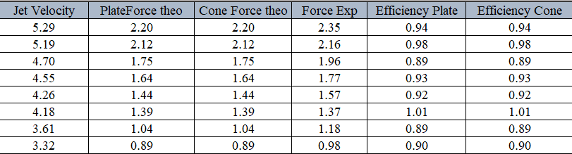
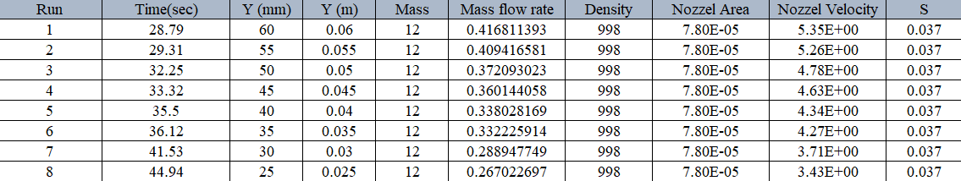
Table (2): Measured and Calculated data, time is seconds, Y: height in mm, mass flow rate, Volumetric flow rate, velocity in m/s, Force in newtons and efficiency in percent (%) for Flat Plate.

Figure (1): Graph of the relationship between experimental and theoretical value of force for flat plate

Figure (2): Graph of the relationship between experimental and theoretical value of force for flat plate

For Hemispherical cup:
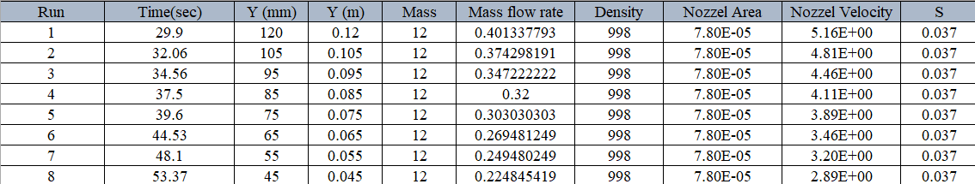
Table (3): Measured and Calculated data, time is seconds, Y: height in mm, mass flow rate, Volumetric flow rate, velocity in m/s, Force in newtons and efficiency in percentage (%) for Hemispherical cup.
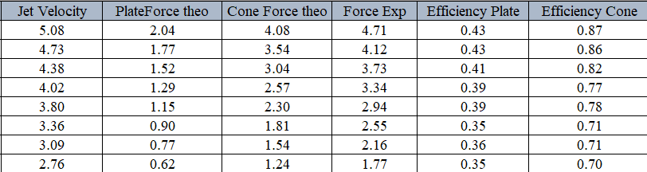

Figure (2): Graph of the relationship between experimental and theoretical value of force for hemispherical cup

Discussion of Results
The purpose of the experiment was to understand the concept of a water jet, obtaining the forces resulted by the impact of water into multiple experimented vanes (which models a vane of a water turbine) and calculating some important parameters such as the efficiency for the experimented vanes by conducting a comparison between the theoretical and experimental values of forces exerted by the jet. The aim of the experiment was achieved, which was reaching a conclusion about the working methodology of a system of water turbine and a comparison between the different vanes type, furthermore the theoretical concepts of newton’s law and momentum equation were observed experimentally in the experiment and through the calculations.
Tables (2) and (3) show the recorded experimental data along with the calculated theoretical, experimental forces and the efficiencies, each table shows the calculated efficiencies for the different type of vanes, the mean value of the efficiency for the hemispherical cup was 94.04%, for the flat plate the calculated mean efficiency was 86.5%, the efficiency somehow indicates the ability of the vane to effectively exert the force of water, a value can be obtained by comparing the theoretical (existing) forces to the exerted force by the vane, as it was expected and due to the geometrical properties of the hemispherical which cause less dissipation of energy due to the pattern of water dispersing , also it can be observed that forces exerted due to the same value of flow is higher for a hemispherical cup than that for the flat plate, which gives advantageous for the hemispherical cup upon the flat plate vane.
Figures (1) and (2) shows a plot for the relationship between the experimental and theoretical value of force, both figures give a gradient close to 1, the data behavior shows that an errors might have occurred in conducting the experiment, such as times recording which was done manually and by observing the bench lever, additionally the jockey weight was required to be calibrated also by naked eyes for each flow changing, for that error might be introduced by mis calibrating the jockey weight.

Conclusion
Obtained efficiencies were 94.04%, 86.5%, for the flat plate and the hemispherical cup respectively.
The experiment studied the effect of a water jet on a plate of two different types, the first one flat plate and the second one hemispherical cup.
When concluding the experiment and preparing the calculation, a difference was noticed for each of the efficiency values for each type of plate.
The hemispherical cup achieves higher efficiencies than the flat plate. This indicates that the losses on the flat plate higher and the direction of water is distributed in all directions, while the hemispherical cup is in one direction only.
The values of efficiencies for flat plate ranged from 34% to 70%, while for hemispherical cup plate it ranged between 65% to 90%. As the efficiency rate does not reach 100% in any system due to some losses within the system itself and because the experiment was carried out practically, which produces some errors such as vibrating the tank of water, incorrect reading of Y values or mismatch in time recording with putting weights on device.
To improve the efficiency values in the experiment, more accurate apparatus and devices should be used, as it helps to take the readings more accurately and easily to avoid any errors and obtain high accuracy.

References
- Fluid mechanics laboratory manual (2022, march).

- White, F. M. (1999, January 1). Fluid Mechanics.

- Zheng, Y., & Liu, Q. (2011). Review of techniques for the mass flow rate measurement of pneumatically conveyed solids. Measurement, 44(4), 589-604.

Appendices

