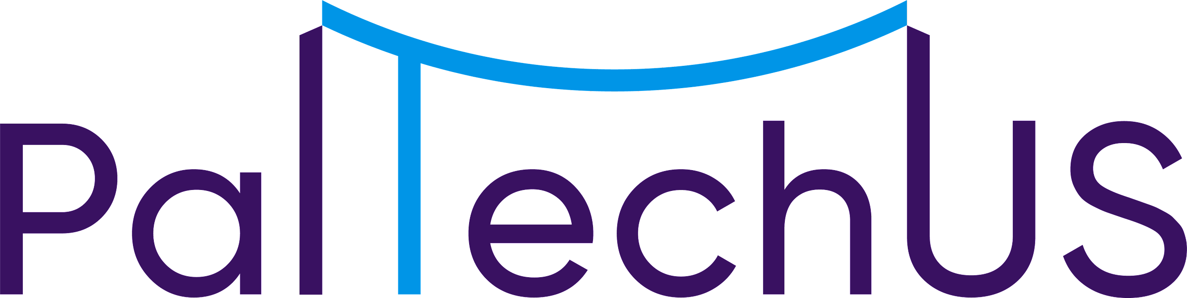

Microsoft Resources Provided to PalTechUS to Share with their Palestinian Universities Partners under Memorandum of Understanding (MOU) Agreements
Resource Name / Hyperlink -Website | Available To | Certification Available at Completion | Additional Notes
Student Certifications | Available to all participating Palestinian Universities students and faculty under a Memorandum Of Understanding (MOU) Agreement with PalTechUS.  A university-provided email address is required to register.  Examples:  name@najah.edu  name@birzeit.edu | Yes, free exam voucher is available once 25 questions are answered on a practice exam.  (Note: voucher expires 60 days after being issued). | Popular Courses:  AZ-900 (Introduction to Azure Fundamentals)  DP-900 (Microsoft Azure Data Fundamentals)  AI-900 (Microsoft Azure Artificial Intelligence (AI) Fundamentals)
Azure for Students Starter Offer | Available to all participating Palestinian Universities students and faculty under MOU Agreement with PalTechUS. | No | Training materials for Microsoft Azure technologies.
Azure for Students | Available to all participating Palestinian Universities students and faculty under MOU Agreement with PalTechUS. | No | Provides $100 of Azure credit that can renewed annually while enrolled in university.
Additional Microsoft Resources for all students /faculty
Microsoft Learn | Available to all participating Palestinian Universities students | No | Includes learning paths and modules.
Architecture Solution using ML - Build a movie recommendation system using machine learning. This is the associated GitHub repository. | Available to all participating Palestinian Universities students | No | Describes a solution that uses Machine Learning (ML) to create recommendations for a movie automatically and at scale. Includes an associated GitHub repository.
Opensource Healthcare Example for FHIR (Fast Healthcare Interoperability Resources) –  (i.e. exchanging health records) | Available to all participating Palestinian Universities students | No. | This repository hosts the general guidance and reference architecture(s) for delivering an Open-Hack focusing on Azure API for FHIR.
Other Open Source projects | Available to all participating Palestinian Universities students | No. | Microsoft engineers and community members maintain thousands of GitHub repository: everything from complete samples to product SDKs, to entire products.

MS Resources for Students – Competitions, Professional Development
Resource Name / Hyperlink -Website | Available To | Certification Available at Completion | Additional Notes
Microsoft Learn | Available to all participating Palestinian Universities students | No | Includes learning paths and modules.
Microsoft Learn Student Ambassadors | Available to all participating Palestinian Universities students | No | The program is for students passionate about technology and advocacy. Applications are reviewed quarterly. It means students will be supported while they build community, make a difference, lead others, learn and share. Students will get access to Microsoft resources and experts to help them on their journey, including exclusive entry into MS global student network.
Imagine Cup | Available to all participating Palestinian Universities students | No | Worldwide competition that challenges students to build a product that improves our world. Registration opens every year in May; competition starts in late September. Participants gain access to technical resources as well as discord channels where they can receive support, mentorship.

MS Resources for Palestinian Universities Professors
Resource Name / Hyperlink -Website | Available To | Certification Available at Completion | Additional Notes
Microsoft Learn for Educators Program | Available to Palestinian Universities Professors | No | Program in which University Professors can teach MS technologies in their classroom.
Microsoft Imagine Academy | Available to Palestinian Universities Professors | Yes | Certification offers and programs for universities.

