Chapter 10 E-business and Enterprise Resource Planning Systems

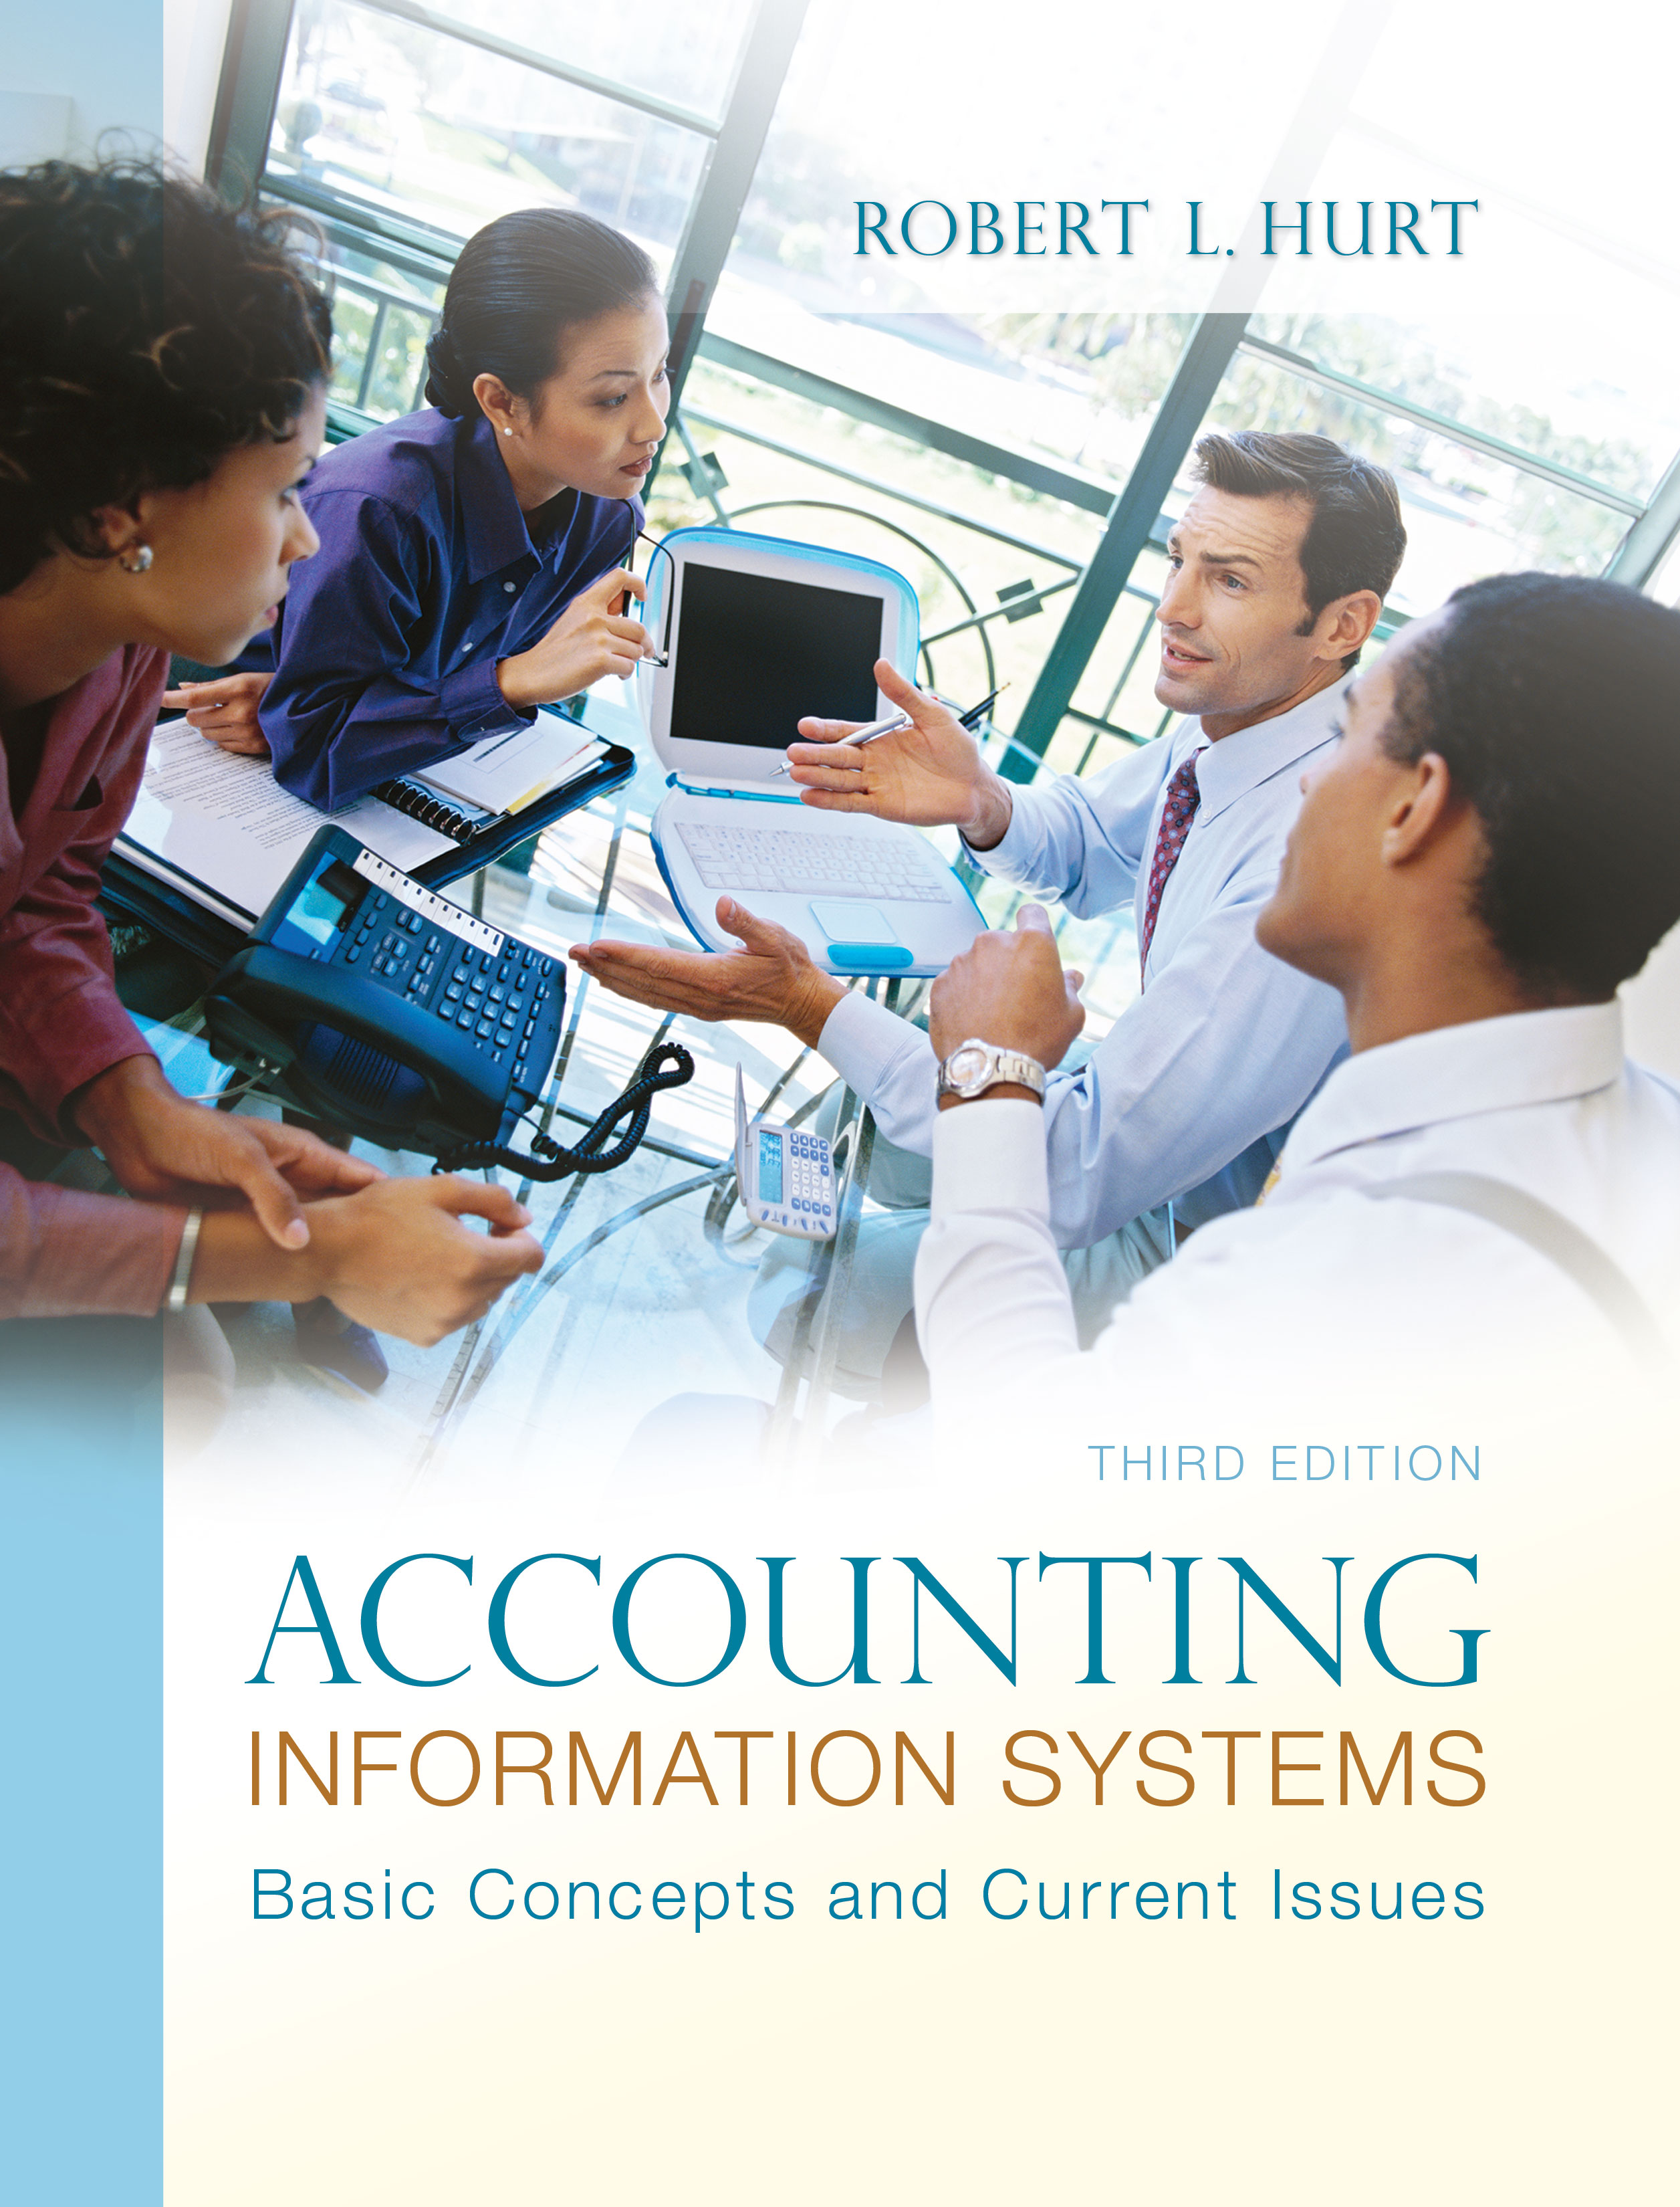
1. Reading review questions

a. What is the distinguishing characteristic of e-business that makes it different from traditional brick-and-mortar businesses? The principal defining feature of e-business is transacting business via some form of computer network.

b. The chapter discusses five basic types of e-business arrangements. Identify and describe each one; give an example of each type other than the example in the chapter. Business-to-business: Inventory suppliers selling goods to Home Depot. Business-to-consumer: Barnes and Noble selling books and related items to individuals. Government-to-business: The City of Los Angeles Business Assistance Virtual Network (http://www.labavn.com/) posts RFPs on its web site. Government-to-consumer: The United States Department of State (http://www.state.gov/) posts travel alerts for US citizens abroad. Consumer-to-consumer: Via Angie’s List, individuals can create and disseminate reviews to potential customers of local businesses.

c. What is an enterprise resource planning system? An ERP system is a sophisticated form of relational database software. Typically organized in modules, an ERP system can provide more integrated information for running a business than separate information systems for the various disciplines.

d. What common problems cause ERP implementations to fail? What can managers do to promote successful ERP implementations? The chapter discusses ten common problems that lead to ERP failure: poor leadership from top management, automating existing redundant processes, unrealistic expectations, poor project management, inadequate education and training, trying to maintain the status quo, bad match between software and processes, inaccurate data, “IT project” view, and significant technical difficulties. Successful implementations can be promoted by: obtaining organizational commitment, communicating strategic goals clearly, viewing the project as an enterprise-wide venture, selecting a compatible system, resolving multi-site issues and ensuring data accuracy.

e..Prepare a response to the questions for this chapter’s “AIS in the Business World.” I was very fortunate to have three assistants available to prepare responses to the AIS in the Business World vignettes for the third edition; I’ve posted their responses on my AIS blog: www.bobhurtais.blogspot.com.

2. Reading review problem

a. How might an HR outsourcing company use e-business to attract new clients? To accomplish its goals for existing clients? An HR outsourcing company could advertise on the Internet, offering lower costs and more efficient completion of HR tasks than keeping HR services “in house.” For existing clients, an HR outsourcing firm could use activity-based costing / activity-based management to keep its costs low; it could also incorporate a secure network where clients could access their HR information.

b. How would an HR outsourcing firm use the four ERP modules discussed in the chapter? The customer relationship management module would be used to track the names and details of companies and their employees that had hired the firm; it might be used, for example, to bill clients on a monthly basis. The outsourcing firm would use the human resource management module to manage its own employees, tracking things like performance reviews and contact information. Supply chain management would cover relationships between the outsourcing firm and its vendors for items like office supplies, information technology and other assets. Financial management would be used to integrate relevant information from the other modules, ultimately leading to the preparation of financial statements and other AIS outputs.

c. Would an HR outsourcing firm be considered an application service provider? Why, or why not? An HR outsourcing firm would be considered an application service provider; it would be considered an Internet ASP if it relied on information technology to provide its services (as most do). An HR outsourcing firm offers its specialized services to customers for a fee.

3. Multiple choice review questions. Answers to all of these questions appear at the end of the textbook itself.

4. Making choices and exercising judgment
The point of these exercises, which appear in every chapter throughout the third edition, is to encourage students to think critically and “outside the box.” Thus, I am not providing solutions to them, as doing so would likely discourage the purpose of these exercises.

5. Field exercises
Answers to these exercises will vary significantly; thus, like the previous set, I am not preparing published solutions for them.

6. Internal controls in e-business
Internal controls appropriate to e-business might also include:
Password rotation. Employees should be required to change their passwords periodically—perhaps every six months.
Password composition. Passwords should be “strong.” They should incorporate upper- and lower-case letters, as well as digits. They should be at least eight digits long, and not comprise words you’d find in a dictionary.
Adequate documentation. Steps for common business processes should be developed with user consultation and documented.
Daily file back-ups. All data should be backed up at the end of each business day on a secure server or other media.
Virus protection. Software should be installed to promote data integrity.

7. Types of computer networks
a. Local-area network: A Local Area Network (LAN) is a computer network covering a small local area, like a home, office, or small group of buildings such as a home, office, or college.
b. Network architecture: In computing, network architecture is the design of a computer network.
c. Network protocol: The set of standard rules for data representation, signaling, authentication, and error detection required to send information over a communications channel.
d. Network topology: A network topology is the pattern of links connecting pairs of nodes of a network.
e. Node: A node is a device that is connected as part of a computer network. Nodes can be computers, personal digital assistants (PDAs), cell phones, or various other network appliances, such as routers, switches, and hubs.
f. Server: In information technology, a server is a computer system that provides services to other computing systems—called clients—over a network. The term is most commonly applied to a complete computer system today, but it is also used occasionally to refer only to the hardware or software portions of such a system
g. Wide-area network: A wide area network or WAN is a computer network covering a wide geographical area, involving a vast array of computers.

8. Forms of e-business
a. Buying materials for professional practice from www.aicpa.org: B2B
b. Electronic reporting of state unemployment taxes: G2B
c. Filing personal income taxes with TaxSlayer.com: B2B and G2C
d. Getting medical advice from www.webmd.com: B2C
e. Making appointments with the Department of Motor Vehicles: G2C
f. Online banking: B2C or B2B
g. Paying traffic citations online: G2C
h. Purchases from Amazon.com: B2C
i. Receiving the online newsletter from the Institute of Management Accountants: B2C
j. Registration for seminars sponsored by the Association of Certified Fraud Examiners: B2C

9. Promoting ERP success

10. Application service providers
a. After needs identification, organizations might:
Write a request for proposal which identifies the purpose of and specifications for potential ASPs.
Select a committee to evaluate the proposals. The committee should include members with backgrounds in information technology and accounting; it should also incorporate the people who will actually be using the ASP.
Develop an objective set of evaluation criteria for the proposals.
Evaluate the proposals using the criteria; select a small number for further consideration.
Arrange interviews and / or demonstrations of the finalists.
Contact clients of the finalists to get their points of view.
Select an ASP.

b. SAS70 statements
i. Not true
ii. True
iii. True
iv. Not true
v. True
vi. True
vii. Not true
viii. True
ix. True
x. True
c. The database would include at least two tables. The first would contain client names and identification information (name, address, phone); it could also include licenses and certifications. The second table would incorporate the primary key from the client table and details about CPE units completed, such as subject, source and number of hours. Internal controls would likely include password protection and backing up files daily.

11. Terminology

1. B
2. J
3. G
4. F
5. E
6. C
7. H
8. D
9. A
10. I

12. Multiple choice questions
1. B
2. A
3. B
4. C
5. C

13. Statement evaluation
a. Sometimes true. E-business doesn’t necessarily lead to higher profit margins.
b. Always true.
c. Sometimes true. It can, but doesn’t necessarily do so in every case.
d. Never true.
e. Always true.
f. Never true.
g. Always true.
h. Always true.
i. Always true.
j. Always true.

14. Prior material application.

a. When an organization implements an ERP system or enters into the e-business arena, it is exposed to a variety of risks. Use the COSO ERM framework discussed in Chapter 4 to design a generic risk management plan for one of those two situations.

ERM plan for a company entering the e-business arena:

Internal environment: Company executives discuss the importance of enterprise risk management, relating it to the proposed e-business venture.

Objective setting: The company sets a goal of increasing its sales from e-business by 10% in the coming year.

Event identification: Price points on merchandise offered might be too high.

Risk assessment: The risk of prices being too high is at least moderate, particularly without sufficient market research.

Risk response: Avoid.

Control activities: Engage in continuous market research on prevailing prices for similar goods and services.

Information and communication: Post the ERM plan on the corporate intranet where it can be accessed by employees only. Send periodic e-mail reminders to look at the plan.

Monitoring: Assign a dedicated group of employees to monitor the plan on a regular schedule and propose modifications to it as necessary.

b. A small bookstore wants to expand its operations to include e-business. Use the generalized model of business process management discussed in Chapter 4 to develop a plan for doing so.

Generic step | Bookstore example
1. Select the process and define its boundaries. | The bookstore could initially focus on the process of buying inventory from vendors.
2. Observe, document and map the process steps and flow. | Develop a systems flowchart of the current inventory purchase process.
3. Collect process-related data. | Collected data could include: transaction processing times, cost per transaction (other than the inventory itself), employee satisfaction with the current process.
4. Analyze the collected data. | Graph the time and cost data to see trends more clearly; summarize the results of employee satisfaction surveys. Determine if the expansion into e-business is justified.
5. Identify and prioritize potential process improvements. | Develop a list of specific ways to move the inventory purchase process into e-business. Consider, for example, if initial forays should focus on a subset of vendors / inventory.
6. Optimize the process. | Design the new process; develop a new systems flowchart or other form of systems documentation.
7. Implement and monitor process improvements. | Pilot test the new system; continue monitoring the data collected and analyzed in Steps 3 and 4. Make appropriate changes and expand the system as necessary.

c. A business plan is essential for starting an e-business venture. Do some research on how to develop a business plan; you might start by consulting www.sba.gov or by asking a strategy / entrepreneurship professor at your university. Document the steps for developing a business plan using one of the formats discussed in Part Two of the book.

