

Faculty of Engineering and Technology

Electrical and Computer Engineering

Department

ENEE3102

Electronics Laboratory

Prelab Exp #3

The Transistor Biasing and the DC Parameters

Student name :Dalal Bawatneh (1170329)

**Part 1:**

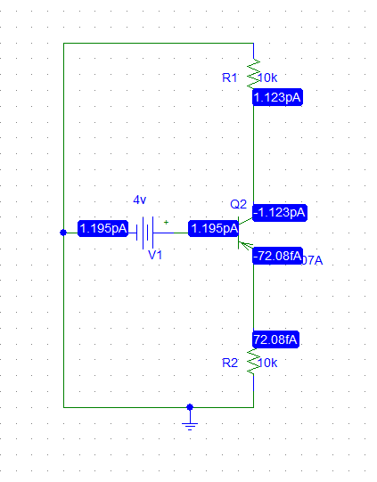**For pnp:**

**1**

**Forward**

**Reversed**

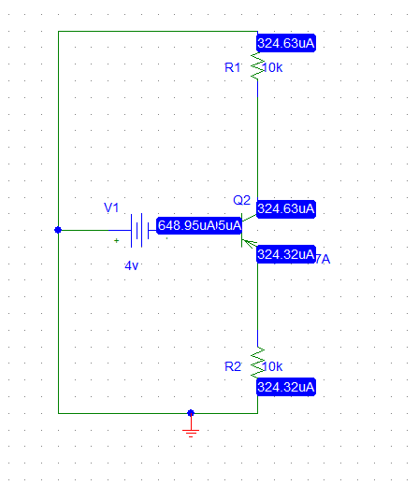

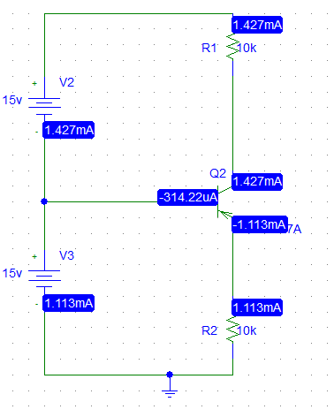**2- forword**

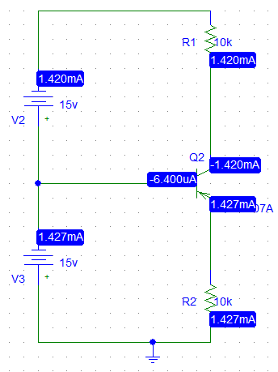

**Reversed**

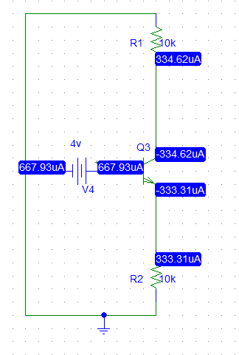 **For npn**

1. **Forward**

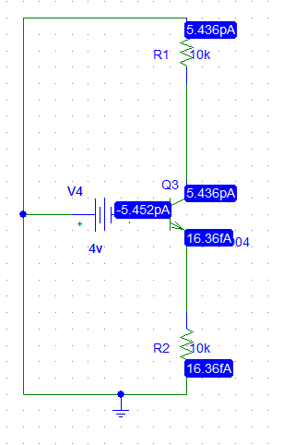**Reversed**

**2-**

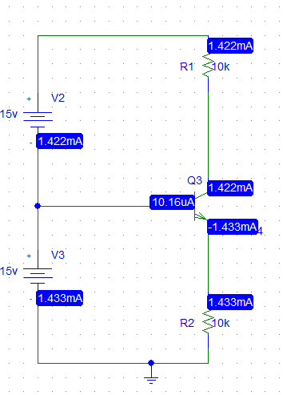

**Forward**

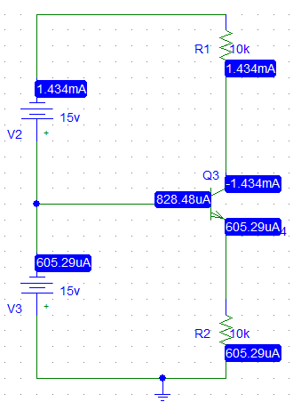**Reversed**

**Part 2:**

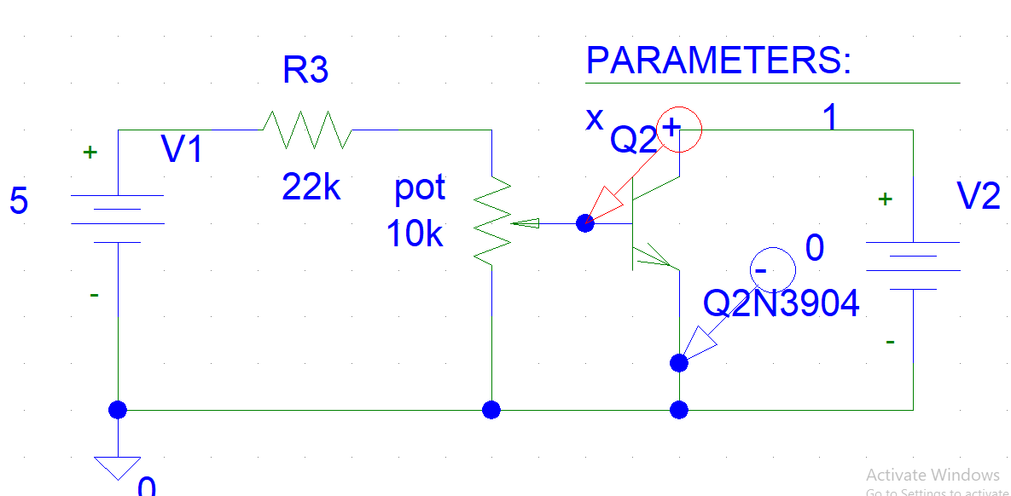





|  |  |  |
| --- | --- | --- |
| VCE | IB(micro A) | VBE(V) |
| 0 | 0 | 0.389 |
| 0 | 5 | .488 |
| 0 | 10 | 0.51 |
| 0 | 15 | 0.533 |
| 0.2 | 0 | 0.468 |
| 0.2 | 5 | 0.632 |
| 0.2 | 10 | 0.650 |
| 0.2 | 15 | 0.671 |
| 0.4 | 0 | 0.468 |
| 0.4 | 5 | 0.641 |
| 0.4 | 10 | 0.653 |
| 0.4 | 15 | 0.678 |

**B:Forward Current Transfer Characteristic:**

|  |  |  |
| --- | --- | --- |
| VCE(VOLT) | IB(MICRO | IC(m) |
| 2.5 | 0 | -25 |
| 2.5 | 0.5 | 0.286 |
| 2.5 | 2 | 0.303 |
| 2.5 | 5 | 0.24 |
| 2.5 | 15 | 0.3 |
| 5 | 0 | -5.204 |
| 5 | 0.2 | 0.662 |
| 5 | 2 | 0.688 |
| 5 | 5 | 0.715 |
| 5 | 15 | 0.7 |
| 10 | 0 | -14 |
| 10 | 0.5 | 2.26 |
| 10 | 2 | 2.3 |
| 10 | 5 | 2.37 |
| 10 | 15 | 2.6 |

**C: Reverse Voltage Characteristic:**

|  |  |  |
| --- | --- | --- |
| IB(MICRO | VCE(VOLT) | VBE(V) |
| 2.5 | 0 | 0.475 |
| 2.5 | 0.5 | 0.623 |
| 2.5 | 2 | 0.614 |
| 2.5 | 5 | 0.625 |
| 2.5 | 15 | 0.623 |
| 5 | 0 | 0.487 |
| 5 | 0.5 | 0.632 |
| 5 | 2 | 0.629 |
| 5 | 5 | 0.633 |
| 5 | 15 | 0.634 |
| 15 | 0 | 0.538 |
| 15 | 0.5 | 0.673 |
| 15 | 2 | 0.677 |
| 15 | 5 | 0.675 |
| 15 | 15 | 0.676 |