Chapter 01 Role and Purpose of Accounting Information Systems

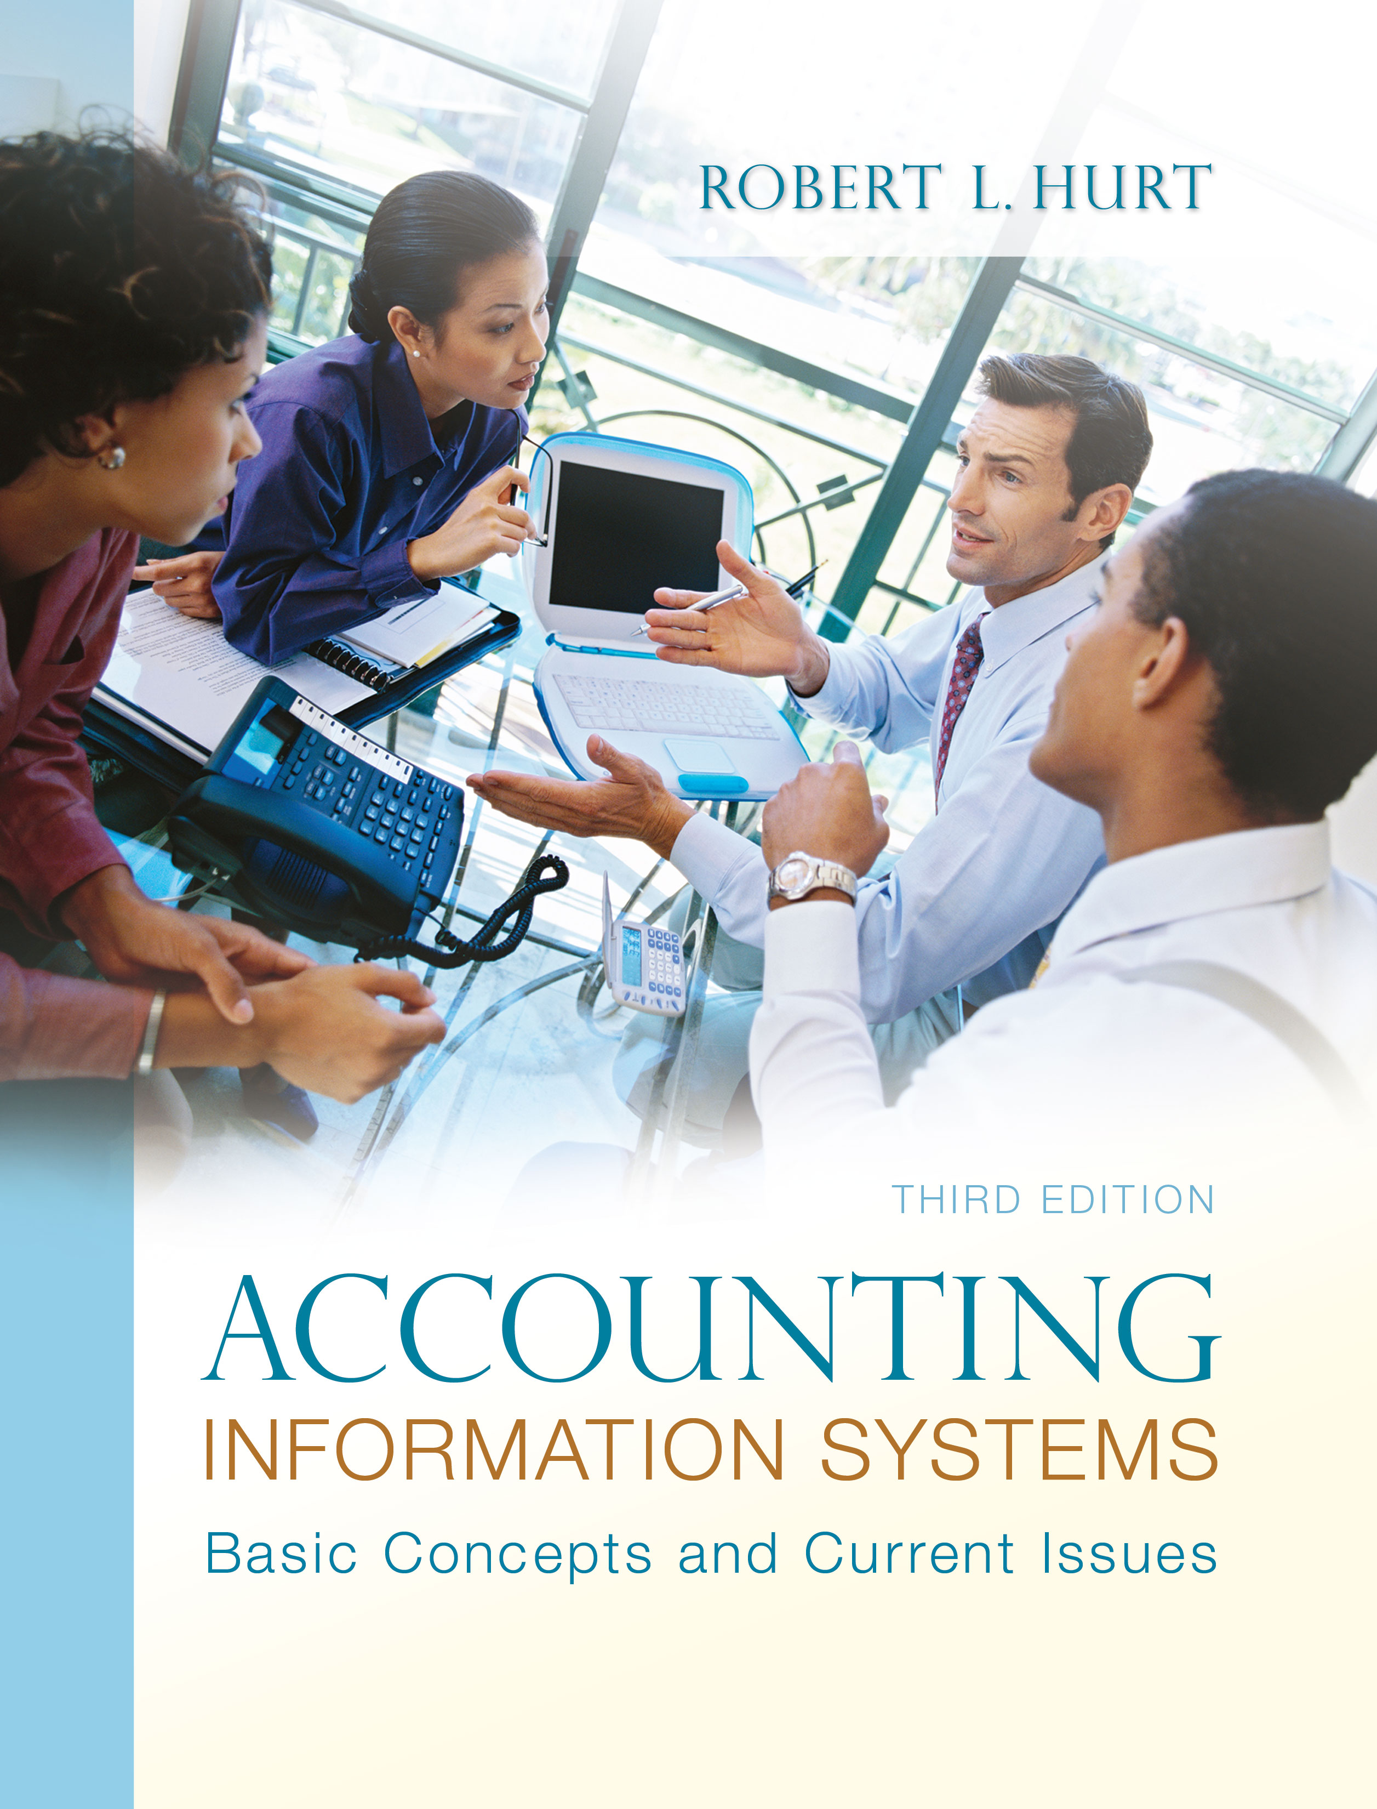
1. Reading review questions

a. What is an accounting information system? An accounting information system, like all systems, is a collection of inter-related parts designed to achieve a specific goal. In the case of AIS, that goal is to prepare information for decision making.

b. Describe the purpose of the FASB conceptual framework. Discuss how it relates to your study of accounting information systems. The FASB conceptual framework was published in 1977; its intended purpose was to provide some guidance for the development of future accounting principles. The framework relates to the study of AIS in many ways, including identifying the elements of financial statements tracked by the AIS and specifying the characteristics information should have to make it useful for decisions.

c. List and discuss the five parts of a generic accounting information system. The five generic parts of the AIS are: inputs (such as source documents), processing (such as with general ledger software), outputs (such as the general purpose financial statements), storage (such as in master and transaction files) and internal control (such as separation of duties).

d. Compare and contrast sponsored information, practitioner/public information, and scholarly information. All three types of information can, under the right circumstances, be useful. Sponsored information is a lot like advertising; someone has paid a fee to have the information disseminated. Practitioner information focuses on the application of ideas to some specific case, such as a journal article that explains how a company estimates bad debts. Scholarly information meets much more rigorous standards for peer review, generalizability and research design.

e. Identify five broad criteria you can use to evaluate information on the Internet and in other sources. The University of Maryland University College offered five criteria for information evaluation. They are: authority, accuracy, objectivity, currency and coverage.

f. In a manner specified by your instructor (e.g., individually or with a group, as a written paper or as an oral presentation), prepare an original response to one or more of the questions for this chapter’s “AIS in the Business World.” I was very fortunate to have three assistants available to prepare responses to the AIS in the Business World vignettes for the third edition; I’ve posted their responses on my AIS blog: www.bobhurtais.blogspot.com.

2. Multiple choice review questions. Answers to all of these questions appear at the end of the textbook itself.

3. Reading review problem

a. Does Dairy Queen need an accounting information system? Why, or why not? All organizations need some form of AIS to capture data and transform it into information that will be useful for decisions. The sophistication and technical aspects of the system may vary across organizations.

b. Suggest one example of each generic AIS element within the context of Dairy Queen. Inputs for Dairy Queen’s AIS could include receiving reports for raw materials and receipts for bank deposits. Processing tools include cash registers and general ledger software, while outputs would include the general purpose financial statements and reports from an individual restaurant to the corporate office. Storage elements Dairy Queen might incorporate include sales transaction files and vendor master files. Internal controls could include the use of cash registers for transaction processing, as well as using standardized recipes to avoid wasting material.

c. How might this case be incorporated in other accounting courses, such as financial accounting, cost accounting and taxation? A generic case for a company like Dairy Queen could be incorporated in many other accounting courses. In financial accounting, the case might focus on how to record common transactions in Dairy Queen’s AIS; it could also be a vehicle for analyzing the company’s financial statements. Cost accounting aspects of the case would include the use of direct material and direct labor standards for preparing menu items, as well as potential applications of activity-based costing. A taxation course might look at the corporate income tax filings and related documents, then recommending tax planning ideas to management.

4. Making choices and exercising judgment
The point of these exercises, which appear in every chapter throughout the third edition, is to encourage students to think critically and “outside the box.” Thus, I am not providing solutions to them, as doing so would likely discourage the purpose of these exercises.

5. Field exercises
Answers to these exercises will vary significantly; thus, like the previous set, I am not preparing published solutions for them.

6. Information types

a. scholarly
b. popular / practitioner
c. popular / practitioner
d. scholarly
e. scholarly
f. popular / practitioner
g. popular / practitioner
h. sponsored
i. sponsored
j. sponsored

7. Other than those listed in Question 5, find one or two examples (each) of sponsored, practitioner, and scholarly Web sites, journals, or other periodicals. Be prepared to explain your choices and their classifications.
Sponsored: The web site for Hewlett-Packard (www.hp.com) is an example of sponsored information; its main purpose is to sell HP products and services.

Popular / practitioner: The Wall Street Journal (online.wsj.com) is an example of this type of information. It is designed primarily for people in business.

Scholarly: Issues in Accounting Education is an example of a scholarly journal; its articles are typically written by professors, for professors. (If your school’s library has access to Cabell’s Directories of Publishing Opportunities, you might consider using it to identify scholarly journals.)

8. Look up the following references online or in your school’s library. Using the criteria and specific questions from the UMUC Web site referenced in the chapter, evaluate and discuss the quality of each reference. (Note: I found all these articles through ABI Inform; many of them may also be accessible on the publications’ own web sites. I’m analyzing the first article in the list to demonstrate how to use the UMUC criteria.)

“Xelltec Reports Laptop Security Microchip.” Wireless News, 25 February 2011.

Authority: This brief article is very weak in terms of authority, as its author is listed as “anonymous.” Presumably, the article was written by someone at Xelltec.

Accuracy: The article appears to have no major errors of fact; however, it does not provide much in the way of facts since its main purpose appears to be publicity for the security microchip.

Objectivity: This article’s main purpose is to advertise the security microchip; thus, it is not very objective. Note the last sentence, which states that the company is in the business of selling security devices.

Currency: The article was published in February 2011. Thus, its information is fairly current.

Coverage: As far as it goes, this article does an OK job of coverage. However, in the broader sense, its coverage is inadequate, since it does not compare the company’s security microchip to other forms of IT security.

9. Terminology
1. E
2. C
3. G
4. F
5. D
6. H
7. B
8. A
9. J
10. I

10. Multiple choice questions
1. A
2. C
3. B
4. B
5. C

11. Statement evaluation
a. sometimes true. Data can be stored either electronically, on paper or both. When data are stored electronically, they might be stored on a disk, on a flash drive, on a network or in some other medium.

b. never true

c. always true

d. sometimes true. If information found on the Internet meets established criteria, such as those suggested by UMUC, it can be very reliable.

e. always true

f. always true

g. sometimes true. Whether internal and external users can use the information depends on a number of factors, including the type of information and the sophistication / background of the users themselves.

h. never true

i. sometimes true. Source documents can be paper-based; they can also be, and increasingly are, electronic.

j. sometimes true. Some questions in AIS have a single correct answer, such as “what is the journal entry to record the purchase of inventory on account in a perpetual system.” On the other hand, many questions in AIS have more than one good answer, such as when someone evaluates the suitability of information.

12. Blog exercise
Learning objective: “Explain the structure of most accounting information systems.”

Knowledge: List the five generic parts of most accounting information systems.

Comprehension: Consider a well-established business like Barnes and Noble bookstores. Give one example of each generic AIS element that Barnes and Noble would use.

Application: The accounting information system has five generic elements, one of which is internal control. Suggest three internal controls you would recommend for a Barnes and Noble retail store.

Analysis: A specific internal control can relate to one or more of the other four AIS elements; for example, backing up data files relates to both storage and processing. How would the following internal controls relate to the other generic AIS elements: bank reconciliation, procedures manual, data encryption.

Synthesis: Consider the following items that might be part of an accounting information system: sales invoice, receiving report, making journal entries, receiving previously purchased inventory, statement of cash flows, accounts payable aging, customer master file, sales transaction file, password rotation requirements, company e-mail policy. Group them based on the five generic elements of the AIS.

