Pre lab experiment 10

Lab basic

Omar Nazal

1200629

Eng; Shadi Banouhra

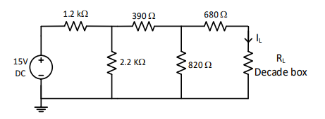



The maximun power at r= 1.2kΩ

2- 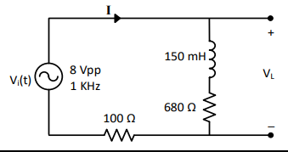



Phase shift = (1.3938-1.2500)\*10^-3 \*f\*360= 51.7 0



Irms= 2.3ma

\



Vrms= 2.69v

p= I v cos theta = 3.854mw

Q new= p tan(0)

Q old= p tab theta

Qnew – Qold= p tan0- p tan theta old

Delta Q = -xc\*v^2

C= 0.1 uf



In phase after adding capacitor 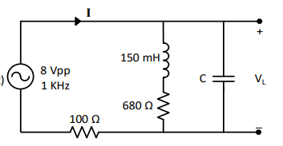

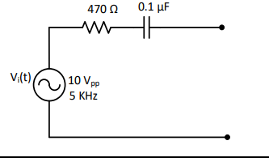

3 - 

I=3.75mA

P=i^2 r = 6.6mw