

Faculty of Engineering and Technology

Electrical and Computer Engineering Department

**Electronics Laboratory (ENEE3102)**

**Final lab**

**Operational Amplifier**

***Name:Huthifa quzmar # ID :1172092***

***Instructor: Mohammad Jehad Al Ju'Beh TA: Eng. Amjad Z Sha'lan***

***Section: 2***

# Abstract

**The aim of this experiment is to study and investigate the application of The**

**Operational Amplifier circuits such as adding, Voltage follower, Comparator, Integrator and Differentiator**

# Theory

❖ **The Operational Amplifier**

**The primary use of the operational amplifier is as signal amplifier. By using feedback, operational amplifiers can be designed to have a wide range of gains. The op-amp draws very little current into its inputs. This means that the input impedance looking into the inverting and the non-inverting inputs is very large. The open-loop gain is also very large. Assuming the openloop gain is infinity, we can show that the voltages at the inverting and the non-inverting terminals should be approximately the same (potential) at all the times. Because of this, we say that the two terminals “track” each other. Based on these assumptions, a simple procedure for op-amp analysis can be formed and we have a lot of applications as:**

###### **• Adding Application**

**In a great many practical applications the input to the inverting amplifier is more than one voltage. The simplest form of multiple inputs is shown in figure 1**

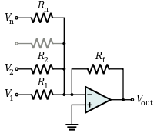

**Figure1. Op-amp Voltage Adding Circuit**

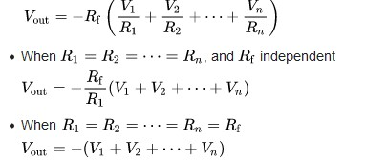

###### **• Voltage Follower Application**

**Used as a buffer amplifier to eliminate loading effects, and Vin = Vout. The circuit is shown in figure 2**

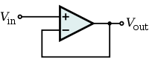

**Figure2. Op-amp Voltage Follower Circuit**

###### **• Comparator Application**

**The Op-amp comparator compares one analogue voltage level with another analogue voltage level, or some preset reference voltage, VREF and produces an output signal based on this voltage comparison. In other words, the op-amp voltage comparator compares the magnitudes of two voltage inputs and determines which is the largest of the two. In the figure 3 shown the circuit and result**

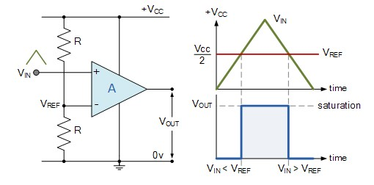

**Figure3. Op-amp Comparator Circuit and result**

###### **• Comparator with Hysteresis Application**

**For the inverting comparator circuit above, VIN is applied to the inverting input of the op-amp. Resistors R1 and R2 form a voltage divider network across the comparator providing the positive feedback with part of the output voltage appearing at the noninverting input. The amount of feedback is determined by the resistive ratio of the two resistors used. In the figure 6 shown the circuit and result**

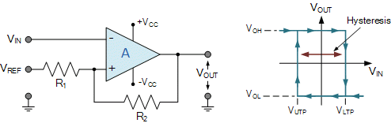

**Figure6. Op-amp Comparator with Hysteresis Circuit and result**

###### **• Active Clipping Application:**

**The Clipper, is a wave shaping circuit that takes an input waveform and clips or cuts off its top half, bottom half or both halves together. Active Clipping circuit as shown Figure 7**

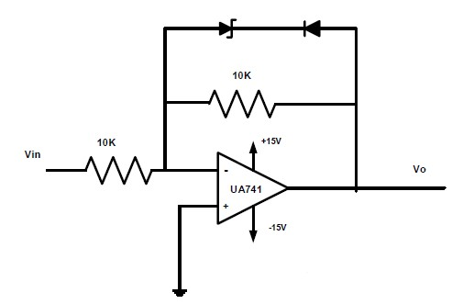

**Figure7. Active Clipping Circuit**

# Procedure & Data analysis

##### I. Adding Application

1. Set up the circuit of Figure 8, V1 is controlled by the potentiometer and V2, is obtained from the variable dc source on the trainer.

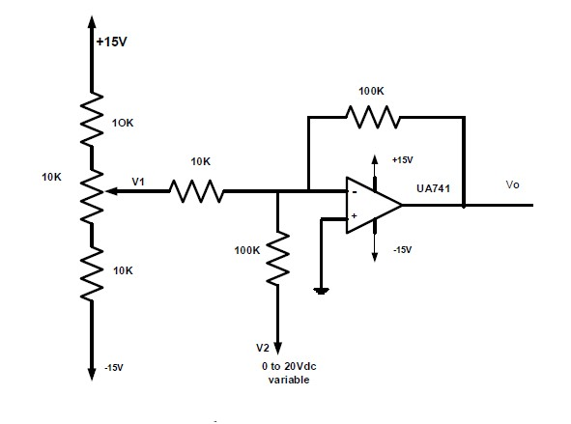

Figure8. Op-amp Voltage Adding Circuit

1. Measure the output voltage for V1, V2 as shown in table.1.
2. Calculate the expected output voltage for each step using the formula :

Vo =XV1 + YV2 where X, Y is the resistors ratios.

X = -100k/10k = -10 , Y = -100k/100k = 1

• Vo = -(10 V1 + V2 )

|  |  |  |  |
| --- | --- | --- | --- |
| Input voltage | |  | Output voltage |
| V1 | V2 | V0 | Calculated voltage |
| 0.5 | 2 | -7.03 | -7 |
| 0.1 | 6 | -6.99 | -7 |
| 0.3 | 4 | -7.00 | -7 |
| -0.9 | 2 | 6.98 | 7 |
| -1.1 | 4 | 7.01 | 7 |
| -1.5 | 6 | 8.98 | 9 |

Table.1

The expected output voltage is approximately equal to the output voltage

#### II. Voltage Follower Application

1. Set up the circuit of Figure 9

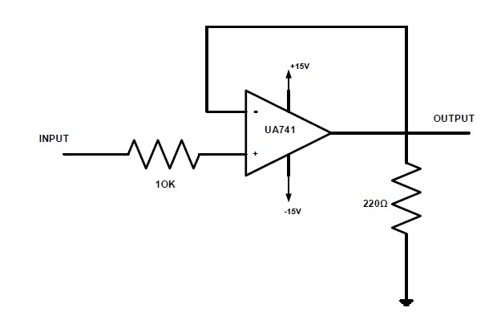 Figure9. Op-amp Voltage Follower Circuit

1. Measure and records Vo for Vi (2V, 3V,and 4V).

|  |  |  |  |
| --- | --- | --- | --- |
| Vin | 2 | 3 | 4 |
| Vout | 1.98 | 3.95 | 4.8 |

1. Draw the output Vo(t) for Vi(t) is 5.2V p-p sinusoidal with 1.126kHz.

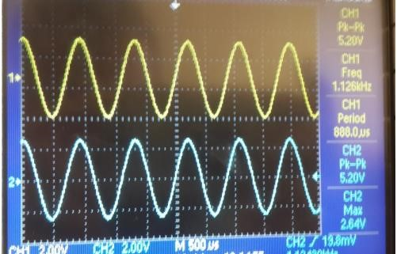

The emitter follower circuit configuration acts as a buffer, presenting high impedance to the circuit that is driving it, while offering a lower impedance output.

* What is the relation between your Vi, Vo?

Vi = Vo

### III. Comparator Application

1. Set up the circuit of Figure10

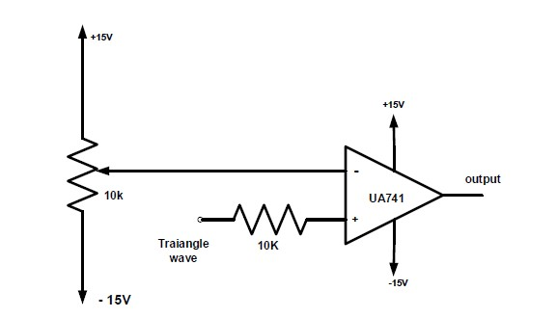

Figure10. Op-amp Comparator 2. Use 1 kHz triangular input signal from the function generator.

1. Set the triangle input signal to 4 Vp-p and change the dc reference voltage so that you obtain an output of positive Vsat then negative Vsat and a square wave output.
2. For each of these cases draw the output voltage and record the value of the dc reference voltage.

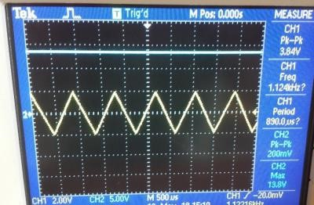

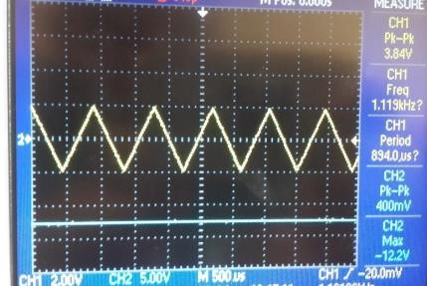

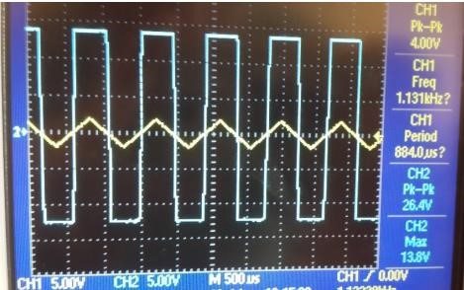

### 

***V. Comparator with Hysteresis Application***

1. Connect the Schmitt trigger circuit shown in Figure13

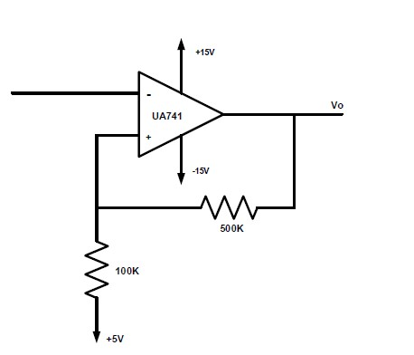

Figure13. Op-amp Comparator with Hysteresis

1. Put Vi (t) = 15Vp-p sine wave of frequency 1.12 kHz.
2. Sketch the output voltage with respect to Vi (t).

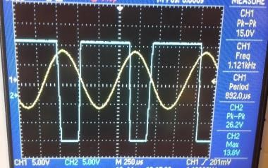

1. Indicate the levels of Vi (t) where Vo (t) changes its level. Vo (t) changes When Vut = 6.6 V and VLT=2 V

.

# Conclusion

To conclude , the experiment was excellent , all parts was done and the experiment run , and understand study and investigate the application of The Operational Amplifier circuits such as adding, Voltage follower, Comparator, Integrator and

Differentiator

### References

Electrical and computer engineering department, Electronics lab manual.

Dr.Mohammad Jihad Al-Juba Lecture Notes**.**