

Faculty of Engineering and Technology

Electrical and Computer Engineering Department

ENEE2102

Circuit Laboratory

Pre Lab Experiment # 3

**Simple Resistive Circuits**

Prepared by:

**Tamara Amro 1172771**

Supervised by: **Dr.Jasser Sa’ed**

Teacher assistance: **Ahmad Zahran**

**April 2021**

**Table of Contents**

**Abstract3**

**Theory 3**

**Part 1: The Kirchhoff’s Laws ……………………..…………………………………………3**

**Part 2: The voltage & Current divider rule…………………………………..…………….4**

**Part 3: Short & Open circuit ......……………………………………………………………6**

**Data ……………………………………………………………………………………………....7**

**Procedure &Calculation ………………………………………………………………………8**

**Conclusion**1**5**

**References** …………..………………………………………………………………………………………………………………….16

**Abstract:**

**The Aims of this experiment to verify the Kirchhoff’s Voltage Law (KVL), Kirchhoff’s Current Law (KCL), that the elements connected in series have the same current and the elements connected in parallel have the same voltage and to derive the voltage and current divider rule .Also to study effects of short and open circuit resistor in electrical circuits.**

**Theory:**

**Part 1:**

**Kirchhoff's circuit laws are two**[**equalities**](https://en.wikipedia.org/wiki/Equality_(mathematics))**that deal with the**[**current**](https://en.wikipedia.org/wiki/Electric_current)**and**[**potential difference**](https://en.wikipedia.org/wiki/Potential_difference)**.**

**The Kirchhoff's circuit laws:**

1. **The Kirchhoff’s Voltage Law (KVL): states that the directed sum of the**[**potential differences**](https://en.wikipedia.org/wiki/Potential_difference)**(voltages) around any closed loop is zero.**

$$\sum_{i=1}^{n}{V_{i}}=0$$

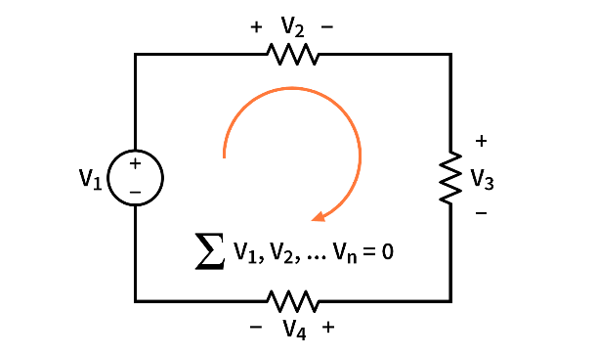

1. **Kirchhoff’s Current Law (KCL): states that the algebraic sum of currents in a network of conductors meeting at a point is zero.**

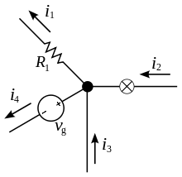

$$\sum_{i=0}^{n}{I_{i}}=0$$

**Part 2:**

* **The voltage divider rule: is a**[**passive**](https://en.wikipedia.org/wiki/Passive_circuit)[**linear circuit**](https://en.wikipedia.org/wiki/Linear_circuit)**[1] that produces an output**[**voltage**](https://en.wikipedia.org/wiki/Voltage)**($V_{out}$) that is a fraction of its input voltage ($V_{in}$). According to this circuit:**

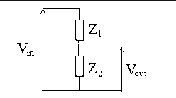

**Where: Z is passive component.1**

**Current in series is equal =I**

**According to the Kirchhoff’s Voltage Law (KVL):**

$$\sum_{i=1}^{n}{V_{i}}=0$$

**According to Ohm’s Law[2]:**

**So:**

**……. (1)**

**…….. (2)**

**Where: I Z2=Vout …… (3)**

**By substituting eq (2) in eq(3):**

$\frac{V_{in}}{Z_{1}+Z_{2}}Z_{2}=V_{out}$**(Voltage divider rule)**

**The voltage V1 about Z1:**

* **The current divider rule:** **is a simple**[**linear circuit**](https://en.wikipedia.org/wiki/Linear_circuit)**that produces an output**[**current**](https://en.wikipedia.org/wiki/Electric_current)**(IR2) that is a fraction of its input current (IT).**

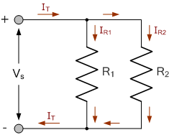

**According to the Kirchhoff’s current Law (KCL):**

$$\sum_{i=0}^{n}{I_{i}}=0$$

$$I_{T}=I_{R1}+I_{R2}$$

**Where: Voltage in parallel is equal = Vs**

**According to Ohm’s Law: $I=\frac{V}{R}$ $I_{T}=I_{R1}+I_{R2}$…..(1)**

**So: $$I_{T}=\frac{V_{s}}{R_{eq}}$$**

**Where $R_{eq}=\frac{R_{1}R_{2}}{R_{1}+R_{2}}$**

$I_{T}=\frac{V_{s}(R_{1}+R_{2})}{R_{1}R_{2}}$**…… (2)**

**According to equation (1):**

$I_{T}-I_{R1}=I_{R2}$**, $I_{R1}=\frac{V_{s}}{R_{1}}$**

**By substitute equation (2) in (1):**

$$\frac{V_{s}(R_{1}+R_{2})}{R_{1}R_{2}}-\frac{V_{s}}{R_{1}}=I_{R2}$$

**So:**

$\frac{V_{s}R_{1}}{R_{1}R_{2}}=I_{R2}$**(Current divider rule)**

**By using the same method to find IR1:**

**Part 3:**

**Short circuit implies that the two terminals are externally connected with resistance R=0, the same as an ideal wire. This means there is zero voltage difference for any current value.**

**Open circuit** **implies that the two terminals are points are externally disconnected, which is equivalent to a resistance R=∞. This means that zero current can flow between the two terminals, regardless of any voltage difference.**

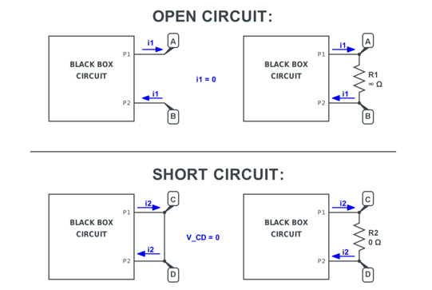

**Data:**

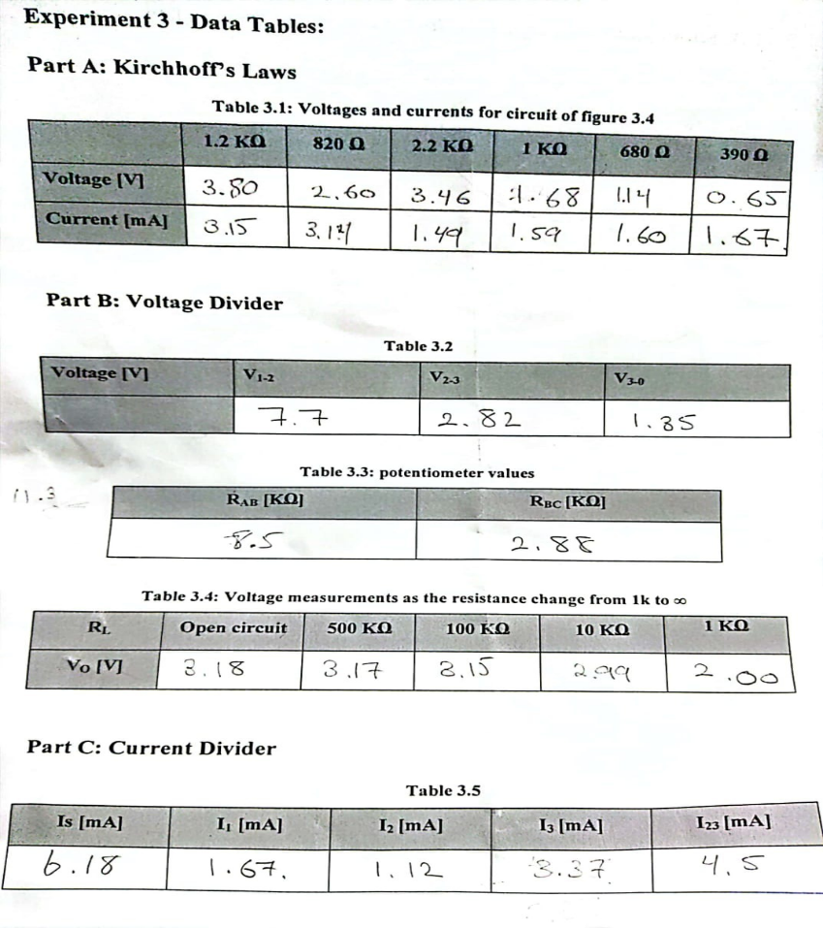

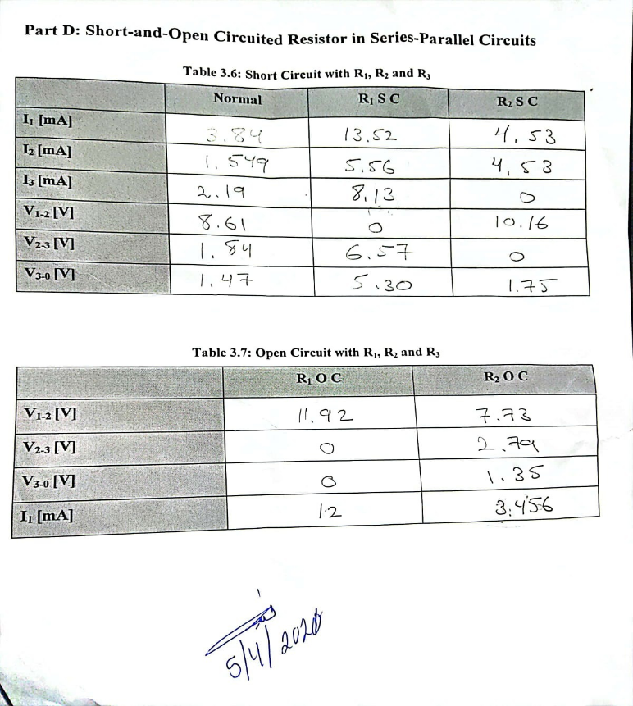

**Procedure &Calculation:**

**A power supply, a digital multimeter, and a variety of resistors were used.**

**1) Kirchhoff’s laws:**

**The circuit in figure (1) was connected,** **and the power supply was set to 10 V.   
Then, the voltage on each resistor was measured relative to the ground and the current in each branch was measured.**

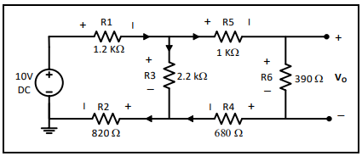

Figure 1

**The results appear in this table:**

|  |  |  |  |  |  |  |
| --- | --- | --- | --- | --- | --- | --- |
|  | 1.2KΩ | 820Ω | 2.2KΩ | 1kΩ | 680Ω | 390Ω |
| Voltage (V) | **3.80** | **2.60** | **3.46** | **1.68** | **1.14** | **0.65** |
| Current (mA) | **3.15** | **3.14** | **1.49** | **1.59** | **1.60** | **1.67** |

**The theoretical values:**

|  |  |  |  |  |  |  |
| --- | --- | --- | --- | --- | --- | --- |
|  | 1.2KΩ | 820Ω | 2.2KΩ | 1kΩ | 680Ω | 390Ω |
| Voltage (V) | **3.888** | **2.657** | **3.455** | **1.669** | **1.135** | **0.651** |
| Current (mA) | **3.240** | **3.240** | **1.571** | **1.669** | **1.669** | **1.669** |

**\*\*There is some difference between theoretical and experimental values because there is some errors in digital multimeter.**

**Q1) Using measured values of I and Verify KCL on upper middle node, verify KVL on the left loop:**

**KCL : I (at 1k)+I (at 2.2K)=I(1.2K)**

**(1.59+1.46)mA=3.08mA it is near from experimentally 3.15mA**

**KVL at left loop: 1*(1.59)+390*(1.67*10-3)+680*(1.60*10-3)-2.2*(1.49)=0.0513**

**So it is satisfy**

**2) Voltage divider:**

* **The circuit in figure (2-a) was connected, and the power supply was set to 12V.**

**V1-2, V2-3 and V3-0 were measured relative to the ground** 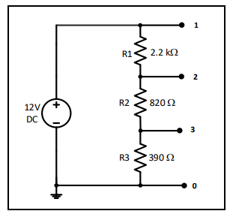

Figure 2-a

**The experimentally measurement:**

|  |  |  |  |
| --- | --- | --- | --- |
| Voltage (V) | V1-2 | V2-3 | V3-0 |
|  | **7.7** | **2.82** | **1.85** |

**The theoretical Measurement:**

|  |  |  |  |
| --- | --- | --- | --- |
| Voltage (V) | V1-2 | V2-3 | V3-0 |
|  | **7.742** | **2.886** | **1.372** |

** **There some errors come from wires and Devices**

**Q2) from measured values, around which resistor did the largest and smallest voltage drop occurred? Explain why?**

**The resister whose value equals 2.2K has the largest voltage drop around it and the resister whose value equals 390 ohm has the smallest drop voltage around it since the voltage drop depends on the current passes through the resister and its resistivity, but the current is equal for the both resisters (series connected) the voltage drop depends only in the value of the resistor.**

**Q3) Using measured values of V, verify V1-2 , V2-3 , V3-0 =12V**

**\*\*7.7+2.82+1.85=12.37 (There is some error from device and wires)**

* **The circuit shown in the figure (2-b) was connected and the Vin was set at 12V, after that we changed the POT.TILL until V0= 3V, and we measured Rab, Rbc.**

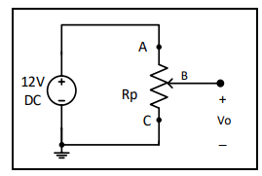

Figure 2-b

**The results appear in this table:**

|  |  |
| --- | --- |
| RAB(KΩ) | RBC(KΩ) |
| 7.5 | **2.88** |

**The Theoretical values:**

|  |  |
| --- | --- |
| RAB(KΩ) | RBC(KΩ) |
| 7.5 | **2.5** |

**\*\*There is some error from ohm meter**

* **The circuit shown in the figure (2-c) was connected and the Vin was set at 12V, after that we measured different values of V0 for Rl= 1k, 10k, 100k, 500k and ∞ (open circuit).**

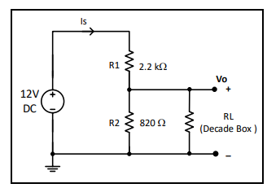

Figure 2-c

**The experimentally measurement:**

|  |  |  |  |  |  |
| --- | --- | --- | --- | --- | --- |
| RL | Open circuit | 500KΩ | 100KΩ | 10KΩ | 1KΩ |
| V0 (V) | **3.18** | **3.17** | **3.15** | **2.99** | **2.00** |

**The Theoretical values (from pspise)**

|  |  |  |  |  |  |
| --- | --- | --- | --- | --- | --- |
| RL | Open circuit | 500KΩ | 100KΩ | 10KΩ | 1KΩ |
| V0 (V) | **3.18** | **3.2455** | **3.2390** | **3.0760** | **2.0398** |

**\*\*There is some difference between them**

**Q4) Using measured values, plot V0 vs RL. Explain the change V0 as RL is changed:**

**When the value of Rl is variable the voltage across it is increase, so the value of voltage is almost constant.**

**3) Current divider:**

**The circuit shown in the figure.3 was connected and the Vin was set at 15V, after that we measured Is, I1, I2, I23, I3 and V0, V1.**

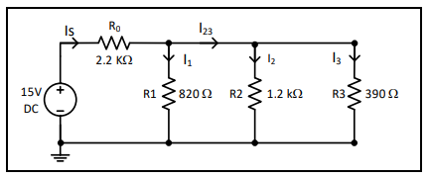

Figure 3

**The results appear in this table:**

|  |  |  |  |  |
| --- | --- | --- | --- | --- |
| Is (mA) | I1(mA) | I2(mA) | I3(mA) | I23(mA) |
| 6.18 | **1.67** | **1.12** | **3.37** | **4.5** |

**The Theoretical values (from pspise):**

|  |  |  |  |  |
| --- | --- | --- | --- | --- |
| Is (mA) | I1(mA) | I2(mA) | I3(mA) | I23(mA) |
| 6.207 | **1.640** | **1.120** | **3.447** | **4.567** |

**\*\* The Theoretical & Experimentally nearly the same**

**Q5) from measured values of I, through which resistor did the largest and smallest current passed? Explain why?**

**The lowest current passes through the largest resistor which is connected in parallel which is the 1.2k ohms. In other hand, the largest current is the current passes through 2.2k since it doesn’t distribute (before the node).**

**Q6) Using measured values of I, Verify that Is=I1+I2+I3:**

**Is=1.67+1.12+3.37=6.16mA it is near from experiment value=6.207mA**

**4) Short and Open Circuited Resistor in series-parallel circuits**

* **The circuit shown in the figure.4 was connected and the value of Vin was set at 12V, after that**
* **We measured the voltages V1-2, V2-3, V3-0 and the currents Ia, Ib, Ic.**
* **We set R1 as a short circuit, after that we measured V1-2, V2-3, V3-0.**
* **We set R1 as an open circuit, after that we was measured the values V1-2,V2-3,V3-0.**
* **We repeated step c for R2 and R3.**

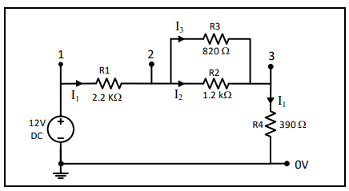

Figure 4

**The results record in these tables:**

|  |  |  |  |
| --- | --- | --- | --- |
|  | Normal | R1 SC | R2 SC |
| I1(mA) | **3.84** | **13.52** | **4.53** |
| I2 (mA) | **1.549** | **5.56** | **4.53** |
| I3 (mA) | **2.19** | **8.13** | **0** |
| V1-2 (v) | **8.61** | **0** | **10.16** |
| V2-3 (v) | **1.84** | **6.57** | **0** |
| V3-0 (v) | **1.47** | **5.30** | **1.75** |

|  |  |  |
| --- | --- | --- |
|  | R1 OC | R2 OC |
| V1-2 (v) | **11.92** | **7.73** |
| V2-3 (v) | **0** | **2.79** |
| V3-0  (v) | **0** | **1.35** |
| I1 (mA) | **12** | **3.456** |

**The theoretical results at normal:**

**I1=3.9mA**

**I2=1.583mA**

**I3=3.9mA**

**\*\*The two results nearly exactly**

**Q7) what is the value of the short circuit voltage? Is there any current in the circuit when a resistor is open circuit?**

**When the circuit shorted the voltage will be zero , when the resistor open there is no current pass on it (current will be zero).**

**Conclusion:**

**Part 1: Kirchhoff’s circuit laws**

**The aim of this part was to verify the KVL and KCL, and the results got in**

**“Experimental part” were acceptable compared with the results got in “theoretical**

**Part”.**

**Part 2: voltage divider and current divider rules:**

**The aim of this part was to verify the voltage divider and current divider rules, the**

**Results got in “experimental part” were acceptable compared with the result got in**

**“Theoretical part” with some errors come from devices and wires.**

**Part 3: short –and- open circuited resister in series- parallel circuits:**

**The aim this part was to examine and to see the effects of short and open resister in an electrical circuit.**

**Where the short circuit is implies that the two terminals are externally connected with resistance R=0, the same as an ideal wire. This means there is zero voltage difference for any current value.**

**And the open circuit is implies that the two terminals are points are externally disconnected, which is equivalent to a resistance R=∞. This means that zero current can flow between the two terminals, regardless of any voltage difference.**

**The value got in this part is very logical value .For example; the voltage across the R1 when it is shorted was zero.**

**Note :** **The result got in laboratory is acceptable, since when it was compared with the result got in pspice but there is some errors come from multimeter and wires**

**References:**

* [**https://en.wikipedia.org/wiki/Short_circuit 9/2/2021**](https://en.wikipedia.org/wiki/Short_circuit%209/2/2021)**,10:00pm**
* **Circuit lab Manual 12/2/2021, 11:00 pm**
* [**https://www.electronics-tutorials.ws/dccircuits/kirchhoffs-current-law.html**](https://www.electronics-tutorials.ws/dccircuits/kirchhoffs-current-law.html) **,9/12/2021, 9:40 pm**

1. **Passive component is an electronic component which can only receive energy, which it can either dissipate, absorb or store it in an** [**electric field**](https://www.electrical4u.com/what-is-electric-field/) **or a** [**magnetic field**](https://www.electrical4u.com/magnetic-field/)**. Passive elements do not need any form of electrical power to operate such as resistor**

   **Active component is an electronic component which supplies energy to a circuit. And have the ability to electrically control electron flow such as battery…**
2. **Ohm's law states that the**[**current**](https://en.wikipedia.org/wiki/Electric_current)**through a**[**conductor**](https://en.wikipedia.org/wiki/Electrical_conductor)**between two points is directly**[**proportional**](https://en.wikipedia.org/wiki/Proportionality_(mathematics))**to the**[**voltage**](https://en.wikipedia.org/wiki/Voltage)**across the two points.** 