**Formula sheet Final Exam**

**Introduction**

ρ water = 998kg/m3, g =32.2 ft/s2=9.81m/s2, Water γ =9790 N/m3 =62.4 lbf/ft3

P atmosphere = 101 kPa

, 



**Fluid statics**

Pabs  = Patm + Pgauge



P down = Pup +ɤ h

P=P0 exp [- g (z-z0 ) /RT0]



FR = ϒhc A = Pc A ,



, , 

$Xcpi=-γ\sin{θ Ixyi/}$ $PCGiAi=-γ\sin{θ Ixyi/}$ FRi

FRi

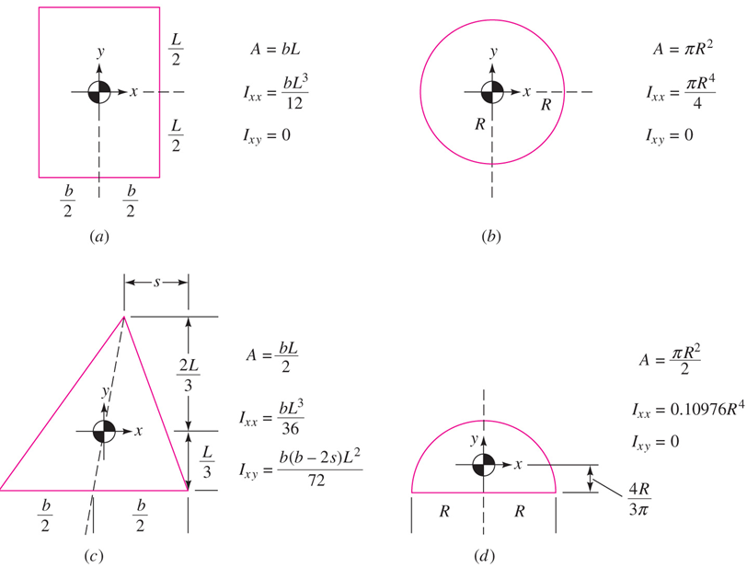

FV = ∫ ϒ dV = ϒ V

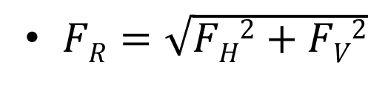

,  Angle with horizontal

F B = ϒ Vbody , XB = (1/V) ∫ x dV Which is the centroid of submerged volume.



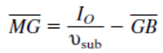

**Mass conservation**

ρ = P/ (TR)



$\dot{m}=ρVA=ρQ$

$$\frac{dmcv}{dt}=\sum_{in}{\dot{\dot{m}i-\sum_{out}{\dot{me}}}}$$

For Steady flow ∑ m`in  = ∑ m`out

**The Linear Momentum Equation**



For steady flow $\sum{F=\sum_{out}{\dot{m}V-\sum_{in}{\dot{m}V}}}$

**Energy equation**





$$\dot{m}=ρVA=ρQ$$

$$\dot{W}pump=\dot{m}ghp=ρgQhp=γQhp$$

hminor = K (V2/2g) = hm

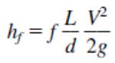,

Re= ρVL/μ = VL/ν

, 

HGL=z + p/ϒ , EGL = HGL + *V*2/(2*g*)

**Bernoulli’s equation**

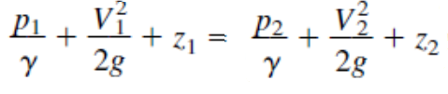



Dh = 4 (cross section Area / wetted perimeter) = 4Ac/Pw

*NPSH = hs - hv*

*NPSH = Psys - Pvap*