

Faculty of Engineering and Technology

Department of Electrical and Computer Engineering

Digital Electronics and Computer Organization

ENCS 2110

**Experiment No. 2 - Comparators, Adders, and Subtractors**

Pre Lab2

Student Name: alaa moqade

Student ID : 1211910

Instructor : Jamal Seyam

T.A : Haleema Hmedan

Section : 1

partners: Amal, Mohammed hasune

1. half adder

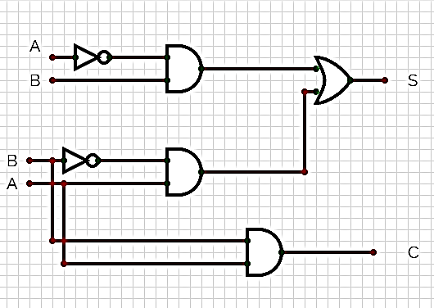

2)

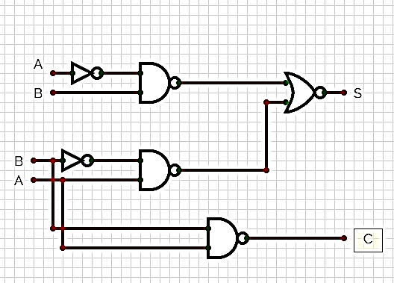

3)

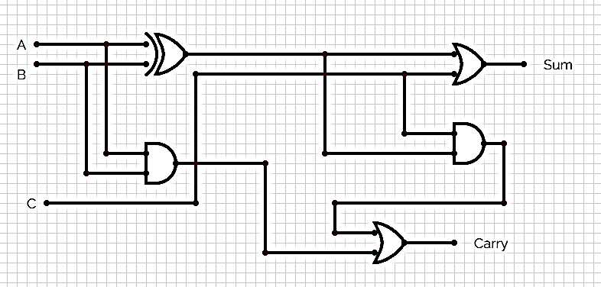

4)full adder

