Chapter 05 Information Systems Concepts

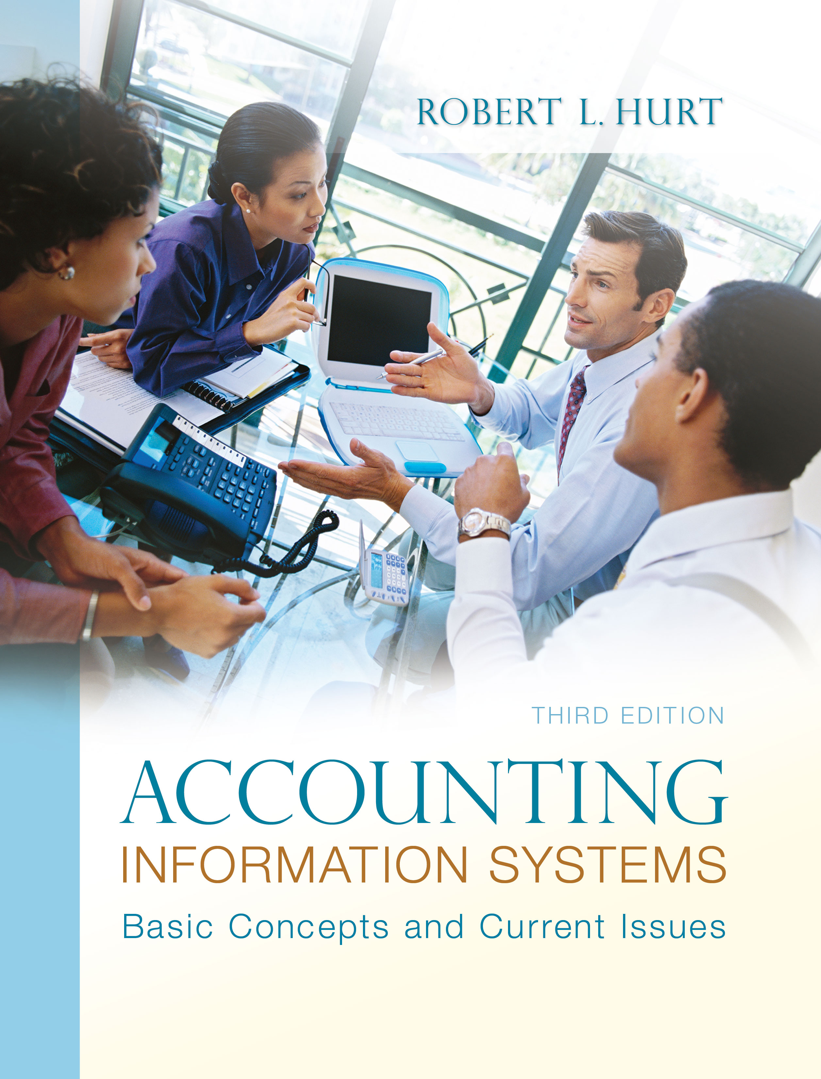
1. Reading review questions

a. What are the steps in the systems development life cycle? What activities does each step involve? The systems development life cycle comprises the seven steps listed and described below:

- Initiation / planning: A need for a new / revised system is identified. This phase often involves feasibility studies.
- Requirements analysis: Analysts determine what needs the system should meet; data collection methods include surveys, interviews, observation and focus groups.
- Design: Designers develop the first “concept sketches” of the system.
- Build: Based on the design specifications, one or more systems professionals build the system.
- Test: Users test the system and provide feedback on what works and what doesn’t work.
- Implementation: The system “goes live.”
- Operations and maintenance: The system is operated and maintained, which includes needed modifications.

b. What are the costs and benefits of using the SDLC? The SDLC is a well-structured methodology that provides for plenty of user input. It can, however, be inflexible; changes may be difficult and expensive once the process is underway.

c. How can the SDLC be useful in accounting information systems? The SDLC can be used to design, create and implement an accounting information system or some part(s) of it. It can also be used to select off-the-shelf software.

d. What are the levels in the capability maturity model? What characteristics distinguish each level? The CMM comprises five levels, listed and described below:

- Chaotic: Processes lack cohesion; they may be specific to an individual who does not share them.
- Repeatable: Processes become more mature; they are developed and implemented according to a schedule, with major milestones indicated throughout.
- Defined: Processes are developed from broader organizational standards, rather than being viewed in isolation from one another.
- Managed: The efficiency and effectiveness of a process are measured through benchmarks and other standards.
- Optimized: An attitude of quality pervades the organization.

e. What factors should managers consider when choosing information technology resources? Managers should consider “big picture” issues such as organizational need, strategic fit, personnel involvement and financing methods. They should also consider factors more closely related to individual projects, such as cost, adaptability, training requirements and vendor reliability.

f. Prepare a response to the questions for this chapter’s “AIS in the Business World.” I was very fortunate to have three assistants available to prepare responses to the AIS in the Business World vignettes for the third edition; I’ve posted their responses on my AIS blog: www.bobhurtais.blogspot.com.

2. Reading review problem

a. How would workers in the case have used the SDLC to make the changes described? In the accident reporting system, workers would have identified a need for faster, more reliable information (initiation / planning). They would ask system users and potential users about desirable qualities in the new system (requirements analysis). Based on those requirements, designers would lay out database specifications, prototypes of screen layouts and other elements of the system (design). A team would use those specifications to build the system (build), after which it would be tested by a group of users (test). After further revision based on testing feedback, the system would be deployed throughout the organization (implementation). Finally, the system would be run, maintained and updated as necessary (operations / maintenance).

b. Compare the "before" and "after" processes in the case you chose. How would you classify each one using CMM? The “before” process, at minimum, meets the characteristics of a repeatable process; the narrative implies a consistent approach with a milestone of six weeks to produce a paper report. After the modifications, the process may have moved up one level on the CMM (defined), but may also have remained a repeatable process; the difference would hinge on how the new process was developed.

c. Which macro- and micro-level factors for IT selection are indicated / implied in the case? In the accident reporting system, relevant macro-level factors include need and strategic fit. Micro-level factors likely included cost and system reliability.

3. Multiple choice review questions. Answers to all of these questions appear at the end of the textbook itself.

4. Making choices and exercising judgment
The point of these exercises, which appear in every chapter throughout the third edition, is to encourage students to think critically and “outside the box.” Thus, I am not providing solutions to them, as doing so would likely discourage the purpose of these exercises.

5. Field exercises
Answers to these exercises will vary significantly; thus, like the previous set, I am not preparing published solutions for them.

6. Capability maturity model classification
a. Repeatable—Alastor sets a goal, so he is engaging in some planning that may result in consistency over time.
b. Managed—The process is measured in terms of time and money. This process is not optimized because the president focuses on just one of the three projects.
c. Optimized—Monthly meetings focused on process improvement indicate it is ingrained in the organization.
d. Repeatable—Each day, Christina sets a goal by deciding how many clients she will contact.
e. Chaotic—The two people disagree about the best way to build a doghouse, likely leading to each one doing it in the way that seems best to them.
f. Managed—Magdy compares the actual capital structure with the optimal capital structure (a form of measurement).

g. Optimized—The company has an overall quality improvement plan.
h. Chaotic—Sebastian had no legitimate methodology for hiring a new employee.
i. Defined—The payroll manager is acting in accordance with broader organizational policies.
j. Defined—Management seeks to understand relationships.

7. Systems development life cycle
a. Build—Dolores is actually creating the database tables.
b. Operations and maintenance—Answering questions is an element of operating the system.
c. Design—Esther is thinking conceptually about the form.
d. Test—Liliane is working with simulations.
e. Requirements analysis—The DFDs are used as a basis for discussing the sales / collection process with sales staff.
f. Initiation / planning—Tony has identified a goal / need.
g. Implementation—The system has been implemented using a direct cutover methodology.

8. Requirements analysis
a. Questions to ask as part of requirements analysis might include: What don’t you like about the current system? How comfortable are you working with computers? How often do you need to consult the current inventory tracking system? Do you need to track inventory from remote locations? How many kinds of inventory should the system track?

b. Questions to ask as part of requirements analysis might include: How many appointments do you usually take in a day? How comfortable are you working with computers? What problems are you experiencing with the paper-based system? Does anyone schedule appointments for you other than you? How much would you be able to budget for this project?

9. Designing, building and testing an information system.
The accident reporting system would need an “accident report” table. That table would likely include a transaction number as a primary key, the date on which the accident occurred, the place where it occurred and the person filing the report. Since an individual accident can involve many automobiles, the accident report table would not include data on automobiles; that data would be included in a junction table.

10. AICPA Top Technology Initiatives
The AICPA develops the list based on surveys of its members. The 2011 list includes:

- Control and use of mobile devices
- Information security
- Data retention policies and structure
- Remote access
- Staff and management training
- Process documentation and improvements
- Saving and making money with technology
- Technology cost controls
- Budget processes
- Project management and deployment of new technologies

Student reports will vary significantly.

11. Terminology
1. I
2. G
3. H
4. B
5. C
6. F
7. D
8. J
9. A
10. E

12. Multiple choice questions
1. A
2. D
3. D
4. A
5. D

13. Statement evaluation
1. Sometimes true. The SDLC is one alternative for systems development; in some cases, it may be the best.
2. Never true.
3. Always true.
4. Always true.
5. Always true.
6. Sometimes true. While organizations should try to move through the CMM on an organization-wide basis, that doesn’t always happen. Thus, processes in two different departments can be at two different levels.
7. Sometimes true. Organizations can skip levels of the CMM, although doing so isn’t a really good idea most of the time.
8. Always true.
9. Sometimes true. The “managed” stage focuses on both defining and measuring. ABM can be used for those purposes, but it isn’t always.
10. Never true.

