CHAPTER 1: Relativity I
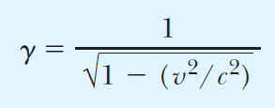 | Gamma factor
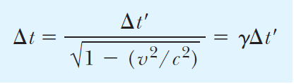 | Time dilation
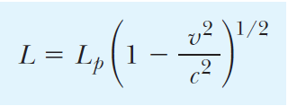 | Length contraction
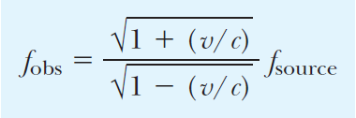 | Relativistic Doppler effect
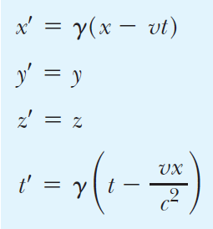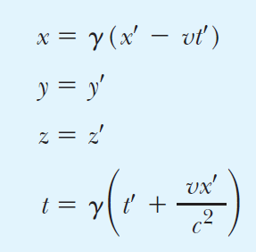 | Lorentz’s transformation  (Left: S S’)  (Right: S’ S)
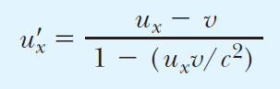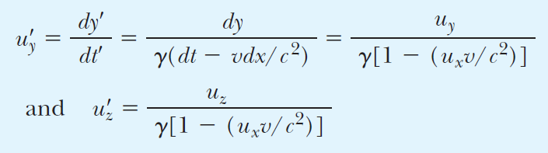 | Lorentz velocity transformation
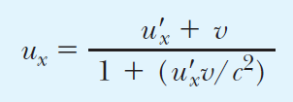 | Inverse Lorentz velocity  transformation

CHAPTER 2: Relativity II
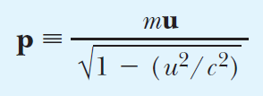 | Definition of relativistic  momentum
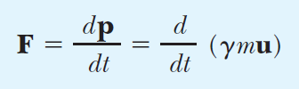 | Relativistic form of Newton’s second law
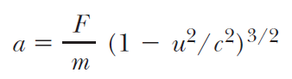 | Relativistic acceleration
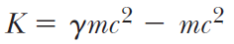 | Relativistic kinetic energy
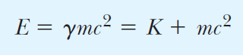 | Definition of total energy
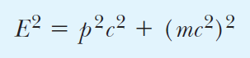 | Energy–momentum relation
 | Disintegration energy
“the sum of the mass–energy of a system of particles before interaction must equal the sum of the mass–energy of the system after interaction…” | The law of the conservation of  mass–energy

CHAPTER 3: The Quantum Theory of Light
 | Quantization of energy
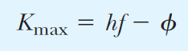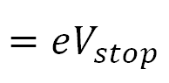 | Max. kinetic energy of photo-electron
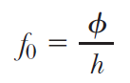 | Threshold frequency
 | Bragg equation
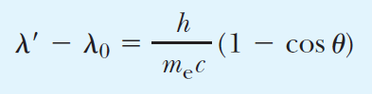 | Compton effect
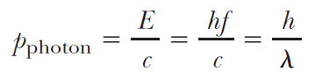 | Momentum of photon

CHAPTER 4: The Particle Nature of Matter
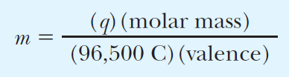 | Faraday’s law of electrolysis
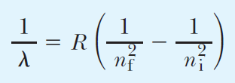 | Rydberg’s formula for Hydrogen (or: Balmer’s empirical relation)
 | Orbital angular momentum of electron
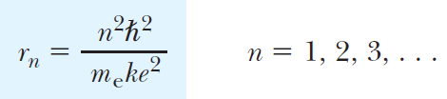 | Radii of Bohr orbits in Hydrogen
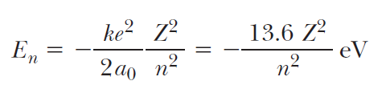 | Energy levels of an electron orbiting a charge Ze  (In Hydrogen Z=1)
“Predictions of quantum theory must correspond to the predictions of classical physics in the region of sizes where classical theory is known to hold.” | Correspondence principle

CHAPTER 5: Matter Waves
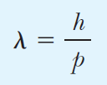 | De Broglie wavelength
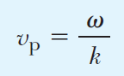 | Phase velocity
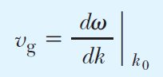 | Group velocity
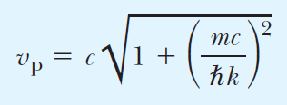 | Phase velocity of matter waves
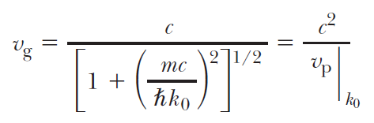 | Group velocity of matter waves (=velocity of the particle)
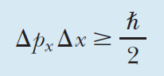 | Momentum–position  uncertainty principle
“ If a measurement of position is made with precision Δx and a simultaneous measurement of momentum in the x direction is made with precision Δp_{x}, then the product of the two uncertainties can never be smaller than ℏ/2.” | Momentum–position  uncertainty principle
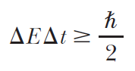 | Energy–time uncertainty principle
“Electrons are very delicate and rather plastic—they behave like either particles or waves, depending on the kind of experiment performed on them. In any case, it is impossible to measure both the wave and particle properties simultaneously.” | Complementarity

CHAPTER 6: Quantum Mechanics in One Dimension
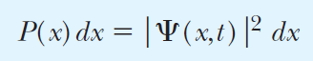 | Born interpretation of Ψ
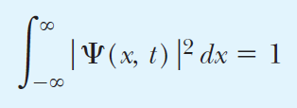 | Normalization condition
 | Plane wave representation for a free particle
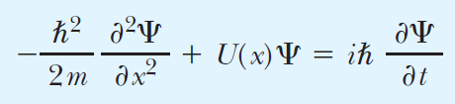 | The Schrödinger wave equation
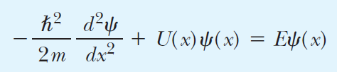 | Time-independent Schrödinger equation
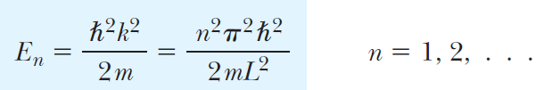 | Allowed energies for a particle in a box
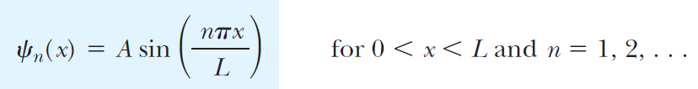 | Stationary states for a particle in a box
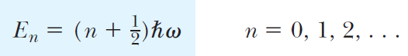 | Energy levels for the harmonic oscillator
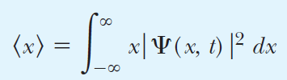 | Average position of a particle
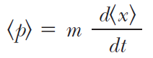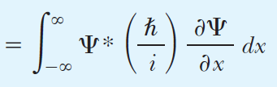 | Average momentum of a particle

CHAPTER 7: Tunneling Phenomena
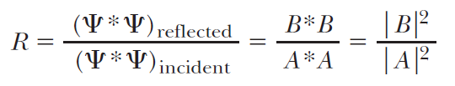 | Reflection coefficient for a barrier
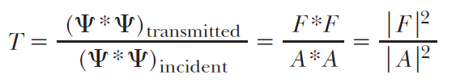 | Transmission coefficient for a barrier
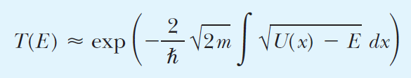 | Approximate transmission coefficient of a barrier with arbitrary shape
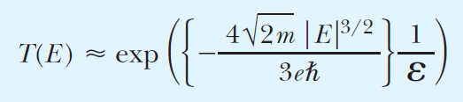 | Transmission coefficient for field emission
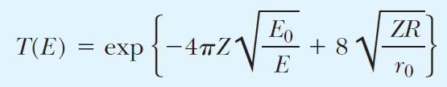 | Transmission coefficient for α particles of an unstable nucleus

CHAPTER 8: Quantum Mechanics in Three Dimensions
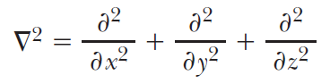 | Laplacian in the three spatial dimensions
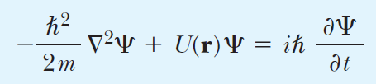 | Schrödinger equation in three dimensions
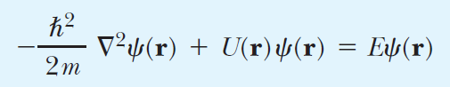 | The time-independent Schrödinger equation
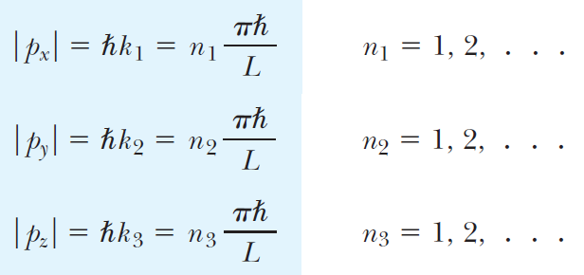 | Allowed values of momentum components for a particle in a box
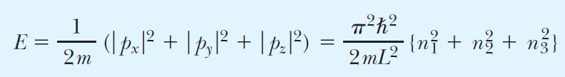 | Discrete energies allowed for a particle in a box
“It is impossible to specify simultaneously any two components of angular momentum.” | Uncertainty principle for angular momentum

Summary of Ch.8 is on page 289 in the textbook [306 in pdf]
