NUTD343
Lab Experiments

Lab (1)
General Instructions and safety rules

Scince you will be working with unseen living forms, it will be necessary that you develop asset of techniques that are not only will determine the success or failure of your scientific probing ,but they will also be essential to protect you and others around you against potentially harmful forms .

Laboratory safety is a careful process, with the goal of preventing injuries and disease from occurring among students. scientists, laboratory staff ,and the community.

Assume that all the organisms you work with are disease producing forms (pathogens). Many of them will be harmless, but some are not.

The following safeguards should be observed all times :

1.Dont eat , drink , smoke or chew pens in laboratory .

2.you must wear lab coat, shoes ,and goggles while in the laboratory .

3.long hair should be tied back so that it does not catch fire in a Bunsen burner flame and does not fall into sterile media.

4.Wipe your bench top with disinfectant at the beginning and end of every laboratory period.

5.Wash your hands thoroughly before leaving the laboratory.

6.Immediatly report all accidents such as spills, cuts, burns, or other injuries to the instructor .

7.Know the location of the fire extinguisher and eye wash station .

8. leave all laboratory facilities and equipment in good order at the end of each class.

9. before leaving the laboratory ,check to make sure the gas to the Bunsen burner is turned off.

10.Never ,under any circumstances ,remove equipment, media or microbial cultures from the laboratory .

Tools and instrument you will deal with at Food microbiology lab
1. Loop.
2. Needle.
3. Spreader.
4. petri dish.
5. Tube.
6. Pipette.
7. Pipette filler.
8. Universal bottle
9. Rack.
10. Bunsen burner.
11. Autoclave.
12. Autoclave bag.
13. Oven.
14. Incubator
15. Micro pipette.
16. Yellow and blue tips.
17. Droppers.
18. Slide.
19. Cover clip.
20. Water bath.
21. Balance.

Sterilization of equipment and materials

Wire loop
Heat to redness in Bunsen burner flame.

Empty glassware and glass (not plastic!) pipettes and Petri dishes

Hot air oven, wrapped in either grease proof paper or aluminum and held at 160ºC for 2
Hours, allowing additional time for items to come to temperature (and cool down!).
Note: plastic Petri dishes are supplied in already sterilized packs.

Culture media and solutions
Autoclave

Glass spreaders and metal forceps
In alcohol (70% alcohol)then – Flaming

Disinfectants
Commonly available disinfectants
Ethanol 70% (v/v)

.
Using a wire loop

Wire loops are sterilized using red heat in a Bunsen flame before and after use. They must be heated to red hot to make sure that any contaminating bacterial spores are destroyed. The handle of the wire loop is held close to the top, as you would a pen, at an angle that is almost vertical. This leaves the little finger free to take hold of the cotton wool plug/ screw cap of a test tube/bottle.

Report # 1
General Instructions and safety rules

Student Name:………………………… Date:……………………………. .
Section :………………………………… day:…………………………….

1. What the laboratory safety means?

…………………………………………………………………………………………………………………………………………………………………………………………………………………………………………………………………………………………………………………………………………………………………………………………………………………………………………………………………………………………………………………………………………………………………………………

2. Explain:

A. long hair should be tied.
………………………………………………………………………………………………………………………………………………………………………………………………………………………………..

B. you must wear lab coat, shoes, goggles while in the lab.
…………………………………………………………………………………………………………………………………………………………………………………………………………………………………………………………………………………………..

3. How we get rid of the microbial cultures? By which machine?

3. Name these instruments and its use:

A………………………………………
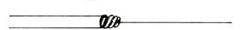

B……………………………………..



C………………………………………..
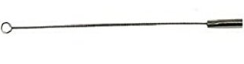

Best wishes...Hana’a Khalaf

Lab (2)
The Microscope
and Differential staining of bacteria ,Gram stain

Using the microscope
The setting up of a microscope is a basic skill of microbiology its many uses in practical microbiology, from aiding in identification to checking for contamination, be successfully accomplished. The amount of magnification of which a microscope is capable is an important feature but it is the resolving power that determines the amount of detail that can be seen.
You should know that the ordinary compound light microscope, is the most commonly used type of microscope in different medical laboratory.

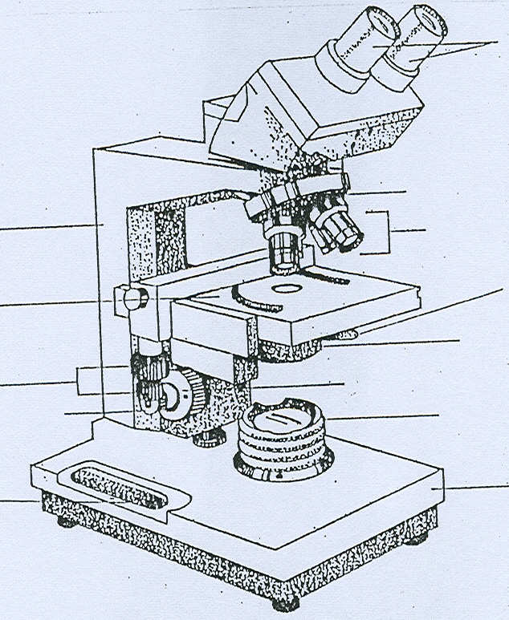

With your instructor review How to use the compound light microscope and review all parts of it.
By this microscope in the microbiology laboratory you can use it for:

Bacteria and yeast
Yeast can be seen in unstained wet mounts at magnifications x100. Bacteria are much smaller and can be seen unstained at x400 but only if the microscope is properly set up and all that is of interest is whether or not they are motile. A magnification of x1000 and the use of an oil immersion objective lens for observing stained preparations are necessary for seeing their characteristic shapes and arrangements. The information gained, along with descriptions of colonies, is the starting point for identification of genera and species but further work involving physiology, biochemistry and molecular biology is then needed.

Moulds
Mould mycelium and spores can be observed in unstained wet mounts at magnifications of x100 although direct observations of “mouldy” material through the lid of a Petri dish or specimen jar at lower magnifications with the plate microscope are also informative (but keep the lid on!).
Routine identification of moulds is based entirely on the appearance of colonies to the naked eye and of the mycelium and spores in microscopical preparations.

Stained preparations
A “smear” of bacteria or yeast is made on a microscope slide, fixed, stained, dried and, without using a cover slip, examined with the aid of a microscope. Aseptic technique must be observed when taking samples of a culture for making a smear. A culture on agar medium is much preferable to a liquid culture for making a smear. A smear that is thin and even enables the shape and arrangement of cells to be clearly seen and ensures that the staining procedure is applied uniformly.

There are two broad types of staining method:

(1) a simple stain
involves the application of one stain to show cell shape and arrangement and,
sometimes, inclusions that do not stain, e.g. bacterial endospores;

(2) a differential stain
involves a sequence of several stains, sometimes with heating, and includes a stage which differentiates between either different parts of a cell, e.g. areas of fat storage, or different groups, e.g. between Gram-positive and Gram-negative bacteria.

The reaction of bacteria to Gram’s staining method is a consequence of differences in the chemical structure of the bacterial cell wall and is a key feature in their identification.
Yeast cells can be stained by Gram’s method but it is of no value in their identification. The basis of Gram’s staining method is the ability or otherwise of a cell stained with crystal violet to retain the colour when treated with a differentiating agent, usually alcohol (although professionals sometimes use acetone). Bacteria that retain the violet/purple colour are called Gram-positive.
Those that lose the colour, i.e. called Gram negative, are stained in the contrasting colour of a counterstain, usually pink/red.

Making a smear.
1. Clean a plain microscope slide thoroughly using lens tissue.
2. Label a microscope slide with a marker pen to record the culture being used, date and
initials; this is also a useful reminder of which side of the slide is being used.
3. Flame a wire loop to ensure that no culture accidentally remains from a previous
operation.
4. Transfer one or two loopfuls of tap water on to the centre of the slide.
5. Flame loop and allow to cool.
6. Using aseptic technique, transfer a very small part of a single colony from a plate or
slope of agar medium into the tap water.
If the amount of culture on the loop is easily visible you have taken too much!
7. Make a suspension of the culture in the tap water on the slide and thoroughly but
gently spread it evenly over an oval area of up to 2 cm length.
8. Flame the loop. If it is necessary to use a liquid culture or sample, the use of tap water
to prepare the smear will probably be unnecessary and may result in a smear with too
few cells.
9. Dry the suspension by warming gently over a Bunsen burner flame and then “fix” it by
quickly passing it through the flame a few times. This is called a heat-fixed smear; it
should be visible to the naked eye as a whitish area. Fixing is necessary to ensure that
cells adhere to the slide and to minimise any post mortem changes before staining.
A simple stain.
1. Put the slide with the fixed smear uppermost on a staining rack over a sink or staining
tray.
2. Thoroughly cover the smear with stain and leave for, usually, 30 seconds.
3. Hold the slide with forceps (optional but avoids stained fingers), at a 45° angle over the
sink.
4. Rinse off the stain with tap water.
5. Blot dry the smear with filter/fibre free blotting paper using firm pressure but not sideways
movements that might remove the smear.
6. Examine under oil immersion.
7. When finished, dispose of slides into discard jar.
Suitable stains include basic dyes (i.e. salts with the colour-bearing ion, the chromophore, being
the cation) such as methylene blue, crystal violet and safranin.

A differential stain: Gram’s staining method
Times of the staining periods depend on the formulation of the staining solutions which are not standard in all laboratories. Therefore, the times given here relate only to the solutions specified here.
a. Put the slide with the fixed smear uppermost on a staining rack over a sink or
staining tray.
b. Thoroughly cover the smear with crystal violet solution and leave for 1 minute.
c. Hold the slide with forceps (optional but avoids stained fingers), at a 45° angle
over the sink.
d. Pour off the stain, wash off any that remains (and any on the back of the slide)
with iodine solution.
e. Put the slide back on staining rack.
f. Cover the smear with iodine solution and leave for 1 minute. Iodine solution acts
as a “mordant” (a component of a staining procedure that helps the stain to
adhere to the specimen), a crystal violet-iodine complex is formed and the smear
looks black.
g. Hold the slide with forceps at a 45° angle over the sink wash off the iodine
solution with decolarizer 95% (v/v) ethanol (not water); continue treating with alcohol until
the washings are pale violet.
h. Rinse immediately with tap water.
i. Put the slide back on staining rack.
j. Cover the smear with the counterstain, e.g. safranin solution, for 30
seconds.
k. Rinse off the stain with tap water.
l. Blot dry the smear with filter/fibre free blotting paper using firm pressure but not
sideways movements that might remove the smear.
m. Examine under oil immersion.
n. When finished, dispose of slides into discard jar.

Always use a young culture because older cultures of Gram-positive bacteria tend to lose the
ability to retain the crystal violet-iodine complex and appear to be Gram-negative; but some
bacteria are naturally only weakly Gram-positive. The amount of alcohol treatment (the
differential stage) must be judged carefully because over-treatment washes the crystal violet iodine complex from Gram-positive bacteria and they will appear to be Gram-negative. Take care to make an even smear otherwise alcohol will continue to wash the violet/purple colour from thick parts of the smear while thin parts are being over-decolorised. At the end of the procedure,
check that the labeling has not been washed off by the alcohol. Don’t despair if the stained smear
is not visible to the naked eye; this may happen with a Gram-negative reaction.

Report # (2)
The Microscope
and Differential staining of bacteria ,Gram stain

Student Name:………………………… Date:……………………………. .
Section :………………………………… day:…………………………….

1.Name these microscope and label the fine and coarse adjustment knobs .

…………………………………………………………… ……………………………………………………………….

2.This table talk about how Gram stain works.

Stain step | Gram reagent | What happens | Color of  G +ve cell | Color of  G -ve cell | Dayes present in cells
Primary
Mordant
decolorizer
counterstain

Best wishes ..Hana’a Khalaf
Lab (3)
Microbial Food analysis

1: Reasons for microbial food analysis.
• to meet certain set standards
· to estimate the shelf-life of the product
· to determine quality of the food
· for public health purposes

2: The organisms to look for;
i) Indicator organism(s);
Definition: an indicator organism or group of organisms is one whose numbers in a product reflect the success or failure of "good manufacturing practices". Coliform groupof microorganisms and Escherichia coli are commonly used as indicator organisms.

ii) Index organism;
Definition: an index organism is one whose presence implies the possible occurrence of asimilar but pathogenic organism. E. coli is used an index organism and its presenceindicates possible presence of pathogenic enterobacteriacea e.g. Salmonella sp.

iii) Food poisoning organisms
The are two types of food poisoning organisms
· those which cause the decease by infection
· those which produce toxin in food
a)Those which cause infection must grow in food in large numbers and cause infection when consumed together with food. The most common microorganisms in this categoryincludes Salmonella typimurium, enteropathogenic E. coli, Vibrio parahaemolyticus,Yersinia enterocolytica etc.
b) Those which cause intoxication must grow in food in large numbers and produce enough toxin and when consumed together with food cause intoxication. The most common microorganisms in this category includes, Clostridium botulinum, Staphylococcusaureus and toxigenic fungi e.g. Aspergillus flavus.

iv) Infectious microorganisms
Definition: Organisms whose presence in small numbers in food or water and when consumed can cause infection. In this case the food acts as a vector but not necessarily as a growth medium.Infectious organisms can be transmitted by various ways including man to man and are said to be contagious. Organisms in this group includes; Vibrio cholerae O1, Salmonella typhi, Shigella sonnei, Bacillus anthracis, Hepatitis B virus
etc.
v) Spoilage organisms
Definition: Spoilage organisms are the organisms whose growth in the food creates
undesirable characteristics in that food. Any microorganism which is not intentionally
added into food or intentionally allowed to grow in food so as to impart certain qualities in that food is considered a contaminant. Growth of the contaminant in that food will spoil the food making it unfit for human consumption. Some useful microorganisms e.g. lactic acid bacteria are considered as spoilage organisms when in beer, wine and fruit juices but
not in milk.

3: How to analyze
i) Quantitative analysis
· Serial decimal dilution
· Aerobic plate count
· Pour plate count
· Total viable count
· Yeast and Molds count

ii) Qualitative analysis
presence or absence of a specified microorganism e.g.
· Salmonella sp.
· E. coli
· V. cholerae O1

4: Culture Methods
· pre-enrichment broth
· enrichment broth
· selective enrichment
· selective agar
· Differential agar

5:Biochemical tests
· sugar fermentation
· amino acid decarboxylation
· gelatin liquefaction

Serology
· agglutination
· precipitin
· coagulation

Colony morphology
· shape
· colour
· texture
· size

Cell shape by microscope
· bacillus
· coccus
· streptococcus

Gram stain characteristics
· gram positive
· gram negative

Motility
motile
number of flagella
arrangement of flagella
non motile

Isolating of Bacteria: Pure Culture Technique

Colony isolation
Natural environment usually support the growth of many different types of microorganisms within the same space. When those environments are sampled and cultured they produce a mixed population or Mixed culture . to be able to study the unique characteristics of an individual species it is essential that its is separated from all other organisms around it.

A pure culture is the culture that contain only a one species of organisms. The primary step in all microbiological investigation is to obtain a pure culture .

We can isolate bacteria by culturing methods employing petri dishes such as:
- Streak plate method.
- Pour plate technique or dilution method.
- Spreading technique.
- The use of selective media

1.Streak plate method .
Material
1. A nutrient broth culture contain mixture of two organisms.
2. A nutrient agar plate.
3.Maconky agar plate or Blood agar plate.
4.Inculating loop.

Procedure:
1.Remove one loopful of the unknown mixture.
2. lift the lid of nutrient agar plate and gently streak the loop on the surface of the agar near the edge of one quadrant of the plate.
3.Flame the inoculating loop and allow it to cool for 5 sec.
4. As shown in the figure streak the organism from quadrant 1 to quadrant 2.
5.Repeat step 3.
6. streak the organism from quadrant 2to quadrant 3.
7. Repeat step 3.
8. streak the organism from quadrant 3to quadrant 4.
9. incubate the plate at 37c⁰ over night.

After 24 hours of incubation you should have a genetically pure culture to work with .This may serve as your stock plate for any future experiments.

2.Pour plate technique or dilution method.
A pour plate ia a method of melted agar inoculation followed by petri dish incubation .
Materials:
1. A nutrient broth culture contain mixture of two organisms.
2. Three tubes of melted nutrient agar .
3. Sterile empty petridishes .
4.Inoculating loop.

Procedure:
1.lable the melted nutrient agar which have cooled to around 50-45 ⁰c as 1 ,2and 3 at the same time label the three sterile petri dishes as 1,2 and 3.
2. Inoculate tube 1 with one loopful from the mixed culture tube and mix by swirling the medium.
3. Flame the loop ,pick a loopful of inoculum from tube 1 and inoculate tube 2,during this work the tubes are in the water bath with temperature around 55⁰c to keep it melted.
4. Flame the loop ,pick a loopful of inoculum from tube 2 and inoculate tube 3.
5.Pour the contenants of all tubes in the labeled petridishes..
6. allow the plates to cool and solidify.
7.Incubate the plates at37⁰c overnight.

Colony form within the agar matrix rather than on top as they do when streaking a plate, pour plates are useful for quantify microorganisms that grow in solid medium, Because the pour pate embeds colonies in agar it can supply a sufficiently oxygen deficient environment that it can allow the growth and quantification of microaerophiles.

3.Spreading technique.
Spreading a plate is an additional method of quantifying microorganisms on solid medium. Instead of embedding microorganisms in to agar ,as is done with the pour plate method ,liquid culture are spread on the agar surface using a device that looks like a hockey stick.
An advantage of spreading a plate over the pour plate method is that cultures are never exposed to 45⁰c + melted agar.

Material
1. A nutrient broth culture contain mixture of two organisms
2. A nutrient agar plate.
3.Maconky agar plate or Blood agar plate
4. Spreader.
5.70% alcohol.

Procedure
1. take 0.1 ml of the nutrient broth culture contain mixture of two organisms and put them on the surface of the A nutrient agar plate
2. take 0.1 ml of the nutrient broth culture contain mixture of two organisms and put them on the surface of the Maconky agar plate or Blood agar plate.
3. Dip a spreader in 70% alcohol.
4. flame the spreader and cool .
5. spread the microorganisms.
6.Incubate the plates at37⁰c overnight.

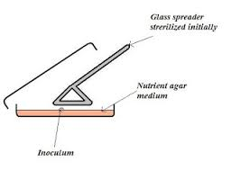

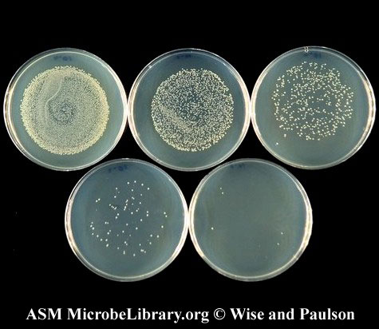

The result for spreading technique.

4.The use of selective media
Look at the table below to remember all types of media

Type of media | Description | Examples
All purpose media | Support the growth of all types of microorganisms. | -Nutrient agar  -Nutrient broth
Enriched media | Support the growth of fastidious organisms. This media is a general purpose media add to it components such as blood, serum, extracts of plants or animal tissues. | -Blood agar  -Chocolate agar
Selective media | This media would select for the growth of certain types of microorganisms by inhibiting the growth of others e.g a media that allow the growth of G -ve bacteria and inhibit the growth of G +ve . | -EMB  -S.S agar  -MSA  -Mac
Differential media | Thia media allows the differentiation between types of bacteria according to there cultural characteristics on it.It contain certain reagents e.g indicators as phenol red. | -MacConkey  -Blood agar.

So If we want to isolate pure culture of certain bacteria we use selective media for this bacteria.
-Mannitol salt agar (MSA)
This medium is selective for salt –tolerant organisms like Staphylococcus species in their ability to ferment mannitol . Staph aureus exhibits a yellow colonies on the agar.
MSA agar is red whan staph aureus ferment the mannitol turn it to yellow .

-Eosin methylene blue agar (EMB)
This medium is selective for detection and isolation of Gram negative intestinal pathogens. A combination of eosin and methylene blue is used as an indicator and allows differentiation between organisms that ferment lactose and those that do not. methyene blue acts as inhibitor to Grame –positive bacteria. Colonies of E.coli normally have a dark center and green metallic sheen. whereas the colonies of lactose fermentors appear pink but lactose non fermentors are colorless.

-MacConkey (Mac) agar plate
Mac is a selective and differential plating medium recommended for detection and isolation of Salmonella and Shigela and E.coli. This media contains pepton ,lactose, bile salts, neutral red and crystal violet .Gram negative bacteria are differentiated by their ability to ferment lactose .
Lactose fermenter appear bright pink.
Non Lactose fermenter utilize the pepton,t hus yielding an alkaline reaction which changes the color to clear or yellow. These colonies are uncolored and transparent. Gram positive organisms are inhibited by crystal violet and bile salts in the medium.

Report # (3)
Isolating of Bacteria: Pure Culture Technique

Student Name:………………………… Date:……………………………. .
Section :………………………………… day:…………………………….

1. Compare between the 2 methods of pure culture ,pour plate and spreading technique .

Method | Agar (form and temp) | Instrument used | Colonies location
Pour plate

Spreading

2.Explain these statements.
a. Pour plate technique good for quantification of microaerophiles.

b. Gram +ve bacteria cant grow on EMB medium.

Best wishes ..Hana’a Khalaf

