

Faculty of Engineering and Technology

Department of Electrical and Computer Engineering

Digital Electronics and Computer Organization

ENCS 2110

**Experiment No. 4 - Digital Circuits Implementation using Breadboard**

pre Lab 4

Student Name: alaa moqade

Student ID : 1211910

Instructor : Jamal Seyam

T.A : Haleema Hmedan

Section : 1

3) Design and implement the following circuit using the gates on the chips as shown in Figure 4.1(. Your final circuit must include the ICs, their pin numbers, and the connections between the pins.).

1. Build Full Adder using basic gates.

Using And, OR, XOR chips you can build Full Adder gate like this :

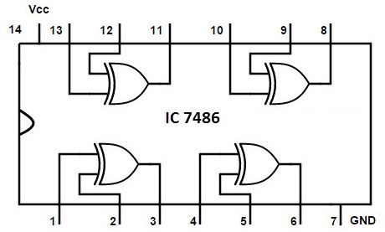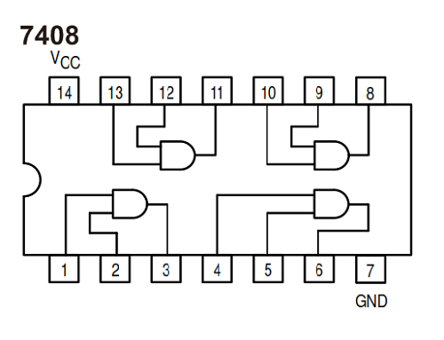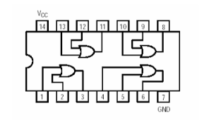

OR chips And chips XOR chips

