

Faculty of Engineering and Technology

Electrical Engineering Department

ــــــــــــــــــــــــــــــــــــــــــــــــــــــــــــــــــــــــــــــــــــــــــــــــــــــــــــــــــــــــــــــــــــــــــــــ

Pre Lab

Experiment#9

Active filters

**Student’s Name: Tayma yasin**

**Student’s No : 1142391**

**Instructors :Dr. Naser ismail**

Eng. Bilal ismail

**Part A: First order active low-pass filter :**



**Figure 9.5: First order Active Low Pass Filter**

**Pispice :**

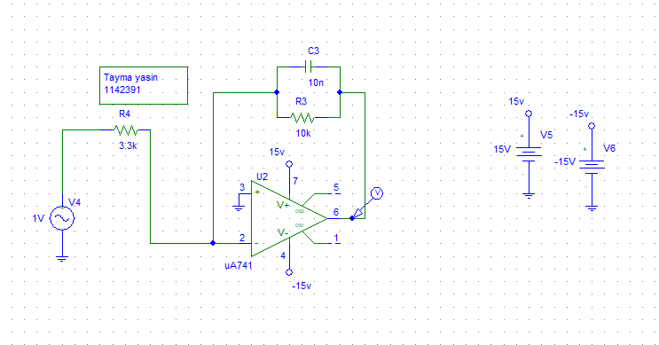

**Vmax =3.032 V, cut off frequncey with $\frac{Vmax}{\sqrt{2}}=\frac{3.032}{\sqrt{2}}=2.142V,$**

**Cut off frequency =1.5896KHZ.**

**Smiluation :**

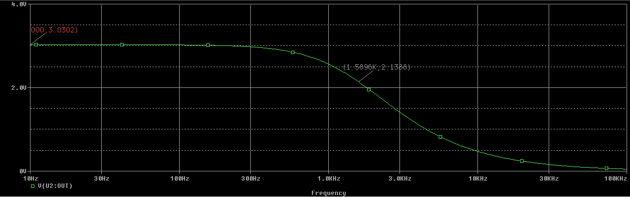

**Part B: Second Order Low Pass Butterworth Filter:**

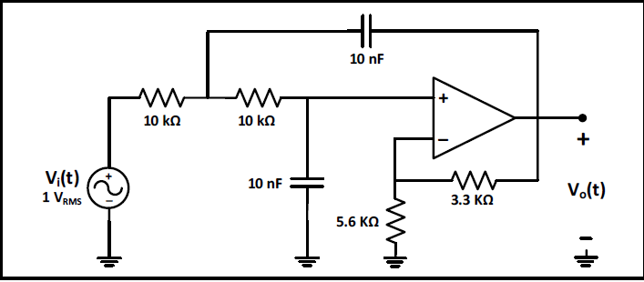

**Figure 9.6: Second Order Low Pass Butterworth Filter**

**Pispice:**

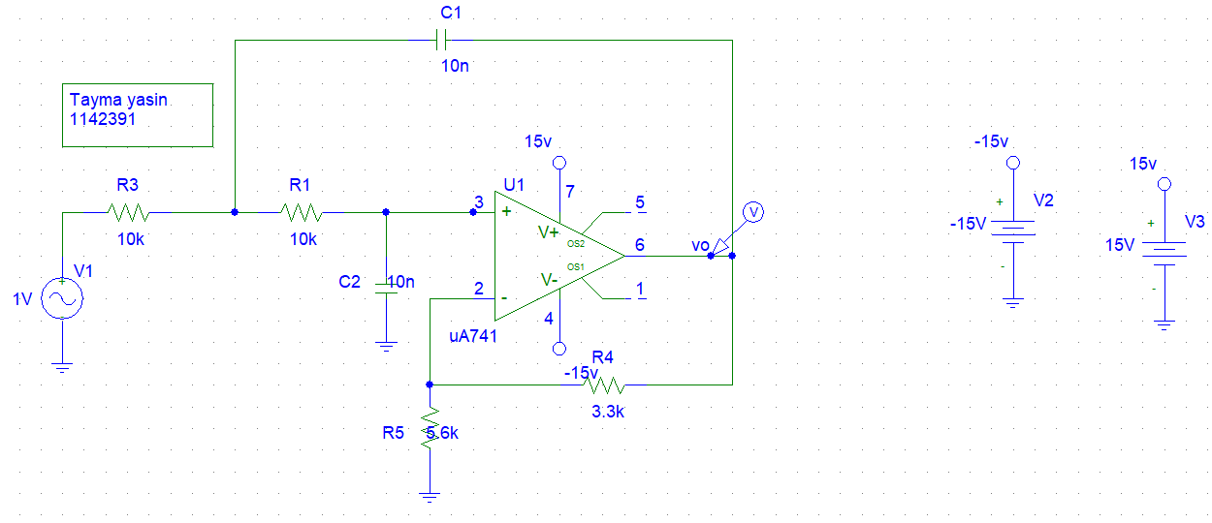

**Vmax =1.589 V, cut off frequncey with $\frac{Vmax}{\sqrt{2}}=\frac{1.589}{\sqrt{2}}=1.123V,$**

**Cut off frequency =1.6016KHZ.**

**Smiluation:**

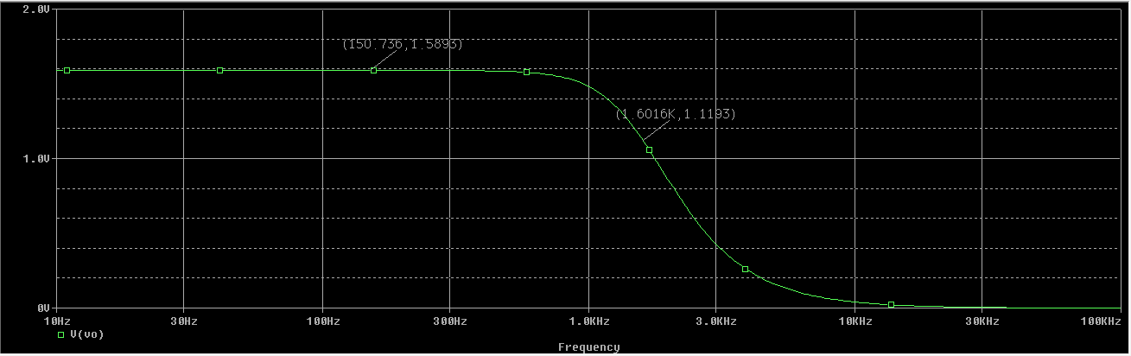

**Part C: First order active high -pass filter :**



**Figure 9.7: First Order Active High-Pass Filter**

**Pispice:**

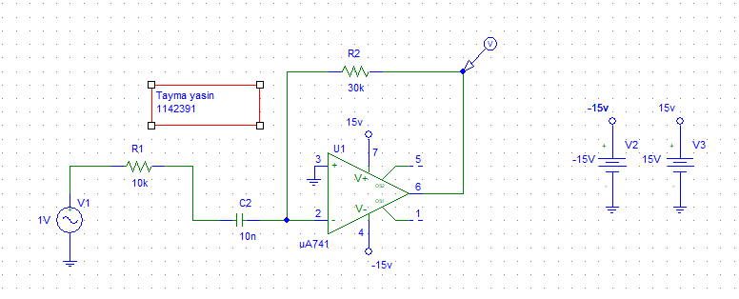

**Vmax =2.998V, cut off frequncey with $\frac{Vmax}{\sqrt{2}}=\frac{2.998}{\sqrt{2}}=2.119V,$**

**Cut off frequency =1.5778KHZ.**

**Smiluation:**

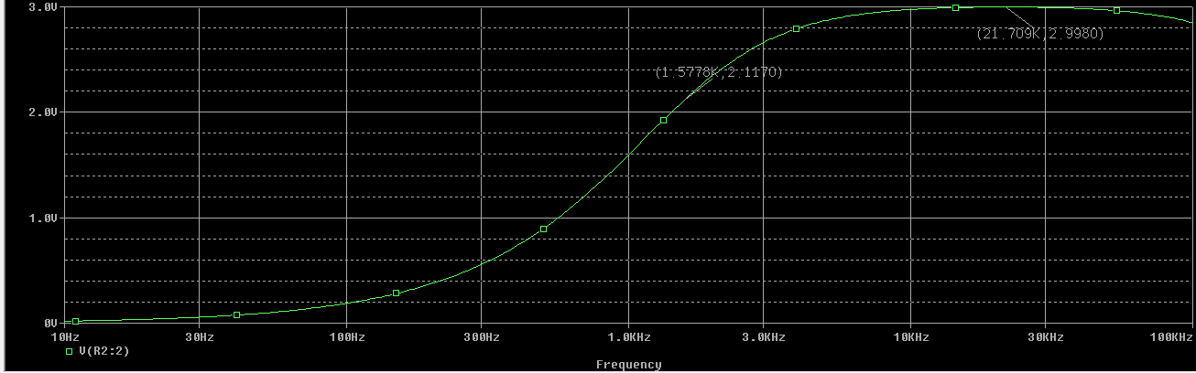

**Part D: Second Order High Pass Butterworth Filter :**

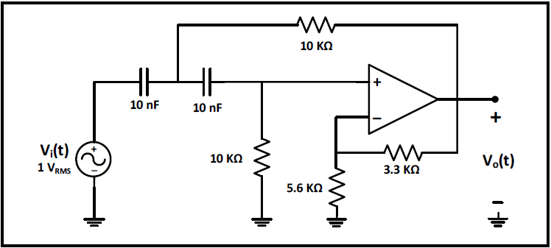

**Figure 9.8: Second Order High Pass Butterworth Filter**

**Pispice:**

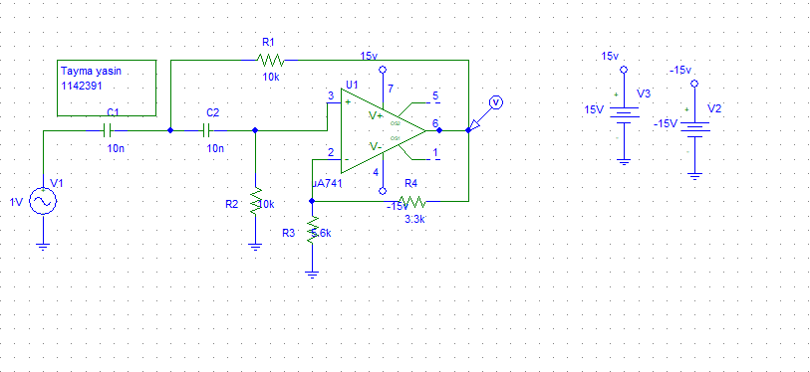

**Vmax =1.582, cut off frequncey with $\frac{Vmax}{\sqrt{2}}=\frac{1.582}{\sqrt{2}}=1.118V,$**

**Cut off frequency =1.5778KHZ.**

**Smiluation :**

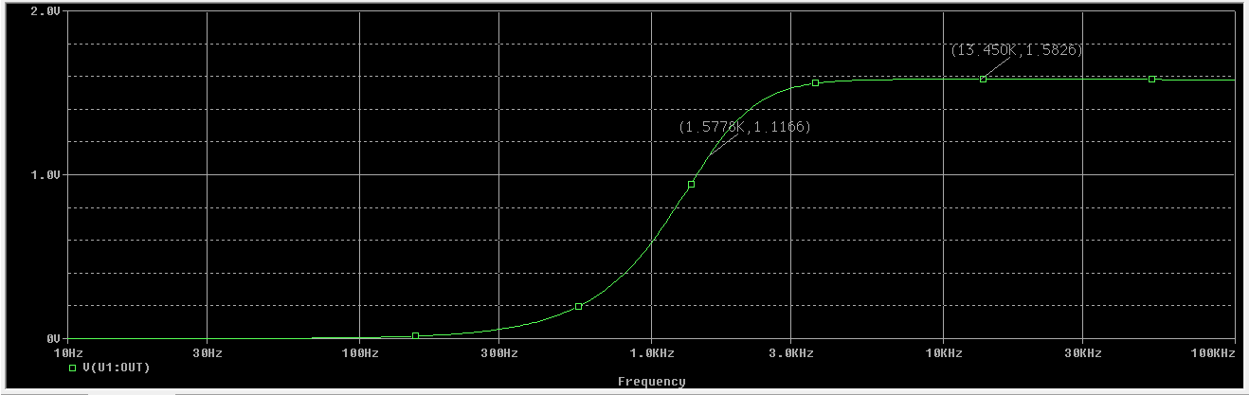

**Part E: Active band-pass filter :**



**Figure 9.9: Active band pass filter**

**Pispice:**

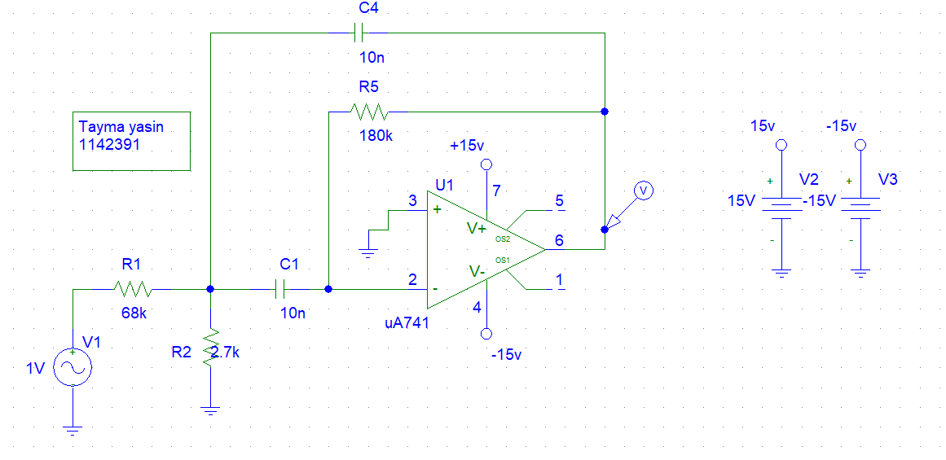

**Part F: Active band-reject filter :**



**Figure 9.10: Active band reject filter**

**Pispice:**

