Chapter 11 Computer Crime and Information Technology Security

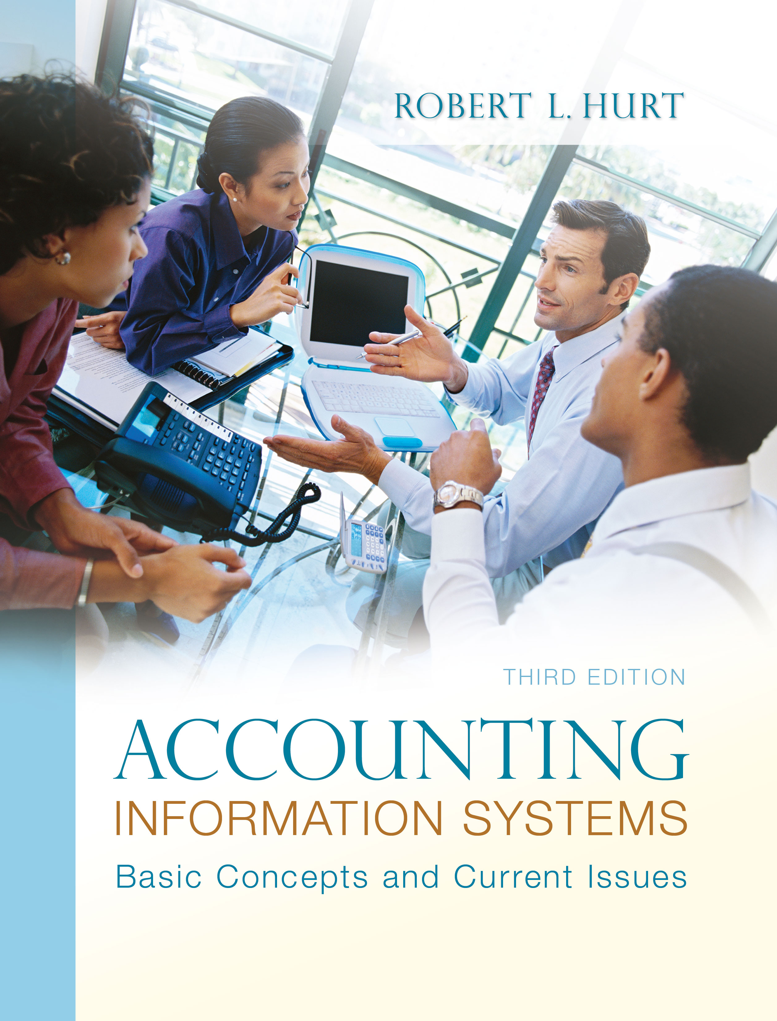
1. Reading review questions

a. What four common classifications are often associated with computer crime? Carter’s taxonomy includes: target (where the computer is the object of the crime), instrumentality (where the computer is instrumental in committing the crime), incidental (where the computer simplifies criminal action) and associated (where the presence of computers has created new forms of crime).

b. What computer crime–related risks and threats are associated with information systems? The chapter discusses eleven types of risks and threats: fraud, error, service interruption & delays, disclosure of confidential information, intrusions, information theft, information manipulation, malicious software, denial of service attacks, web site defacements and extortion.

c. What categories are commonly associated with computer criminals? Describe each category. “Script kiddies” use code written by others to perpetrate computer crime. Hackers may be motivated simply by the challenge; cyber-criminals, by the potential for financial gain. Organized crime has also made significant inroads in computer crime. Corporate spies may be former employees or consultants, attempting to compromise an organization’s information system. Terrorists have also become involved in computer crime; and, corporate insiders may engage in computer crime if disgruntled or otherwise unhappy.

d. How can organizations safeguard against computer crime? How can they detect it and recover from it if it happens? What role does CoBIT play in those tasks? Organizations can safeguard against computer crime via a strong system of internal controls. Internal controls can focus on the CIA triad: confidentiality, integrity and availability of information. Information systems controls fall into three major categories: physical (such as fire suppression systems), technical (such as requirements for strong passwords) and administrative (such as procedures manuals). COBIT stands for Control Objectives for Information and Related Technology; developed by the Information Systems Audit and Control Association (ISACA), COBIT can guide managers and others in developing a strong internal control system.

e. What is CoBIT? What are the seven information criteria discussed in the CoBIT
framework? COBIT is a set of standards which gives accountants and other information systems professionals clear guidance in establishing strong internal controls, thereby deterring fraud. The seven information criteria are: effectiveness, efficiency, confidentiality, integrity, availability, compliance and reliability of information.

f. Respond to the questions for this chapter’s “AIS in the Business World.” I was very fortunate to have three assistants available to prepare responses to the AIS in the Business World vignettes for the third edition; I’ve posted their responses on my AIS blog: www.bobhurtais.blogspot.com.

2. Reading review problem

a. Use Carter’s taxonomy for computer crime to classify the case. This case fits at least two of Carter’s classifications. The criminals used wireless technology to commit the crime, thus exemplifying instrumentality. Additionally, theft of credit card numbers has been known to happen for some time; in this case, the computer made it easier, so it constitutes an “associated” crime.

b. What business risk(s) / threat(s) are exemplified by it? At minimum, this case fits into the following risk / threat categories: fraud, disclosure of confidential information, intrusion and information theft.

c. Which element(s) of the C-I-A triad was/were compromised in the case? Confidentiality and integrity were immediately compromised in this case; the customers’ credit card numbers were stolen, and the integrity of the data was at issue. If the issuing banks temporarily disabled the cards when the crime was discovered, availability might also be compromised.

d. What internal controls would you recommend to address the problem? Data encryption would be an important internal control in this case. In addition, credit card users should regularly and frequently review their credit card records online to detect fraudulent use as it happens. Many credit card issuers have dedicated security departments whose primary job is to monitor card activity. Insurance would also be an important corrective control.

e. Discuss elements of the CoBIT framework that are relevant to this case. This case touches at least two of CoBIT’s domains of knowledge: acquire & implement, as well as monitor & evaluate. Credit card issuers and firms that accept credit cards need to acquire and implement IT appropriate to preventing, detecting and correcting the situation; through careful monitoring and evaluation, they will be able to uncover problems quickly and efficiently. In addition, the case has a close relationship to the “IT resources” point of view, as companies consider what resources they need to combat the problem. Almost all of CoBIT’s information criteria have some relevance as well, as the information associated with credit cards and related transactions need to meet them.

3. Multiple choice review questions. Answers to all of these questions appear at the end of the textbook itself.

4. Making choices and exercising judgment
The point of these exercises, which appear in every chapter throughout the third edition, is to encourage students to think critically and “outside the box.” Thus, I am not providing solutions to them, as doing so would likely discourage the purpose of these exercises.

5. Field exercises
Answers to these exercises will vary significantly; thus, like the previous set, I am not preparing published solutions for them.

6. Applying Carter’s taxonomy
a. Incidental.
b. Target (the computer is the object of the attack) and associated (computers themselves have “created” this form of computer crime)
c. Target (computer is the object) and instrumentality (the backdoor allows the former employee access to the information system)
d. Incidental (theft of assets can happen even without computers) and associated (identity theft has increased because of the presence of computers)
e. Incidental (illegal pyramid schemes have existed for quite some time) and instrumentality (since e-mail was used to perpetrate the crime)
f. Incidental (espionage is not limited to scenarios involving IT)
g. Target (changing data), instrumentality (computer is used to change grades)
h. Incidental

7. Identifying business risks and threats
a. Extortion
b. Denial of service attack
c. Web site defacement
d. Disclosure of confidential information
e. Intrusions
f. Fraud
g. Error
h. Service interruption & delay
i. Information manipulation
j. Information theft
k. Malicious software

8. Classification of controls
a. Technical. Access control software restricts access to an organization’s information system via passwords or other means.
b. Administrative. Employees should be supervised to promote strong internal control.
c. Administrative. Authorized employees and others can be required to wear identification badges while on an organization’s premises.
d. Technical. Encrypted data are “garbled” so that they cannot be read without decryption keys.
e. Technical. Firewall software restricts both incoming and outgoing traffic.
f. Administrative. Internal auditors can check systems for both security and efficiency.
g. Technical. Organizations can employ, for example, automatic lockouts after three attempts to access a system without an authorized user name and password.
h. Physical. Information systems should be kept behind locked and alarmed doors.
i. Administrative. Organizations can require online or in-person seminars on a periodic basis.
j. Physical. Security guards can restrict access to sensitive areas.
k. Administrative. A well-developed security policy can outline specific acceptable and unacceptable actions.
l. Physical. If a fire breaks out, smoke detectors can help minimize the damage.
m. Physical. UPS protect an organization against electrical failures.

9. CoBIT information criteria
a. Effectiveness and availability—the information is not available on a timely basis.
b. Efficiency—this company is likely too large to maintain its AIS without the benefit of information technology.
c. Confidentiality and (potentially) compliance—that information should be kept confidential. If “identification numbers” refers to Social Security numbers, the company may also be violating the law.
d. Availability—the system is unavailable because of the damage.
e. Compliance—the organization is violating SOX.

10. Internal controls
a. Procedures manuals (preventive) and internal audits (detective / corrective) can facilitate the timely production of financial statements.
b. Properly installed general ledger and / or ERP software (preventive) can increase the company’s efficiency and help safeguard its information.
c. Employee information should be password protected (preventive) and stored behind a firewall (preventive, detective).
d. A procedures manual (preventive) which prohibits food & drink around file servers could address the problem. Backup systems (corrective) and insurance (corrective) would also be helpful.
e. Independent and / or external audits (preventive, detective) can help keep an organization compliant with SOX.

11. CoBIT
a. The documents on the web site describe the focus areas as follows: Strategic alignment focuses on ensuring the linkage of business and IT plans; on defining, maintaining and validating the IT value proposition; and on aligning IT operations with enterprise operations. Value delivery is about executing the value proposition throughout the delivery cycle, ensuring that IT delivers the promised benefits against the strategy, concentrating on optimizing costs and proving the intrinsic value of IT. Resource management is about the optimal investment in, and the proper management of, critical IT resources: applications, information, infrastructure and people. Key issues relate to the optimization of knowledge and infrastructure. Risk management requires risk awareness by senior corporate officers, a clear understanding of the enterprise’s appetite for risk, understanding of compliance requirements, transparency about the significant risks to the enterprise, and embedding of risk management responsibilities into the organization. Performance measurement tracks and monitors strategy implementation, project completion, resource usage, process performance and service delivery, using, for example, balanced scorecards that translate strategy into action to achieve goals measurable beyond conventional accounting.
b. CoBIT applies the principles of the COSO documents within the context of information technology. So, it specifically discusses IT-related risks and suggests internal controls for addressing them.
c. Figures 3 and 4 in the Executive Summary of CoBIT (pp. 6 and 7, respectively) illustrate the components and their relationships.

d. The SDLC comprises seven parts. The table below suggests how each part would relate to a CoBIT project:
SDLC phase | CoBIT application
Initiation / planning | Recognize a need for stronger IT control
Requirements analysis | Use CoBIT objectives to assess IT control needs
Design | Work together to develop controls for each domain
Build | Create procedures manuals, training programs and systems needed for designed controls.
Test | Test controls in a subset of departments / domains / processes.
Implementation | Roll out the new controls across the organization.
Operations & maintenance | Periodically monitor the system and update as required.

e. Both models rely on phases / stages to describe maturity levels. But, whereas the CMM was originally focused on software (and later on business processes), the CoBIT model looks specifically at information technology. The CoBIT model does not try to measure levels, nor does it strive to move different IT processes through the levels simultaneously. Page 21 of the executive summary provides an excellent chart that discusses the levels of the CoBIT maturity model.

12. Terminology

1. C
2. F
3. E
4. H
5. B
6. A
7. J
8. G
9. D
10. I

13. Multiple choice questions
1. A
2. B
3. C
4. A
5. A

14. Statement evaluation
a. Always true.
b. Sometimes true. Computer crime can also involve the computer as a target, associated with or incidental to the crime.
c. Sometimes true. Computer crime can be committed by organized crime groups, but other types of computer criminals can engage in similar activities.
d. Always true.
e. Always true.
f. Always true.
g. Always true.
h. Never true.
i. Sometimes true. Criminals can be internal or external to the organization.
j. Always true.

15. Prior material application

a. Consider the five generic elements of most accounting information systems. For each element, suggest one way it could be compromised via computer crime. Inputs, such as source documents, could be electronically altered / falsified. The AIS processing function could be compromised in myriad ways, including the use of malicious software. To the extent that outputs are disseminated electronically, they could also be electronically altered; many companies post key financial data on their web sites, opening up the opportunity for web site defacement. Storage of AIS data could be compromised by deleting key data; internal controls can be compromised with malicious software, as illustrated in the reading review problem.

b. Read “Protect Small Business” by Joseph T. Wells in the March 2003 issue of Journal of Accountancy; consider the case presented in the opening paragraphs of the article (Denise, a bookkeeper for a small trucking firm). Work with a group of students and / or interview a forensic accountant / certified fraud examiner to suggest a series of steps you could use to investigate the fraud. Document your steps using one of the techniques described in Part Two of the text.

In the August 2003 issue of Journal of Accountancy, Wells wrote an article titled “Sherlock Holmes—Part One.” In that article, he lays out a generic process often used to conduct a fraud examination. The steps are summarized below:

1. Gather data, such as from the AIS, interviews and other sources.

2. Analyze the data to detect abnormalities or evidence of unusual activity.

3. If sufficient predication exists, develop a fraud theory—a hypothesis about how the fraud occurred.

4. Gather additional evidence. Revise the fraud theory as needed.

5. Interview people to gain more information. Interviews should start with neutral third-party witnesses, and end with the suspect(s).

6. Prepare a report as to the findings.

7. If necessary, testify in court.

c. Explain how the use of XBRL helps organizations respond to CoBIT’s seven information criteria. XBRL can make the preparation of AIS documents more efficient, saving time by employing information technology. Data are also more readily available, since XBRL tags can be interpreted by a wide variety of hardware and software platforms. XBRL also helps meet the criterion of integrity, provided instance documents are properly prepared using appropriate taxonomies.

d. This chapter provided a three-part taxonomy for IT controls; earlier in the text, you learned that internal controls have four broad purposes. Fill in the table below with appropriate examples; be prepared to explain your reasoning.

Internal control purpose | Physical  controls | Technical  controls | Administrative controls
Safeguard assets | Lock rooms containing IT assets | Require login credentials before using IT assets. | Establish & enforce a policy of no eating / drinking around IT assets.
Ensure financial statement reliability | Set up an alarm that will detect unauthorized intrusions to the AIS. | Prepare financial statements using appropriate forms of IT. | Create & utilize an internal audit function.
Promote operating efficiency | Create sufficient, but not excessive, copies of documents used in the AIS. | Utilize IT to perform appropriate tasks. | Make operating efficiency part of performance evaluation.
Encourage compliance with management directives | Require managers to interact with workers, rather than trying to manage from behind a desk. | Create a dedicated web site where employees can make suggestions for process improvements. | Make compliance with management directives part of performance evaluation.

